Roadmap for targeting decisions

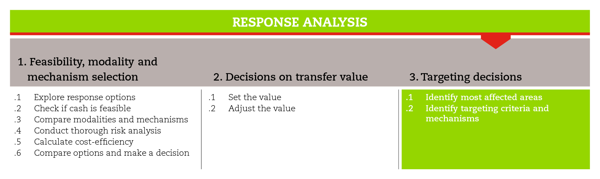

INTRODUCTION
This road map will guide you through the process of making targeting decisions. This process should take place at an initial stage of response analysis, as targeting decisions influence the choice of the response modality and mechanisms. Targeting approaches usually include an initial geographical targeting followed by the selection of households/individuals.
The road map provides suggestions on which CiE tools are most useful for this step and sub-steps. The tools will need to be adapted to your need and context.
You should always aim to comply with the minimum standards listed under this step, as this will contribute to the quality of your response.
It is likely that you will need to move back and forth between the different sub-steps to guide your decision-making as information and processes are completed and feed into each sub-step.
If you need more detailed guidance on targeting, consult the reference documents suggested at the end of this road map.

MINIMUM STANDARDS
- Targeting should be collaborative and involve multiple stakeholders, like government, other agencies and affected communities.
- When conducting geographical targeting, include criteria related to the impact of the emergency and the vulnerabilities of the area.
- Targeting criteria must be linked to the objectives of the intervention, relevant for the local population and context, and measureable with the resources available.
- The choice of the targeting mechanism should be a trade-off between the imperative to act, , accuracy and affordability.
- Ensure clear and regular communication with affected communities in order to reduce the risk of misunderstanding and complaints around targeting.

SUB-STEPS AND TOOLS
Targeting involves aligning your chosen programme activities to specific beneficiaries. This requires clear project objectives based on assessed needs. A number of targeting approaches exist and you will need to choose the one that best suits your context. All your decisions on targeting will need to be clearly communicated with internal and external actors as well as the affected population. They will also have to consider the local markets and intended beneficiary access to them, as well as coverage and access to potential delivery agents and methods. In order to facilitate the engagement of multiple stakeholders throughout the targeting process, you may want to create a working group.

Geographical targeting
Geographic targeting in an emergency refers to the identification of specific administrative units or livelihood zones or similar boundaries for your emergency response. You will have identified these during module 2 when planning your assessment. The geographic locations affected by an emergency are identified primarily through secondary data and information on where the affected population is.
The selection of the intervention area will be based on data collected both prior to and after the emergency. When, in the immediate aftermath of a rapid-onset emergency, it is difficult to have access to reliable information, this selection, often, will be based on experience and coordination.
The tool key elements of geographical targeting goes into further detail regarding the selection of intervention areas.
Targeting in urban areas can be challenging because of the population density and mobility, and the lack of updated maps of informal settlements. In order to overcome these difficulties and target specific urban vulnerabilities it is possible to ‘break’ the city into small grids and street groups (see urban vulnerability mapping tool).

Blanket versus targeted distributions
Once you have narrowed down your geographical area of operation, your next decision will be to decide whether a blanket approach where everyone in the community is targeted is appropriate. This means providing assistance to all the population in that geographical area. This is especially appropriate to meet immediate needs after a rapid onset disaster or when access to the population is constrained by security issues and markets are functioning to supply the goods and/or services. Blanket targeting speeds up the response and is suitable for shelter, food security, WaSH and nutrition needs. It suits both one off distributions and repeat distributions.
Geographic targeting is complemented with household/individual targeting, which involves developing targeting criteria.

Household targeting
The first decision to be made is whether to target households or individuals. This will depend on the objective of the intervention. As a norm, if the objective is to meet minimum households needs identified in the minimum expenditure basket, targeting at household level is often best; this is also the case for shelter interventions with a cash component. When the objective is to support recovery and livelihoods, or improve health and nutrition support services for vulnerable groups, individual targeting may be more appropriate.
Some types of intervention (e.g., shelter, water) will target whole communities.
The second decision is about the targeting criteria. Usually, household and individual targeting criteria are based on indicators of vulnerability, and can be context-specific, related to social welfare status or specific vulnerable groups. The tool identifying targeting criteria suggests what appropriate criteria should look like and provides examples of commonly used targeting criteria.
Ensure that the targeting criteria are inclusive of marginalized groups or people with specific needs. If the project objective does not allow for targeting such groups, refer them to other types of assistance.

The third decision is about the targeting mechanism. The most commonly used mechanisms are community-based targeting, self-targeting and categorical targeting. All of these mechanisms have pros and cons, so your decision will likely be a trade-off between the imperative to act, accuracy and affordability. Also, you will also to consider which mechanism is more appropriate given the impact of the emergency and the type of programme being planned. A SWOT analysis could be conducted to analyze the different targeting mechanisms against issues like security, safety, protection, costs, time and human resource requirements. The tool choosing the targeting mechanism will provide you with the key elements to ponder and select an appropriate targeting mechanism. It is important to note that any chosen mechanism will have to be adapted to the specificities of the context.
REFERENCE DOCUMENTS
Targeting Strategy and Determining Eligibility in Multipurpose Cash Grants Toolkit, UNHCR (2016). http://www.cashlearning.org/downloads/mpg-toolkit-pdfs/mpg-part3-4.pdf
ICRC (2016) ECOSEC Executive Brief on Multi-Purpose Cash Grants.
Cross and Johnston (2012) 'Cash transfer programming in emergencies - A toolkit for practitioners' (CaLP). Topic 3 Targeting and verification in urban context. Pages 28-36.
http://www.cashlearning.org/resources/library/251-cash-transfer-programming-in-urban-emergencies-a-toolkit-for-practitioners
MacAuslan and Farhatt (2013) ‘Review of urban food security targeting methodology and emergency triggers’. OPM.
http://www.foodsecuritycluster.net/sites/default/files/Oxfam-ACF%20Urban%20food%20security%20targeting%20and%20triggers%202013-07-12%20final.pdf
ACF (2010) ‘Identification of vulnerable people in urban environments: Assessment of sustainable livelihoods and urban vulnerabilities’.
http://www.foodsecuritycluster.net/sites/default/files/ACF%20-Identificationof%20Vulnerable%20People%20inUrban%20Environments.pdf

