Roadmap for cash-sensitive community assessment

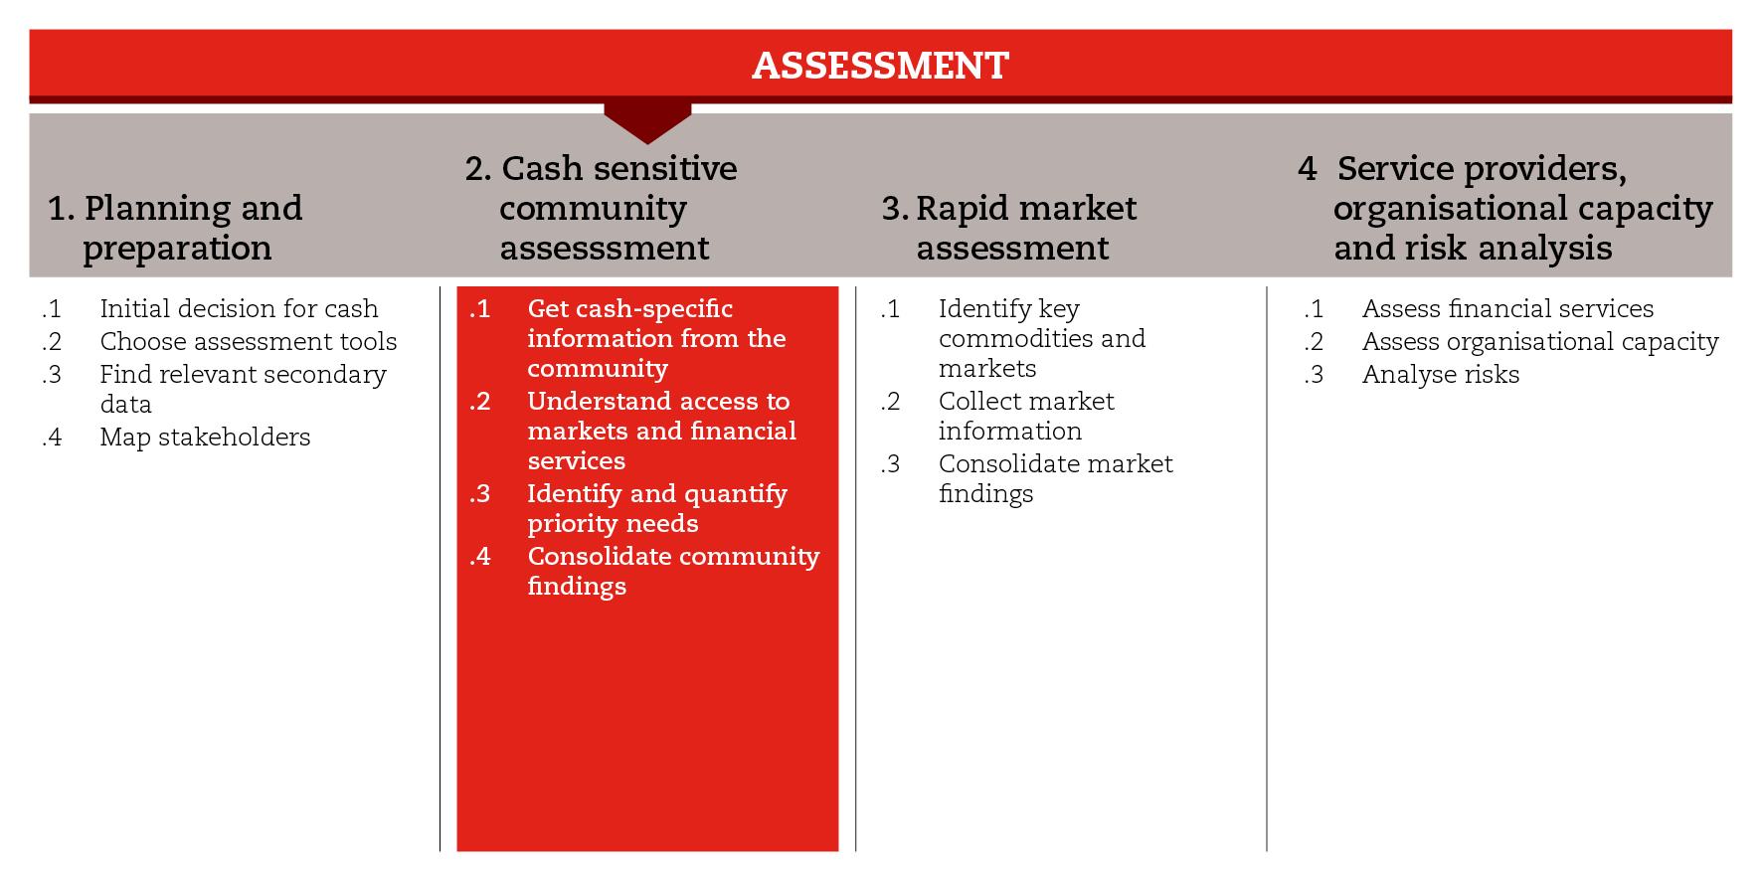

INTRODUCTION
In order to consider cash among the potential response modalities and mechanisms, you must ensure that your assessment is cash-sensitive at every step. This road map will help you to gather cash-specific information during the community level assessment.
For the purposes of the CiE Toolkit, community assessment has been divided into four non-sequential sub-steps. For each sub-step, you will find a set of tools that will allow you to gather cash-specific information from shock-affected communities and households. The sub-steps and tools made available have been developed based on the assumption that most assessment approaches and tools do not allow for obtaining cash-specific information. They recommend a set of cash-specific topics and questions that should be part of your emergency assessment at community and household levels. Depending on the time available and the depth of the analysis, you may choose to use one or more of the suggested tools.
The first sub-step can help you gather information on community and household access to, use of and preferences regarding cash. The second sub-step can help you gather more in-depth information on community access to key markets and commodities, as well as to financial services. The third sub-step can help you identify and quantify the priority needs of the shock-affected population. The fourth and last sub-step can help you organize the cash-specific information collected at community and household levels so you can facilitate its integration into the general assessment report.
In the reference documents you will find more resources that might be helpful when trying to make your community assessment cash-sensitive.

MINIMUM STANDARDS
- Information on community and household access to and use of cash, as well as on preferences regarding the different types of assistance, must be gathered during the assessment.
- Community assessments should look within and beyond the household unit and consider different age, gender and diversity groups.
- Information on the access to and use of markets and financial services must be gathered at community and household levels in the first place.
- The priority needs of the shock-affected population should be defined and quantified in monetary terms, using local prices.
- Cash-specific information gathered at community and household levels should be integrated into the standard assessment report.

SUB-STEPS AND TOOLS

Get cash-specific information from community
An emergency assessment should allow you to understand the impact of the shock on the affected population, particularly on their ability to satisfy their basic needs, and access markets and essential services (including mobile phones and financial services). Based on this understanding, you will be able to make decisions on cash feasibility and appropriateness both in the short term and during response analysis. The feasibility may vary with different population groups so you may need to link this with your response option and targeting strategies later on (Module 3).
When conducting community assessments, look within and beyond the household unit. Make sure that individuals of different age, gender and diversity groups (HIV positive, disabled, etc.) are given a voice. In the analysis ensure that information is disaggregated accordingly.
The sub-step tools suggest cash-specific questions to be considered when conducting focus group discussions and interviews with key informants at community and household levels. The community-level tool is focused on the community’s access to and use of cash, as well as its preferences and potential issues around cash-based assistance. The household-level tool is focused on the access of households to and their control over cash, their use of financial services and their ownership of and capacity to use mobile phones, as well as their experience with cash assistance and preferences for different types of assistance. Among the questions suggested, you can choose those that are more relevant to your context, then adapt and incorporate them into your assessment questionnaires.

Understand access to market and financial services
This sub-step informs market assessment (step 3) and financial services’ capacity assessment (step 4). On the one hand, it provides an understanding of the key commodities purchased and the key markets accessed by the affected population. On the other hand, it provides an understanding of the affected population’s access to and use of financial services and mobile phone technology. This understanding gives an indication of which markets should be assessed (step 3) and which service providers should be investigated further (in step 4 and during response analysis). The sub-step tools are questionnaires that can be used to gather specific information which is useful for generating this understanding when conducting focus group discussions with community members or representatives.

Identify and quantify priority needs
One of the objectives of the assessment is to identify the priority needs of the shock-affected population. These needs can be translated into typical expenditure baskets – food and/or non-food items, and basic and/or livelihoods expenditure, depending on the objective of the response. Information on which items should be included in each of these baskets either can be obtained from secondary data (e.g., national expenditure surveys) or can be collected in the field (e.g., through focus group discussions with representatives of different wealth groups).
From a multipurpose cash grants perspective, it is important to identify sector-specific needs and group the needs that can be potentially met by cash assistance. It is also important to distinguish between recurrent and one-off needs. For example, while food and hygiene items will need to be purchased regularly, shelter materials for construction will be probably bought just once.
Once identified, the priority needs should be quantified in monetary terms using local prices, so that cash can be considered an option in the response analysis phase. This value will be part of the cost component of the different modalities and mechanisms, making it possible to analyse the cost-efficiency and cost-effectiveness of the different options, and to determine the value of the transfer, should a cash response be appropriate.
In this sub-step, you will find a tool that can be used both in the assessment phase, to quantify the priority needs, and in the response analysis phase, to calculate the value of a potential cash transfer. The tool is based on the calculation of a Minimum Expenditure Basket (MEB), which outlines the shock-affected population’s basic needs based on estimated monthly expenditures. The tool also distinguishes between recurrent and one-off needs.

Consolidate community findings
Using the tools available in this step, you probably will have gathered very useful cash-specific information at community and household levels. This sub-step tool can help you consolidate and organize your findings, and integrate cash-specific information into your standard assessment report format.
REFERENCE DOCUMENTS
Guidelines for Cash Transfer Programming - International Red Cross and Red Crescent Movement. http://www.ifrc.org/Global/Publications/disasters/finance/cash-guidelines-en.pdf
Good Practice Review: Cash Transfer Programming in Emergencies. Humanitarian Practice Network (2011) http://www.odihpn.org/documents%2Fgpr11.pdf
UNHCR (2015) Operational Guidance and Toolkit for Multipurpose Cash Grants. http://www.cashlearning.org/mpg-toolkit/
ECHO (2015) Common Principles for Multi-Purpose Cash-Based Assistance.
http://ec.europa.eu/echo/files/policies/sectoral/concept_paper_common_top_line_principles_en.pdf
ICRC (2016) ECOSEC Executive Brief on Multi-Purpose Cash Grants.
UNHCR (2015) Guide for Protection in Cash-based Interventions. http://www.cashlearning.org/downloads/erc-guide-for-protection-in-cash-based-interventions-web.pdf

