Roadmap for cash feasibility, modality and mechanism selection
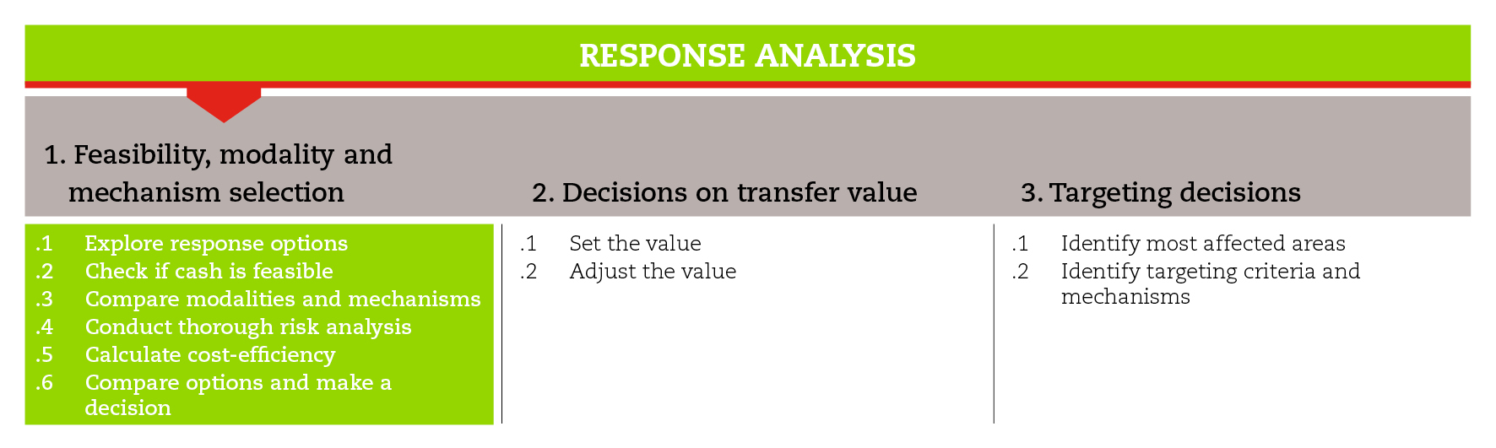

INTRODUCTION
This road map will guide you through the process of cash feasibility and selecting the response modalities and mechanisms that best meet the objectives established for the emergency response.
The road map also provides suggestions on which CiE tools are most useful for this step and sub-steps. The tools will need to be adapted to your need and context.
You should always aim to comply with the minimum standards listed under this step, as this will contribute to the quality of your CTP response.
It is likely that you will need to move back and forth between the different sub-steps to guide your decision-making as information and processes are completed and feed into each sub-step.
If you need more detailed guidance on cash feasibility, modality and mechanism selection, consult the reference documents suggested at the end of this road map.

MINIMUM STANDARDS
- Multipurpose cash grants should be considered among the potential response options from the beginning.
- Response modality and mechanism selection should be based on a comparative analysis
- Comparison criteria should be weighted according to their relevance in the context and in relation to the intervention objectives.
- Alignment with the policies and practices of local government and other humanitarian actors should be sought.
- The capacity of the agency and its partners, to deliver assistance through the selected modality and mechanism must be considered.
- Beneficiary preferences and capacity (e.g., familiarity and use of technology) must be considered.
- Some level of cost analysis, including the cost-efficiency of multipurpose cash grants, must be included when comparing different modalities and mechanisms
- Risks associated with the selected modality and mechanisms, including protection-related risks, must be analysed and registered. The selected option should not present any unacceptable risk.
- Time issues (e.g. seasonality, time required to set up a mobile transfer mechanism) must be considered.
- The rationale behind the final choice must be shared with the management line and should be shared with the key stakeholders.

SUB-STEPS AND TOOLS
Before starting you must have decided which needs (food security, livelihoods, shelter, health, water and sanitation or multi-sectoral) should be met and set the objectives of your intervention.
The following sub-steps are included under cash feasibility, modality and mechanism selection.

Explore potential response options
In order to come up with a broad list of response options, you can conduct a brainstorming session with key stakeholders, encouraging them to think widely and freely about possible options. Involving national and local governments in the response analysis process can contribute to the acceptability of cash-based assistance. At this stage, nothing should be excluded. This might help in promoting innovative ideas. The tool ‘response intervention options’ suggests potential response options for each phase, according to sectors and objectives.
Multipurpose cash grants should be considered among the potential response options from the beginning, as its unrestricted nature increases beneficiaries’ choice and flexibility allowing to meet multi-sector needs.

Check if cash is feasible
In general, feasibility criteria include: market capacity and functioning; humanitarian and physical access; organizational capacity; government policies; donors’ resources and policies; and time considerations. The tool ‘is cash feasible?’ suggests a checklist with criteria and key considerations that will help you decide whether cash is a feasible option. Depending on the nature and context of the crisis, a combination of transfer modalities and delivery mechanisms may be required and used at various stages of the crisis.

Identify and reflect upon the relevant comparison criteria
In order to compare the different response options, you will need to identify relevant criteria for your analysis. The comparative analysis will inform your decision-making process. The tool comparison criteria for modalities and mechanisms suggests questions related to the most common criteria to help you understand what to consider when comparing modalities (in-kind, cash, voucher) and cash delivery mechanisms (direct cash, mobile money, money transfer, stored value card). The tools advantages and disadvantages of different modalities and advantages and disadvantages of different delivery mechanisms might give you elements that will help you to answer the suggested questions.
Further analysis may be necessary regarding risks and cost-efficiency (see sub-steps below).

Conduct a thorough risk analysis
Risk analysis is cross-cutting and takes place throughout the response analysis. It is the process of identifying risks, assessing their likelihood and impact, and deciding what to do with them. The risks associated with the different response options should inform the final decision (see sub-step below). The tools risk matrix template and risk register template will help identify and record the main risks as well as potential mitigation measures. The risk analysis process will be explained in the tool road map for risk analysis. The IFRC CBP SOPs provide a detailed Risk Management checklist.
Ensure that the selection of response modalities and mechanisms takes into account protection-related risks and benefits. Risk analysis should consider what are the protection-related risks, how they can be mitigated through programme design, and what are the protection-related benefits associated with the different modalities and mechanisms.

Calculate cost-efficiency
In the process of transfer modality selection, a simple calculation can be carried out to help you compare the costs associated with different modalities (in-kind, vouchers and cash) and when possible with different delivery mechanisms. The cost-efficiency quick calculation tool allows you to calculate the cost-efficiency of different response options based on the value of transfer and the implementation costs associated with each modality or mechanism.
At this stage you should also consider whether multipurpose cash grants are likely to be a cost efficient means to meet multiple humanitarian needs. E.g. the provision of MPGs might reduce the resale of in kind assistance or facilitate access to services.

Compare options and make a decision
A decision making tool provides you with guidance on how to identify which response modalities and mechanisms best meet the objectives established for your emergency intervention. The decision making scorecard template allows you to score the response modalities and mechanisms in relation to all the criteria that have been taken into account throughout the analysis. The score card can be used to select modalities and mechanisms at the same time, because mechanisms can influence the performance of associated modalities.
REFERENCE DOCUMENTS
International Red Cross and Red Crescent Movement (2007) Guidelines for cash transfer programming http://www.ifrc.org/Global/Publications/disasters/finance/cash-guidelines-en.pdf
ICRC (2014) EcoSec Executive Brief on Cash Transfer Programming
Harvey P., Bailey S. (2011) Good Practice Review: Cash transfer programming in emergencies. Humanitarian Practice Network. http://www.odihpn.org/documents%2Fgpr11.pdf
FAO (2011) A response analysis framework: Discussion papers http://www.fao.org/fileadmin/user_upload/emergencies/docs/Response_Analysis_Framework_DiscussionPapers.pdf
Common Delivery Mechanisms. Annex 4 of the Operational Guidance and Toolkit for Multipurpose Cash Grants UNHCR (2016). http://www.cashlearning.org/downloads/mpg-toolkit-pdfs/mpg-annex4.pdf

