Roadmap for decisions on the value and frequency of the transfer

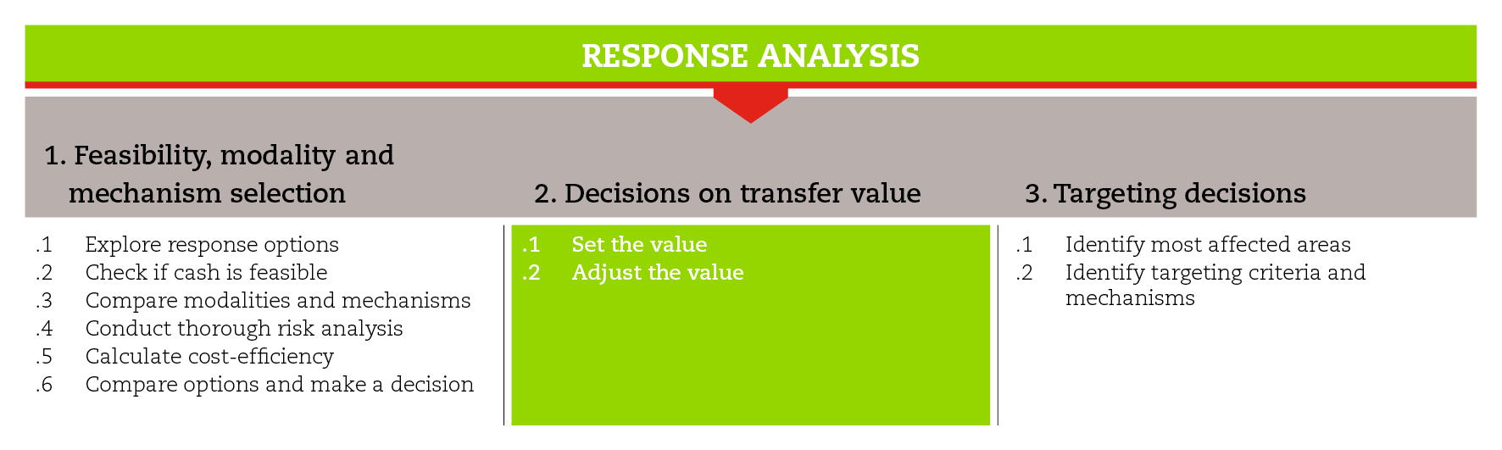

INTRODUCTION
This road map will guide you through the process of deciding on the value and frequency of the cash transfer that best meets the objectives established for the emergency response.
The road map also provides suggestions on which CiE tools are most useful for this step and sub-steps. The tools will need to be adapted to your need and context.
You should always aim to comply with the minimum standards listed under this step, as this will contribute to the quality of your CTP response.
It is likely that you will need to move back and forth between the different sub-steps to guide your decision-making as information and processes are completed and feed into each sub-step.
If you need more detailed guidance on the value and the frequency of the transfer, consult the reference documents suggested at the end of this road map.

MINIMUM STANDARDS
- Involve stakeholders, particularly the government, humanitarian actors and local communities in the process of setting the value of the transfer.
- When setting the value of the transfer, consider the cost of a Minimum Expenditure Basket (MEB) and, when appropriate, align it to the national poverty line.
- Seek harmonization with existing programmes to avoid conflict with existing social safety nets or, better, to reinforce or adapt them to humanitarian contexts.
- When planning for adjustments to the value of the transfer, establish clear triggers, budget for contingency resources and inform stakeholders on the rationale behind potential adjustments.
- Consider the local rates for labour payment, and relevant national legislation/taxation when setting the wages for a CFW project.

SUB-STEPS AND TOOLS

Set the value
The process of setting the value of the transfer starts with the calculation of a Minimum Expenditure Basket (MEB), which outlines the shock-affected population’s basic needs based on estimated monthly expenditures. When calculating the value of the transfer, one should distinguish between recurrent and one-off needs (e.g. food needs to be purchased on a regular basis, against shelter materials, which will probably be acquired just once).
The calculation of the value of the transfer should take into account the gap between the affected population’s needs and their capacity to provide for themselves without resorting to negative coping strategies. Programme objectives, other sources of assistance, and resources available should also be factored in. If resources are insufficient to cover the gap, the risks for the most vulnerable groups should be identified and relevant mitigation strategies should be developed. Furthermore, it is important to seek harmonization with existing cash transfer programmes, in order to avoid conflicts or, ideally, to reinforce or adapt existing social safety nets to humanitarian contexts.
In the toolkit you will find a ‘transfer value quick calculation tool’, which can help determine the value of a multipurpose cash transfer, including a MEB and one-off expenditures. When dealing with different modalities (e.g., cash for work) or with specific sectors (e.g. shelter, livelihoods), you may have to consider additional issues, some of which are listed in the tool ‘considerations on setting the value’.

Adjust the value to household size
It is simpler to give a fixed transfer regardless of household size but more equitable to give more money to households with more people. However, having a transfer dependent on household size may be challenging especially in emergencies, because it requires updated and reliable information on household size and more complex registration and payment procedures. Eventually, you will need to make a compromise between what is fair and what is feasible. The tool deciding whether or not to adjust the value to household size lists some pros and cons of fixed and variable transfers.

Decide on the frequency
Cash transfers can be given:
- For immediate needs as a one-off payment,
- In instalments to meet a recurrent need, or
- In instalments linked to a household investment such as livelihood assets or shelter.
One-off payments are more suitable to meet immediate needs and allow for responses at scale at relatively low cash transfer values. There will be a number of household level needs that one-off cash transfers can help meet, although not all households will spend their entitlements in the same way as they will have variable priorities.
Instalments are preferable for recurrent household needs such as food and non-food items that such as fuel, hygiene products or water. They are also suitable for livelihoods/shelter/recovery as grants are larger and more technical support is often needed from organisation (e.g., LH business plans / shelter technical supervision).

Adjusting the value to price changes
If the transfer is planned through several instalments, you may need to consider the potential negative effects of inflation on people's entitlements. This can be made in two ways:
- factoring in the expected inflation over the intervention period when calculating the value: the value will be adjusted for the estimated average inflation over the considered period. (see transfer value quick calculation tool)
- developing a contingency plan to adjust the value of the transfer or shift modality when inflation exceeds pre-established cut-off levels of prices. The tool ‘adjusting the value to price changes’ helps you understand which steps can be necessary to respond promptly and efficiently to price changes.
REFERENCE DOCUMENTS
The MPG Transfer Value. Part 3 in the Multi-Purpose Cash Grant Toolkit (2016) http://www.cashlearning.org/downloads/mpg-toolkit-pdfs/mpg-part3-3.pdf
Survival or Minimum Expenditure Basket (S)MEB Samples. Appendix A of MPG Standard Operating Procedures in Multi-Purpose Cash Grant Toolkit (UNHCR 2016).
ICRC (2016) ECOSEC Executive Brief on Multi-Purpose Cash Grants.
Learning from cash responses to the tsunami (2006) Issues Paper 3. Setting the value. ODI
htpp://www.odi.org/publications/3997-learning-cash-responses-tsunami-issues-papers
International Red Cross and Red Crescent Movement (2012) Market Analysis Guidance (MAG)
International Red Cross and Red Crescent Movement (2007) Guidelines for cash transfer programming Pages 28-30.
htpp://www.ifrc.org/Global/Publications/disasters/finance/cash-guidelines-en.pdf
ACF (2007) Implementing cash-based interventions. Pages 69-75.
http://www.actionagainsthunger.org/publication/2007/10/implementing-cash-based-interventions-guideline-aid-workers

