Roadmap for programme set-up

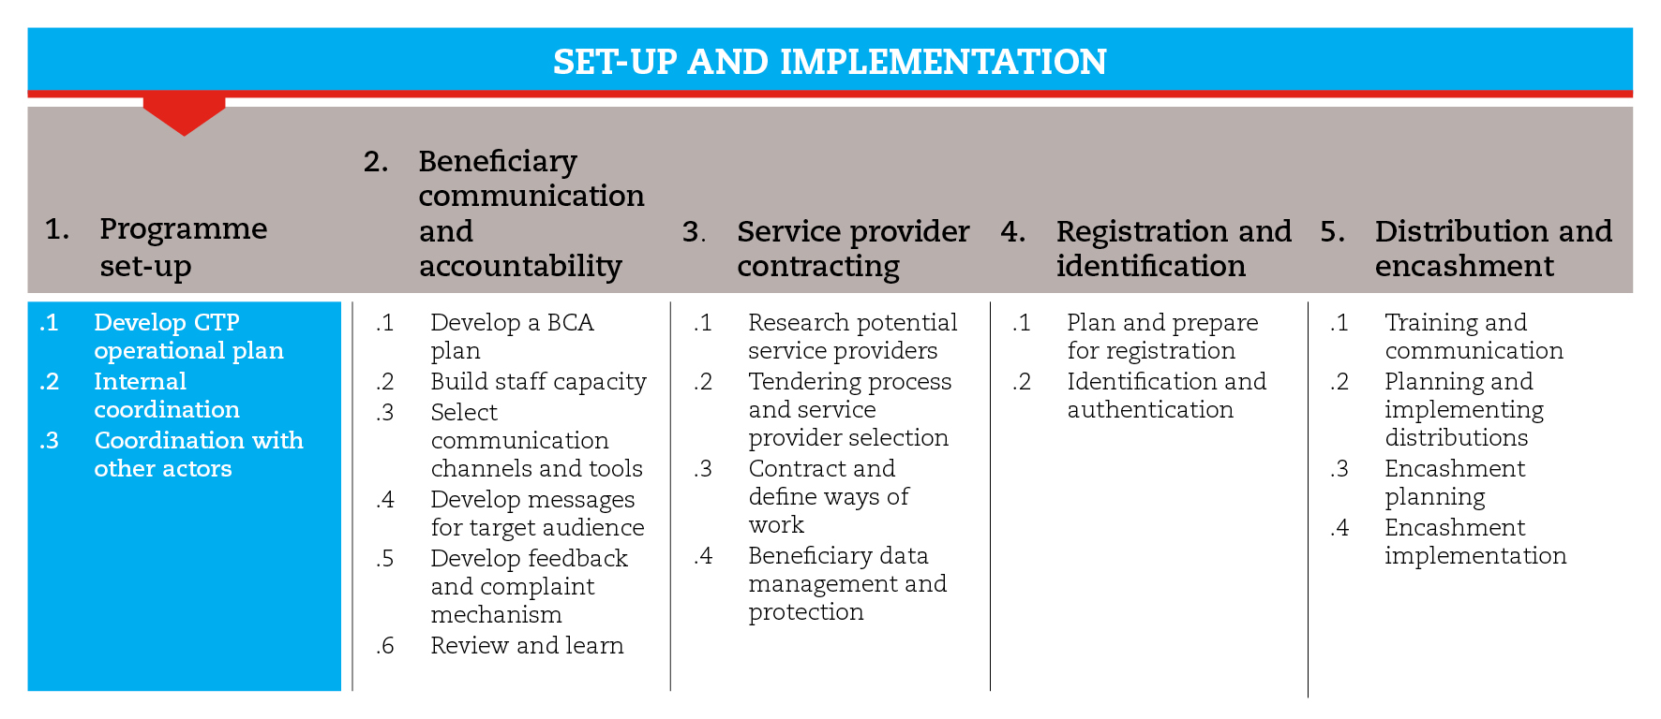

INTRODUCTION
This road map will guide you through the process of setting up a programme. It includes guidance on how to develop an operational plan of action and how to establish internal and external coordination mechanisms.
Also, the road map provides suggestions on which CiE tools are most useful for this step and sub-steps. The tools will need to be adapted to your need and context.
You should always aim to comply with the minimum standards listed under this step, as this will contribute to the quality of your response.
It is likely that you will need to move back and forth between the different sub-steps to guide your decision-making as information and processes are completed and feed into each sub-step.
If you need more detailed guidance on programme set-up, consult the reference documents suggested at the end of this road map.

MINIMUM STANDARDS
- The operational plan of action must include a logframe with measurable indicators for each expected output and outcome.
- Indicators should be limited in number and look at processes, outputs, outcomes and markets.
- In the case of multipurpose cash grants (MPG), indicators should be broad enough to allow for capturing secondary impacts.
- Tasks and activities in the operational plan need to be agreed with internal and external stakeholders, including the government.
- Internal roles and responsibilities must be defined in alignment with existing Standard Operating Procedures (SOPs), and agreed upon within the organization.
- Participation in existing coordination mechanisms should be ensured, so as to harmonize approaches, avoid duplications and gaps, and share experiences.

SUB-STEPS AND TOOLS

Develop an operational plan
A strong plan of action is critical to the success of any programme and should be prepared after the assessment and response analysis phases. The operational plan of action will allow you to detail the overall strategy, specific objectives, field structure, resources and costs of the cash intervention. Also, it will help you define expected outputs and outcomes, which will be used later to measure the efficiency and effectiveness of the response.
In this sub-step you will find a set of templates to support you in developing the PoA, including:
- logical framework
- budget template
- risk matrix
- HR plan, and
- detailed work plan
Remember that setting up a delivery mechanism from scratch takes time, often more than two months. The time needed to complete the set-up process will depend on factors like the context and size of the intervention, and the proactiveness of the service provider and the agency. In this sub-step you will find an e-transfer planning process with timeframe. Some actions to consider to help speed up the setting up of the cash delivery system include:
- considering cash in envelopes or vouchers while you set up a different mechanism
- working in coordination with other agencies and using an existing mechanism
- adopting existing tried and tested delivery mechanisms (those in place for social protection programming or those already in use by other humanitarian actors).
- comparing whether it can be quicker and more effective for the Host National Society to set up the agreements for the delivery mechanism than the IFRC or ICRC because of legal and administrative aspects and capacity.

Internal coordination
The Red Cross Red Crescent Movement must coordinate internally and ensure this is in support of the Host National Society (HNS) in international operations. The HNS will be implementing the programme with support from RC/RC Movement partners and where this is not the case will certainly be present and possibly in contact with the recipient population after the programme is over, and therefore must be involved and approve the cash transfer programming approach.
Internally, each unit will need to engage in specific aspects of the cash transfer programme. These roles and responsibilities should be detailed in the SOPs developed during the preparedness phase. When SOPs are not available, refer to the sub-step tools for suggestions on the main CTP roles and possible division of tasks. The decision on who will be responsible for what in your CTP programme should be agreed among all units. In the RCRC MOVEMENT KEY DOCUMENTS FOLDER, you will find IFRC and ICRC CTP SOPs which identify the roles of different functions/departments for different types of cash transfer modality.

Coordination with other actors
The Red Cross Red Crescent Movement actors should always share information and look for ways of collaborating with other organizations. Depending on the type of programme, key stakeholders can include ministries (e.g. social welfare, labour, agriculture, trade, supply and commerce), civil protection/defence, military forces, United Nations, international and local NGOs. Respective bodies and organizations should be encouraged to actively participate in the design and set-up of the response. Where there is added value the RC/RC movement should participate in existing coordination bodies, often established and led by the local government, IASC clusters and/or NGOs. These efforts can result in or take advantage of common databases that can support coordinated assessment, data analysis, delivery, reporting, monitoring etc.
In case of CTP, it will be particularly important to engage with the government to ensure acceptance. Bringing on board government bodies and international organization (such as the World Bank) involved in national safety nets will avoid overlapping or conflict with existing safety nets, or better to reinforce or adapt them for humanitarian contexts. Be sure to identify a CTP Focal point who can attend cash coordination meetings and represent the Movement appropriately.
The sub-step tools provide guidance on how to fit CTP coordination into the wider coordination system. The IASC cluster coordination system encourages thematic working groups to be convened to discuss sector specific issues. As cash transfers are not a sector response, but a modality that is appropriate for use by many sectors, a specific Cash Transfer Coordination group may be convened. The Movement should be represented at these meetings to inform other actors of Movement CTP activities and to ensure the CTP programmes are recorded in the 4ws matrix (where, what, who, when). It is a good forum to get additional technical peer support and ideas.
REFERENCE DOCUMENTS
IFRC (2008) Relief ERU field manual. https://www-secure.ifrc.org/DMISII/Pages/03_response/0306_eru/030602_eru_relief/146900_relief%20ERU_EN_LR.pdf
Making the Case For Cash: A field guide to advocacy for cash transfer programming CaLP (2011)
http://www.cashlearning.org/resources/library/30-making-the-case-for-cash-a-field-guide-to-advocacy-for-cash-transfer-programming-screen-version
Guidance on coordination - Coordination toolkit CaLP
http://www.cashlearning.org/resources/coordination-toolkit
Field advocacy guide for CTP - Coordination toolkit CaLP
http://www.cashlearning.org/resources/coordination-toolkit
Protection Risks and Benefits Analysis Tool. Annex 2 in the Multi-Purpose Cash Grants Toolkit. UNHCR (2016) http://www.cashlearning.org/downloads/mpg-toolkit-pdfs/mpg-annex2.pdf
Template of Standard Operating Procedures for the Design and Implementation of Coordinated Multi-Purpose Cash Grants. Annex 3 of the Multi-Purpose Cash Grant Toolkit (2016) http://www.cashlearning.org/downloads/mpg-toolkit-pdfs/mpg-annex3.pdf

