Roadmap for beneficiary communication and accountability

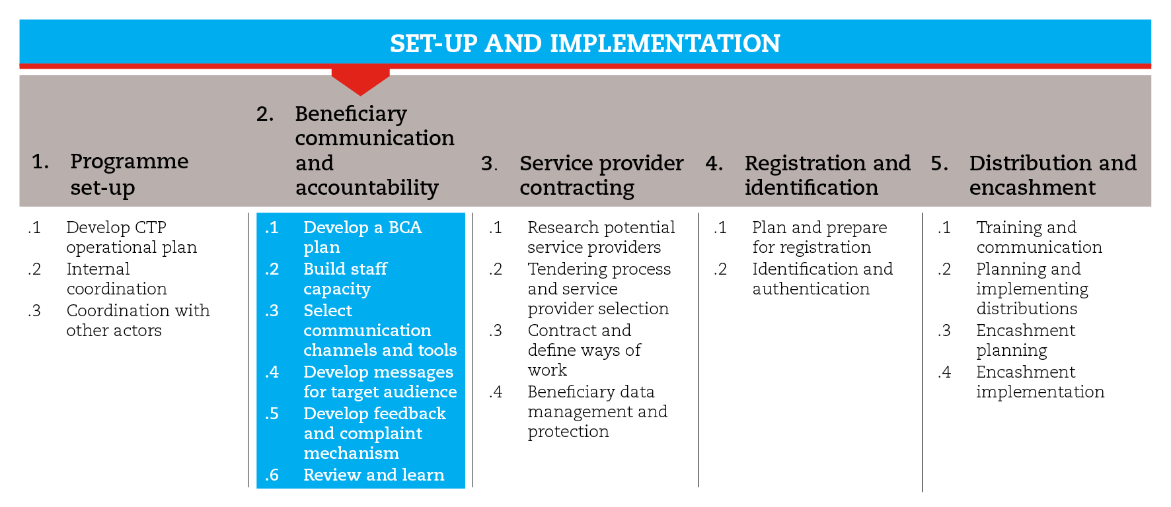

INTRODUCTION
This road map will provide you with the necessary guidance to communicate with and be accountable to beneficiaries. By communicating about what you are doing you show respect for communities and make it more likely that the programme will succeed. A good communication plan helps establish trust manage expectations and encourage participation and collaboration.
The road map also provides suggestions on which CiE tools are most useful for this step and sub-steps. The tools will need to be adapted to your need and context.
You should always aim to comply with the minimum standards listed under this step, as this will contribute to the quality of your response.
It is likely that you will need to move back and forth between the different sub-steps to guide your decision-making as information and processes are completed and feed into each sub-step.
If you need more detailed guidance on beneficiary communication and accountability, consult the reference documents suggested at the end of this road map.

MINIMUM STANDARDS
- Develop a beneficiary communication and accountability plan that involves your stakeholders and clearly defines roles and responsibilities
- Establish systematic and transparent mechanisms through which people affected by disaster or conflict can provide regular feedback and influence programmes (Sphere)
- Enable people to lodge complaints about the programme easily and safely and establish transparent, timely procedures for response and remedial actions (Sphere)
- Ensure that feedback and complaints are followed up and adequately addressed
- Develop an internal feedback mechanism (whistle-blowing), so that staff and volunteers can reveal suspected error and fraud.

SUB-STEPS AND TOOLS

Develop a BCA plan
A Beneficiary communication and accountability (BCA) plan defines the approach that a programme will use to communicate with communities. You may need to use a variety of activities in order to roll out your communication plan. The activities might be one-time, periodic or ongoing. Consider the order in which different people will need to know information. For example, staff may need to be informed before they can explain the programme to others. Often, programmes need to inform community leaders and other community groups before informing the wider community.
The sub-step tools can help you ask and answer the right questions throughout the process, and develop a BCA workplan and budget.

Build staff capacity
Given the cultural and contextual nature of communication, having volunteers and local staff well trained in BCA is crucial to guarantee good-quality programme delivery. Efforts to train volunteers and staff on BCA must span all programmes. Such efforts should be aimed at improving their capacity to communicate with affected populations and use BCA tools in information management. A training package directed at volunteers and staff should be developed and rolled out.

Select communication channels and tools
Your context, objectives and target audience will determine which communication channels and tools will be most suitable. Ideally, you should aim to prioritize two to four key channels or tools (mixing oral and written).

Develop messages for target audience
First, you should identify which groups inside and outside the community may have an effect on or be affected by the programme activities. Then you should define what to communicate to each group in order to achieve the programme objectives. The sub-step tools can help you identify what needs to be communicated to different audiences. In the toolkit you will also find a list of frequently asked questions about the programme which staff should be ready to answer and ten communication rules for communicating successfully with beneficiaries.

Design and set up a feedback and complaint response mechanism (CRM)
A BCA plan should ensure systematic information sharing and two-way communication, promoting dialogue and allowing organizations to gather ideas, suggestions and feedback from communities. This requires the development of a complaint and response mechanism (CRM) focused on beneficiary feedback which must receive a reply. The term ‘feedback and complaint’ mechanisms could be encouraged as an incentive to focus on both positive and negative feedback.
The benefits of feedback and complaint response mechanisms
- Recognize the dignity and rights of project beneficiaries, including the right to express their opinions and concerns
- Enhance accountability to the communities that are being supported and other stakeholders
- Allow early identification and management of issues and risks
- Improve protection of staff by providing them with a way to investigate and respond to issues
- Improve protection of National Societies from unverified rumours and speculations
- Demonstrate competence and transparency to donors
- Promote continuous learning and improvement
Among the tools made available in this sub-step you will find the key elements to be considered before and while designing and setting up a successful CRM, as well as practical tools based on the Lebanese Red Cross CRM, which should serve as a basis for you to use as you develop your own tools and procedures.
Besides a CRM focused on beneficiary feedback, a system allowing volunteers and staff to reveal suspected error and fraud should be put in place. This is extremely important in CTP, as the management of large sums of cash can present threats.

Review and learn
A BCA review can be either a stand-alone activity or part of an overall programme review. Before you implement the plan, you should decide with your team how and when to review the BCA plan. This reminds staff that it’s important to learn and improve over time.
REFERENCE DOCUMENTS
Beneficiary Communication and Accountability (IFRC) http://www.ifrc.org/PageFiles/94411/IFRC%20BCA%20Lesson%20Learned%20doc_final.pdf
Communicating cash: A field guide to beneficiary communications in cash transfer programming. CaLP (2011)
http://www.cashlearning.org/resources/library/28-communicating-cash-a-field-guide-to-beneficiary-communications-in-cash-transfer-programmeming-screen-version
Develop a communication plan in nine steps. Communication toolbox CRS.
http://www.crsprogrammequality.org/storage/pubs/general/communication-toolbox-template-develop-a-communication-plan.pdf
Setting up Complaints Response Mechanisms (Save the Children International)
http://www.qualityandaccountabilitynetwork.care2share.wikispaces.net/file/view/2011+SCF+CRM+guide+FINAL.pdf
MPG Programme Quality, in Operational Guidance and Toolkit for Multipurpose Cash Grants (UNHCR 2016)

