Roadmap for monitoring and evaluation (M&E) planning
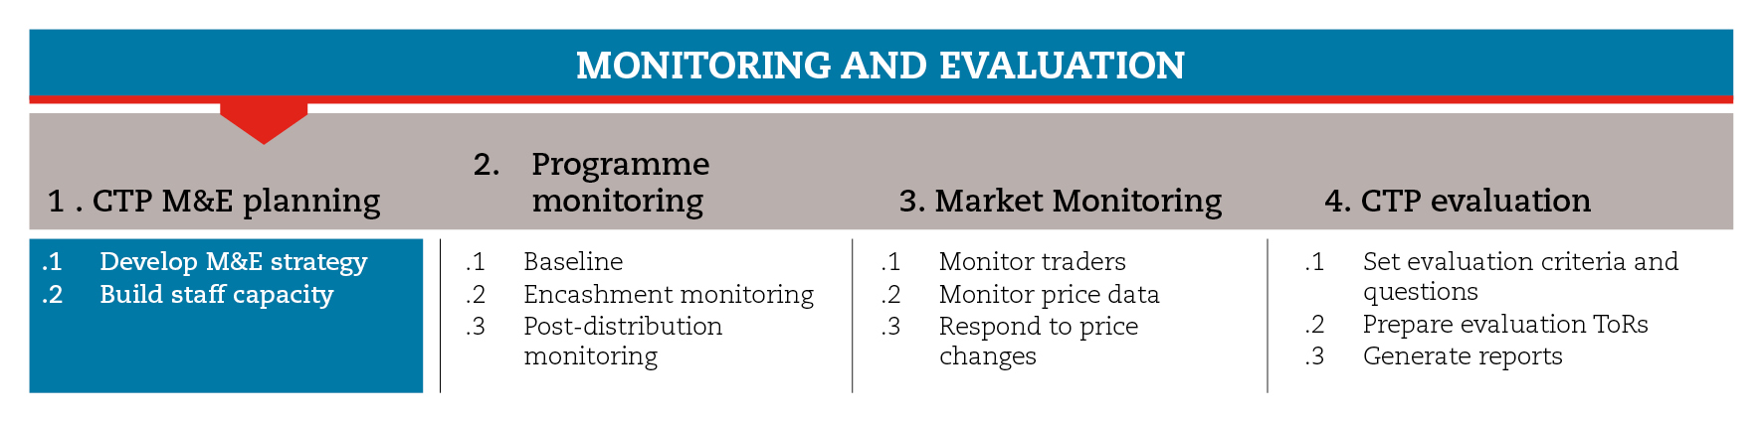

INTRODUCTION
This roadmap will guide you through the process of planning for monitoring and evaluation. This process involves developing a comprehensive M&E strategy (including a detailed activity work plan and an M&E matrix with indicators and means of verification) and building the capacity of volunteers and staff.
The roadmap provides suggestions on which CiE tools are most useful for this step and sub-steps. The tools will need to be adapted to your need and context.
You should always aim to comply with the minimum standards listed under this step, as this will contribute to the quality of your response.
It is likely that you will need to move back and forth between the different sub-steps to guide your decision-making as information and processes are completed and feed into each sub-step.
If you need more detailed guidance on monitoring and evaluation planning, consult the reference documents suggested at the end of this roadmap.

MINIMUM STANDARDS
- M&E planning should happen at the design phase of the programme
- M&E should be based on programme indicators and sources of verification established in the logical framework
- Indicators should be limited in number and look at processes (whether entitlements have been timely received), outputs (how entitlements have been used), outcomes (if and how the programme has affected beneficiaries and non-beneficiaries) and markets (effects on prices and traders).
- In the case of multipurpose cash grants (MPG), indicators should be broad enough to allow for capturing secondary impacts.
- Monitoring team must be trained and tools must be tested beforehand.

SUB-STEPS AND TOOLS

Develop an M&E strategy
Response-specific indicators (outcome indicators, output indicators, process indicators) will have been developed during the programme set-up phase for the logical framework. In the sub-step tools, you will find a logical framework and a checklist of key elements to be considered when monitoring the process and impact of a programme.
In the case of multipurpose cash grants (MPG), which increase flexibility on the use of cash by beneficiaries, it is important to set a broad monitoring system that can also capture secondary impacts (e.g. changes in access to education, health, etc.).

Based on the logical framework, you should develop:
- An M&E work plan, detailing all the activities needed to ensure a smooth monitoring and evaluation process, and providing clear indication of who is responsible for each activity, with whom the responsible person should coordinate, and when each activity should be conducted.
- An M&E matrix, which includes all indicators to be monitored. For each indicator, the matrix should list: which data sources and collection methods should be used, how frequently data should be collected and by whom, and how the monitoring data will be used. Focus group discussions, key informant interviews and household surveys are the methods most commonly used. As a rule of thumb, include quantitative and qualitative components, and take triangulation concerns into account. Consider that using a range of methods and a range of respondents (e.g. beneficiaries and non-beneficiaries, men and women, etc.) will allow you to crosscheck and have greater confidence in the results.
In the sub-step tools you will find an M&E work plan and matrix templates.
Sampling is a key piece of information that is not included in the M&E matrix but should be defined before collecting data. Sampling refers to the number of people, shops, traders, service provider agents, etc. that are to be monitored per month, and/or the number of distribution/encashment sites to be visited for monitoring each month. In the sub-step tools you will find a survey sample calculator and a brief sampling guidance. These tools can help you establish physical verification targets.

Build staff capacity
The quality and reliability of the monitoring results and recommendations will to a great extent depend on the capacity of the M&E team. Therefore volunteers and staff who will be involved in collecting and analysing data must be trained. In the sub-step tools you will find an introductory PowerPoint presentation accompanied by facilitator notes targeted at technical and middle management staff. Also, you will find brief guidance on how to conduct focus group discussions and interviews.
REFERENCE TOOLS
ICRC measuring results 2009.
http://www.icrc.org/eng/resources/documents/publication/p0995.htm
Non-food items and emergency shelter cluster guidelines on post-distribution monitoring. IOM 2012. http://www.foodsecurity.nrc-handbooks.org/assets/NFI_ES_cluster_PDM_guidelines_July_2012-copy.pdf
IFRC (2011) Project/programme monitoring and evaluation (M&E) guide.

