Roadmap for market monitoring

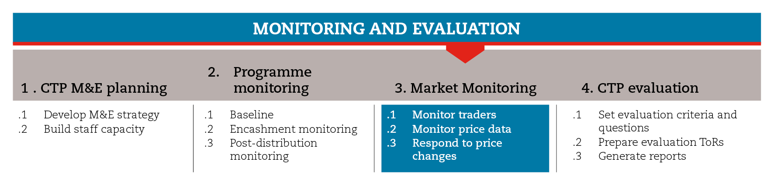

INTRODUCTION
This roadmap will guide you through the process of monitoring the market, particularly prices. The focus on prices is justified by the fact that prices are the most relevant market-related indicators to understand whether the project is reaching the expected objectives without causing harm. Price changes impact the ability of beneficiaries to access what they need in the local market.
The roadmap provides suggestions on which CiE tools are most useful for this step and sub-steps. The tools will need to be adapted to your need and context.
You should always aim to comply with the minimum standards listed under this step, as this will contribute to the quality of your response.
It is likely that you will need to move back and forth between the different sub-steps to guide your decision-making as information and processes are completed and feed into each sub-step.
If you need more detailed guidance on market monitoring, consult the reference documents suggested at the end of this roadmap.

MINIMUM STANDARDS
- Prices should be monitored throughout the programme cycle
- Finance and Logistics should be involved in price monitoring
- Cut-off price levels for programme adjustments should be set
- Contingency plans should be in place to allow decisions on programme adjustments due to price changes

SUB-STEPS AND TOOLS

Monitor traders
Depending on the type of project being conducted, the objectives of the intervention and contextual factors that need closer attention, you may decide to monitor market-related factors such as commodity availability, quantity and quality, and traders. Monitoring traders allows you to detect any problem on the supply side, as well as the potential effects of the programme on the market. Among the sub-step tools you will find a trader questionnaire covering the issues of supply, demand, prices, and payment through mobiles.

Monitor price data
Price monitoring should involve Logistics and Finance departments, as they usually have price monitoring systems in place. It can be based on secondary and/or primary data. In the sub-step tools you will find a checklist of issues to be considered when deciding whether or not to use secondary data. Also, you there are checklists to help field monitors conduct a regular and consistent primary price data collection, and tools that can help you organize price data in Excel spreadsheets, identify significant price changes, and understand whether the price changes identified are related directly to your project or are linked to general issues.

Respond to price changes
When implementing cash transfer programmes, price increases can affect the purchasing power of the transfer. The decision on whether or not to respond to that will be based on your capacity to adjust the project accordingly. Independently of what has caused price changes, having contingency plans and budget will influence your capacity to respond. In general terms, you can respond to significant price changes by:
- adjusting the value of the transfer regularly
- shifting the transfer modality
- establishing agreements with traders
- supporting the market, services and infrastructure
In the sub-step tools you will find brief guidance on the suitability of each of these responses and how they should be planned and implemented.
REFERENCE TOOLS
Rapid Assessment for Markets (RAM) International Red Cross and Red Crescent Movement

This roadmap is based on the Price monitoring chapter of the Market Assessment Guidance (MAG).

