Roadmap for programme evaluation

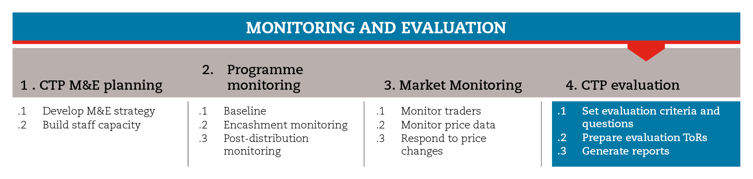

INTRODUCTION
Programme evaluation involves assessing, in a systematic and objective manner, an ongoing or completed intervention, its design, implementation and results. The aim is to determine the relevance and fulfilment of objectives, developmental efficiency, effectiveness, impact and sustainability. An evaluation should provide information that is credible and useful, enabling the incorporation of lessons learned into the decision-making process of both recipients and donors
This roadmap will provide you with brief guidance on the different types of evaluation, as well as on how to set evaluation criteria and questions, and prepare terms of references and reports.
The roadmap also provides suggestions on which CiE tools are most useful for this step and sub-steps. The tools will need to be adapted to your need and context.
You should always aim to comply with the minimum standards listed under this step, as this will contribute to the quality of your response.
It is likely that you will need to move back and forth between the different sub-steps to guide your decision-making as information and processes are completed and feed into each sub-step.
If you need more detailed guidance on programme evaluation, consult the reference documents suggested at the end of this roadmap.

MINIMUM STANDARDS
- Any programme should always include an evaluation component that will allow you to draw lessons, improve future practice and policy, and enhance accountability.
- Evaluation should be planned during the design phase of the programme.
- Programme evaluators should be external to the implementation team.
- Beneficiaries and non-beneficiaries should be consulted in the evaluation process.
- Evaluation should be coordinated with other aid actors to reduce costs and the administrative burden on communities.
- Evaluation results should be made widely available, particularly to policy-makers and operational staff.

TYPES OF EVALUATION
According to when they are conducted, evaluations can be classified as:
Real time evaluations, which, often, are undertaken at an early stage of the programme. They are common in humanitarian and post-conflict settings, where baseline data may be non-existent, institutional memory may be deficient due to a rapid turnover of staff, and security risks make it difficult conduct interviews and surveys.
Mid-term evaluations, which are aimed to assess the continued relevance of the programme and the progress made towards achieving its objectives. They provide an opportunity to adjust the programme so that its objectives can be achieved within the expected timeframe.
Final evaluations, which normally are undertaken towards the end of the implementation phase of the programme. They determine the extent to which anticipated objectives and outcomes have been achieved.

SUB-STEPS AND TOOLS

Set evaluation criteria and questions
At this stage, it is essential to define the ‘issues’ for the evaluation. These issues will provide an evaluation framework, and will serve as a basis for the development of the questions to be answered by the evaluation. This will help evaluators develop a clear set of conclusions and recommendations. Key stakeholders should be engaged in the definition of the evaluation issues and questions. In the sub-step tools you will find key evaluation questions.
When evaluating cash transfer programmes, you should consider the potential indirect effects on the local economy. The analysis of multiplier effects extends the scope of the evaluation beyond the impact on beneficiaries to include the effects on other local actors. In the sub-step tools, you will find a step-by-step guidance with tools to evaluate the multiplier effects on the local economy.

Prepare Terms of reference (ToRs)
The terms of reference should define the purpose and scope of the evaluation, provide detailed guidance on how it should be conducted, and explain which results are expected from it and to whom the findings are addressed.
In the sub-step tools you will find a ToR template. Also, you will find a checklist to verify if you have considered all the key aspects when developing the ToRs.

Elaborate reports
Evaluation reporting should be clear, be as free as possible from technical language and include the following elements: executive summary, profile of the activity evaluated, description of the evaluation methods used, main findings, lessons learned, conclusions and recommendations. In the sub-step tools you will find an evaluation report template as well as case study templates.
REFERENCE DOCUMENTS
Evaluating humanitarian action using the OECD-DAC criteria. ALNAP http://www.alnap.org/resource/5253
IFRC (2011) Project/programme monitoring and evaluation (M&E) guide.

IFRC (2011) Project/programme monitoring and evaluation (M&E) guide
UNDP. Handbook on Planning, Monitoring and Evaluating for Development Results

