Roadmap for service provider selection and contracting

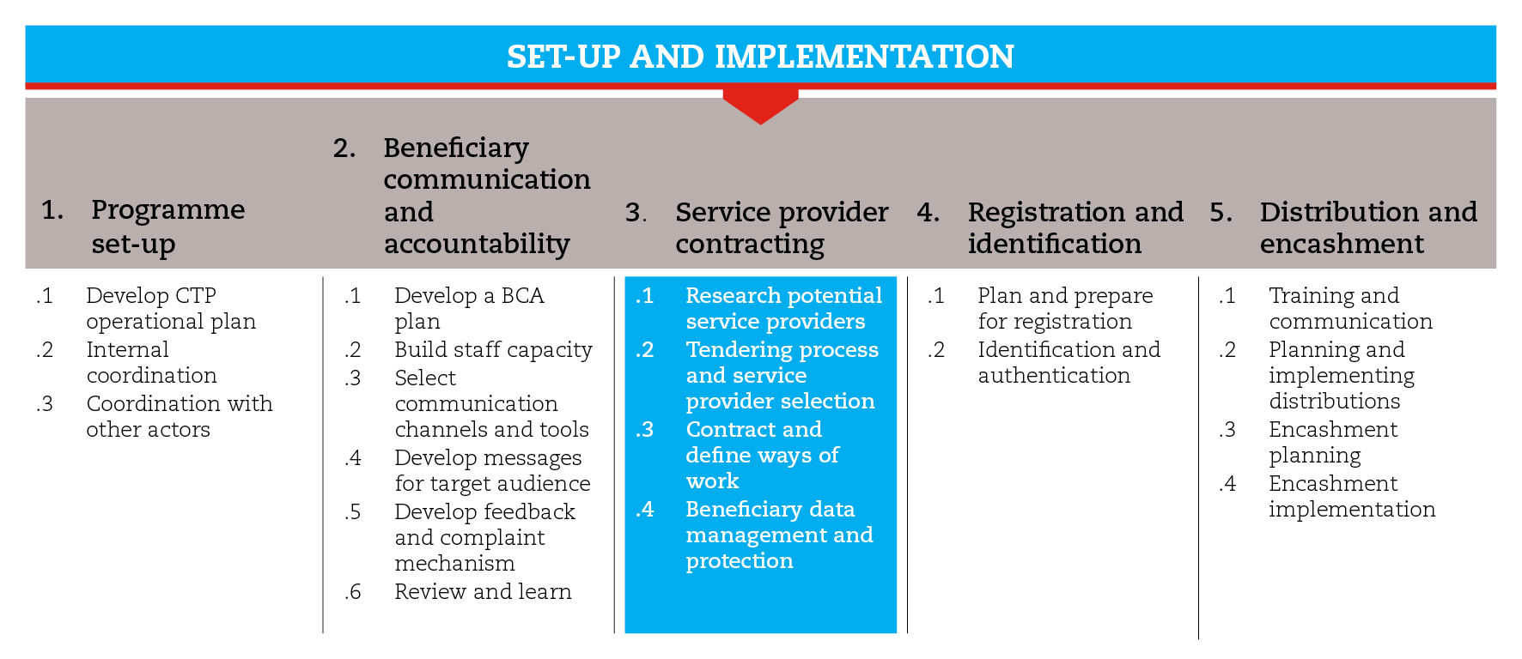

INTRODUCTION
Programme implementation is usually done with the support of service providers, which are for-profit, private-sector businesses that provide relevant services for the implementation of the programme. In the case of in-kind or voucher programmes, service providers can be wholesalers, supermarkets, local vendors, etc. In the case of cash transfer programmes, they are financial service providers, such as banks, MFI, mobile phone operators, etc. that take responsibility for the encashment.
This road map will guide you through the process of selecting and contracting financial service providers for CTP. The process includes researching and narrowing down potential service providers according to established criteria, conducting a tendering and selection process, then finally contracting and defining ways of working with service providers. When working with financial service providers, it is extremely important to address potential risks related to beneficiary privacy, as well as fraud and abuse.
In the voucher modality box, you will find specific tools to help you select and contract traders for commodity and cash vouchers.
The road map will provide suggestions on which CiE tools are most useful for this step and sub-steps. The tools will need to be adapted to your need and context.
You should always aim to comply with the minimum standards listed under this step, as this will contribute to the quality of your CTP response.
It is likely that you will need to move back and forth between the different sub-steps to guide your decision-making as information and processes are completed and feed into each sub-step.
If you need more detailed guidance on selecting and contracting appropriate partners, consult the reference documents suggested at the end of this road map.

MINIMUM STANDARDS
- Finance and logistics should be involved in the selection and contracting of potential service providers
- Selection criteria should be included in the Terms of Reference (ToRs) for the tendering process
- Ensure that the contracts with service providers abide by the general contractual terms and conditions

SUB-STEPS AND TOOLS

Research and narrow down potential service providers
You should consider carefully the capacity of potential service providers to deal with cash transfers in emergencies and the risks of working with them. There may be only a few viable service providers from which to choose. Consider the following to help narrow down your choice:
- how they meet the needs of both the organization and the intended beneficiaries,
- their geographical coverage,
- the fees they charge, and
- the quality of service they offer.
The tools in the sub-step can help you understand what to demand from specific service providers so that they can be included in the selection process.

Tendering process and selection of service providers
The next steps will depend on the organization’s procurement protocols. Normally, procurement entails a formal tendering process conducted by the Logistics department. Since the potential partners will have been researched, narrowed down and looked into in detail, you will, most likely, conduct a tendering process restricted to those that passed the initial screening. If there is only one viable option, you will probably go for a no-bid or a sole source contract.
The Terms of Reference (ToR) elaborated for the tender process should include the purpose of the service requested; expected duties to be performed and deliverables, quality standards and support provided by the commissioning agency. The expected technical proposal contents and the evaluation criteria should be described in annexes. In the sub-step tools, you will find ToR template.
The evaluation of the proposals must be based on the criteria shared with tender participants in the ToRs, and involve finance and IT staff to be part of the process so that all criteria are considered:
- costs,
- speed,
- the flexibility of the service provider to meet the project needs,
- the ease of communication and coordination with them
- the capacity to provide technical support, and
- any ‘red flag’ issues identified in the research phase.

Contract and define ways of work
There are different ways to partner legally with a service provider. Most likely, you will have a standard contract template, which can be adapted with a few minor adjustments. Depending on the relationship with the partner and the nature of the programme, you may prefer to use a simple letter of agreement. In most cases, however, the service provider, especially if it is a bank or a mobile phone company, will have a standard service contract template. In this case, make sure that the relevant organizational and programmatic concerns are being addressed. In the sub-step tools you will find a service provider contract template, as well as lists of general terms and conditions for all service contracts and minimum contract requirements for an e-transfer service provider.

Beneficiary data management and protection
Beneficiary data management and protection is particularly important in cash transfers that involve a financial service provider. Multiple layers of control must be put in place around the collection, use, disclosure and storage of beneficiaries' personal information in order to address privacy-related risks as well as fraud and abuse-related risks. Beware of data sharing done insecurely over email, and therefore potentially accessible to third parties.
The means chosen for data management and security will be influenced by factors like:
- local legislation,
- the scale of the programme,
- the technical knowledge and resources available, and
- service provider requirements.
In the sub-step tools, you will find a set of principles for beneficiary data protection and suggestions of data protection model clauses.
REFERENCE DOCUMENTS
USAID and NetHope Payment Innovations. e-Payment Toolkit. solutionscenter.nethope.org/programs/c2e-toolkit
Working With Banks: A field guide to negotiating with banks in cash transfer programming (2011) CaLP http://www.cashlearning.org/resources/library/34-working-with-banks-a-field-guide-to-negotiating-with-banks-in-cash-transfer-programming-screen-version
E-transfers in emergencies: implementation support guidelines" 2013 CaLP http://www.cashlearning.org/resources/library/390-e-transfers-in-emergencies-implementation-support-guideline
Financial Service Provider (FSP) Review Checklist, Appendix C of Annex 3 ‘MPG Standard Operating Procedures’ in Operational Guidance and Toolkit for Multipurpose Cash Grants (UNHCR 2016) http://www.cashlearning.org/downloads/mpg-toolkit-pdfs/mpg-annex3.pdf
MPG Programme Quality, in Operational Guidance and Toolkit for Multipurpose Cash Grants (UNHCR 2016) http://www.cashlearning.org/downloads/mpg-toolkit-pdfs/mpg-part3-6.pdf

