Roadmap for rapid market assessment
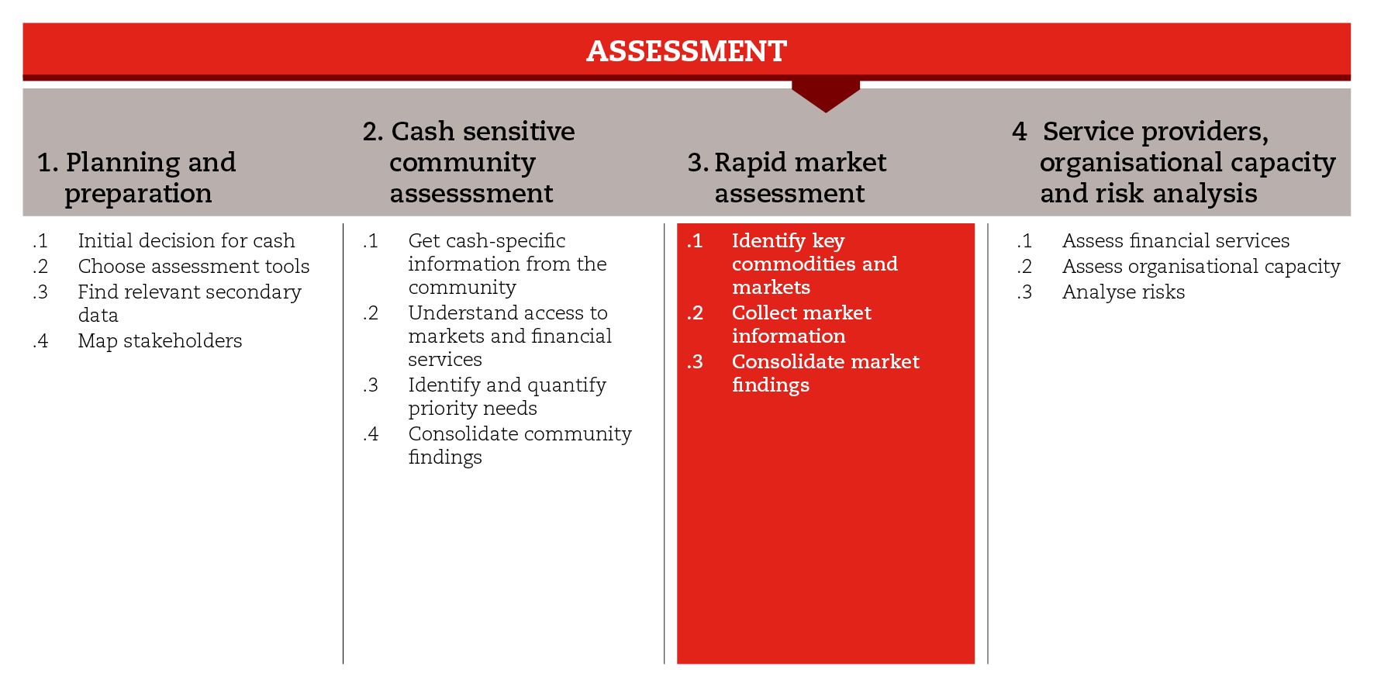

INTRODUCTION
In emergencies, market assessments can help to understand the market capacity to supply the shock-affected population with priority commodities and services. They can also help you understand the risks of potential interventions causing harm and how to support recovery. This road map will assist you to move through the process of conducting a rapid market assessment after a shock.
For the purposes of the CiE Toolkit, the rapid market assessment process has been divided into three sub-steps. The first sub-step guides you through the selection of commodities and marketplaces to be assessed. The second sub-step supports the collection and consolidation of relevant information from the selected marketplaces. The third sub-step guides your analysis and conclusions on the market capacity.
The process and tools suggested here have been taken from the RAM guidelines. You can choose to follow the RAM or, if time and resources allow, another in-depth approach, like the MAG or EMMA. In the reference documents suggested at the end of the road map, you will find the RAM guidelines and other market assessment approaches from which you can choose.

MINIMUM STANDARDS
- When conducting a market assessment, adopt a multi-sector approach, focusing on commodities, services and markets that are central to households’ priority needs and livelihoods.
- Base your analysis on secondary data, and on first-hand information from the affected population and other key market informants
- Cross-check information coming from different sources
- Involve Logistics, as that department usually has good knowledge of local markets and is used to dealing with traders
- Use maps to represent graphically how markets are organized and how they have been affected
- When drawing conclusions and making recommendations, make clear reference to findings (including risks) on which they are based

SUB-STEPS AND TOOLS

Identify key commodities and markets
Conducting a rapid market assessment in the aftermath of a shock can be challenging because the situation tends to change very rapidly and information is not always readily available or reliable. In order to identify key commodities and markets, you can refer to secondary data gathered during planning and preparation (step1), and to information collected from communities and households (step2). You will need to distinguish the markets for basic household goods, such as food, from those filling more sector-specific needs that arise because of the shock, notably shelter needs. Furthermore, you should consider market systems related to protection, e.g. alternative care, health, legal services, transport, education, birth registration. Different market assessment tools are appropriate for different types of goods and services. In addition, you can also conduct discussions with key market informants to cross-check and complement this information.
Remember that in order to consider the appropriateness of multipurpose cash grants, the market assessment should take a multi-sector approach so as to feed in the definition and calculation of a minimum expenditure basket (MEB) and one-off needs of the affected population.

Among the sub-step tools you will find a questionnaire for focus group discussions with key market informants, as well as a guide for drawing market maps. Preliminary market maps can be very helpful for identifying key informants to interview and bottlenecks to be investigated in the field. Market maps are a good way to represent and understand the structure of a market system, and should be updated continuously, as market information is obtained from different sources.

Collect market information
Once key commodities and markets have been identified, discussions with key market informants and traders can help you obtain a quick and basic understanding of the market situation, with a focus on the key commodities. Remember that different people interact differently with markets, therefore make sure to use an age, gender and diversity lens. Logistics can play an important role in the choice of key market informants with whom to hold discussions, as they know and have contact with local traders (particularly wholesalers).
Among the sub-step tools you will find questionnaires that can guide your discussions (or interviews) with key market informants and traders, and a set of questions that can help you consolidate the information gathered and draw conclusions at the end of the visit to each marketplace. You will also find a list of questions associated with criteria with which traders should comply in order to take part in voucher programmes.

Consolidate market findings
Based on whether or not the different marketplaces have the capacity to supply the shock-affected population with sufficient quantities of key commodities, in a timely manner, you will: i) determine the potential for CTP responses, and ii) make response option recommendations for consideration during response analysis. Consider that your recommendations will need to be challenged by other aspects, such as programme objectives, cost-effectiveness and efficiency, organizational capacity, beneficiary preferences and security issues, which may influence the final decision on the best response option.
Among the sub-step tools, you will find a conclusion tree that can help you determine the capacity of the marketplace. The conclusion tree should be used in conjunction with sub-step 2 questionnaires. You will find also a report format for consolidating all the information gathered and the conclusions made throughout the rapid market assessment.
REFERENCE DOCUMENTS
International Red Cross Red Crescent Movement (2013) Rapid assessment for markets (RAM): Guidelines for an initial emergency market assessment
International Red Cross Red Crescent Movement (2013) Market Analysis Guidance (MAG): Guidelines for market assessment in the project cycle
Emergency Market Mapping and Analysis Toolkit (EMMA) (2010) http://emma-toolkit.org
Toolkit for Logistics in C&V. Part 1: Trade logistics assessment (WFP) http://www.logcluster.org/sites/default/files/wfp_trade_logistics_assessment_2014.pdf
Market analysis in emergencies (CaLP) (2012) http://www.cashlearning.org/resources/library/257-market-analysis-in-emergencies
Minimum requirements for market analysis in emergencies (CaLP) (2013) http://www.cashlearning.org/resources/library/351-minimum-requirements-for-market-analysis-in-emergencies
Pre-crisis Market Mapping and Analysis – Step-by-step Guidance for Practitioners (IRC, Oxfam) (2014) http://www.cashlearning.org/resources/library/545-pre-crisis-market-mapping-and-analysis---step-by-step-guidance-for-practitioners
Market Information and Food Insecurity Response Analysis – MIFIRA. Barrett, C., et al. (2009) http://pdf.usaid.gov/pdf_docs/PNADS361.pdf
Market Analysis Framework: Tools and Applications for Food Security Analysis and Decision-Making (WFP) (2011) http://documents.wfp.org/stellent/groups/public/documents/manual_guide_proced/wfp243856.pdf
Multi-Sector Market Assessment in “Operational Guidance and Toolkit for Multipurpose Cash Grants”, UNHCR (2016), part 1.3 and Annex 1.

Mercy Corps (2015). Labour and Market Assessment Guidance and Tip Sheets. https://www.mercycorps.org/research-resources/labor-and-market-assessment-guidance-and-tip-sheets
WFP (2013) Labour Market Analysis Guidance - for Food Security Analysis and Decision-Making. http://documents.wfp.org/stellent/groups/public/documents/manual_guide_proced/wfp258583.pdf
Mercy Corps, SCI, IRC (2016) Labour Market Analysis in Humanitarian Contexts, A Practitioner’s Guide. http://www.cashlearning.org/downloads/lma-guidance---january-2016.pdf

Mercy Corps (2013) Private Sector Engagement Toolkit. https://www.mercycorps.org/research-resources/private-sector-engagement-tool-kit

Rapid Assessment for Markets, International Red Cross Red Crescent Movement, 2013

