Roadmap for preparing and analysing

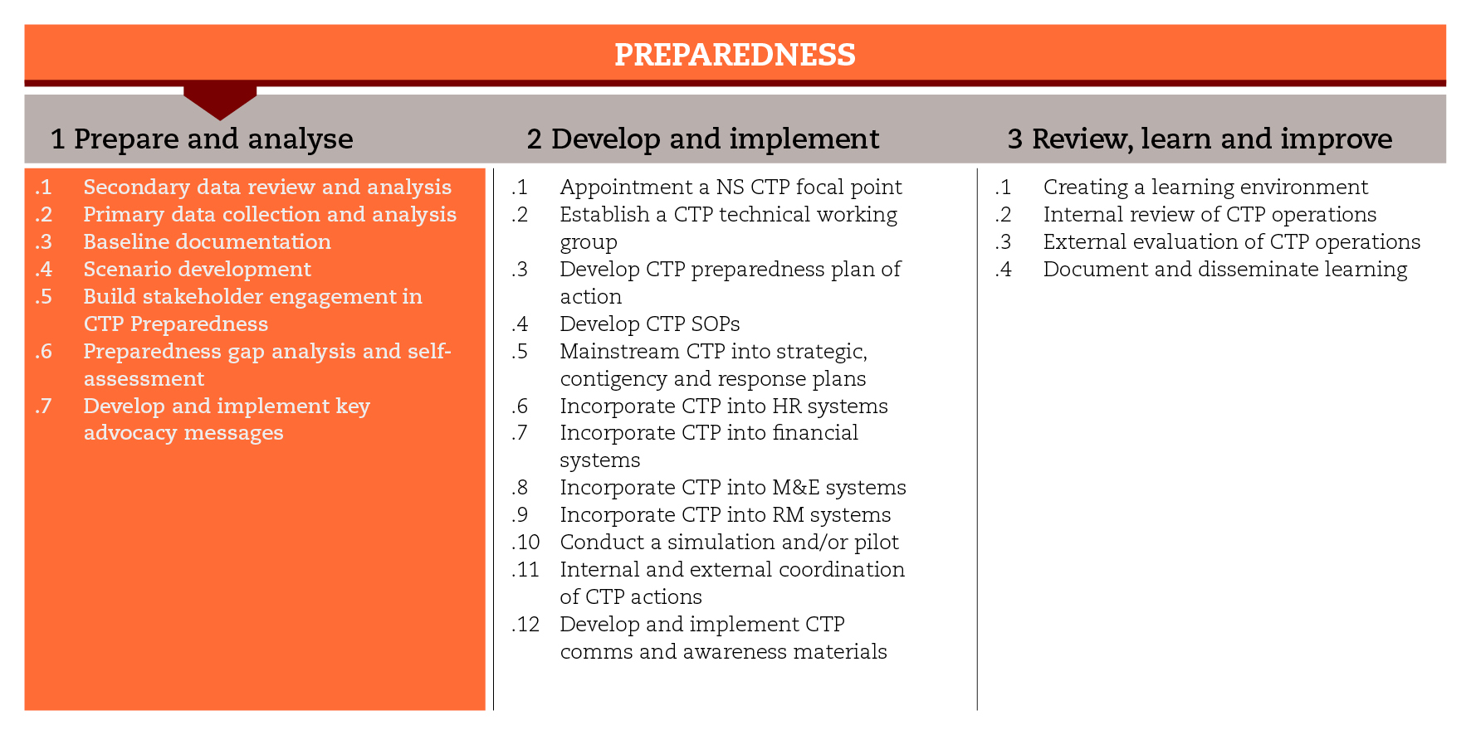

INTRODUCTION
In order to implement cash-based responses in time and at scale after an emergency, cash-specific issues must be taken into account throughout the preparedness process. This road map will focus on the processes of documenting a baseline, developing scenarios, and identifying the CTP preparedness gap. The road map structure reflects the stage ‘prepare and analyse’ of the International Red Cross and Red Crescent Movement CTP Guidelines for mainstreaming and preparedness which includes 7 sub-steps. Each sub-step is associated with tools that may be useful as you move along the process. The outputs produced will feed into each other. You may not be able to use all the suggested tools, but you should at least comply with the minimum standards set for the process.

MINIMUM STANDARDS
- Secondary data collection and analysis should be carried out first, and should indicate the information gaps to be covered by primary data collection.
- Baselines should be embedded in annual strategic and contingency plans, and should include an analysis of key stakeholders, market conditions service providers’ capacity, community access and preferences, and risks associated with a potential CTP response.
- All the secondary and primary data that is gathered should be consolidated and readily accessible in a baseline report.
- Scenarios should be built upon the context analysis and include a first indication of the potential response options.
- Among the possible scenarios, at least the ‘worst-case scenario’ should be developed.
- Advocacy should be part of the preparedness process from its start, and should address internal and external concerns that can create obstacles to a CTP response.
- The main decision-makers from key departments (disaster management, health, logistics, finance, branch development etc.) should be engaged actively in the CTP preparedness process.
- A self-assessment should be carried out as a way to identify organizational capacity gaps to implement CTP in time and at scale.

SUB-STEPS AND TOOLS

Secondary data review and analysis
The review and analysis of secondary data is usually the first step in preparedness planning, as it provides a reference point against which the scale and scope of a future disaster can be understood. Secondary data can be gathered from a wide range of sources, including local government, United Nations and other development and humanitarian agencies. Focus should be given to data on: hazard and disaster history, vulnerabilities, and government programmes and policies; the legal framework (including privacy and data protection issues); coordination mechanisms; market capacity and dynamics; and infrastructure and services. In the sub-step tools you will find a list of websites that might provide useful secondary data. When using secondary data remember to ask yourself: is the source reliable, the methodology sound and the data useable?

Primary data collection and analysis
Secondary data is used to understand the context, but, normally, it will not provide the complete picture. It is likely that you will have to collect first-hand information to fill relevant gaps and answer outstanding questions. This is called primary data collection and can be undertaken through a variety of means, including interviews and focus group discussions with key informants. Among the sub-step tools you will find tools that can help you map key stakeholders: parties that can influence significantly or are important to the success of a potential cash intervention. You will also find checklists for cash-specific information that should be gathered from the key informants, particularly humanitarian agencies, local authorities, communities, and financial service providers. Moreover, you will find tools that can help you quantify the priority needs of the population and calculate the value of a potential cash transfer. Finally, you will find tools that can help you conduct baseline market and risk analysis.

Baseline documentation
By writing a final baseline report, you ensure that all the secondary and primary data gathered is consolidated and readily accessible. The report should embrace aspects relative to situation analysis and the level of CTP capacity and preparedness, the enabling context and risk analysis. The baseline report template will provide the foundation for the development of scenarios.

Scenario development and analysis
A scenario is a set of assumptions, built upon baseline information, about how an emergency can take place and evolve as a consequence of triggering factors or events, such as conflicts, disasters, etc. The scenario development can take advantage, also, of information generated in the other sub-steps, particularly preparedness gap analysis.
The first place to check before beginning the scenario development is with the National Society country contingency plan. If this does not exist, a good way to start with scenario development is with brainstorming for possible emergency scenarios that could require humanitarian assistance. Among the possible emergency scenarios, only a few (generally two or three) will merit being developed. For the purpose of selecting the scenarios to be developed, the sub-step tools include a scenario analysis matrix.
A scenario should include: its likelihood and potential severity; its triggers and assumptions; its potential context and impact; and the humanitarian needs and operational constraints potentially associated with it. It should also give an indication of the potential response options (modality and mechanisms) and their scale. This analysis should be based on the baseline findings, particularly beneficiary preferences, and market and service providers’ capacity. Among the sub-step tools you will find a checklist to verify the feasibility of cash options and a scenario development template, where all this information can be consolidated.

Building stakeholder engagement in CTP preparedness
It is critical that the main decision-makers from key departments (disaster management, health, logistics, finance, branch development etc.) are represented and engaged in the CTP preparedness process. A workshop can serve the purpose of introducing the basics of CTP, and examining the baseline findings and scenarios developed. During the workshop, participatory activities, for example, a SWOT analysis can be used to engage the stakeholders in thinking through the existing blockages and opportunities that each department foresees in implementing a CTP. Among the sub-step tools you will find some tips for organizing a preparedness workshop, a CTP information and awareness Power Point presentation, and an example of preparedness SWOT analysis.

Preparedness gap analysis and self-assessment
A preparedness gap analysis will allow you to review the current operational readiness for CTP and identify priority areas for development. This gap analysis can be carried out during a workshop attended by key staff from all relevant departments (programming/ support services). The sub-step tools include a checklist for organizations to identify their operational readiness, capacity and gaps in implementing CTP responses, and an Excel template to generate scoring for the key self-assessment areas. The results of the exercise should be incorporated into the preparedness Plan of Action (PoA).

Develop and implement key advocacy messages
Advocacy is particularly important around CTP. There are still many concerns about reputational risks, misuse of cash, corruption and the need for complex monitoring and financial controls associated with a CTP. These concerns can create obstacles to scaling-up CTP in emergencies and should be addressed through advocacy efforts from the beginning of the preparedness phase. Each organization should consider the key issues relevant to its own context and develop key advocacy messages to address them. Among the sub-step tools you will find the outline of an internal advocacy process to encourage a stronger engagement with CTP.
REFERENCE DOCUMENTS
IFRC (2014) Operational guidance: Initial multi-sectorial assessment – scenario development. Page 54.
IFRC (2013) Cash transfer programming – engaging National Society leadership. Guidance to support internal advocacy
IFRC Facilitation guide for contingency planning working groups
International Red Cross and Red Crescent Movement Market analysis guidance (MAG): http://www.icrc.org/eng/assets/files/publications/icrc-002-4200.pdf

