HELPFUL TRICKS FOR REVIEWING AND CLEANING DATA IN EXCEL
- FINDING DUPLICATES
- Select the range of cells you wish to test. ...
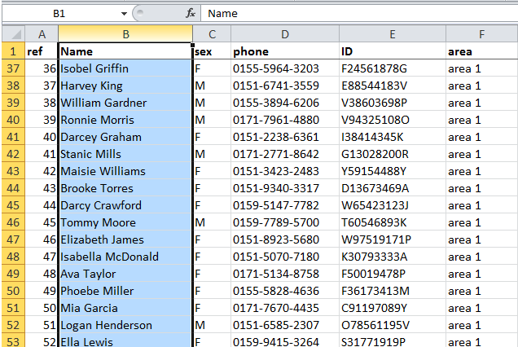
- On Excel's Home tab, choose Conditional Formatting, Highlight Cells Rules, and then Duplicate Values.
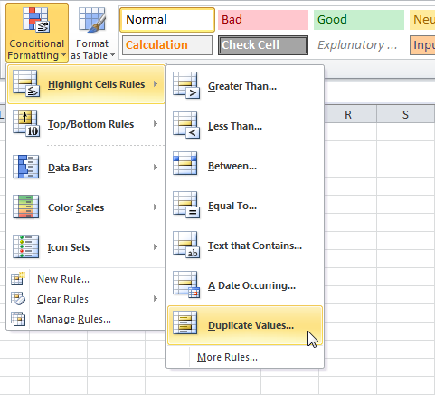
- Click OK within the Duplicate Values dialog box to identify the duplicate values.
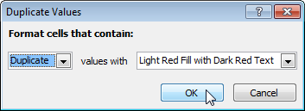
- Filter your Data
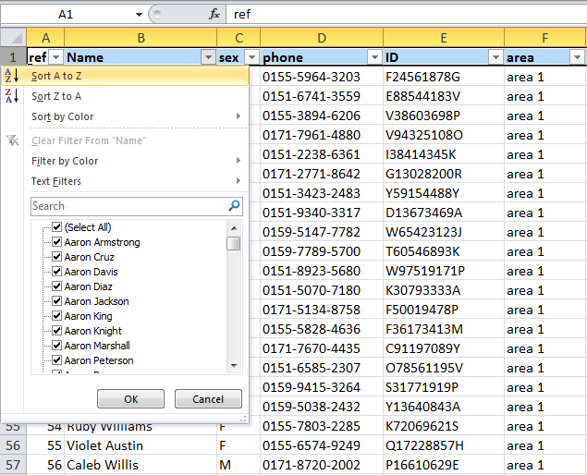
- Duplicate values in the list will now be identified.
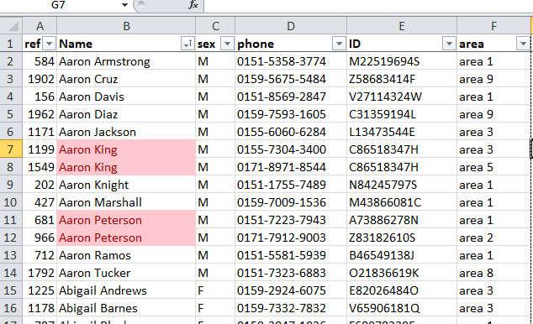

- COUNT THE NUMBER OF CHARACTERS IN A CELL
- If you need to count the total characters in a cell, you can do so using the LEN function. The LEN function simply counts all characters that appear in a cell. All characters are counted, including space characters. 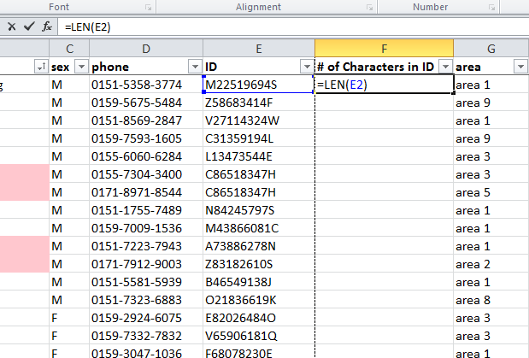

- Filter your Data – to spot differences in the number of character
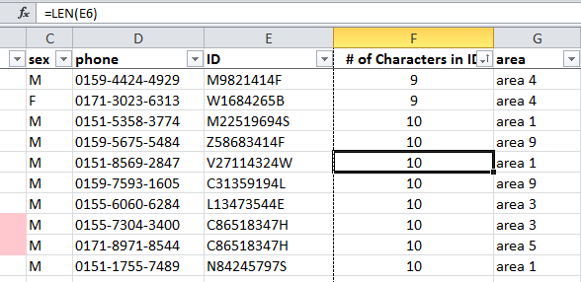

- SPLIT TEXT INTO DIFFERENT CELLS - If you have text in one cell you can spread it out across multiple cells
- Add extra columns to your files to make space for new cells
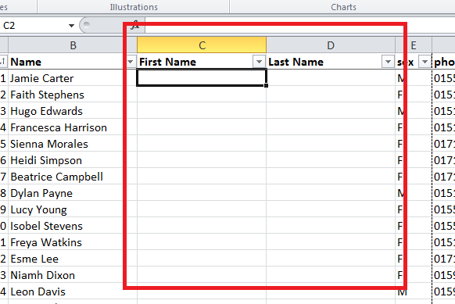
- Select the cell or column that contains the text you want to split.
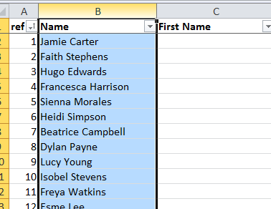
- Click Data >Text to Columns and the wizard will walk you through the process:
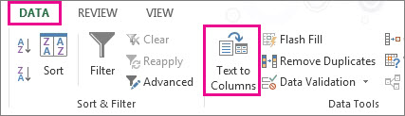
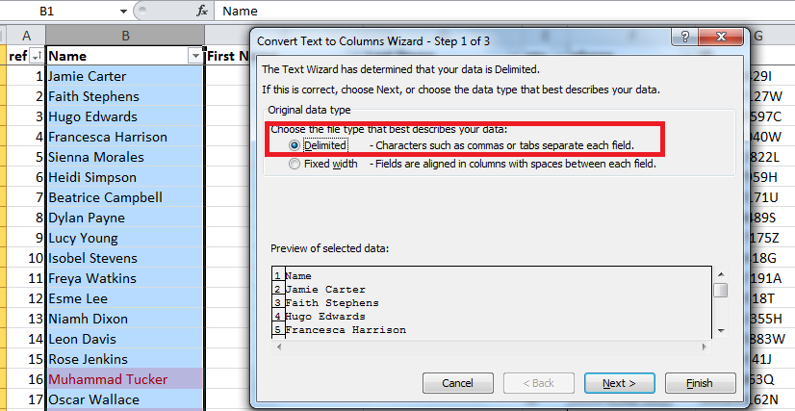
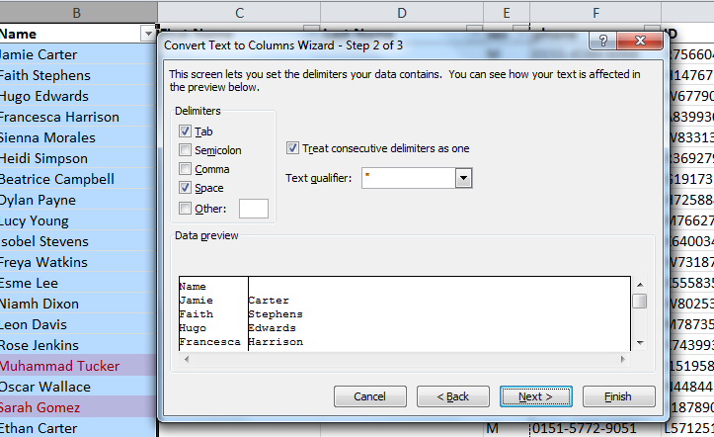
- Select the destination as the extra columns you added earlier:
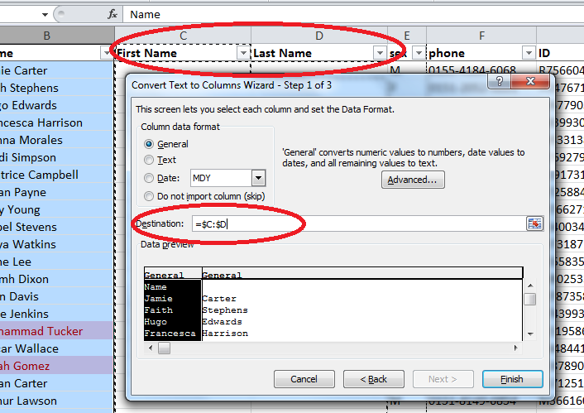
- Your text is now separated into two new cells:
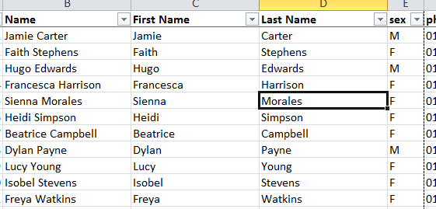
- SPLIT TEXT STRING
If you want to split a text string in Excel, there are three functions that are built in to Excel for this purpose. These are the Excel Left function, the Mid function and the Right function. These functions are described below:
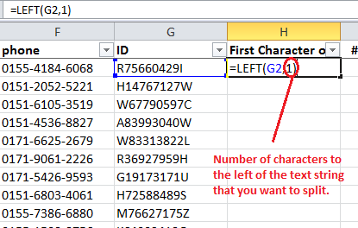
LEFT FUNCITON: returns a specified number of characters from the left (the beginning) of a supplied text string. For example if you want to use the formula to split the text string at the first space:
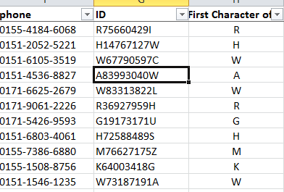

RIGHT FUNCITON: returns a specified number of characters from the right (the end) of a supplied text string. For example if you want to use the formula to split the text string at the last space:
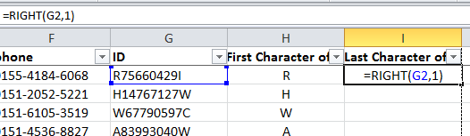

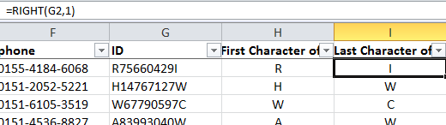

MID FUNCITON: returns a specified number of characters from the middle of a supplied text string, beginning at a specified character. For example:
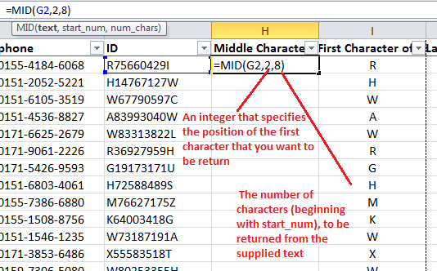

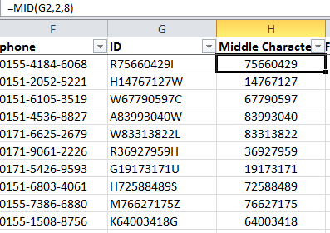

- COMBINE TEXT FROM DIFFERENT CELLS INTO ONE CELL
The CONCATENATE function allows you to combine text from different cells into one cell. In our example, we can use it to combine the text in column A and column B to create a combined name in a new column. Before we start writing the function, we'll need to insert a new column in our spreadsheet for this data.

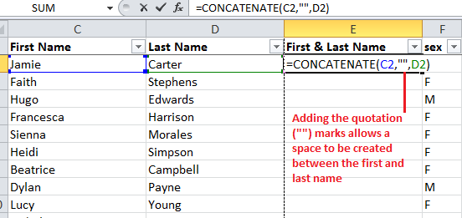
- ADVANCE FILTERING – E.G. FILTER BY AREA THEN LAST NAME
- Go to Home > Sort & Filter > Custom Sort
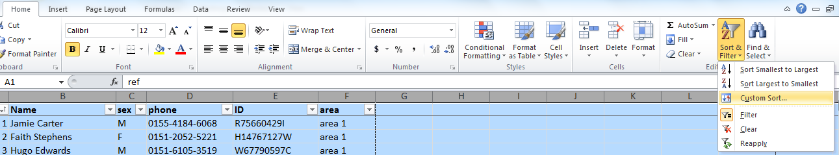
- Choose your first sorting category (e.g. Area) then your second sorting category ( Name)
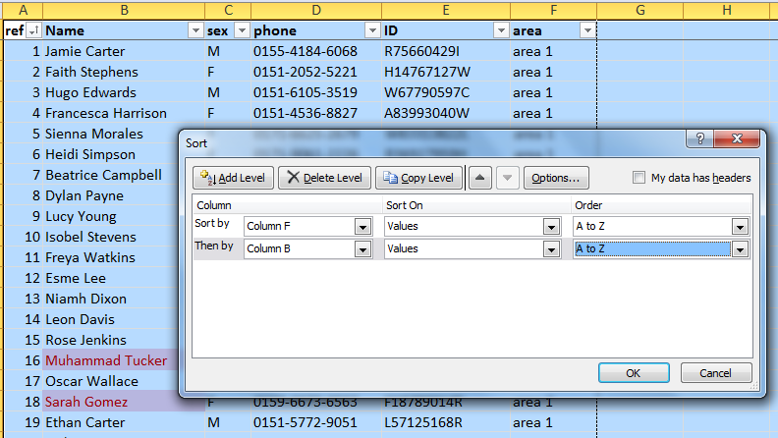

Your data is now sorted first by area and secondly within each area by alphabetical order of name:
