KoBo accounts and permissions
- Accounts
# | Phase | Account  Form status | Description | Use
1 | Production | HNS Admin  parent | for owner only, with full access to forms and data | Manage form and data collected in a locked account to enable data protection and avoid wrong manipulations
2 | Production | HNS Collect  child | for collectors only, to feed data collected | HNS Admin shares with this account the data collection rights only, so that collectors can not risk to alter the form, nor see the collected data
3 | Production | HNS Data  child | for decision-makers, to access the data collected | HNS Admin shares with this account to view the data but not the form. For example, IM can share data with the Cash team
4 | Test | HNS Test  independent | store forms in development and testing phase | No production form here.  Test forms to be deleted once moved to HNS Admin  Rule can be set to delete all collected data once a week
5 | Training | HNS Training  independent | store training exercises | Forms can be created, modified, altered, with full access to the data as it is only meant to be used for training purposes

- Permissions
 | View form | Edit form  ("edit project") | View submissions | Add submissions | Edit submissions | Validate submissions
Description  Accounts | access form but not the data | make changes to the collected data or the project description, which includes viewing permissions | access collected data | only collect data but not see results | view and make changes to collected data | add a validation step before exporting data
1- HNS Admin
2- HNS Collect
3- HNS Data
4- HNS Test
5- HNS Training

- Permission sharing
  - Correct process
a- SUMMARY > Share project
b- FORM > … (More Actions) > Share this project
c- SETTINGS > Sharing

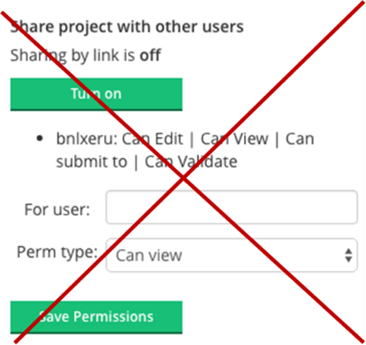
  - Incorrect process (old version)
SETTINGS > General

