Mobile data collection instructions guide for IM

Mobile data collection instructions guide for IM 1
1. Introduction 1
1.1. Minimum requirements 1
2. Set the web platform 2
3. Design the forms 2
3.2. Adapt existing forms 3
3.3. Field and value description 5
4. Loading of forms 7
4.1. Load new or updated form(s) from the server to the mobile device 7
5. Analyse collected data 8
5.1. How to analyse the data? 8
5.2. How to transfer the data? 9
5.3. Ready to use analytical templates 9
6. Current limitations of ODK 10
6.1. There are 2 types of data 10
6.2. Possible alternatives 10

Introduction
This instruction guide is targeted to IM or Admin delegates for Cash responses or Relief ERU deployments, and is intended to provide basic knowledge to set up and maintain the various tools for mobile data collection, and analysis of data for subsequent reporting.

Minimum requirements
- Good knowledge in Excel is needed
- Only little or no knowledge in ODK is possible

Set the ODK server

Select and set-up the most appropriate platform in collaboration with the National Society which might already use one.

In case you need to select a platform, here is a non-exhaustive comparison chart to help making a decision:

Web platforms | Kobo Toolbox (humanitarian account) | formhub | ODK Aggregate |  |  | Ona
 |  |  | Own  web-based server | cloud-based Google engine | VM (virtual machine)
- Platform still maintained? | Yes | No | Needs set-up | Needs set-up | Needs set-up | Yes
- Works offline | No | No | No | No | Yes | No
- Platform fully free of charge or are there costs related to various plans? | Yes  Hosted and supported by UN OCHA | Yes | Internal costs | Google Engine pricing structure | Yes | No  (from $99 to $199 per month)
- Degree of technical knowledge to set up the platform | None | None | IT or ODK expert needed | IT or ODK expert needed | Advanced level | None
- XLSForms can be loaded directly | Yes | Yes | No  (first convert XLSForm to XForm) | No  (first convert XLSForm to XForm) | No  (first convert XLSForm to XForm) | Yes
- Limits on the number of submissions and Gb of storage space (per week, month, year)? | Unlimited | Unlimited | Limited to server’s size | Limited by the related costs | Limited by computer size | Yes  (500 submissions per calendar month with 15 private forms, 1 private project and unlimited public projects)
- Quick visualisation of data on a map (without GIS manipulations)? | Yes | To be verified | No | No | No | Yes
- Platform compatible with the “pulldata” function enabling to preload data into forms? | Yes | No | To be verified | To be verified | To be verified | Yes
- Can the platform accept several administrators for a same form? | No, but possible to clone a form | To be verified | Yes | Yes | No, because the form is on 1 PC only | Yes

In case of an existing Internet connexion, Kobo Toolbox is recommended as it enables:
- a quick deployment and
- easy maintenance of tools
- a secure storage of data
- all that at no cost

In case of the absence of Internet connexion, ODK Aggregate VM will be recommended. Follow the steps below when choosing this solution:
- Download and install VirtualBox (https://www.virtualbox.org/) to run the VM.
- Download ODK Aggregate VM https://gumroad.com/l/odk-aggregate-vm. Follow the readme.txt instructions (“# Basic Usage” section)
- Convert the XLSForm (.xls format) to an XForm (.xml format). We recommend XLSForm Offline.
- Use ODK Aggregate, all instructions available in the following link: https://www.google.com/intl/en/earth/outreach/tutorials/odk_aggregate.html

NB: All tools here above are available in the ODK Resources folder.

Design the forms
Several open source software options for mobile data collection by humanitarian organizations exist. The solution selected by IFRC is Open Data Kit (ODK), with ODK Collect app for Android devices.
Two important links exist to dig in further into ODK:
- https://opendatakit.org/
- http://xlsform.org/

Few tips on survey content design
Asking good questions & set robust forms
yield clear & accurate data
Use decision tree | Follow a logic all along the questionnaire  in order to ensure a continuous flow of options
Set constraint checks | - Check that children are below 18  - Make sure that phone numbers have a fixed number of digits  - Do not allow negative amount in a bank deposit cell  - Prevent misspelling of district names, etc.
Translate | Translate in official local language, no familiar tense
Test surveys | Test, test, test,… and test

  - Create forms from scratch
There are 3 methods to create forms:
    - Build
Web-based wysiwyg (what you see is what you get) interface, easy to learn but limited in the functionalities you can develop in the form. Most of the ODK web platforms offer the build functionalities.

    - XML coding
Native language on which is based ODK, enabling unlimited functionalities, but much more complex to master. Only recommended for very specific and complex surveys, and to real IT people.

    - XLSForm
Excel based form developing tool, a bit more complex to learn than the ‘Build’ option, but enabling a wider range of functionalities. Recommended to IM people.
All data is organized in 3 worksheets as follow:
- Survey: List all questions that respond to a series of parameters
- Choices: List all options for multiple choice questions
- Settings: Summarize a few settings for the form

See details in chapter 2.3. Field and values description

Adapt existing forms
Some XLSForms are already created, based on the main templates of the toolkit.
They can be quickly adapted to each response, following the below steps:

    - Generic changes to all XLSForms:
List of adaptations to be processed in all XLSForms

Worksheet | Location line or column | To adapt
Survey | group ‘location_details’ when applicable:  - ‘District’  - ‘Township’  - ‘Village/Neighbourhood’  - ‘Sub-Village/Sub-Neighbourhood’ | Adapt naming to local context in language fields, columns C, D and E
 | column E:  ‘label::Local language’ | Translate all text from column C ‘label::English’ to local language
 | column H:  ‘hint::Local language’ | Translate all text from column F ‘hint::English’ to local language
 | column P:  ‘constraint_message::Local language’ | Translate all text from column N ‘constraint_message::English’ to local language
Choices | column E:  ‘label::Local language’ | Translate all text from column C ‘label::English’ to local language
 | columns B, C, D, E, F G | Enter all the details of the selected geographic locations
Settings | column F:  ‘label::Local language’ | Translate all text from column D ‘label::English’ to local language
 | column C:  ‘default_language’ | Set ‘default_language’ to the desired language

    - Forms list and specific changes
List of already developed XLSForms :
- with their corresponding reference tool
- when the preload of a CSV format beneficiary list is required (pulldata function)
- if any specific change is required to adapt the file to each operation

Reference tool | ODK template | CSV preload | Specific changes
 |  |  | Work  sheet | Location | To be adapted
M4_2_5_2 Feedback and complaint form template | M4_2_5_2a-ODK-Feedback_and_complaint-XLSForm | no | Survey | Line 22 : ‘phone_nb’ | Change number of digits if different from 10
M4_4_1_2 Beneficiary master data, lists, reports | M4_4_1_2a-ODK-Beneficiary_registration-XLSForm | yes | Survey | Line 30 : ‘mobile_nb’ | Change number of digits if different from 10
 | M4_5_2_3a-ODK-Beneficiary_verification-XLSForm | yes | None | - | -
 | M4_5_2_3c-ODK-Beneficiary_distribution-XLSForm | yes | None | - | -
M4_5_2_1 Distribution site assessment checklist | M4_5_2_1a-ODK-DistributionSite_Assessment-XLSForm | no | None | - | -
M4_5_5_2 Reconciliation tool | M4_5_5_2a-ODK-Reconciliation-Cash_withdrawals-XLSForm | no | Survey | Line 16:  ‘amount’ | Specify local currency
 | M4_5_5_2c-ODK-Reconciliation-NFI_waybills-XLSForm | no | None | - | -
M4_5_5_3 Safe and Stock Count Form | M4_5_5_3a-ODK-Reconciliation-Safe_movements-XLSForm | no | Survey | Line 8:  ‘intro’ | Specify local currency
 | M4_5_5_3c-ODK-Reconciliation-Physical_stock-XLSForm | no | None | - | -

    - CSV preloading of existing data

ODK-Beneficiary-List.csv
Called by the “pulldata” calculation function, this CSV file enables to preload the beneficiary list into an ODK form (like the forms for beneficiary verification or beneficiary distribution), so that each beneficiary can be looked up (with RCRC ID for example), found and checked through the form during the distribution process.

How to extract the CSV list from the Master data file?
Once the beneficiary list is finalized and approved, it can be loaded for the official operations:
- Open file called “M4_4_1_2 Beneficiary master data, lists, reports.xlsx”
- Select worksheet called “Beneficiary-list-ODK.csv”
- In the File tab, Save As… “Beneficiary-list-ODK.csv”, with file format “Comma Separated Values (.csv)”:
  - Press “Save Active Sheet”
  - Press “Continue”
- Open the csv file with a text editor (TextEdit for example) to cross-check that separators are commas
  - If the column separator is a semi-colon, Find/Replace All semicolons (;) by commas (,), save and close
- Into the web platform, for relevant ODK forms, upload the resulting CSV file as following:
  - Into the form settings
  - Upload as a “Form Media File”

Field and value description
The survey worksheet corresponds to the sequencing of the actual questions of the form. Each column of the survey worksheet enables specific behaviours and functionalities in the form.

Here below is a description of each column and the and values used in the templates.
For more details and up-to-date info, please visit: http://xlsform.org/

Column | Values | Description of effect on mobile device
WORKSHEET ‘survey’
type | begin group  end group | Opening and closing of a set of related questions
 | begin repeat  end repeat | Loop of questions that will repeat as many times as mentioned in column ‘repeat_count’
 | calculate | Perform calculations using the values of preceding questions, or pull data from .csv  Formula is inserted in a ‘calculation’ column
 | date | Date input
 | geopoint | Collect a single GPS coordinates
 | image | Take a picture
 | integer | Integer (i.e., whole number) input
 | note | Display a note on the screen, takes no input
 | select_multiple | Multiple choice question; multiple answers can be selected
 | select_one | Multiple choice question; only one answer can be selected
 | text | Free text response
name | (unique variable name for that entry) | Column naming of the survey results excel export
label::language | label::English | Actual text seen in the screen of the mobile device or in the form on a web page.  As many translation columns can be used as needed
hint::language | (message) | Instructing the user how to answer the question  As many translation columns can be used as needed
choice_filter | district=${district} | Cascade selection from a predefined list in the ‘choices’ worksheet
required | yes | Answering the question is mandatory to move to the next screen (not relevant for “note” type questions)
appearance | quick | Moves directly to the next question after an answer is selected
 | field_list | All questions listed in a group appear in one single screen
 | number | Only numbers accepted
 | no-calendar | For a date, change the calendar appearance  More suitable for small screens
 | draw | Sketch a drawing with your finger on the mobile device screen
 | signature | Trace a signature into the form, for image type questions
relevant | not(selected(${comment_type}, 'other')) | Skip a question based on the response to a previous question
 | selected(${consent}, 'yes') | Make an additional question appear based on the response to a previous question
 | ${blankets_received}<${blankets_planned} | Make an additional question appear based on a formula result of previous questions
constraint | regex(., "^[A-Z\d ]{1,100}$") | Checks for answer validity: UPPERCASE only
 | regex(., "^[0-9\d ]{10}$") | Checks for answer validity: 10 digits only
 | . <= today() | Checks for answer validity: the date can not be in the future
 | .>=0 | Checks for answer validity: positive only
 | .=${count_males}+${count_females}+${count_children} | Checks for answer validity: calculation formula
 | if(condition, a, b) | Check for answer validity: (logical test, value if true, value if false)
constraint_message | (message) | Message appearing when the ‘constraint’ result is invalid
default | '1990-01-01 | Calendar position by default to enter birthdate
calculation | pulldata('ODK-Beneficiary-List.csv','LastName','RCRC_ID_key',${rcrcid}) | Indicate which field to pull from which row of which .csv file
repeat_count | ${count_photos} | Can be a fixed or variable number related to the answer of a previous question
WORKSHEET ‘settings’
clean_text_values | FALSE | Allows interpreting the inserted line breaks
style | pages | Separate questions groups into pages (on Enketo)

To customize ODK forms with fonts, colors, sizes, and links (« Markdown »), see some coding possibilities in the following link:
https://nafundi.com/blog/posts/customize-odk-forms-with-fonts-colors-sizes-and-links/

Loading of forms
The loading process of forms consists of 2 steps:
    - loading the XLSForm to the server through the web platform
    - and then from the server to the mobile device

Load new or updated form(s) from the server to the mobile device

  - First of all, link the mobile device to the selected platform:
ODK General Settings > Configure Platform settings > Enter URL, Username & Password

  - Then if needed, delete the form(s) to be updated by:
Clicking on “Delete saved forms”:  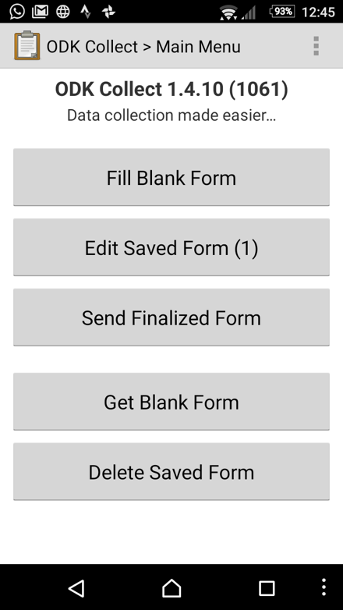 | Click on the “Blank forms” tab,  select the form(s) to be deleted  and click on “Delete selected”  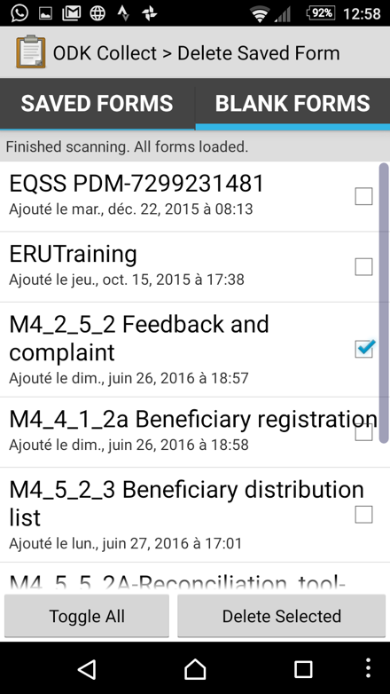

  - Secondly, upload the updated form:
Go back to the main screen  and click on “Get blank form”:  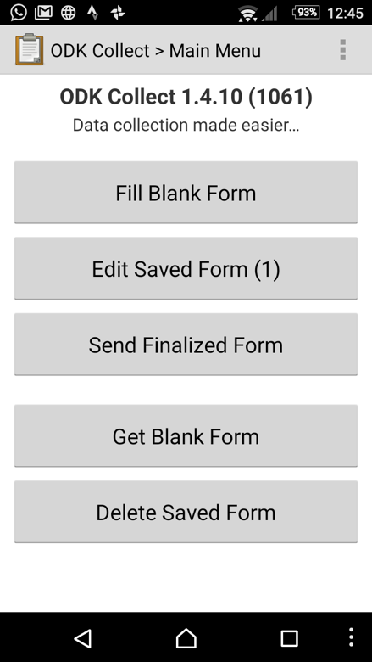 | If not selected automatically,  select the form to upload,  and click on “Get selected”:  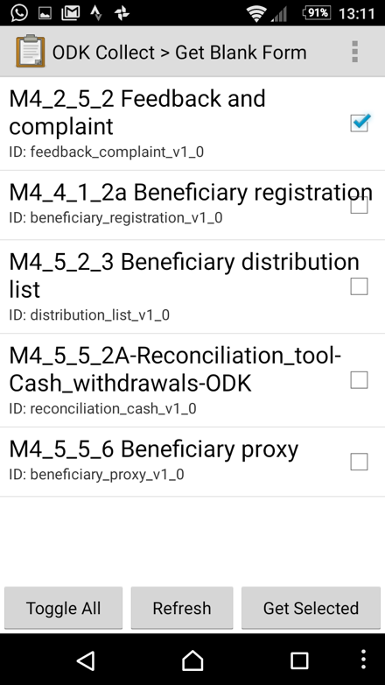

Analyse collected data

How to analyse the data?
Although it might be tempting to go through deep and complex statistical analysis, which often need the lengthy intervention of a costly external consultant and the use of complex tools and technologies (for example SPSS), for time constraint, feasibility and reasonability, basic Excel analysis are usually enough:
- Using filters, sums, pivot tables and charts

How to transfer the data?
- Export data from the web platform in .csv or .xlsx
- Paste the XLS or import CSV data into the analytical template

Ready to use analytical templates
All ODK forms are formatted to analytical templates prepared in Excel.

The format of all analytical templates is always the same, composed of 3 worksheets:
- “About”: instructions on how to use the template file
- “Data”: to copy/paste exported data
- “Analysis”: prepared generic analysis to be refreshed, changed, completed…

    - List of ODK forms and corresponding analytical templates:

Reference tool | ODK forms | Analytical template
M4_2_5_2 Feedback and complaint form template | M4_2_5_2a-ODK-Feedback_and_complaint-XLSForm | M4_2_5_2b-ODK-Feedback_and_complaint-Data
M4_4_1_2 Beneficiary master data, lists, reports | M4_4_1_2a-ODK-Beneficiary_registration-XLSForm | M4_4_1_2b-ODK-Beneficiary_registration-Data
 | M4_5_2_3a-ODK-Beneficiary_verification-XLSForm | M4_5_2_3b-ODK-Beneficiary_verification-Data
 | M4_5_2_3c-ODK-Beneficiary_distribution-XLSForm | M4_5_2_3d-ODK-Beneficiary_distribution-Data
M4_5_2_1 Distribution site assessment checklist | M4_5_2_1a-ODK-DistributionSite_Assessment-XLSForm | M4_5_2_1b-ODK-DistributionSite_Assessment-Data
M4_5_5_2 Reconciliation tool | M4_5_5_2a-ODK-Reconciliation-Cash_withdrawals-XLSForm | M4_5_5_2b-ODK-Reconciliation-Cash_withdrawals-Data
 | M4_5_5_2c-ODK-Reconciliation-NFI_waybills-XLSForm | M4_5_5_2d-ODK-Reconciliation-NFI_waybills-Data
M4_5_5_3 Safe and Stock Count Form | M4_5_5_3a-ODK-Reconciliation-Safe_movements-XLSForm | M4_5_5_3b-ODK-Reconciliation-Safe_movements-Data
 | M4_5_5_3c-ODK-Reconciliation-Physical_stock-XLSForm | M4_5_5_3d-ODK-Reconciliation-Physical_stock-Data

Current limitations of ODK

There are 2 types of data:
- Static, independent data, for example in reports:
  - Beneficiary registration
  - Distribution Site Assessment
  - Feedback and complaint
  - Distribution exit survey
  - Post Distribution Monitoring
  - Reconciliation of Cash withdrawals
  - Reconciliation of NFI waybills

- Dynamic, dependent data, for example in reports:
  - Beneficiary verification
  - Beneficiary distribution
For these 2 reports, there is no ODK functionality:
- to verify if beneficiary was already verified or provided assistance once
- to share correction (mistake) nor addition (proxy details) of data, for example during a distribution between verification and distribution desks
  - Reconciliation Safe movements
No possible control to dynamically match closing balance N with opening balance N+1 in real time
  - Reconciliation Physical stock
No possible control to dynamically match ending stock N with initial stock N+1 in real time

As no instantaneous update of database is possible, in case of dynamic data, mobile data collection tools are suffering some limitations.

Possible alternatives
- ODK new version 2.0 is under construction, with database functionalities. However it might not solve the dynamic need as it will require some internet connection while emergency is, often, working without real time data connection in the field.
- Some alternatives are possible, for example regarding the main issue of possible duplicates during a distribution:
  - Make each cash grant/ NFI unique so that it can be physically distributed only once:

- For cash programs, or mix of cash & NFI:
Pre-assign the cash code to beneficiaries (envelope #, PIN, voucher…) in a difficult to reproduce/falsify paper, SIM card, …

- For NFI only:
Create a difficult to reproduce/falsify 2-parts voucher with a pre-assigned code (for ex. RCRC BenCard number), to be signed by the beneficiary at the verification desk. The voucher’s part 1 is kept at the verification desk, while the beneficiary will leave the voucher’s part 2 at the distribution desk.

