ODK instructions guide for users
Many training examples are available on https://opendatakit.org/help/training-guides/.
- One simple and comprehensive tutorial: https://www.google.com/intl/en/earth/outreach/tutorials/odk_collect.html

Some important considerations:
- Asking good questions yield clear & accurate data
- The mobile device is just a tool, do not forget to focus on your interviewer role
- Enumerators profile is summarized in 3 points:
  - good attention to detail, work ethic and punctual
  - native language speakers
  - if possible with survey experience

- Install ODK on a mobile device
- On your Android device, go to Google Play Store or Android Market Place depending on your device. Search for "ODK" and choose "ODK Collect" from "Open Data Kit"
- Click, Install
(Uninstall old version to install the current most updated one)
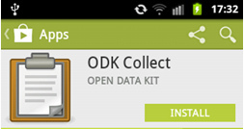
- Click Accept, to start the download

- You can drag the ODK Collect application to your Home Screen, its icon is shown in following figure:

- Load new or updated form(s) from the server to the mobile device
Once IM confirms that forms are ready in the server, you can download them to the mobile device following the below steps:

- First delete the form(s) to be updated:

Click on “Delete saved forms”:  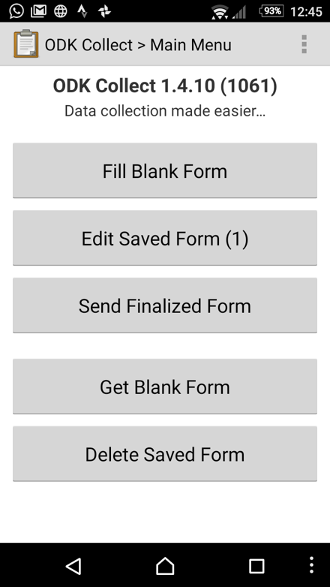 | Click on the “Blank forms” tab,  select the form(s) to be deleted  and click on “Delete selected”  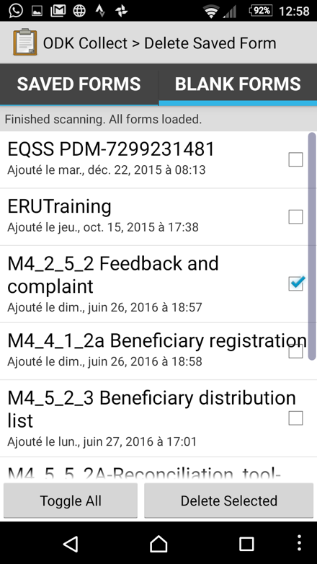

- Secondly, upload the updated form:

Go back to the main screen  and click on “Get Blank Form”: | If not selected automatically,  select the form to upload,  and click on “Get selected”:  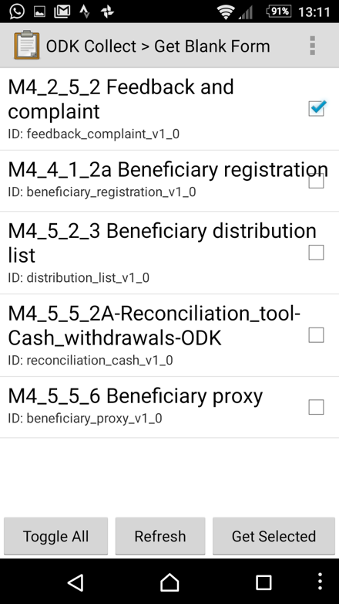
- Fill in a form with ODK
ODK is intuitive and easy to use but requires the user to be systematic and rigorous.

Ensure that daily data is tracked, entered, saved and sent.
- ODK Collect will appear in your application drawer. Select it to launch the application.
- Press “Fill Blank Form” and select the required one
- Swipe the screen from right to left to go to the next page, or left to right to go to the previous page
- Track all data: when a beneficiary collects in-kind/ cash at a distribution, data is entered individually with the relevant date
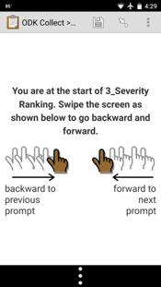
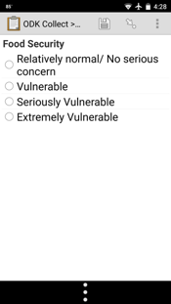
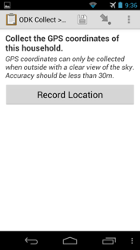
- Screen samples:
- Swipe screen
- Multiple choice
- Take a picture
- Record a GPS point

- When you reach the end of the form, make sure “Mark form as finalized” is checked and click on “Save Form and Exit” >>> Data is saved in the mobile device till it finds a wifi connection
- To enter a new form, press “Fill Blank Form”

The unexpected can happen… no panic, just be prepared!
- Falling out of survey: You might end up at the main menu again. Hit the back arrow button and show up right in the same place you left
- Closing dialogue box: When you hit the back arrow button, 3 options appear:
  - Save changes:
to store the on-going survey and open it later on from the Main Menu, pressing “Edit Saved Form”
  - Ignore changes: – Cautious with this option –
to exit the on-going survey without saving the data entered
  - Cancel:
to come back right the same place you left

- Crash: best practice is to shut down and restart

- Step-by-step checklist
It is recommended to name a ‘technical’ responsible in each team who will be in charge of backing up any issue with regards to ODK.

Steps | Description
Do ahead | Use Android smartphones (version >=4.1) or tablets exclusively (not compatible with iOS iPhone or iPad)
 | Plan alternative power sources: extra battery, power bank, solar panel, plug multiplier to charge various devices at once…
 | Ensure there is sufficient space on the SD Card on the device (minimum 8 GB recommended), no matter the size of the internal memory
Charge each phone with sufficient data credit
Careful: if the survey includes pictures, higher volume of data credit is needed
 | Format smartphones pictures size at the minimum, for example 2 MPx
General settings / Auto send:
  - select “auto send with Wi-Fi” >>> this will allow to upload data every time the mobile device is connected to mobile data or Wi-Fi
  - if you do not have restrictions on data credit, you can also select “auto send with network” >>> this will allow to upload data every time the mobile device is connected to the data network
 | Regularly upgrade ODK Collect version
 | Turn OFF automatic orientation
Be confident with:
  - ODK functions
  - understanding about all surveys questions you are going to conduct
  - dealing with confrontation, long talkers, etc.
Night before | Verify all needed forms are downloaded and ready to use:  - via Wi-Fi at office  - load the forms once to check that they are valid
 | Fully charge phone and alternative power sources
 | Check weather and safety concerns
Start of the day | Sing-out phones/tablets to the selected volunteers/ staff  Assign the same phone to the same person every day
During the day | Be professional and courteous/polite:  - proper introduction when starting each interview  - always thank the respondent when finished  The small size of the mobile phone allows the user to be closer to the respondents. Use this face-to-face opportunity to communicate with her/ him, read body language, introduce yourself, explain the aim of the survey and how data will be used, etc.
Be impartial:
  - ask questions without passing judgment, do not interpret the answers
  - get straight answers and record them
 | Monitor survey questions problem or technical issues to correct them
Monitor safety issues and weather conditions:
  - stay hydrated (drink water)
  - stay dry
 | For the first GPS point of the day wait extra time to get a good GPS fix
Save battery power
  - adjust screen brightness to LOW
  - turn OFF keyboard vibrate and sound
  - turn ON flight mode (Bluetooth, Wi-Fi, data sync, etc. all OFF)
  - check that GPS is still ON (if using)
  - set short screen time-out
  - set language to the native language of the enumerator
  - use only for ODK Collect, and only when collecting survey data
  - no personal uses
End of the day | Volunteer head count
Check that all completed survey forms have been successfully sent
To send completed forms:
  - turn off airplane mode, connect to Wi-Fi
  - if not done automatically, click on “Send Finalized Form”, check mark all the finalized forms and click on “Send Selected”
 | After forms are all sent, delete any of the day’s images from phone memory
 | Sign-in phones
 | Debrief interviewers: problems, issues, concerns, and success stories

