RedRose Data Management Overview

Background

Cash Transfer Programming (CTP) is a strategic priority for the IFRC, evident in the commitment made under the Grand Bargain at the World Humanitarian Summit in 2016. In June 2018, the IFRC Secretary General and the Governing Board endorsed the institutionalization and scale up of cash and called for adequate support to National Societies to be ready to deliver cash programmes.

Cash Data Management has been identified by the Cash Peer Working Group (CPWG) as a priority and have established a sub-working group to identify possible solutions. After a thorough systematic evaluation of different systems in 2017, it was seen that RedRose best met the requirements of the Movement for cash. The CPWG subsequently recommended to pilot RedRose. The Movement has since piloted the platform in 8 countries (Vietnam, Philippines, Lebanon, Kenya, Somalia, Ukraine, Nigeria, Pakistan) for distribution of cash and in-kind in various contexts and scale. With the success of the pilots, the IFRC is recommending to rollout the RedRose data management platform as part of cash preparedness and emergency response.

Data Management

RedRose data management platform integrates with data collection tools (e.g. ODK/Kobo) and payment mechanisms (e.g. mobile money, remittance). It takes various inputs (e.g. beneficiary data, market data, post-distribution surveys) and processes them to enable quality programming and decision making in a safe and secured manner. Current operations rely on Excel spreadsheets and manual manipulation of data, which is time consuming, prone to errors and duplicated efforts, not secured nor auditable (risk of fraud and abuse). The volume of beneficiaries, their movement, and possible recurring payments easily increase complexity. Limited connectivity is also a factor in some contexts. Proper management of cash data on end-to-end CTP business processes is necessary for fast, effective, and quality programming.

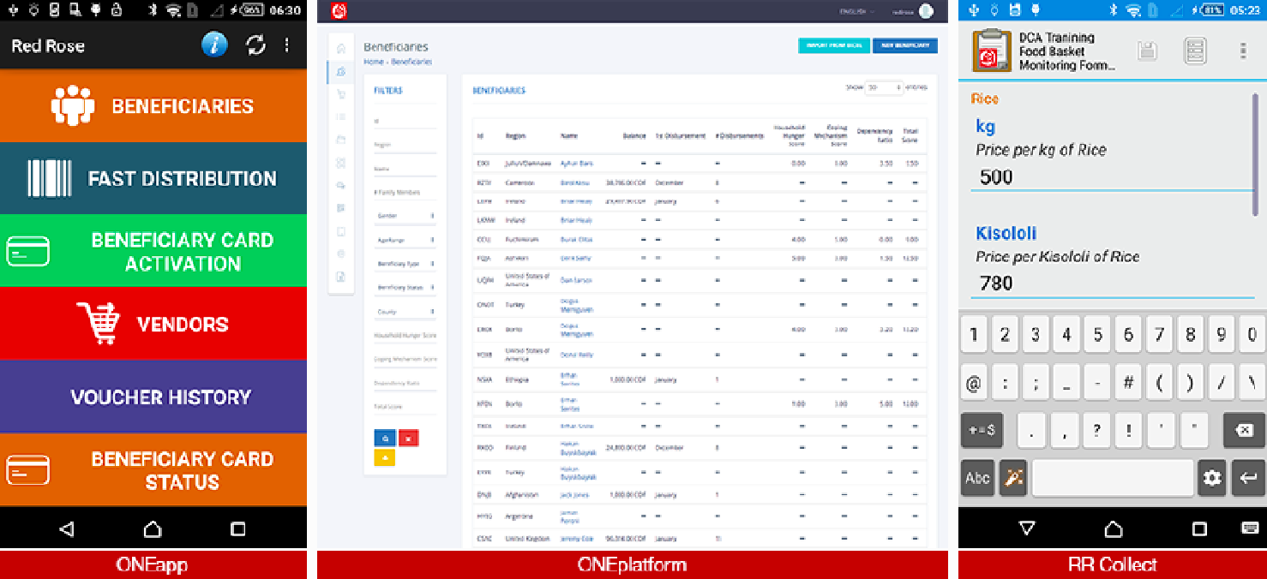
RedRose provides a fully integrated solution that is able to work on online and offline contexts and flexible to manage data for various cash based programmes from direct cash, to mobile money, and e-vouchers. RedRose is also applicable for in-kind and services, making it a comprehensive tool for any assistance types.

Global Framework Agreement

The IFRC established a Global Framework Agreement (GFA) with RedRose on May 2018 allowing Movement components to join the agreement and benefit from the global discount rates and negotiated terms and conditions by signing a Supplementary Agreement. This saves time and effort for NS’s from conducting their own full tendering process and negotiating separately with the vendor. Kenya RC and Lebanese RC have joined the GFA.

There is also non-exclusivity in the use of the platform and it’s pay per use. If NS would like to use other solutions, there are no restrictions. There is no cost to join the GFA. Additionally, NS pays for service fees only when there’s an actual distribution; this allows them to be data prepared with no steep investments.

The piloting of RedRose by the IFRC has demonstrated increase in efficiency and scale, while also demonstrating improved quality of programs through segregation of duties, transparency and accountability with audit logs and strong security features to safeguard sensitive beneficiary information.

