Market Assessment and Analysis Principles
Introduction
Programme design for humanitarian response starts with initial programme assessments, including cash feasibility study and needs assessment, generally consists of three elements: community assessment, market assessment and assessment of financial services.
Community assessment consists of understanding the needs and capacities of communities affected by crisis, including how they access goods and services and their preference around assistance delivery.
Market assessment and analysis are often used interchangeably. Market assessment refers to the exercise of collecting primary and secondary market data. Market analysis is the process where we use the data to understand how markets function, or how it has been impacted by an event or crisis and the results can be used for evidence-based decision making in terms of programme design and implementation. These processes of collecting and analyzing market data provides a snapshot of how the market system is functioning at that moment in time. For a comprehensive view of the market system and its evolution over time, they need to be repeated regularly and not just as a one-off exercise.
Markets are essential for people to purchase and sell goods and services and to obtain jobs. Therefore, understanding the role of markets in the lives and livelihoods of crisis and conflict affected populations is a crucial component of humanitarian situation, response analysis and monitoring during implementation.
As a humanitarian actor, our interventions can have positive (e.g. the multiplier effect) and negative (inflation or poor-quality products available undermining life/livelihoods) impacts on local market systems. It is essential that humanitarian responses, delivered either through cash and vouchers (CVA) or in-kind, are market-sensitive, and protect livelihoods, local jobs and businesses. In order to take the right decision on how best to support crisis and conflict affected populations, it is crucial to understand the local markets dynamics and how our response can impact or rely on them.
Market analysis can be conducted for many different purposes. This can focus on: specific good and/or service available in the marketplace; on understanding complex supply chains or to identify where market support activities may be required. In connection with CVA, it is usually conducted to determine whether disaster or conflict affected populations can access the required goods and services at sufficient quantity and quality in the local market. Furthermore, market analysis can identify blockages and bottlenecks in the wider market system (including supply patterns) and thus help to identify market support interventions to strengthen market systems.
It is important to note that no specialist skills or economics background is required for basic market assessment when using existing RC/RC Movement market assessment methodology (RAM and MAG) thus making market assessment more accessible for teams on the ground.
The RCRC Movement has a presence in almost every country, providing regular assistance often in cyclical or protracted crises. As the size and longevity of our potential interventions increases (number of beneficiaries and total assistance) the larger the positive or negative impact on local markets. It therefore becomes critical to consider and understand more comprehensively the state of the relevant market to determine the best-suited assistance modality to assist beneficiaries.

Purpose
With an increasing need for more in depth market assessments comes a need for better defined roles and responsibilities within Market Analysis. This is to ensure that we have the appropriate resources; trained, deployed and able to conducts all activities within the Market Analysis in a quality and timely manner.
Programme, Logistics and Finance departments along with Management need to participate to a degree and be involved in defining the scope and content of a market assessment. Each department has specific expertise which can provide valuable information on the structure and functioning of markets (i.e. pricing, seasonality, ethical issues, quality aspects, security concerns, etc.)
Market assessment within the Movement should be a joint responsibility of Programme and Logistics to ensure that the implications of using cash, in-kind or services (or a combination of these) are properly analyzed during program design.
Logistics contributes to the insight into local supply chains and local providers which provides perspective on Supply to complement the Programmes’ demand perspective illustrated in the diagram below.
Demand is focused on the beneficiary perspective and their requirements of the market (needs). This is built around and driven by the community assessment, which looks at beneficiary preference and acceptance, access to markets and cash, as well as important goods, services and critical markets.
Supply side focuses on the suppliers’ perspective and any aspects limiting the market functionality. This looks at traders’ and service providers’ capacity and willingness, market competitiveness, enabling factors including external factors influencing the market system (e.g. trade laws or importation rules), the infrastructure and services (e.g. credit or storage facilities) and financial services providers.
The process of meeting a comprehensive understanding of the market environment will follow a logical flow. The community assessment and identification of the critical markets systems conducted by Programme will be the starting point. Following that, programme and logistics (and finance as applicable) will work together to develop a comprehensive list of market actors (e.g. importers, producers, production suppliers, wholesalers, traders, retailers, FSPs etc.) related to the critical markets and operating context.
The data collection activities will be conducted collaboratively based on the agreed points below:
- Setting the analytical and geographical scope: including the purpose and objectives; number of and types of market actors to be interviewed; in which geographical locations (including outside of the country for international supply chains) and the defined time frame. The scope should ensure confidence that enough meaningful information will be collected.
- An agreed comprehensive questionnaire covering relevant supply and demand information that will be used by all data collections teams.
- An Assessment and Resource plan including selection of market assessment tools and guidance, develop a schedule outlining who does what and when, budget, equipment and trained teams. This will ensure the scope and time frame are met with the available resources.
The analysis of the collected data will be done jointly following a logical rationale to understand: how well the market functions; what if any market support activities it might need; and what modalities and potential response options could be considered, all detailed in the market analysis report.

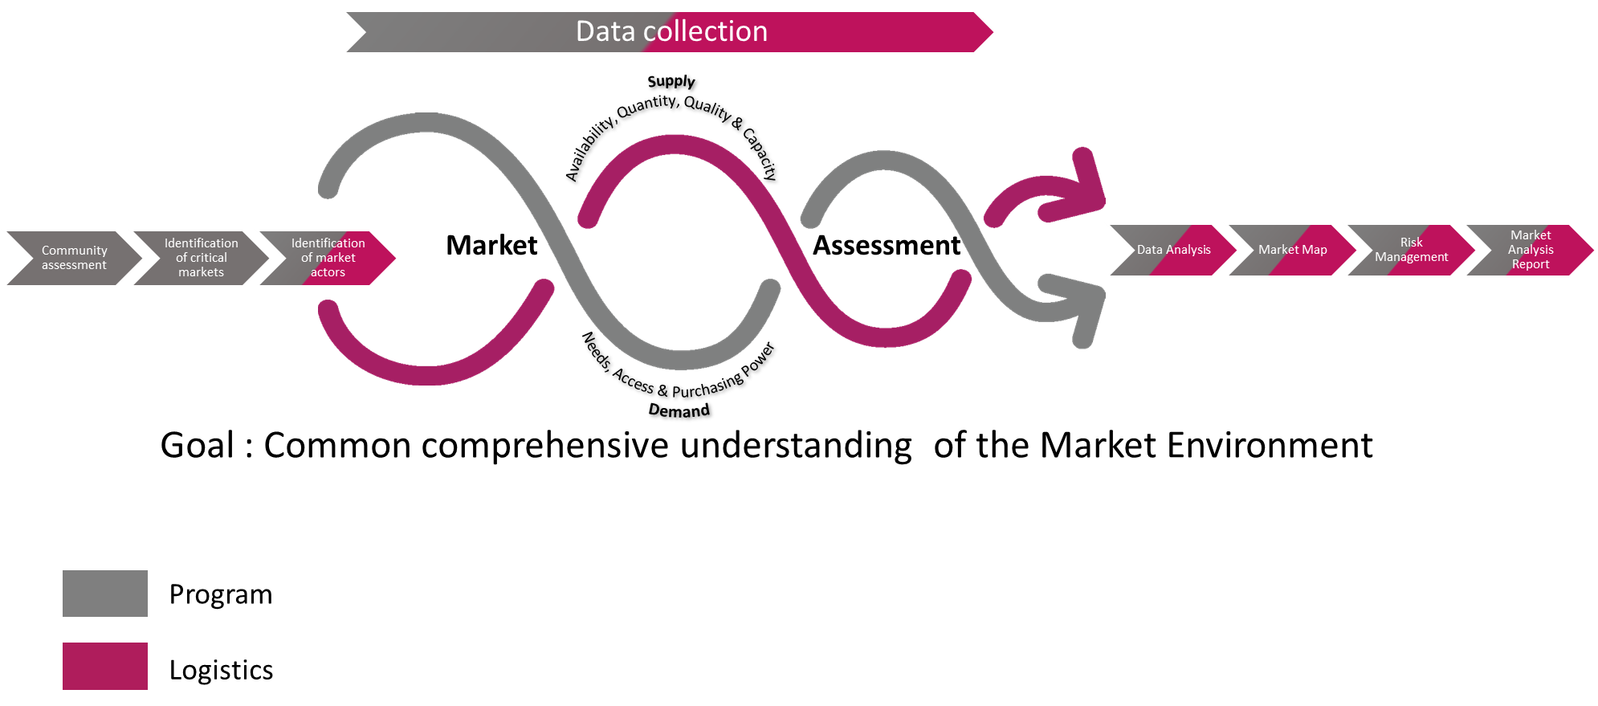

Core Roles and Responsibilities
Following best practice provided by CaLP in the process of clarifying roles and responsibilities, a RACI matrix with a section dedicated to Market Analysis has been proposed and is annexed to this document.
The overall responsibility for the Market Analysis sits with Programme to ensure that it’s connected to the general programmes design and decision making. However, keeping in mind the two perspectives of demand and supply, some of the activities within the overall market assessment will have a shared responsibility and will be conducted jointly.
RACI
RACI stands for Responsible, Accountable, Consulted and Informed.
Responsible is referring to those who do the work to achieve the task
Accountable is referring to those being ultimately answerable for the correct and thorough completion of the deliverable or task. They ensure the prerequisites of the task are met, they delegate the work to those responsible and must sign off (approve) work that the responsible provides.
Consulted is referring to those whose opinions will be sought (subject matter experts) and with whom there is a two-way communication. This will be a discussion and consensus will be reached and sign off. This might be an iterative process.
Finally Informed is referring to those that will be up-dated on progress linked to each steps and activities and with whom there is a one-way communication.
GLOSSARY
Critical Market Systems | The specific market systems that are most urgently relevant to the target population’s needs. Essentially those markets that have or could have a major role in meeting the essential needs of the target population [PCMMA]
Enabling Environment: | The enabling environment or rules that influence how a market system works – sometimes these are called ‘dis-enabling’ factors because they make a market system work badly. It forms one ‘layer’ in market system mapping and analysis. See also Market Map
Market | Refers to a system of exchange between two or more actors or players. The exchange can be for goods or services, or for money and can take place in a physical space or through virtual media such as the internet. Markets are sometimes defined by forces of supply and demand, rather than geographical location e.g. ‘imported cereals make up 40% of the market’.
Market Analysis | Analysis of market information to understand how a market functions, or how it has been impacted by an event or crisis.
Market -based programming / market support activities | Market-based programming or market-based interventions are understood to be projects that work through or support local markets. The terms cover all types of engagement with market systems, ranging from actions that deliver immediate relief to those that proactively strengthen and catalyze local market systems or market hubs.
Market Map | A market map is a visual depiction of how an entire market system works, including all the actors in the market, how they relate to each other, the volume of produce being traded / exchanged by different actors, and prices. Market maps contain the following three elements: a) the market chain; b) market services; c) the enabling (or dis-enabling) environment or rules.
Multiplier Effect | Indirect effects of cash transfers whereby increased expenditure by recipients contributes to income growth for non-recipients, expansion of markets for local goods, or increased demands for services. The ‘economic multiplier’ is the estimated number by which a change in some other component of aggregate demand is multiplied to give the total amount by which the national income is increased as a result of direct and indirect benefits from that change in demand.
Purchasing Power | The ability to purchase goods (this is usually defined by income).
Response Analysis | The link between situational analysis (broadly speaking, needs assessment and other contextual information) and programme design. It involves the selection of programme response options, modalities and target groups; and should be informed by considerations of appropriateness and feasibility and should simultaneously address needs while analysing and minimizing potential harmful side-effects. [Maxwell, D. 2013]

We will use the term Market Analysis through this document to encompass the process and outputs.
Note that “Goods and services” are also referred to as “commodities” in other RC/RC movement tools such as the RAM/MAG
Important to note the distinction between basic market assessment and more complex market assessment which might require a different level of expertise (for example the labour market or rental market).
The Rapid Assessment of Markets (RAM) is focused on the assessment and analysis step and provides rough guidance and tools for market monitoring. The Market Analysis Guidance (MAG) provides guidance and tools on how to integrate market considerations throughout the project cycle.
Data collection activities need to be planned and contextualized but framed by the various tools that are currently being developed and that already exist such as the RAM / MAG.
The Cash Learning Partnership (CaLP) is a global partnership of humanitarian actors engaged in policy, practice and research within Cash and Voucher Assistance (CVA) of which ICRC is a member.
The CaLP Glossary www.cashlearning.org/resources/glossary

