Roadmap for developing and implementing
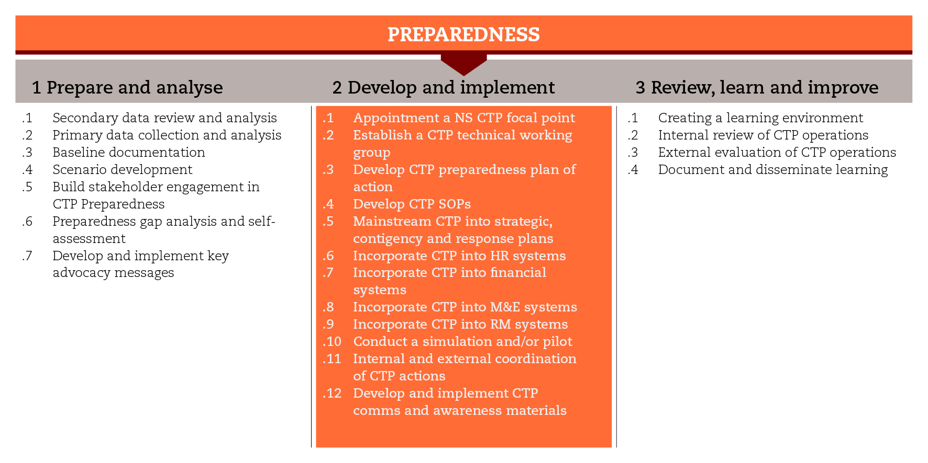

INTRODUCTION
In order to implement cash-based responses in time and at scale after an emergency, cash-specific issues must be taken into account throughout the preparedness process. This road map will focus on the processes of developing the minimum internal conditions for building CTP preparedness, mainstreaming CTP into key areas, and implementing the CTP preparedness Plan of Action.
The road map structure reflects the stage ‘develop and implement’ of the International Red Cross and Red Crescent Movement CTP Guidelines for mainstreaming and preparedness and covers all its sub-steps associated with tools that can help you move along the process. You may not be able to use all the suggested tools, but you should at least comply with the minimum standards set for the process.

MINIMUM STANDARDS
- A CTP focal point should be appointed at the beginning of the preparedness process.
- A CTP Technical Working Group (TWG) made up of representatives from all departments involved in CTP delivery must be established under the leadership of the CTP focal point.
- The CTP TWG should lead the development of a preparedness Plan of Action (PoA) that includes activities, outputs, indicators, responsibilities, timeframe and budget.
- The CTP TWG should lead the development of CTP standard operating procedures (SOPs).
- CTP should be mainstreamed into strategic, contingency and response plans, including human resources, finance, monitoring and evaluation, and resource mobilization.
- Simulations or pilots should be conducted to test the CTP operational readiness, and should be repeated over time.
- CTP coordination must take place internally and, also, should involve external stakeholders such as government, donors and other humanitarian agencies.
- CTP should be mainstreamed into regular communications strategy and plans, particularly into beneficiary communication and accountability systems.

SUB-STEPS AND TOOLS

Appoint a National Society CTP focal point
The decision to strengthen CTP readiness should be followed by the appointment of a CTP focal point. This person will promote CTP, build engagement and ownership, and establish effective coordination and communication. She or he will lead the CTP Technical Working Group (TWG), and will work as an internal and external advocate for CTP, participating in CTP meetings and networks, inter-agency technical working groups, donor meetings, regional and international meetings as appropriate. The CiE Toolkit makes available ToRs for a CTP focal point.

Establish a CTP technical working group (TWG)
A CTP TWG should be established and should work to identify and agree upon the activities to be included in the Plan of Action (PoA). The TWG will be led by the CTP focal point and will be made up of appropriate representatives from all departments that will be involved in CTP delivery. Board members, senior managers in programmes or support services, staff and volunteers with CTP experience, branch representatives, Movement partners, and, perhaps, external participants with relevant experience can be invited to join the TWG also. The tool CTP TWG key responsibilities can be a good starting point for the development of a ToR.

Develop the CTP preparedness Plan of Action (PoA)
The CTP preparedness PoA should be realistic, achievable, and aligned to any existing contingency and preparedness plans. It should include activities, outputs, indicators, responsibilities, timeframe and budget, in order to enable CTP delivery in time and at scale in emergencies. The TWG is responsible for identifying the appropriate and relevant objectives and outputs, and presenting the draft PoA for approval. The TWG is also responsible for implementing and monitoring the approved PoA, with the CTP focal point managing and coordinating the whole process, ensuring coherence between the parts, and reporting to senior management. The CiE Toolkit makes available CTP preparedness PoA templates, which consist of a logical framework, a plan of activities, a budget spreadsheet, and a Gantt chart.

Develop CTP standard operating procedures (SOPs)
CTP SOPs can improve the speed, accountability and efficiency of CTP responses by providing simple and clear guidance on the processes related to CTP. They should outline roles and responsibilities, and support decision-making for each of the different departments involved in CTP preparedness and response. The CTP TWG should lead the development of CTP SOPs. Once developed and approved, CTP SoPs must be tested and updated. Staff and volunteers should be trained continuously on their content. The sub-step tools include a CTP SOP template and an example, as well as a training package.

Mainstream CTP into strategic, contingency and response plans
It is important to develop and incorporate CTP options at all levels, in general strategic, preparedness and contingency planning and response plans and to promote the strengthening of CTP capacities to build confidence and readiness to deliver CTP at scale. The sub-step tools include a template to develop contingency plan.

Incorporate CTP into human resource systems
Building the CTP capacity of staff and volunteers is critical to improve the CTP response capacity. CTP training is needed not only by staff and volunteers of operational disaster response teams, but also by staff from support departments such as Logistics, Finance and Communication, to ensure that they have a good understanding of the needs, constraints and processes involved in CTP responses. A range of CTP training materials has been developed by the Movement and is available for use in both online and face-to-face trainings. It is important that CTP training and capacity building is budgeted for. The sub-step tools include a capacity building plan and competency framework.

Incorporate CTP into financial systems
Typically, logistical, administration and financial systems are designed for in-kind responses and may be too restrictive for delivering CTP in emergencies.
The implementation of cash transfer programmes often depends on a partnership established with implementing partners and service providers. CTP preparedness should therefore include preliminary steps to identify appropriate partners, establish pre-agreements with them and define potential ways of working (identification, registration, encashment procedures and specific control systems). It should also include capacity building of both internal staff and partners. The organization may choose to start by developing the systems for the priority modalities and delivery mechanisms and then expanding these systems as its CTP capacity strengthens. This process goes hand in hand with the development of CTP SOPs. The sub-step tools include a road map for service provider selection and contracting, a tool to gather information for helping to develop a ToR /scope for service provider and the the IFRC standard contract template.

Incorporate CTP into monitoring and evaluation (M&E) systems
Existing monitoring and evaluation mechanisms and systems will need to be adjusted to incorporate CTP considerations. It is possible that some specific tools need to be developed. The CiE Toolkit makes available a road map for CTP monitoring and evaluation planning, a process that involves developing a comprehensive M&E strategy (including a detailed activity work plan and an M&E matrix with indicators and means of verification) and building the capacity of volunteers and staff.

Incorporate CTP into resource mobilization systems
CTP preparedness plans should be kept realistic and consistent with the resources available or potentially accessible. The sustainability of CTP activities is more robust if they are integrated into existing processes and earmarked in the annual budget.
Donors, especially those with recognized CTP funding streams (e.g., ECHO, USAID, DFID), should be approached regularly and CTP should be included in new proposals. The sub-step tool includes a donors’ mapping matrix that can be helpful to organize information about donors.

Conduct a simulation and/or a pilot
Simulations allow for testing the CTP operational readiness and the outputs developed, and should be repeated over time. Learning derived from simulations should be incorporated into preparedness processes. Ideally, CTP simulation exercises should be integrated into regular contingency planning simulation exercises and included in the contingency planning budget. If there are budget constraints, it is advisable to develop a desktop simulation.
Pilots can help further development and testing of CTP preparedness. It consists of rolling out a limited-scale project in real or near-to-real response circumstances. A pilot must be planned carefully and budgeted for. The resource mobilization team would have the responsibility to seek funds for a pilot. It is also possible to conduct a CTP pilot as part of an inter-agency exercise.
The sub-step tools include simulation scripts for five hazard events and simulation training guide.

Internal and external coordination of CTP actions
CTP coordination must take place at different levels, both internally and externally. Internally, there must be coordination between different staff and departments, and between the headquarters and the affected or targeted branches. The hosting National Society should lead the coordination of the Movement partners and the CTP response within a country.
The CTP focal point should participate in national and regional CTP coordination meetings when possible and where they exist. This will help the National Society engage in vital information-sharing, coordination, CTP preparedness and capacity building with other organizations in the country and beyond. The sub-step tools include resources relevant for the purpose of Movement coordination.

Develop and implement CTP communications strategy and awareness materials
Communications for CTP should be mainstreamed into the regular communication strategy and plans. Regular updates and reports on CTP activities should be shared internally and externally to promote awareness and understanding across the organization and among external stakeholders. Besides traditional communication materials and channels, it is possible to consider setting up a web page dedicated to CTP activities which have been implemented and activating social media to promote the CTP experience to a wider audience. The sub-step tools include FAQs about CTP.
Beneficiary communication materials on CTP, including posters, leaflets and other approaches, can be developed during the preparedness phase and adapted to specific responses. During an emergency response, beneficiary communication systems and tools should be ready for access and use. CTP elements should be shared directly with the affected population to improve the effectiveness and accountability of the response. The sub-step tools include a road map that provides guidance on how to communicate and be accountable to beneficiaries.
REFERENCE DOCUMENTS
Cash transfer programming - engaging National Society leadership. Guidance to support internal advocacy. IFRC 2013
IFRC (2011) Beneficiary Communication and Accountability http://www.ifrc.org/PageFiles/94411/IFRC%20BCA%20Lesson%20Learned%20doc_final.pdf
CaLP (2011) Communicating cash: A field guide to beneficiary communications in cash transfer programming
http://www.cashlearning.org/resources/library/28-communicating-cash-a-field-guide-to-beneficiary-communications-in-cash-transfer-programming-screen-version

