Roadmap for reviewing, learning and improving

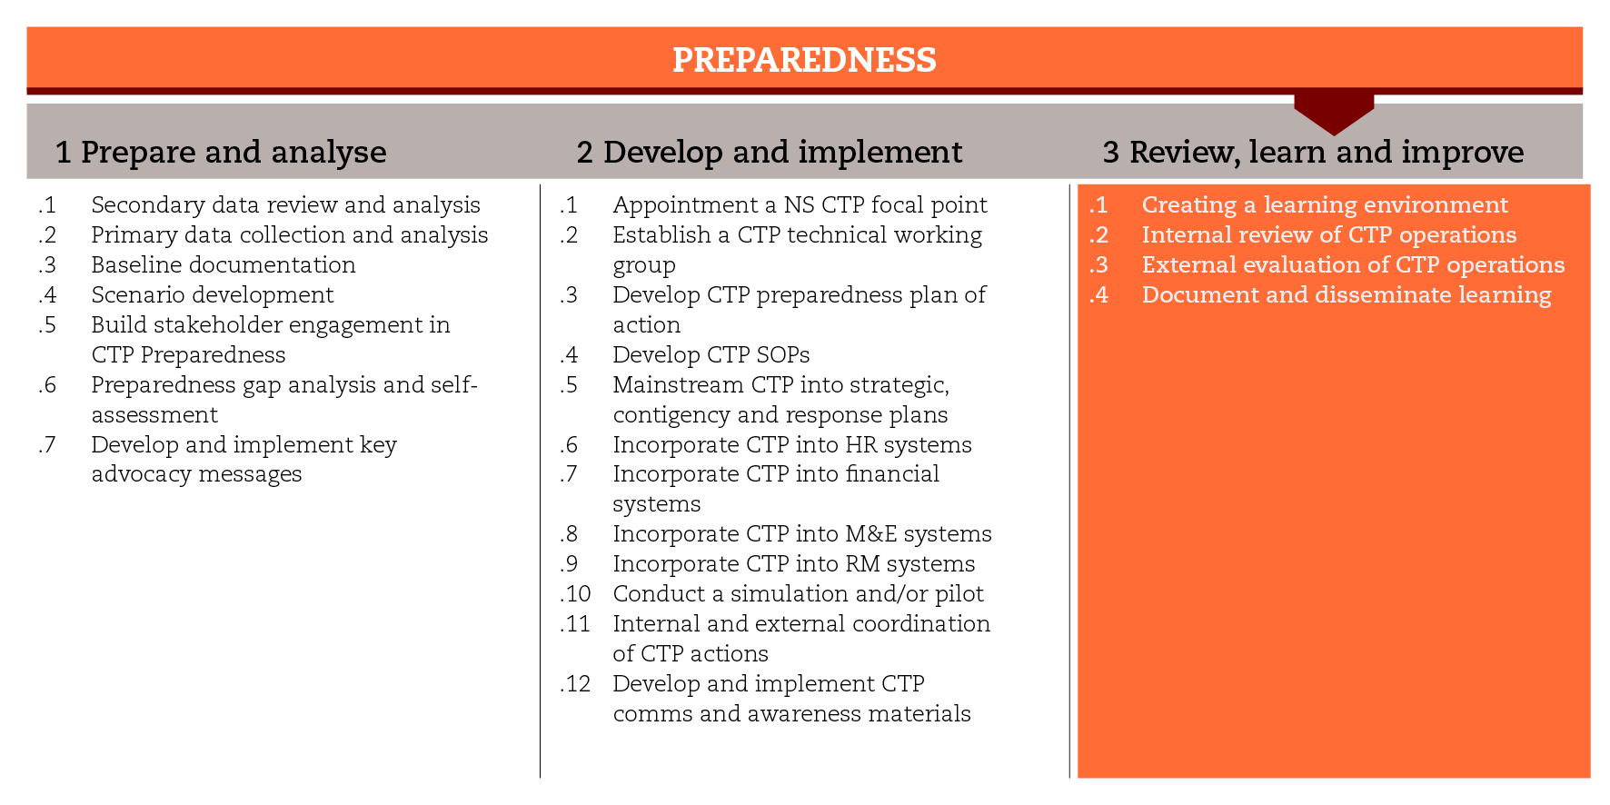

INTRODUCTION
In order to implement cash-based responses in time and at scale after an emergency, cash-specific issues must be taken into account throughout the preparedness process. This road map will focus on the processes of evaluating the CTP preparedness, reviewing the CTP operations and documenting the learning in order to contribute to a growing body of evidence on CTP. The road map structure reflects the stage ‘review, learn and improve’ of the evidence on CTP. The road map structure reflects the stage ‘review, learn and improve’ of the International Red Cross Red Crescent Movement CTP Guidelines for mainstreaming and preparedness.
The steps and sub-steps suggested are not necessarily sequential and even can take place simultaneously. Each sub-step is associated with tools that may be useful as you move along the process. You may not be able to use all the suggested tools, but you should at least comply with the minimum standards set for the process.

MINIMUM STANDARDS
- The CTP preparedness Plan of Action (PoA) should include activities and resources for review and evaluation.
- The Terms of Reference (ToR) for the National Society CTP focal point and technical working group (TWG) should include roles and responsibilities related to CTP preparedness, monitoring and evaluation.
- CTP preparedness should be evaluated through an internal review process led by the National Society focal point and the TWG.
- CTP preparedness processes and tools should be tested and adapted to local contexts.
- CTP operations should be evaluated by an external consultant/team.
- Evaluation reports, case studies and fact sheets should be disseminated internally to Movement partners and externally to other actors and networks.

SUB-STEPS AND TOOLS

Creating a learning environment
The CTP focal point and TWG should take the lead in setting up the CTP preparedness monitoring and evaluation systems and in promoting systematic learning across the different departments. They will plan and conduct reviews of the CTP preparedness PoA and the relevant systems and tools. The sub-step tool made available is a monthly report template that can help the CTP focal point and the TWG gather inputs from across the sectors and inform senior managers and Movement partners on the progress of the PoA.

Internal review of CTP operations
The evaluation of the CTP preparedness process should allow for the identification of the key achievements against plans, the documentation of good practices and the development of recommendations to improve outputs and processes. A one or two day workshop can help in the understanding of key achievements, capturing lessons learned and developing recommendations. The approach and the tools are similar to those used in the initial preparedness workshop. The SWOT analysis and self-assessment tools can be updated and used for evaluation purposes. The sub-step tools include templates for CTP preparedness evaluation, ToRs, and reports, and a short guidance on key issues to be considered when organiszng the learning workshop.

External evaluation of CTP operations
At the end of a CTP emergency response, an external evaluation should be carried out so that the strengths and weaknesses of the process can be identified in a systematic and impartial way. The evaluation should draw out the lessons learned and make key recommendations for improving current and future practices. The evaluation should cover the process, design, outputs (including resources allocated and expended) and impact of the CTP preparedness. The CTP preparedness PoA should include the evaluation of CTP operations, and integrate the learning associated with it. A road map to CTP evaluation is made available in this sub-step.
Case studies conducted by external reviewers are also an interesting way to document the strengths, challenges and solutions found during a CTP experience, and can be used to support resource mobilization and capacity building efforts.

Document and disseminate learning and contribute to global evidence
It is important to share and promote the good practice and learning from the CTP preparedness experience, both internally to the Movement partners and externally to other actors and networks. Dissemination of tools and case studies, news and audio-visual materials can help promote the work of the National Society and make a valuable contribution to the humanitarian sector. A National Society should also be willing to provide peer-to-peer technical support to other National Societies that are implementing similar initiatives. The sub-step tools include templates for developing case studies and factsheets.
REFERENCE DOCUMENTS
IFRC (2012) Contingency planning guide
IFRC (2015) Simulation guidance and templates
Good Practice Review: Cash transfer programming in emergencies. Humanitarian Practice Network (2011) http://www.odihpn.org/documents%2Fgpr11.pdf
Evaluating humanitarian action using the OECD-DAC criteria. ALNAP
http://www.alnap.org/resource/5253

