RAM Tool 4: Drawing market maps

Market maps are used in Steps 1 and 2 of the RAM. Markets can be mapped in different ways. Common to all market maps is that they need to be simple and easy to interpret. Thus, RAM-users focus should be on aspects that are important for the market system and play a role with respect to the shock and a potential relief intervention.

Two types of market maps are introduced here: *Production and Market Flow Maps* and *Market System Maps*.

## A. Production and Market Flow Map

A Production and Market Flow Map is a useful tool to represent commodity flows. It describes the geographic flows and points of exchange (marketplaces) for a commodity from the region in which it is produced to the region it is consumed – i.e. the target region.

An easy way of establishing such a map is to use an official geographical map of the target region and draw the physical commodity flows directly onto it. The map reveals the movements of a commodity from surplus to deficit areas indicating the relevant marketplaces. If sufficient information is available the map can be used to illustrate local or regional differences in commodity volumes and prices.[1] Different sizes in trade flows and marketplaces can be illustrated by different sizes of arrows and (for flows) and dots (for market places). *Figure 1* shows a production and market flow map established by FEWS NET for the flows of maize into Burkina Faso.[2]

### Figure 1: FEWS NET production and market flow map

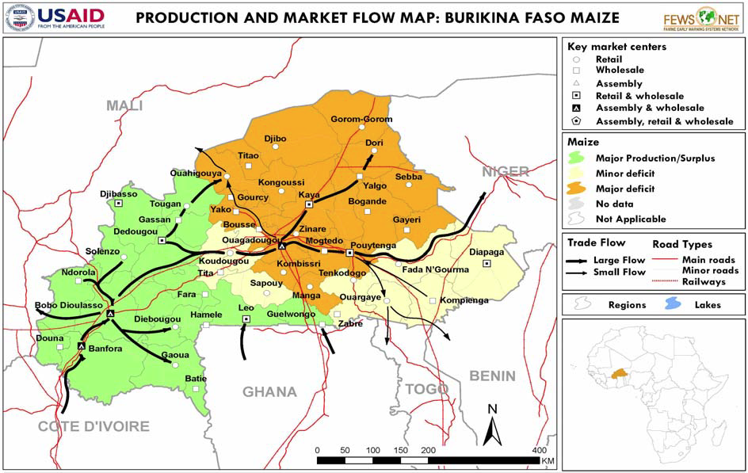

When conducting a mapping exercise RAM-users can add anything the participants judge important to the map. They should however make sure that all aspects are documented sufficiently so that they can remember the meaning of all they noted when they are back in the offices and have to discuss the findings.

Once the maps are discussed and finalized by the RAM-team to illustrate the aspects of importance with respect to the recent shock and the functioning of markets, the RAM-team should devise a refin­ed and focused map. They should only depict the most important aspects on the final map. Crowded maps are often confusing and counterproductive.

The table below gives some examples of aspects that can be of importance when it comes to a pro­duction and market flow map to illustrate the consequences of a recent shock.

### Table 1: Aspects that can be indicated on a production and market flow map

|  |
| --- |
| **Role of the market:** e.g. retail marketplace; wholesale marketplace; assembly marketplace.  **Main type of actors**: e.g. retailers; wholesalers; assemblers; producers.  **Type of the market in term of geography**: e.g. local marketplace; regional marketplace; national market place; cross national marketplace.  **Market size (trade volume)**: e.g. small; medium; large (possibly with estimation of trade volumes).  **Trade obstacles**: potential trade obstacles can be indicated by symbols and that are explained in a legend (e.g. road blocks, toll stations etc.).  **Functionality after the shock**: non-functioning; partially functioning; functioning.  **Distances & access times**: you can note the distances and times to get from one marketplace to another.  **Transport means available**: You can indicate the transport means that are available. |

Production and market flow maps can reveal how the marketplaces of interest are provisioned with the key commodities the shock-affected population need. They can also be used to indicate shock-re­lated interruptions of these flows. RAM-users should establish such a map for each of the commodi­ties they assess as they are useful means to focus the discussions around marketplaces and commodi­ty flows. They should refine the maps during the different steps of the RAM. Market mapping is an iterative process!

## B. Market System Maps

Market systems can be graphically represented by three linear components: the market chain, the supporting infrastructure and services, and the external environment.

Market system mapping is done in two steps: The first step consists of mapping the market system as it functions during ‘normal times’ – i.e., in the case of a shock, one would start by mapping the system as it functioned before the shock. These maps are called baseline maps.

***The market chain*** is the central feature of any *Market System Map*. It is a ‘chain’ of market actors who exchange, buy, and sell commodities thus ‘moving’ them from the producer all the way to the consumer. A market chain illustrates the actors of a market system and the trade relations between them. RAM-users can identify a market chain for a commodity by answering the following questions:

* Who are the market actors that deal with the commodity and what do they do?
* How many actors of each type are there?
* How does the commodity move in the market chain?
* How large are the volumes traded between the different types of market actors?
* How does the selling price change throughout the value chain?

***The supporting infrastructure and services*** are the second feature of a *Market System Map*. Mapping the crucial infrastructure and services and linking them to the actors using them reveals the former’s role in maintaining the market-system efficient and accessible.

***The external environment*** is the third feature of the *Market System Map*. Mapping the norms, rules, regulations, issues and trends that have significant influence on the market environment in which the market actors operate reveals the framework of the market.

The second step market system mapping is to account for the effects of the shock on the market system – i.e. how has the shock affected the different market actors and the exchange between them; how has it affected the infrastructure and services the market actors depend on; and how has it affected the framework of the market system. Signs and symbols can be used to indicate market actors, components, and connections that have been partially or completely damaged. The extent to which these damages affect the functioning of the market-system can be illustrated by noting chan­ges in the number of actors. It is important that the symbols used are well explained and used consis­tently. This map can be called a shock map.

*Figure 2* presents a generic baseline map for a fictitious market system and *Figure 3* a respective fictitious generic shock map. The two maps together allow RAM-users to illustrate the consequences of the shock on the market systems by comparing the situation before the shock with the situation after the shock.

### Figure 2: Market system in ‘normal times’ (baseline map)



### Figure 3: Market system after the shock (shock map)



RAM-users should develop preliminary *Market System Maps* in *Step 1* on of the RAM. It will help them to decide which market actors and key informants they should meet. The maps will help them during their interviews. The RAM-users should update their maps throughout the RAM-process as as new market information becomes available. Again, mapping is an iterative process.

1. For detailed information on how to map a Production and Market Flow Map see FEWS NET (2009b).
2. The example should eventually be replaced by an example from a RC/RC context.