Roadmap for service providers,
organizational capacity and risk analysis
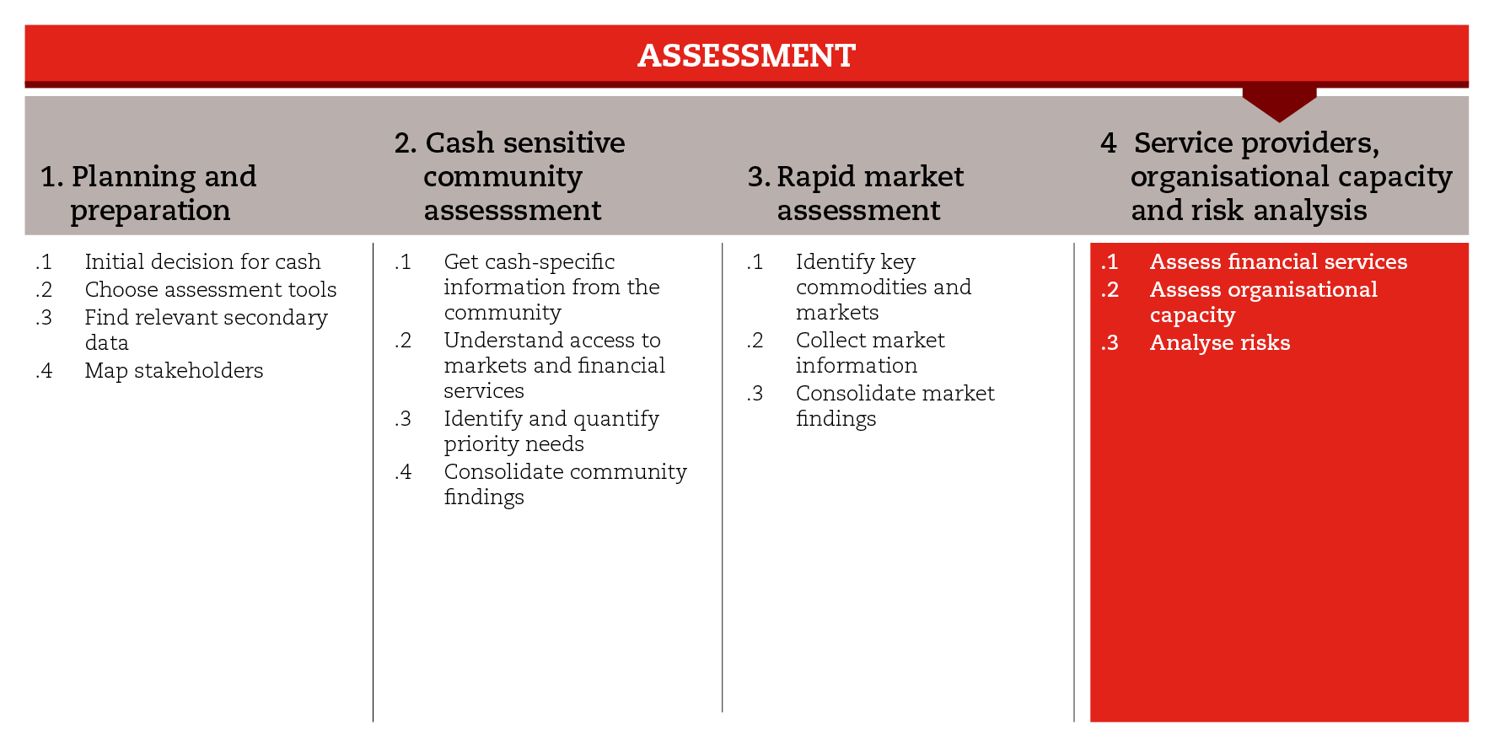

INTRODUCTION
When conducting an assessment, it is important to understand the capacities in place to implement cash transfer interventions and the risks associated with this type of response. This implies broadening the assessment to include these issues and, when necessary, conducting separate capacity assessments. At this stage, relevant background information collected during the preparedness phase can be useful, but it should be updated and contextualized.
Capacity and risk assessment will provide response analysis, set-up and implementation phases with crucial information. Therefore, you should always conduct some level of capacity and risk analysis, but its depth can vary depending on the information and resources available, the context and the scale of the potential response. This road map sets some minimum standards for this purpose.
The different components of capacity and risk assessment have been grouped in three sub-steps. You will find a set of tools for each sub-step. The first sub-step focuses on understanding whether the service providers have the capacity to support a cash-based response. The second sub-step focuses on assessing the capacity of your agency and partners to implement a cash response in a timely manner and at scale. The third sub-step focuses on exploring the risks potentially associated with a cash response.
If you need more detailed guidance on capacity and risk assessment, consult the reference documents suggested at the end of this road map.

MINIMUM STANDARDS
- Conduct some level of capacity and risk assessment, involving the different departments (especially Logistics and Finance), before moving into response analysis
- Information gathered from service providers should be triangulated with secondary data and information gathered at community level
- When assessing financial services, consider both formal and informal services accessed by the shock-affected population
- When assessing the capacity of service providers, make sure that legal and data protection issues are taken into account
- Discussions around organizational and partners’ capacity should include senior management to ensure thorough consideration of opportunities, risks and strategic orientation.
- Risk analysis should start with the identification of macro-level risks and include risks directly associated with cash responses in the given context

SUB-STEPS AND TOOLS

Assess financial services
An initial assessment of financial service providers, including mobile phone operators, should allow you to understand their operational context, from the services they offer, to coverage, accessibility, costs, legal and data-protection aspects. Because of their expertise, support departments (Finance and Logistics) play an important role and sometimes take the lead in the assessment of the capacity of financial service providers. Roles and responsibilities will be defined in the CTP standard operating procedures (SoPs) and good coordination is essential.
Eventually, you should be able to identify service providers and their potential response capacities. This will feed into discussions to be held and decisions to be made during response analysis (Module 3), as well as into the final selection of financial service providers during set-up and implementation (Module 4). Be sure to involve the Finance department in this process.
Among the sub-step tools, you will find a matrix with the main topics to be assessed, potential sources of information and an indication of whether the research on each topic should be desk or interview based. Also, you will find a questionnaire to be used in interviews with representatives of service providers operating in the affected area. This primary information should be consolidated with secondary data and information gathered from the community about its access to and use of financial services (Step 2 tools). For this purpose, you can use the spreadsheet made available in the sub-step tools. This should give you an idea of where services are located and their capacity to reach the affected population.
Depending on the complexity of the service provider sector, it might be opportune to take advantage of the expertise made available during the assessment phase. This expertise can enhance your process of identifying and selecting the service providers that will work with you. This will require more in-depth information on the service providers and may require collaboration with the Finance and Logistics departments. You will find relevant tools in Module 4, Step 3.

Assess organizational capacity
Assessing the organizational and technical capacities of the implementing agency and partners is a vital step in ensuring the quality (including data protection issues), timeliness and scalability of cash transfer. The process should include all departments (managerial, technical and support) involved in CTP implementation. In the preparedness module, you will find a checklist for National Societies to identify their operational readiness, capacity and the gaps in implementing CTP responses.

Analyse risks
Risk analysis is the process of identifying risks, assessing their likelihood and impact, and deciding how to manage them. Risks should be considered throughout the project cycle, starting from the assessment, when risks, particularly macro-level risks, should be identified first. The risks identified will be investigated further in response analysis to determine the feasibility of cash and the appropriateness of the different response options. Throughout the implementation phase, risks will be mitigated and monitored.
The tools suggested in this sub-step include a road map that will guide you through the risk analysis process and can be used also in the response analysis phase. The sub-step tools also include a risk management checklist to help you identify issues to be addressed when determining the feasibility of cash.
REFERENCE DOCUMENTS
CaLP (2013) E-transfers in emergencies: Implementation support guidelines http://www.cashlearning.org/resources/library/390-e-transfers-in-emergencies-implementation-support-guideline
WFP Sharing What Works – Working with payment service providers http://www.cashlearning.org/downloads/resources/tools/share-what-works-psp.pdf
NetHope – E-payments toolkit http://solutionscenter.nethope.org/toolkit/view/c2e-toolkit

