Roadmap for registration and identification

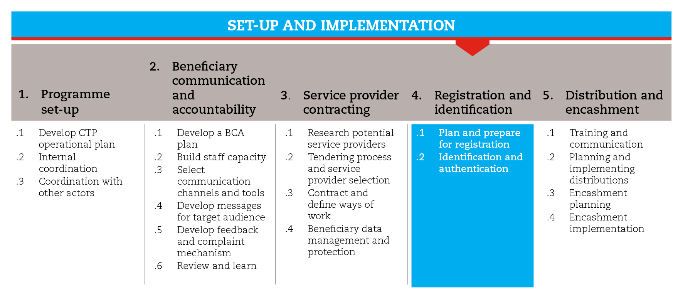

INTRODUCTION
This road map will guide you through the process of collecting and recording relevant information about beneficiaries, and establishing appropriate mechanisms to identify them. Proper registration and identification help ensure accountability and transparency in the use of resources, and facilitates monitoring.
Also, the road map provides suggestions on which CiE tools are most useful for this step and sub-steps. The tools will need to be adapted to your need and context.
You should always aim to comply with the minimum standards listed under this step, as this will contribute to the quality of your CTP response.
It is likely that you will need to move back and forth between the different sub-steps to guide your decision-making as information and processes are completed and feed into each sub-step.
If you need more detailed guidance on registration and identification, consult the reference documents suggested at the end of this road map.

MINIMUM STANDARDS
- Register only those who are eligible to receive the transfer
- Ensure that identification required to register beneficiaries abide by the national financial regulations.

SUB-STEPS AND TOOLS

Plan and prepare for registration
Firstly, you should understand whether registration is appropriate and feasible. For example, if the entire community has been affected by an acute emergency and a blanket distribution is planned, or if the affected population is on the move, you might prefer to use distribution tickets for a one-off distribution. Distribution tickets do not allow for the collection of demographic information, unless beneficiaries are registered at the time of distribution.
Before registering beneficiaries, key preparatory measures will ensure a smooth registration process:

Decide roles, responsibilities and ways of work
Cooperation with local authorities should be ensured. In some cases it is advisable to carry out the registration together with the local administration or even in their premises, e.g. for security reasons.
It is important to define who will collect and record the information and how. When making this decision remember that in some cases beneficiary information may be shared with other agencies and service providers.

Define the type and level of information to be collected
The type of information to obtain for beneficiary identification can vary, depending on the context, but generally includes: given name and surname of the head of household (or beneficiary household member appointed to collect the cash transfer), number of family members, and address or location of permanent and/or temporary residence. In situations where multiple distributions and/or longer-term programmes are planned it may be advisable to collect supplemental information for family members such as: name, gender, age, national ID and date of identification.
It is useful to ienquire about the financial regulations applicable in the country of operation, to anticipate the information (and documentation) beneficiaries may be required to provide. In the absence of this information, refer to the service provider requirements.

Create a database
Electronic databases allow for continuous beneficiary tracking and instant recognition of beneficiary attempts to register more than once. They not only reduce input and duplication errors, but they also facilitate update, back-up, reporting, monitoring and auditing controls.
Electronic databases can be fed either directly during registration, or afterwards. This will depend on whether you will collect data:
- With an online device. In this case, you will be able to update the electronic database directly. Make sure you will have access to an internet connection.
- With an offline device. In this case, you will be able to use the electronic format and upload the information to the electronic database later. Make sure you will have access to a power source or long-lasting batteries.
- By hand. In this case, data can be collected in printed versions of spreadsheets and inserted in the electronic database when access is available.

Develop registration forms
It is important to develop a form that ensures database compatibility. The form can be printed directly from the database. It must permit easy completion by registration teams. It should be tested, and once approved, should not be changed. The tools beneficiary list gives an idea of what such a form can look like.

Organize the registration
The number of beneficiaries that it is possible to register within a given time frame, determines the duration of that process, the space requirements and number of personnel needed. The time required for the different registration areas has to be scheduled and convenient days for registration have to be checked (official/religious holidays or market days have to be avoided). A small test registration run will help to refine these estimates. Set a deadline for registration.
- Choose registration sites: Appropriate areas with manageable numbers of potential beneficiaries have to be defined. Crowd formation, confusion and public pressure can be prevented with organizational measures. Logistical measures based on a checklist must be arranged early on registration day (e.g. preparation of space where registration is to take place, transport of registration personnel, provision of material and registration forms required, and any security issues that need to be considered).
- Se -up and train registration teams: Additional staff may have to be employed on a part-time/temporary basis. Training is absolutely necessary, and should cover how to obtain the relevant information and how to enter the data in the forms, responsibilities and procedures in case of difficulties. A programme staff member should be assigned for support, liaison and supervision of the registration team. Completed registration forms should be collected regularly and monitored/verified for quantity, quality and any possible observations.
- Prepare communities: This process is aimed at reducing tensions that the registration process can produce, particularly between beneficiaries and non-beneficiaries. A few days before the registration starts, a community meeting can allow for information sharing about the project and the methodology used for the identification of the beneficiaries. Explain that only those who are eligible to receive the transfer will be registered. During the meeting, the names of people to be registered can be read and/or displayed in an appropriate place. This allows people who are supposed to register to prepare themselves and reduces the pressure on the registration team to include people who are not on the list. The date and place for the registration, as well as a list of documents required must be made known to beneficiaries well in advance.

Identify and authenticate beneficiaries
The registration should allow you to create a link between each beneficiary and a unique identifier, which can be a form of ID or a password. This identifier will ensure later that the person presenting him/herself to receive the cash transfer is indeed a registered beneficiary. This process is known as authentication. The tool identification and authentication provides a brief guidance on the different ways beneficiaries can be identified from community lists and official ID cards, to technological options including plastic cards with PINs, barcodes or biometrics, and mobile phone SIM cards. The tool beneficiary card provides an example of a possible identifier.
REFERENCE DOCUMENTS
E-transfers in emergencies: implementation support guidelines (2013) CaLP http://www.cashlearning.org/resources/library/390-e-transfers-in-emergencies-implementation-support-guideline
Delivery Money: Cash Transfer Mechanisms in Emergencies (2010) CaLP http://www.cashlearning.org/resources/library/6-delivering-money-cash-transfer-mechanisms-in-emergencies
A quick delivery guide: Cheques (2011) CaLP
http://www.cashlearning.org/resources/library/22-cheques---a-quick-delivery-guide-screen-version
A quick delivery guide: Cards (2011) CaLP
http://www.cashlearning.org/resources/library/235-delivering-cash-through-cards---a-quick-delivery-guide-booklet
A quick delivery guide: Direct Cash (2011) CaLP
http://www.cashlearning.org/resources/library/24-direct-cash---a-quick-delivery-guide-screen-version
A quick delivery guide: Vouchers (2011) CaLP
http://www.cashlearning.org/resources/library/25-vouchers---a-quick-delivery-guide-booklet-version
A quick delivery guide: Voucher fairs (2011) CaLP
http://www.cashlearning.org/resources/library/217-voucher-fairs-a-quick-delivery-guide-booklet-version

