Roadmap for CTP distribution and encashment

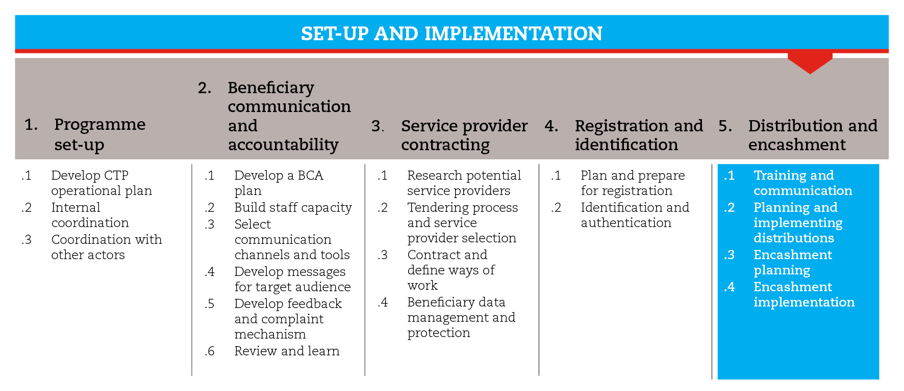

INTRODUCTION
This road map will guide you through the process of distributing items related to the chosen payment mechanism as well as cash itself to beneficiaries. Cash distribution, regardless of whether it is carried out directly by the agency or through financial service providers, will be referred to as encashment. Sometimes, particularly when financial systems are weak or absent in the emergency context, direct encashment is the only available option.
Also, the road map provides suggestions on which CiE tools are most useful for this step and sub-steps. The tools will need to be adapted to your need and context.
You should always aim to comply with the minimum standards listed under this step, as this will contribute to the quality of your CTP response.
It is likely that you will need to move back and forth between the different sub-steps to guide your decision-making as information and processes are completed and feed into each sub-step.
If you need more detailed guidance on distribution and encashment, consult the reference documents suggested at the end of this road map.

MINIMUM STANDARDS
- Both agency and service provider staff should be sensitized, informed and/or trained on cash transfer programming, according to their level of involvement in distributions and encashment.
- Ensure that the encashment plan is consistent with the service provider location and capacity.
- Verify that direct cash distribution sites are safe and guarantee beneficiary dignity.

SUB-STEPS AND TOOLS

Training and communication
Before starting distributions and encashment, field staff should be given a general overview of cash transfer programming. Emphasis should be given to the activities in which they will be involved directly, but they should be able to answer the questions beneficiaries ask most frequently or, at least, they should refer beneficiaries appropriately. Among the sub-step tools you will find a CTP presentation and an end-of-session questionnaire.
When you are working with financial service providers, their staff will need to be sensitized and informed about CTP also. Consider that staff with different responsibilities will have different information needs. As a minimum, all staff should be informed of Red Cross Red Crescent principles and mandate, the programme objectives and scope, roles and responsibilities, beneficiary communication and accountability systems (including the complaint and response mechanism). The sub-step tools include a service provider training.
If the network of agents is larger than your capacity to train them, it may be useful to send them a letter about the programme and the exceptions that may apply for some beneficiaries. This can improve agents’ readiness, increase programme transparency and facilitate monitoring. For this purpose, you will find a sample letter to merchants among the sub-step tools.

Planning and implementing distributions
Depending on the delivery mechanism, you will have to distribute items like vouchers, cards, mobile phones and/or SIM cards, etc. Distribution sites should be chosen and organized carefully, and distribution events should be planned well in advance, in collaboration with the community and the financial service provider. Among the sub-step tools, you will find a distribution site assessment form, a distribution site organization plan, a distribution list and a distribution plan overview.

Encashment planning and agent mobilization
Financial service providers normally rely on independent agents to cover the last mile in the distribution chain. Agents can be shop owners, airtime dealers, or any other business that is used to receiving and making payments and is willing to provide encashment services alongside its primary activity.
You should ask the service provider to supply a list of its agents, with information on their location and daily encashment capacity. This will facilitate grouping beneficiaries in relation to the different encashment points. Service providers should explain the calculation methodology used.
Among the sub-step tools you will find an encashment capacity tool that can facilitate the service providers’ job to compile all necessary information. Also, you will find an encashment time estimation tool that will allow you to understand how many days each agent needs to encash the beneficiaries allocated to it. This will allow you to fill out each agent’s mobilization plan template, with training and encashment dates, and the encashment plan template, with detailed information about the numbers of households, the total amount to be encashed and the time line for each village. This detailed encashment plan is suitable for large-scale distributions, involving multiple locations and several communities. You can use it to coordinate with Logistics, Finance, HR, Security and, if possible, local authorities.

Encashment implementation
The encashment process may vary depending on the delivery mechanism. Ideally you should find detailed internal procedures for encashment implementation through different delivery mechanisms and types of service provider in your agency’s SOPs.
In general terms, any encashment implementation is kicked off with a cash transfer order, which communicates and authorizes the financial service provider to distribute funds on behalf of the Red Cross Red Crescent. The expected encashment point or agent may need to be included also if the document is expected to inform the service provider about the planning process. The financial service provider may supply its cash transfer order template. Otherwise, you can adapt the one made available in the sub-step tools.
You should expect to receive reports from the financial service provider on a regular basis, sometimes daily, showing the status of the individual cash grants. Reports should be in a contractually agreed-upon format. Among the sub-step tools you will find an example of activity report.
When appropriate, especially when the agency is encashing beneficiaries directly, you can produce and circulate internal distribution reports also. The sub-step tools include an encashment report template. You can use it to obtain a quick overview of the cash distributed and the number of beneficiaries served.

Encashment close out
Reconciliation of funds should be carried out regularly throughout the encashment period. At the end of the project, Finance should complete a final reconciliation of funds. All accounts set up for the cash transfer programme encashment should be balanced and reconciled. Any remaining funds should be returned by the financial service provider, and the account(s) closed. All documents, paper and electronic, used for processing and implementing the cash transfers should be kept according to the organization’s record retention policies.
REFERENCE DOCUMENTS
E-transfers in emergencies: implementation support guidelines (2013) CaLP
http://www.cashlearning.org/resources/library/390-e-transfers-in-emergencies-implementation-support-guideline
Delivery Money: Cash Transfer Mechanisms in Emergencies (2010) CaLP
http://www.cashlearning.org/resources/library/6-delivering-money-cash-transfer-mechanisms-in-emergencies
CaLP e-payments in CTP. A quick information sheet.
http://www.cashlearning.org/resources/library/287-e-payments-in-cash-transfer-programming-quick-tool
A quick delivery guide: Cheques (2011) CaLP
http://www.cashlearning.org/resources/library/22-cheques---a-quick-delivery-guide-screen-version
A quick delivery guide: Cards (2011) CaLP
http://www.cashlearning.org/resources/library/235-delivering-cash-through-cards---a-quick-delivery-guide-booklet
A quick delivery guide: Direct Cash (2011) CaLP
http://www.cashlearning.org/resources/library/24-direct-cash---a-quick-delivery-guide-screen-version
A quick delivery guide: Vouchers (2011) CaLP
http://www.cashlearning.org/resources/library/25-vouchers---a-quick-delivery-guide-booklet-version
A quick delivery guide: Voucher fairs (2011) CaLP
http://www.cashlearning.org/resources/library/217-voucher-fairs-a-quick-delivery-guide-booklet-version

