Beneficiary card mail merge instructions

Mail merge function allows to transfer a list of beneficiary’s data to a pre-formatted beneficiary card.
2 files are needed to produce a 3rd file with all individual beneficiary cards:
a/ Main document: Beneficiary card template, in a 1-page Word format
b/ Mailing list: Beneficiary data, in an Excel format

Below are the steps to follow in a chronological order, using the existing Beneficiary card template.

- Open the file “M4_4_2_2a Beneficiary card template-front.docx”
and click on “OK” in the pop-up dialog box:

  - if you receive the message:
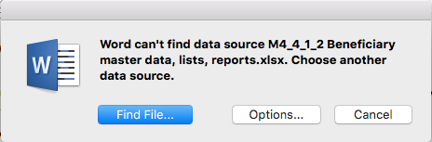
select “Find File…”
open the file “M4_4_1_2 Beneficiary master data, lists, reports.xlsx”
and click on “OK” when the above pop-up dialog box is showing

- In the "Open Workbook" dialog box,
select "ODK-Beneficiary-List.csv"
leave "Cell range" blank
and click on “OK”

The word document of the beneficiary card template is now opened
and linked with the data from the beneficiary list

- Select the "Mailings" menu tab to process some checks before launching the print:
  - “Preview Results” to sample check if data is correctly showing
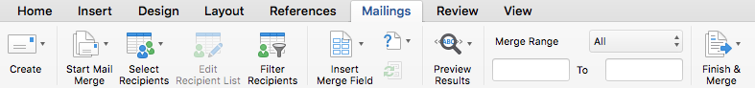

  - “Filter Recipients” to short list only the records needed to be printed out

For example, it is recommended to only print out the list of beneficiaries for the coming planned distribution. See filter settings below:

  - Launch the creation of all labels by pressing “Finish & Merge”
and select “Edit Individual Documents…”
It will take some time and create a new word document with all the beneficiary cards:

Save the merged document in pdf version for archive
and print all front pages, setting the “Presets” Layout as 4 pages per sheet

! TIP !
Make the cards difficult to reproduce:
- use special paper
- stamp them at the back
- make sure that a unique ID is correctly mentioned
- …

  - Print on the back side the generic ‘Beneficiary card template-back’, it will make the card usable for several distributions

