REDROSE SPECIFICATIONS TEMPLATE:

Purpose: This template is to help document the key information that will be used by RedRose technicians to configure or customize the platform to meet the needs of the programme.

Instructions: Please complete the sections below as much as possible. If you need assistance in completing this template, please contact your region’s cash focal point to refer you to someone familiar with RedRose you might be able to consult with. After completing the document, please contact RedRose (help@redrosecps.com) and provide the specifications document to receive feedback on the request.

Table of Contents:

- Background and Context
- Functional Scope
- General Configuration
- Beneficiary Registration
- Distribution
- Approval process
- Attendance Tracking or Services / Cash for Work
- Feedback & Complaints
- Surveys
- Excel Reports
- Dashboards
- Hardware
- Connectivity & Network
- Training
- Support Model

Background and Context

Provide a brief description of the programme or context where the data management solution will be utilized. Include what the disaster or crisis is about, number of people affected or targeted by the operation, general needs assessed. Describe if this is for Emergency, Recovery, or Preparedness as the methods and data required might be different.

Humanitarian Context

Provide a high-level overview of the situation.

E.g.

Mayon Volcano is in Albay province in the Bicol region, around 300 km southeast of the Philippine capital, Manila. On 13 January 2018, Mayon heightened activities, generating steam and ash. As the day progressed, more phreatic eruptions occur, the Philippine Institute of Volcanology and Seismology (PHILVOLCS) raised Mayon from alert level I (abnormal) until alert level IV (hazardous eruption imminent). On 16 January, the provincial board declared Albay under state of calamity, allowing local governments to use their calamity funds for relief operation. An 8-kilometre extended danger zone was implemented when the alert was raised to level IV. Families within the radius were ordered to evacuate and seize activities.

Prolonged evacuation usually leads to food supply shortage, disruption of income generating activities, suspension of classes and difficulties of access to essential items such as sleeping kits and hygiene materials especially for women and children. With further increase in the number of people evacuating from the extended danger zone and with most of them staying in evacuation centres, needs for food, water, hygiene and sanitation products and welfare services are expected to escalate.

DREF allocation was requested aimed at assisting 3,000 families (15,000 people) affected by Mayon Volcano and displaced to evacuation centres to meet their basic needs.

Programme Overview

Describe the programme where the data management solution is planned to be used.

E.g.

National Society | Philippine Red Cross (PRC)
Objectives | Meet basic needs of the most vulnerable affected by the eruption of Mayon Volcano via provision of unrestricted cash assistance.
Duration | Five months (total operation)  Emergency cash distribution over two days in March timeframe
Location | Albay Province  Barangays: Lidong, San Isidro, Fidel Surtida, San Fernando, Sta. Misericordia  Evacuation centers: Bical National High School, Salvacion Elementary School, San Andres
Main Sectors | Immediate basic needs
Number of Households | 3,000 estimated number of households in the evacuation centers.
Household selection criteria | The overall target number of evacuation centres and population is based on discussions with the government authorities. The Government is taking the lead in coordinating response to the evacuees with PRC.
Payment mechanism | Remittance through PHILPOST.  PRC has an existing contract with the financial service provider.
Amount of cash to distribute | 180,000 CHF = 3,000 HH * 60 CHF per HH
In-kind commodities and volume to distribute
Funding  (domestic, bilateral, multilateral through IFRC) | Multilateral through IFRC DREF

Cash SOP or Process

Indicate if there is an existing process for beneficiary registration and encashment. If there is a Cash SOP, please include it as an attachment. If data management will be used for in-kind or services, please indicate if there are specific processes for those, as well.

E.g. High-level process for the Mayon volcano relief operation

Philippine Red Cross has a Cash SOP.
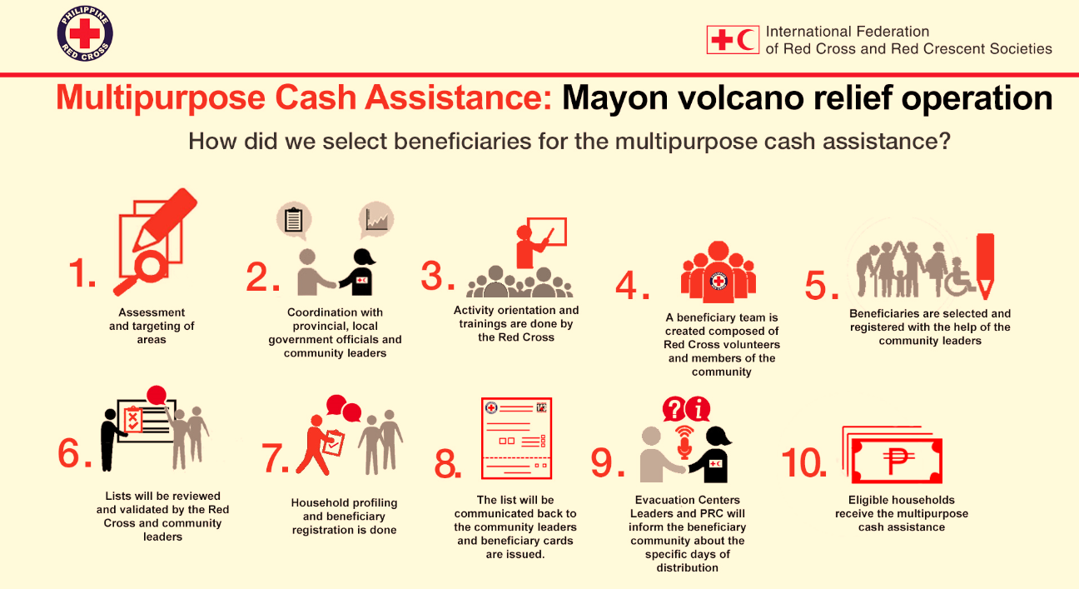

Functional Scope
The following is a list of features available in RedRose, please indicate the ones being considered for this programme and level of priority.

Feature | Priority  (High, Medium, Low)
Beneficiary Registration - includes the creation of forms in ODK (if not already in ODK format), setting up of the beneficiary profile in the web portal, enabling upload of beneficiary data via excel spreadsheet, generation of beneficiary ID cards, and linking beneficiary profile with other surveys as well as feedback mechanism. | High
Beneficiary duplicate checks - ability to automate flagging of possible duplicates based on duplicate check criteria. | High
Beneficiary management - allows searching of beneficiaries based on search strings or criteria, creation of beneficiary groups, download of beneficiary list, bulk updates of beneficiaries. | High
Beneficiary communication (SMS) - ability to send SMS messages to a beneficiary group--if beneficiary provided a phone number and able to receive SMS. Feature will need some configuration and may incur costs for sending SMS messages. | Low
Distribution Planning including approvals - setting up the funding structure, activities that will utilize certain funds, setting of spending limits, enabling of approval workflow to allow segregation of duties between requester and finance approver (or someone authorized to approve activities and funding utilization), generation of beneficiary lists to be used for distribution, built in audit logs. | High
Distribution - allow different ways to facilitate and track distribution e.g. e-vouchers using smartcards, barcode scanning for commodity or cash distribution, semi or fully automated integration with a financial service provider (FSP), reconciliation. | High
Attendance or services tracking - if eligibility is based on attendance (e.g. Livelihoods training or Hygiene promotion). | Low
Feedback Mechanism - record complaints, questions, or general feedback from beneficiaries or community members and allow for the programme team to track these items and link them with beneficiary profiles. | Medium
Cash for Work - ability to setup programmes to track attendance of beneficiaries, the progress of their work, and approval process by site inspectors. Attendance used to calculate cash to distribute. | Not Needed
Dashboard - configuration of the different dashboards for general tracking of activities (e.g. Beneficiary dashboard based on key metrics from registration, Distribution dashboard that can show real time status of distribution, PDM dashboard). | High
Excel Reports - generation of reports based on data in the system. E.g. list of beneficiaries and status of distribution. | High
Audit reports - availability of logs (download of files, login, changes in the data) | High

General Configuration
Please answer the following questions to help identify what needs to be configured in the system.

E.g.

Config Element | Value | Description/Comments
Currency | PHP (Philippine Peso)
Country | Philippines
Default Language | English

User Roles:

Please modify the list below or add new roles with specific access levels.

Role | Access | Description/Comments
Super Admin | ALL system functions including audit logs
Finance | Finance Approval
Programme Manager | Dashboard, beneficiary data, reports, create distribution activities, request for funds utilization
Volunteer | Beneficiary data (read-only)
Vendor (FSP) | Download of payment order and upload of payment distribution updates. Can also be for the login to the RedRose mobile app for distribution purposes.

Beneficiary Registration
Please answer the following questions to help identify what needs to be configured in the system.

What data collection tool would you like to use for this programme? | - ODK / Kobo - Will use own server managed by our NS or IFRC and data be extracted in Excel and uploaded to RedRose  - Would like to use ODK directly integrated with RedRose  - Pen & Paper (manual), will need to transcribe to Excel & upload to RedRose  - Basic Excel (manual), will need to upload to RedRose  - Other tools: Please specify: ________________
Do you already have a Beneficiary Registration form? | - Yes - already in ODK format, please include as an attachment  - Yes - but in Word or Excel version and not in ODK format  - No, we need help designing and creating the form, please see Cash in Emergencies toolkit for templates
Describe the current Steps for registering beneficiaries | Steps:  E.g.  - PRC staff and volunteers go to the community and give information about the programme.  - List of target beneficiaries prepared based on discussions with the community and agreed criteria.  - PRC staff and volunteers go back to the community to register the target beneficiaries who will need to bring a proof of identity. For registration, PRC currently uses own instance of ODK/Kobo, but would like to use the  - Excel is produced with the list of registered beneficiaries and provided to the programme.
Do you need to capture biometrics? (Yes or No -- if yes, which biometrics) | E.g. No  Note: please check your data protection policy or local laws
Do you need to be able to do offline data collection? I.e. when no access to internet | E.g. Yes, when in the field.  Note: Will need internet access when uploading the forms to RedRose, but data collection could be done offline.
Do you have a standard list of geolocations? | E.g. Yes, from HDX website: https://data.humdata.org/dataset/philippines-administrative-levels-0-to-3  Note: Strongly recommend to have standard geolocations (e.g. Province, Municipality, City, Village) to enable accurate reporting and possible check for duplicates. HDX website is a good resource.
Do you need to capture GPS of beneficiaries? | E.g. Yes, to make sure they are in the target area.  Note: please check your data protection policy or local laws

Distribution

Please indicate what you intend to distribute and track using the RedRose system.

Cash

Payment mechanism(s) to use: | - Cash in Envelopes / direct cash (no FSP)  - Remittance  - Mobile Money  - ATM / prepaid cards  - Bank transfer  - Post office / Post bank  - Other: ___________
Planned total cash to distribute (Volume): | E.g. 180,000 CHF = 3,000 HH * 60 CHF per HH
FSP Vendor | E.g. PHILPOST
Existing contract with FSP vendor? | E.g. Yes
Does the vendor require a beneficiary list? | E.g. Yes  Note: please attach sample beneficiary list required by FSP. Usually this includes KYC requirements.
Does FSP support thrid party integration via API? | E.g. PHILPOST currently does not
Would you like to be able to do the reconciliation in the system? | E.g. Would like to see the updated status of payment per beneficiary
Any other requirements? | E.g.  During distribution, there needs to be a Payroll sheet generated with the list of beneficiaries. One copy goes to the vendor and another copy for PRC. Payroll sheet needs to be signed by the recipient of cash or thumbprint if unable to sign. Completed sheets will be used for manual reconciliation.  For the distribution process, the FSP will independently track who has received cash and update their excel spreadsheet or payroll list that they download from RedRose. As a secondary measure, the PRC volunteer will have a mobile phone with the RedRose app to scan the barcodes that will be given to the beneficiaries to indicate that they received cash. At the end of the day, the FSP will upload their spreadsheet in the RedRose platform and the system will do an automated reconciliation to check if the barcodes scanned by volunteers matched the records submitted by the FSP. If there’s a discrepancy, an investigation will need to be conducted and resolved immediately. See process flow for Mayon operation below:  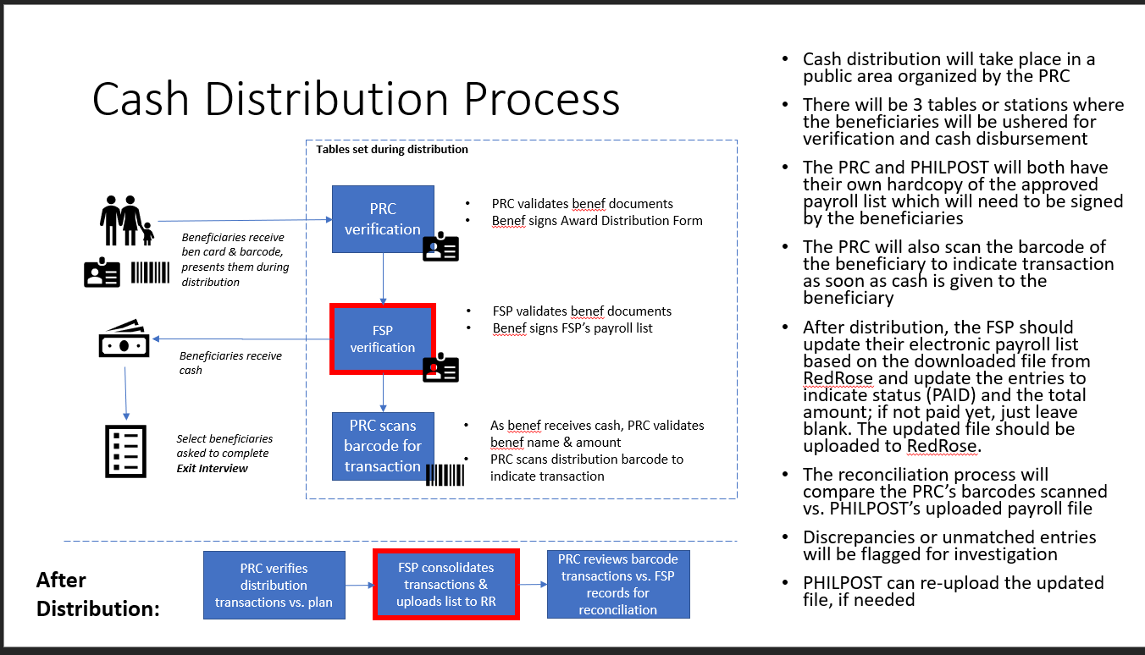

Note on FSP Integration:

There are two possible integration with financial service providers: (1) semi or process integration and (2) full integration via API. The main determining factor for going with one or the other is the feasibility of the FSP to allow an integration with a 3rd party such as RedRose via API’s. If an FSP does not allow such integration or do not have API’s readily available, then the semi integration might be the only option.

- Semi or process integration
This type of integration uses a mix of manual and automated processes. The automation is mostly done in the creation of the payment order that will be provided to the FSP. The structure or data elements in the payment order template will need to be agreed with the FSP and the NS. The data elements are typically what is necessarily to fulfil KYC requirements and authentication of the recipients. The FSP receives the payment order via email or by logging into RedRose with their own credentials and downloading the payment order directly from the system. This is the recommended and more secured way than sending files via email. The other automated part of this integration is in the reconciliation, where the FSP or the programme manager may be able to upload the file with the updated payment status per beneficiary.

- Full integration via API
This type of integration allows the programme manager to send a request with a click of a button to the FSP. The request is sent electronically after finance approval. The FSP then executes the request and sends back the status of payment per beneficiary electronically so the RedRose system is able to update the data as soon as the update from the FSP is received. This type of integration could take several days or longer depending on the readiness of the FSP to integrate with third parties such as RedRose.

In-kind

Will you be distributing a kit or individual items per HH?
What commodities will be given? If kit, please indicate items per kit.
Will you be tracking the kits or the individual items?
What are the estimated volume of kits or individual commodities that will be distributed?
Will the commodities be distributed by vendors?
Will beneficiaries be given a token (e.g. coupon) to redeem at point of distribution?
How do you record who received what during a distribution? (e.g. sign acknowledgement sheet)

Approval process

Who should approve cash disbursements from the system? | E.g. Finance director delegates approval authority to the finance officer.  Note: Approver could be someone from Finance or someone authorized to approve the distribution of cash. Approver should be different from the Requestor (typically programme officer), in order to observe segregation of duties. Approver should also have approver rights only, meaning not able to access beneficiary list directly or not able to request for funds or disbursements.
Other requirements? | E.g. Will need to upload the deposit slip into the system to signify that money is in the bank. This is a customization.

Sample workflow for the approval process in RedRose used for the Mayon operation:
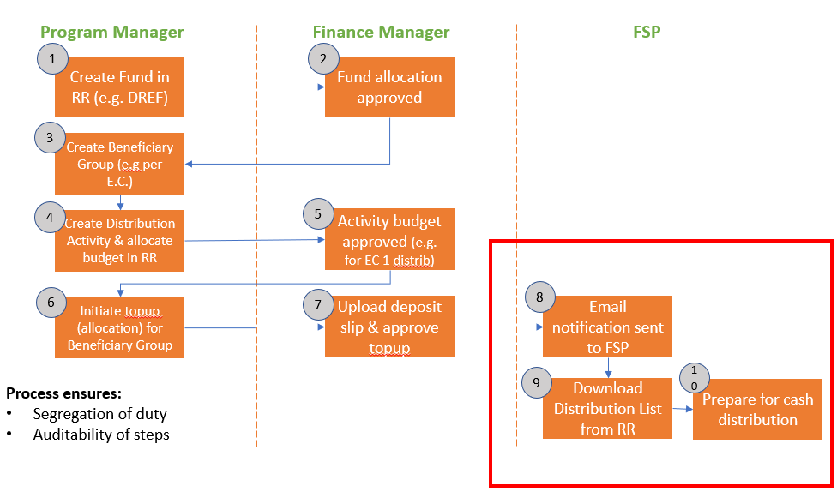

Attendance Tracking or Services / Cash for Work

How many beneficiaries need to be tracked?
Will you use smartcards or QR codes for attendance tracking?
What’s the logic for calculating how much a beneficiary gets based on attendance?
Indicate how much cash to distribute?

Feedback & Complaints

Will you gather feedback from only registered beneficiaries or from non-registered community members also? | E.g. From anyone that may want to provide feedback, question, or complaint.
Will you gather feedback anonymously? | E.g. For those not registered, they may be anonymous (or can indicate contact details in the comment). Otherwise, would like to link the feedback to the beneficiary profile if one exists.
What are the main categories of feedback/complaints you would like to see? | E.g. Complaint, Question, Feedback related to programme, staff/volunteers, vendors (FSP)
Do you want to collect the feedback using Mobile phones? | E.g. Yes, in offline cases also

dicate how much cash to distribute

Surveys

Besides the beneficiary registration, what other surveys or questionnaires will you require for your programme? Indicate if you already have a draft form and if it’s in OKD format. | E.g.  Exit survey - ODK version is available  Post Distribution Monitoring - ODK version is available
Do you require a dashboard to visualize the survey results? If so, do you have key metrics defined already to visualize? | E.g. Yes, but only for the PDM. Sample PDM visualization can be provided.
Are the survey results linked to beneficiaries? | E.g. Yes

Excel Reports
Please indicate which excel reports would be required to be automatically generated:

E.g.

List of beneficiaries and details
List of beneficiaries and status of distribution (i.e. who received what)
List of beneficiaries that have not claimed cash yet

Dashboards
Please indicate which dashboards may be needed for the programme:

Beneficiary dashboard
E.g.

Metrics:
- # beneficiaries registered
- # male, # female
- Geo-locations
- Livelihood needs
- Degree of Shelter damage

Distribution dashboard
E.g.

Metrics:
- # Total beneficiaries received cash
- Total amount of cash disbursed
- Geo-locations
- Rate of distribution over time

Post Distribution Monitoring dashboard
E.g.

Metrics:
- # beneficiaries surveyed
- Geo-locations
- Categories on how cash was spent on
- Was the selection process fair and transparent?
- Were you satisfied with receiving cash or would prefer in-kind?
- Were there tension in your family or community as a result of the cash assistance?

Hardware
Please indicate what hardware exists and what might be needed for the RedRose implementation.

E.g.

PRC can get 10-15 phones from the IFRC and partner National Societies. Phones are basic Samsung smartphones with Android 1.0. No additional hardware is needed at the moment.

Notes: For e-voucher, you may need to include smartcards, portable receipt printers, Android phones with version 3.0+ of Android OS. Hardware can be procured locally or not directly with RedRose except for smartcards and secured paper vouchers due to the security features. If procuring locally, please consult with RedRose technicians to verify the make and model and ensure to test the devices before ordering in bulk, as there could be geographically different configuration.

Connectivity & Network
Please indicate what is required for network and connectivity.

E.g.

Programme teams generally have access to the internet but there might be certain areas in the field where connectivity is weak or not available. Would need to be able to conduct beneficiary registration, surveys including feedback/complaints, as well as do the distribution tracking offline. As soon as there’s better connectivity, all data should be uploaded.

Training
Please indicate what is required for training.

E.g.

Audience | Topics
Programme team | How to use online web portal to setup funds, distribution activities, import beneficiary list, update beneficiary info, create beneficiary groups, via dashboards and reports
Finance approver | How to approve funds allocation and requests for disbursement  How to generate finance reports
Vendor (FSP) | How to login to the RedRose system, download the payroll sheet, and upload the updated payroll spreadsheet for reconciliation.
Volunteers | How to record feedback/complaints  How to register beneficiaries and conduct surveys  How to do distribution via barcode scanning
System Admin | How to manage users and roles  How to access audit logs  How to download raw data files
Management team | How to access the dashboards

Support Model
Please indicate what is required for technical support.

Remote (via Skype group) | E.g. Remote support from RedRose technicians will be sufficient after the setup and training. The focal point will be the PRC cash officer and Geneva resource.
On-site | E.g. Will need a RedRose technician for 2 weeks to do the setup, training, and technical support during the cash distribution. Training needs to be provided to the HQ team so they can train the branches. No additional training required for ODK as volunteers have used them in the past; need to tell them to use RRCollect instead of ODKCollect.

