Guidance on Analysing cash process

This document helps in the preparation for the Analysis of the Cash SOP’s of National Society and mapping of data management activities. The objective of the analysis is to recognize where the pain points related to data manifest within a National Society’s process for cash programming, and which ones could be addressed by a data management system such as RedRose. This will be used to then identify the requirements and needs for a data management platform.

STEPS:

- Start by identifying the steps in your cash process.
- Does your National Society have an existing standard operating procedure (SOP) for cash? If not, can you roughly draw a flowchart for your cash programme? Otherwise, a process flow for in-kind relief distribution might be useful for this exercise.
- If you do not have a documented process yet and would like to use a generic process flow for cash, please see Appendix 1 or 2 for a simple example. You can use this for this exercise and reflect back later when you have more information about your National Society’s process.

- In the cash process, highlight which activities, steps, or areas have data related issues.
- Review the steps in the process and where there are data pain points identify:
  - Stakeholders involved in the step or activity (e.g. cash focal point, finance, volunteer, management, etc.)
  - What data do they need or what data they produce

- Identify the priority of which pain points to address first and which could be addressed using RedRose.
- Reflect on impact and probability of the data pain points from occuring again.
  - Who is experiencing these pain points?
  - Can they be addressed by changing the process or introducing technology?
- Refer to the RedRose introduction for the common features that the system provides and see if they are able to address the priority pain points identified.

- If possible, create a revised process flow highlighting where RedRose is used in the steps.
- See Appendix 3 for an example. See how in the process flow the steps where RedRose and which type of data will be managed in RedRose is reflected.
APPENDIX 1: SIMPLIFIED EMERGENCY CASH PROCESS FLOW

Samples for Recovery:

Verification & validation of ben data
Targeting (geo areas, criteria)
…
Market, FSP, & Needs Assessments
Simplified Cash Process Sample
Beneficiary Registration
Approval & transfer of cash to FSP
Data Needs?
Reconciliation with FSP
Setup & Implementation
Conduct PDM
Cash transfer value calculation
Week 2
Is cash feasible?
Conduct Beneficiary Comms (CEA)
Community mobilization (thru local leaders)
Assessment
Response Analysis
Steps
Week 4
Week 3
FSP selection (assume FSP contracts exist)
Timeline
Phases
Week 1
Monitoring & Evaluation
Stakeholders
Week 6
FSP distributes cash
Training of staff & volunteers

APPENDIX 2: SAMPLE PROCESS FLOW FOR A SECTOR

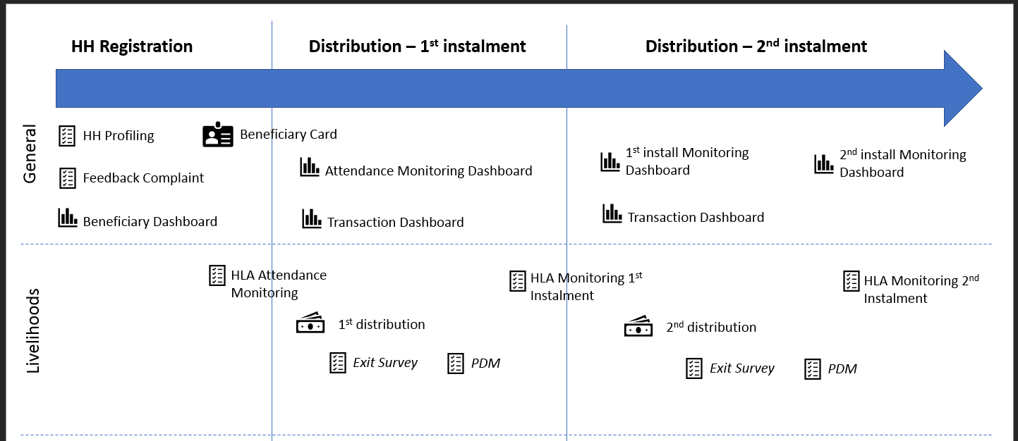

APPENDIX 3: SAMPLE PROCESS FLOW FOR RECOVERY WITH SHELTER AND LIVELIHOODS INTEGRATED

