Data Management: RedRose User Guide

Contents
1. Login 2
1.1. Login 2
1.2. Mobile App 2
1.3. User Guide & Support 2
2. Configuration 3
2.1. User Management 3
2.2. Locations 3
2.3. Donors & Funds 4
2.4. Vendors 6
1. Beneficiary Registration 8
1.1. Beneficiary Registration & Enrolment 8
1.1.1. Adding from the Web portal 8
1.1.2. Importing via CSV 9
1.1.3. Registering beneficiaries using Mobile App 10
4.1. Beneficiary Groups 10
4.2. Duplication Check 14
5. Distribution Planning & Scheduling 14
5.1. Distribution Plan Creation 14
5.2. Assigning Entitlements 17
6. Distribution Tracking 22
6.1. Distribution (in kind & cash) 22
6.2. Reconciliation 24
7. Feedback & Surveys 24
7.1. Feedback & Complaints 24
8. Reporting & Analytics 27
8.1. Report Generation 27
8.2. Dashboards 29

Introduction
This user guide provides step-by-step instructions to allow someone who has not used RedRose before, to build their skills and become competent in using the system. This guide can be used as a reference guide for those wishing to learn by themselves or used in a classroom setting to provide.

Login

Login
It is preferred to use Google Chrome browser, as some of the configuration are not optimized for other browsers.
*** For link to a demo environment and login credentials please contact your regional cash focal point, who can refer you to resources. For data security we cannot publish this publicly. ***
Instance | URL
DEMO | Please send a request

The demo environment should not contain any real beneficiary data or any sensitive data, only fake or mock-up data.
Username & Password:
For the DEMO environment the following users could be used with the associated permission.
Username | Password | Permission
admin | Please send a request | Admin
finance | Please send a request | Finance

Mobile App

You will need an Android smartphone to download the mobile apps. Minimum version Android 4 and ideally with 2 GB RAM or higher.
There are two main mobile applications:
- RR Collect – mobile app used to collect data (ODK based). E.g. register beneficiaries, conduct exit survey, PDM, market monitoring, etc.
- RR Application – multipurpose mobile application used for barcode scanning, card management, vendors PoS, and general distribution (e.g. barcode scanning). For this program, this will be used to scan barcodes assigned to beneficiaries during each instalment payouts.
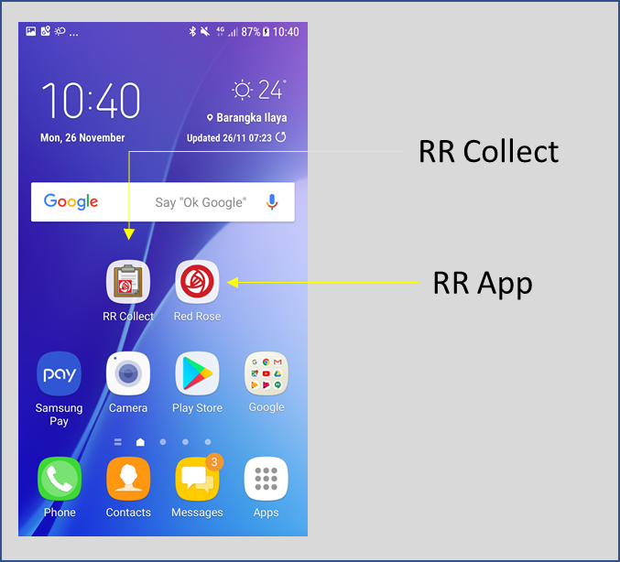
To download these applications, please see the links below:
Instance | RR Collect | RR App
Demo | Please send a request | Please send a request

To download the barcode scanner: http://bit.ly/rrbarscanner
In certain Android versions, you may need to download a File Manager application (e.g File Commander or ES File Explorer or use MyFiles) from Android Play Store and through phone Settings allow installation of apps from “unknown sources” before you can install the downloaded application files (*.apk). If you do not have a google account, you may use the following test credentials: User: Please send a request / Password: Please send a request.
Note: To test e-voucher scenarios, your smartphone will need to have an NFC reader and you will need RedRose smartcards. For biometrics, phones needs OTG capability and biometrics scanner with OTG cable. For this operation, there is no need for NFC reader or biometrics.

User Guide & Support

Link to the generic RedRose user guide: http://training.redrosecps.com/

Configuration

User Management
To view users, go to Users > List. Click on the user and go to “User Role Assignments” to view permissions.
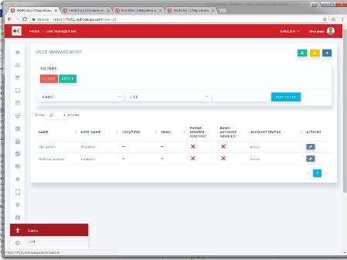

To create a new user, and assign them to an existing role (e.g. System Administrator), go to Users > List > click “+” & complete the profile. Go to Users > > User Role Assignment > click on Users on the left menu > click User Management on top right > select the user > click Add User.
To create a new role and assign a new user to the role, the following elements need to be created or configured in order: Role, User Role Assignment, then User.
You will first need to create a role (Users > Roles > click on the “+” for new role), then go to User Role Assignment (Users > User Role Assignment > click “+” to create a new role assignment), click on “Roles” and select the new role created > select the access rights from the list. Then go to user list (Users > List > click “+” to add a new user > complete user details). Go to User Role Assignment Users > User Role Assignment > click on Users on the left menu > click User Management on top right > select the user > click Add User.

Locations

Since ODK will be used for data collection, a standard list of geolocations for the Philippines from HDX has been configured in the ODK forms already. This standard list will be used for creating new beneficiaries, creating distribution list, etc.
It is also possible to add geolocations from the RedRose portal directly by going to Settings > Geo Hierarchies. Another possibility is to upload geolocation via an excel file. However, entries here are not currently integrated with ODK.
It is advised to include any new geolocations for this demo instance, if necessary, in the ODK xlsform, and not manually inputted from the platform to ensure consistency.

Donors & Funds
Funding details are tracked in the system. To create new funds, go to Finance > Funds > click “+”.
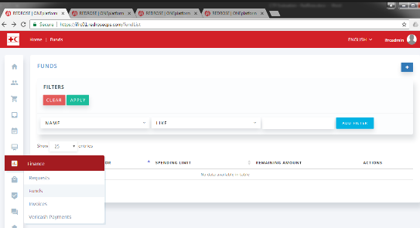

Enter a name and select the Donor from the list. Click on “Add Donor” button to create a new donor. Select a Category for response. Save the form.
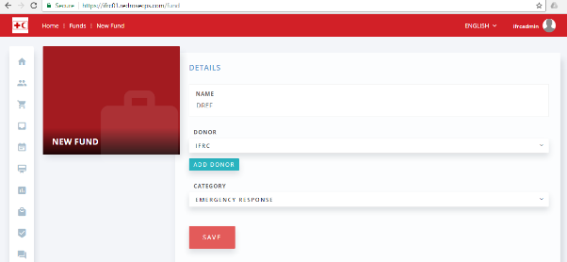
To set a spending limit, click on the Fund name from the list. Enter a spending limit. The currency uses the default set for the country instance (e.g. PHP for Philippines,). Click on Set button. An alert will show to confirm the spending limit. Click Request. This will generate a request for approval of funds. This approval should ideally be done by a Finance person with appropriate approval rights setup.
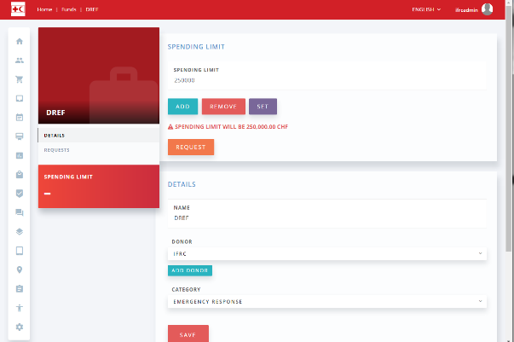

In another browser, login:
Username: finance Password: Please send a request
Go to Finance > Requests. Click on the check button to approve. Once approved, the entry will be highlighted in green. [Alternatively, just click on “Requests” from the funds profile page, to show list of financial requests.]

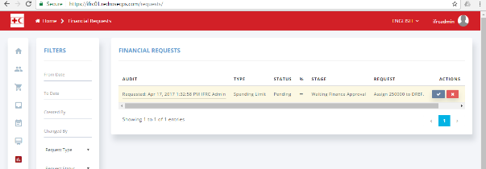
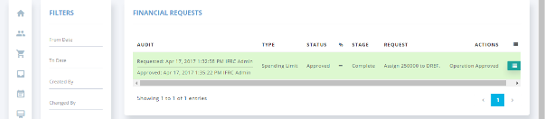

You can go back to Finance > Funds and verify that the spending limit has been updated.
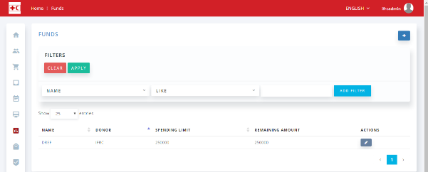

If you want to modify the Spending Limit, you can go the Fund profile, enter an amount. Click on “Add” to add the entered amount to the limit or click on the “Remove” button to deduct the amount from the current total. These operations will require an approval from an authorized finance person as shown in the steps above.

Vendors
Vendors in RedRose could either be a Financial Service Provider (FSP) or a retailer/merchant or other service providers.
For this operation, we will setup for PHILPOST.
To create a new vendor, go to Vendors > List > Click on “+”.
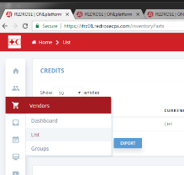
Create vendor for Cash distribution (e.g. PHILPOST). Enter details and Save. The username and password are entered to be used in the RR mobile app, if needed.
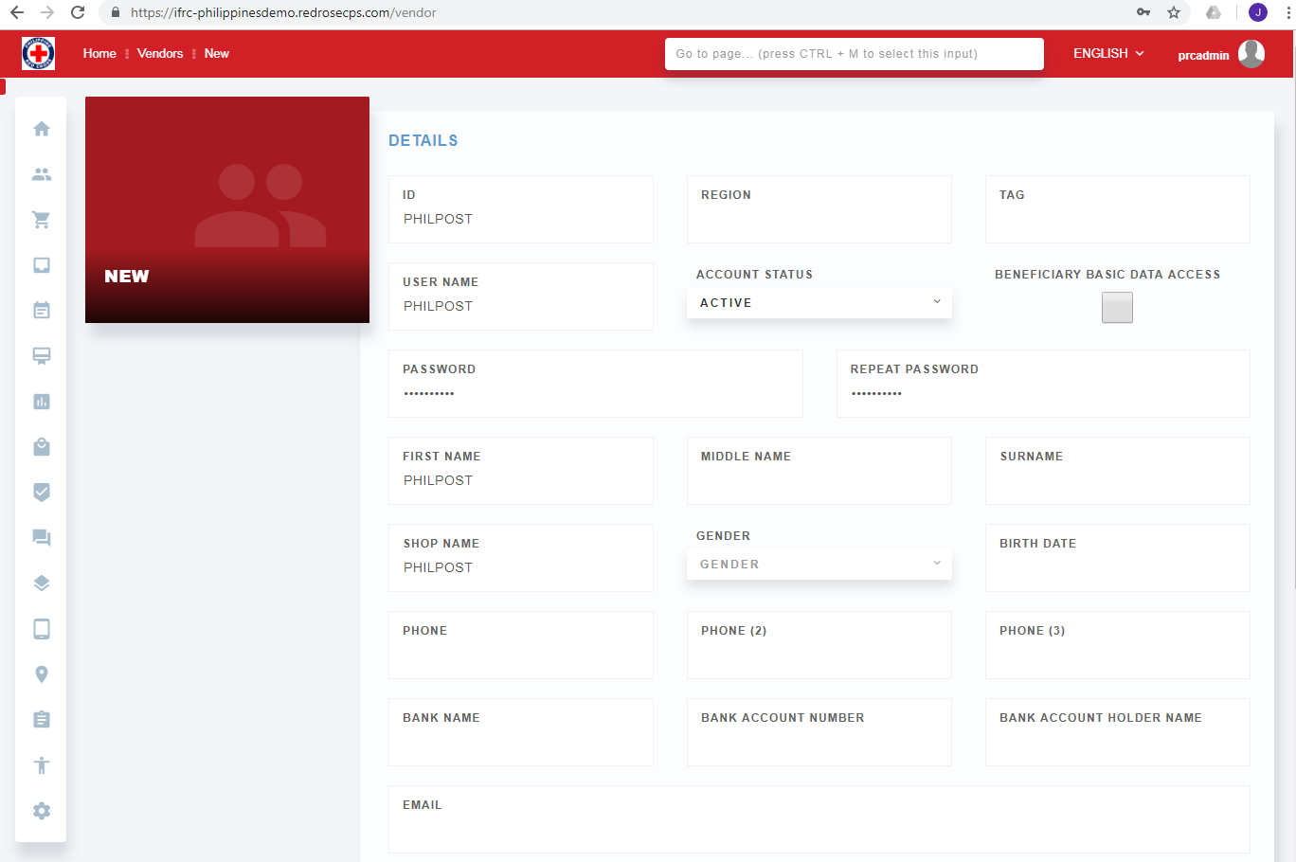

The Vendor List page shows the planned allocations to be distributed by each vendor and the amount disbursed.
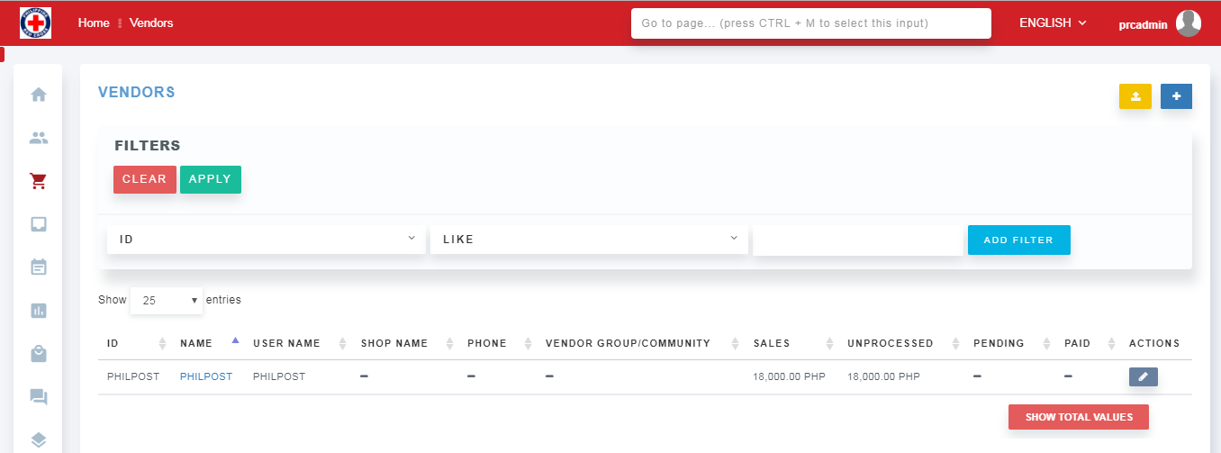

Beneficiary Registration

Beneficiary Registration & Enrolment

Beneficiaries could be added in various ways:
- Adding directly from the web portal
- Importing via Excel/CSV
- Registering using mobile app RRCollect (ODK based)

Adding from the Web portal
Go to Beneficiaries > List. Click on “+” to Add a new beneficiary.
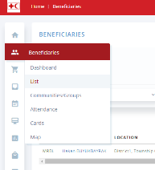
Enter the details. Click Save.
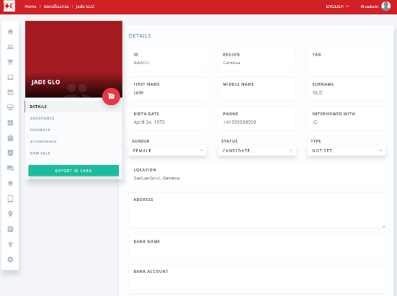
An ID card could then be printed by clicking on the “Export ID Card” button on the left. The ID field could be used as the unique Red Cross Red Crescent ID number.

Importing via CSV
You will need a template to enter the beneficiary information based on the fields configured in the system. You can use the attached excel file. However, note that this template does not have validation for fields (e.g. cascading geo locations or auto-sum of family members). So please be careful and validate the fields before importing, otherwise you may end up with data that do not make sense in the reports.
You can get the template of the CSV by going to the Beneficiary List and clicking on Export. When you open up the Excel spreadsheet, you will see the data fields with corresponding row with data that starts with “m.”. These tags are the RedRose mapping of the data for their own internal database. Some fields are not modifiable such as the m.id. You can add the data you need in this file and upload back into the platform.
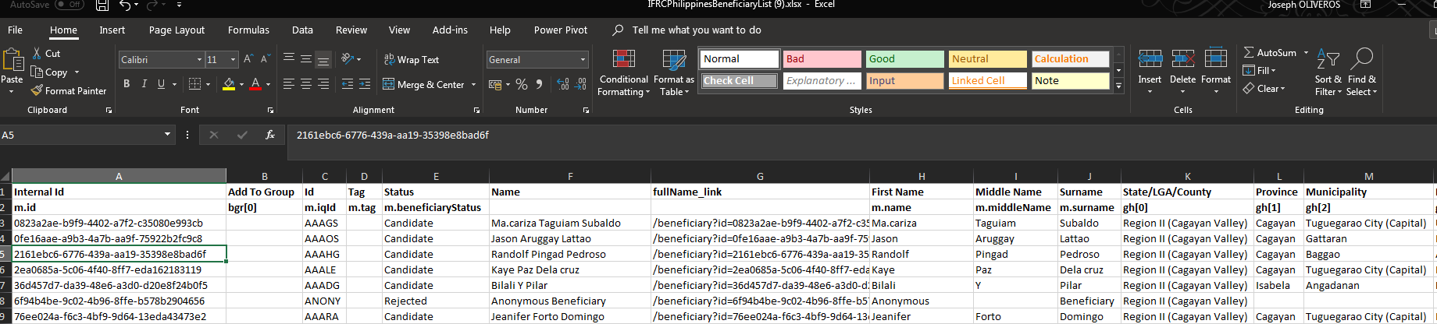
When ready to import, go to Beneficiaries > List > click on the yellow Import button on the top right.
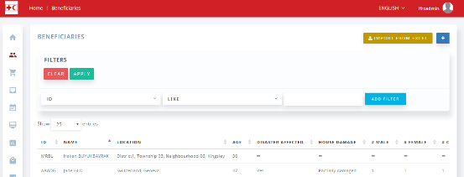

Select the file to import. Select “Insert” mode. Click on Import button.
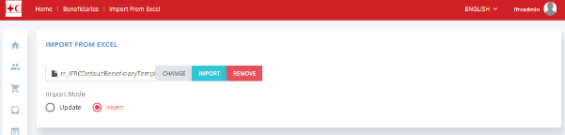

If the import fails, there will be a file downloaded signalling where the errors may come from. In the sample below, some required fields are missing for the last row (e.g. first name, last name).
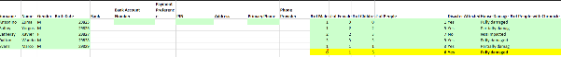
In the template, you can also pre-assign imported beneficiaries to a Beneficiary Group (using “Add to Group” field).

Registering beneficiaries using Mobile App

The RR Collect mobile application is used for registering beneficiaries. This is ODK based. By default, an ODK Aggregated server managed by RedRose is used. Otherwise, it is also possible to configure IFRC’s or the NS’s ODK Aggregate server to integrate with RedRose. In this guide, we will use RedRose’s default ODK server.
To configure:
- On the Android phone, download & install the corresponding RR Collect app using the link mentioned in section 1.2 Mobile App above.
  - If there was already an RR collect app in your phone, make sure to delete it and re-install from scratch. You can only install one instance of the RR collect in your phone.
  - Also, if you are using ODK Collect, you do not have to uninstall it. However, need to make sure the staff/volunteers know which app to use during the registration. Remind the user to look for the right icon (with the RedRose).
  - As a general tip, please delete all saved data including blank forms when setting up a new instance. Old forms could come from previous installations of RR Collect.
- From the app get a Blank Form for the newly created/updated ODK form.
- Start registering beneficiaries. When done, submit the form back to the server. The new entry should be included in the Beneficiaries List.
- In case during the data collection, RR collect asks for a data collector account use: username: Please send a request, password: Please send a request

Beneficiary List Export
You may download the full beneficiary list from the Beneficiaries > List page. Click on the Export button at the bottom.
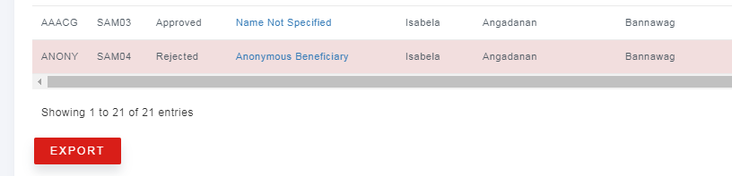
This export should be limited to authorized personnel due to data protection.
Once exported, some of the data fields may be updated. For instance, the TAG field will need to be populated with the PRC’s Reference ID. Which is a unique sequence for beneficiaries based on a naming convention.
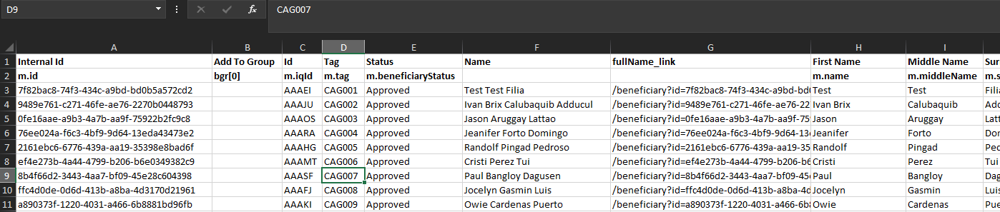

After updating the exported file, you may upload it back into the system. Go to Beneficiaries > List and click on the import button.
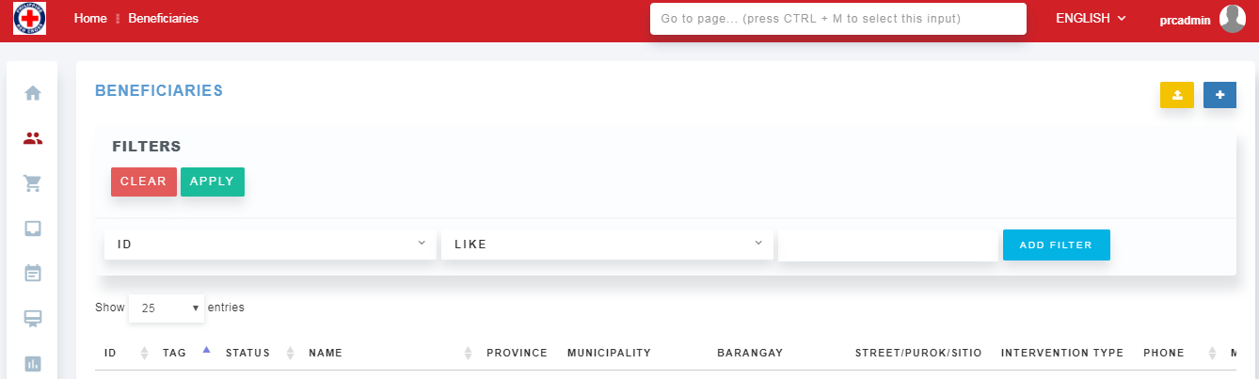

Select the file to import and click on “Update Existing Beneficiaries” button. Then click “Import”.
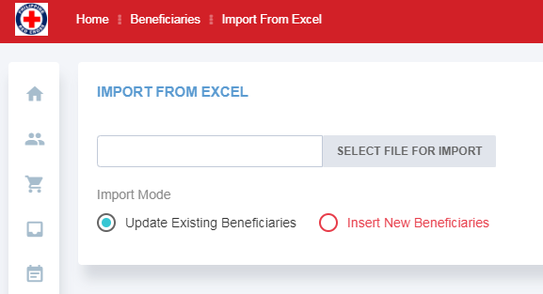

Beneficiary Groups
One way to group beneficiaries is during import, by adding a group name (e.g. “Livelihood Beneficiaries”) to the “Add to Group” field.
Another way of grouping is via Beneficiary Groups.
To create a new Beneficiary Group, Go to Beneficiaries > Communities/Groups. Click on “+”. Enter details and Save.

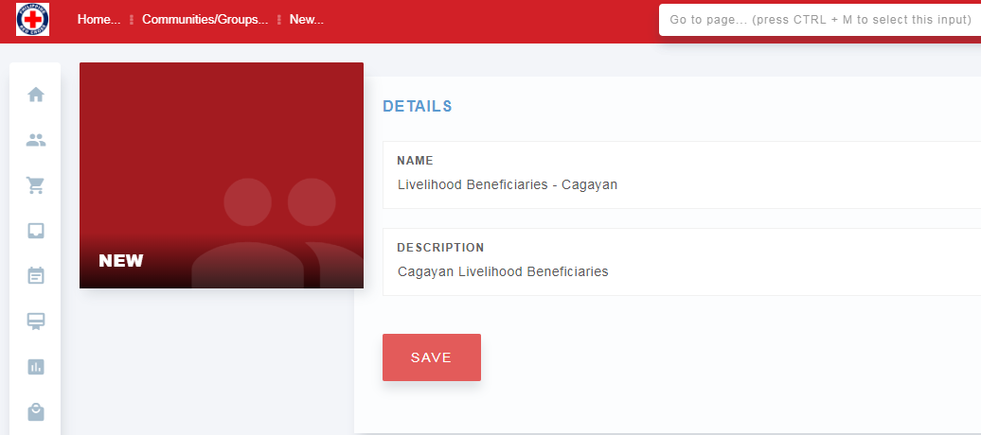

Then go to the newly created group, and click on “Beneficiaries” on the left column. This will show who belongs in this group. You can click on the “Add Beneficiary” button on the top right to add other beneficiaries.
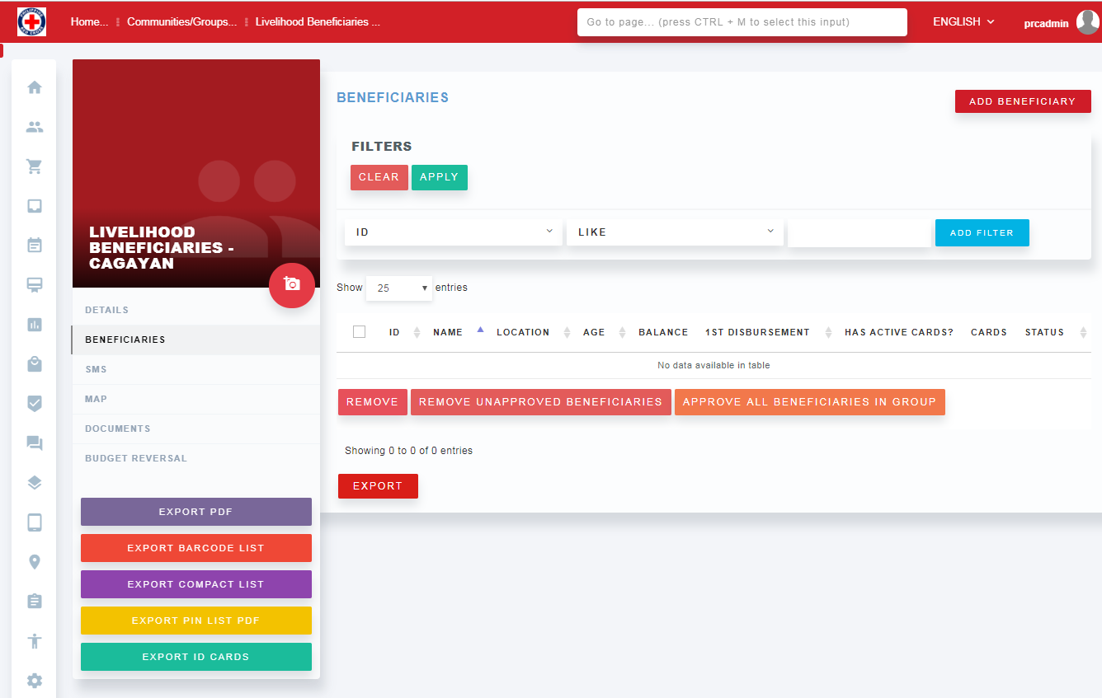

A new window will appear listing all available beneficiaries. Using the filters on the top of the page, go ahead and filter the ones you would like to include in this group. For example, select “Intervention Type” and put “Livelihoods”. For other examples, it’s possible to create groups based on vulnerabilities or gender such as female headed households. The example below is for beneficiaries for Livelihoods intervention in Cagayan. Once filtered, select the ones you want and click on “Add Beneficiary” button, or simply click on “Add Filtered Beneficiaries” and the filtered results will automatically be added without clicking on the checkboxes individually.
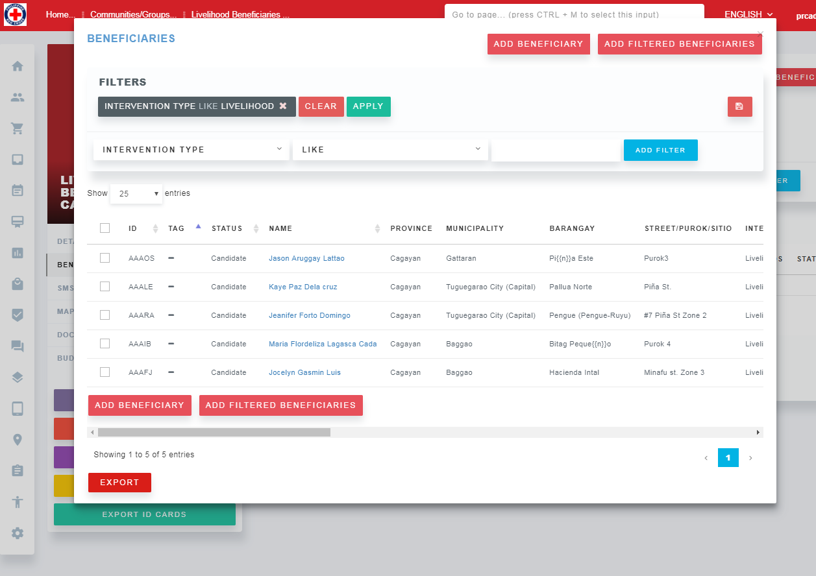

Check if the beneficiaries truly need to be included. Sometimes, beneficiaries have been “Rejected” either due to double entry or ineligibility. You can include this status check on your filter. Otherwise, remove them from the group before finalizing it.
To be eligible for assistance, beneficiaries in the group need to have “Approve” status. So make sure to select “Approve all selected Beneficiaries”, so they become eligible for assistance. Otherwise, again, make sure to remove those that have been set as “Rejected”.

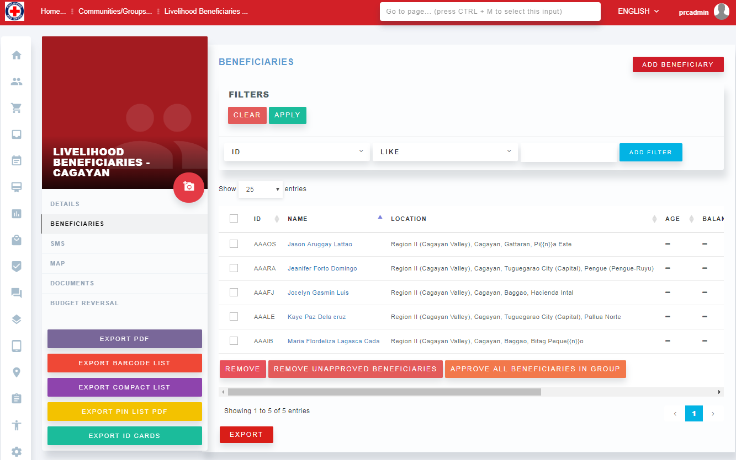

From this page, you can click on “Export PDF” to download a list of beneficiaries with corresponding barcodes, for distribution.
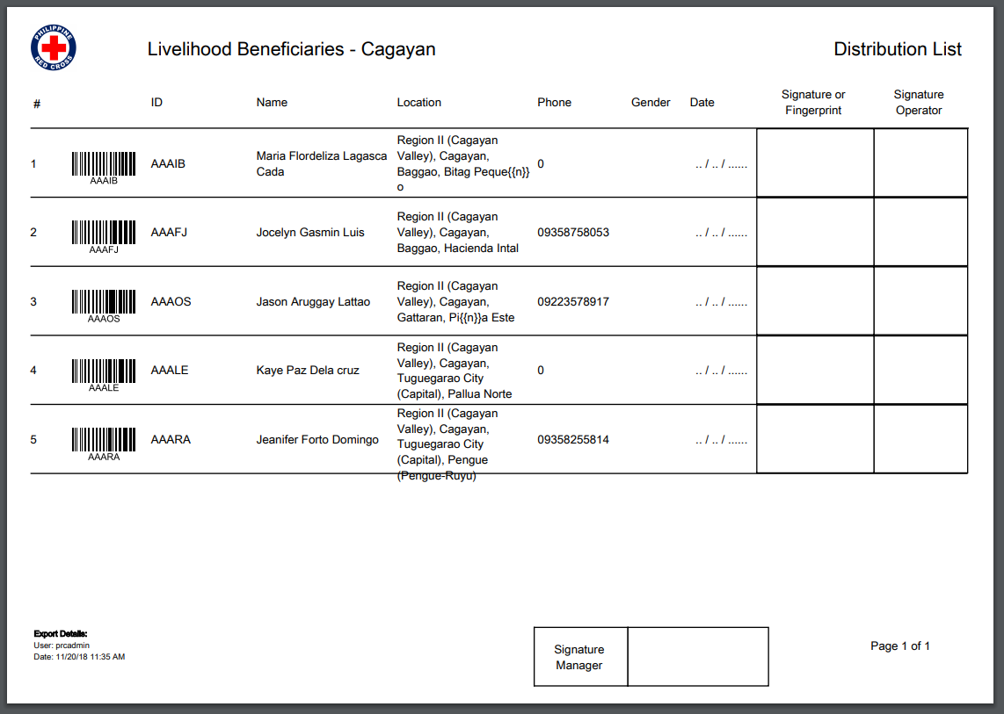
“Export Barcode List” – used to bulk download and print beneficiary barcodes
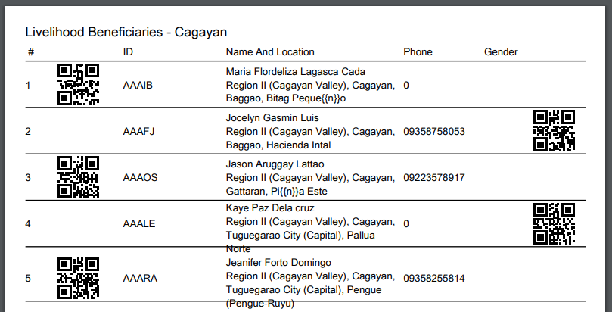

The “Export ID Cards” will allow for printing of Beneficiary ID cards. There will be two beneficiary cards per page.
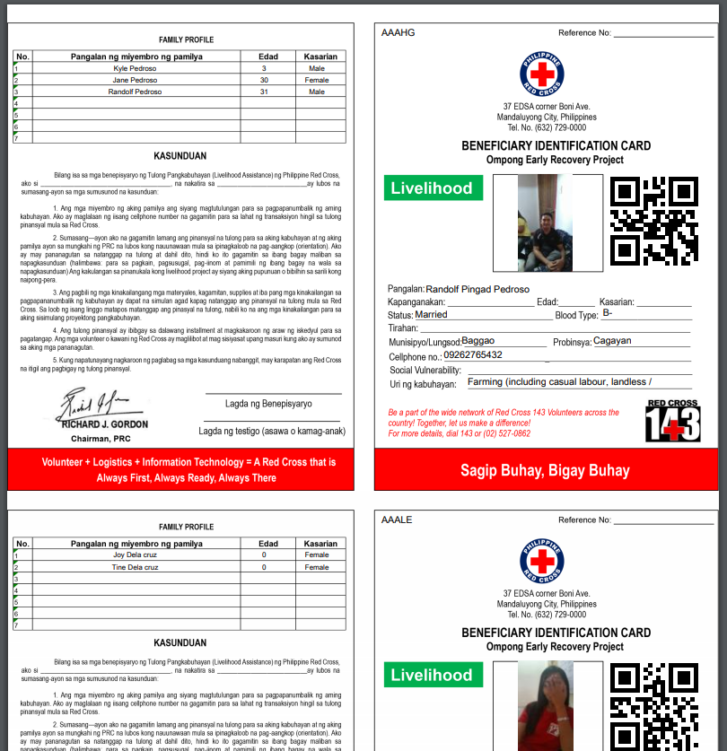

Beneficiary List

Go to Beneficiaries > List to see all the registered beneficiaries in the system.

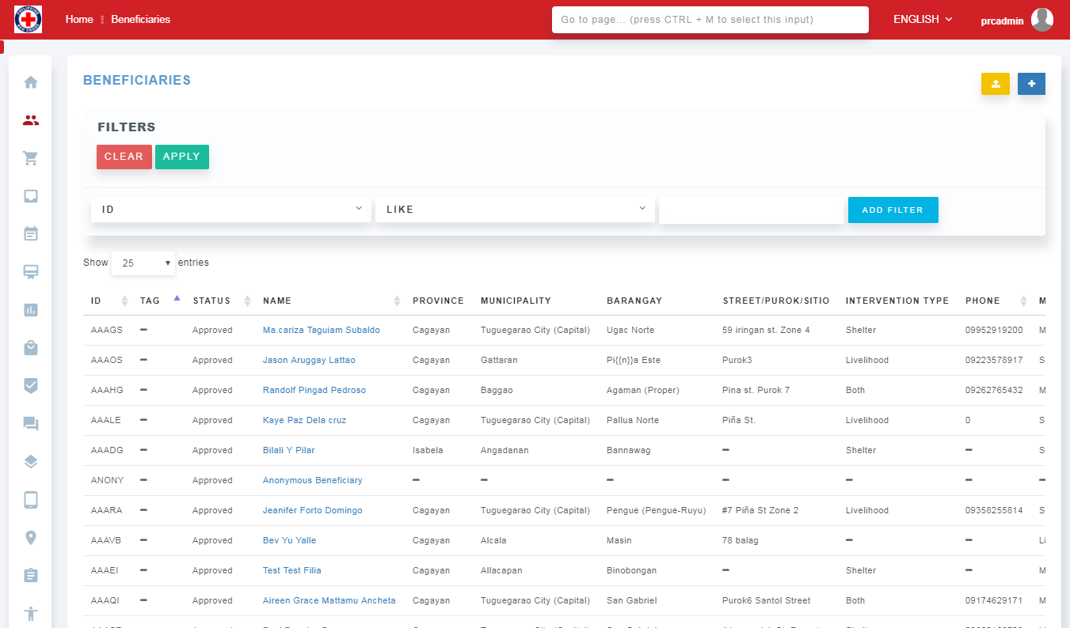
You can download all Beneficiaries registered in the system by going back to the Beneficiary List and clicking on “Export” button.
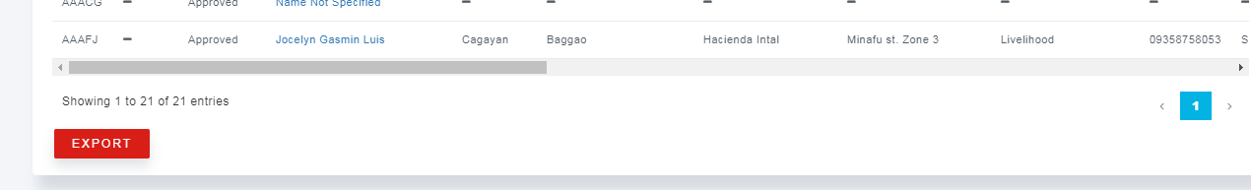

You can use the filter widgets to search and filter the beneficiary list. You can also use the sort buttons to sort the fields.
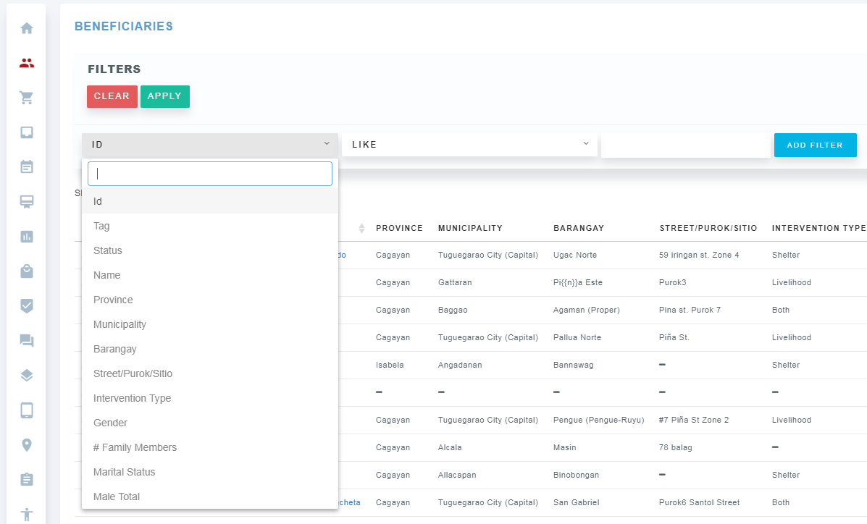

Beneficiary Profile

From the Beneficiary List page, click on a beneficiary name to view the Beneficiary Profile.
All surveys, feedback, and transactions linked to this beneficiary are available from the profile page.
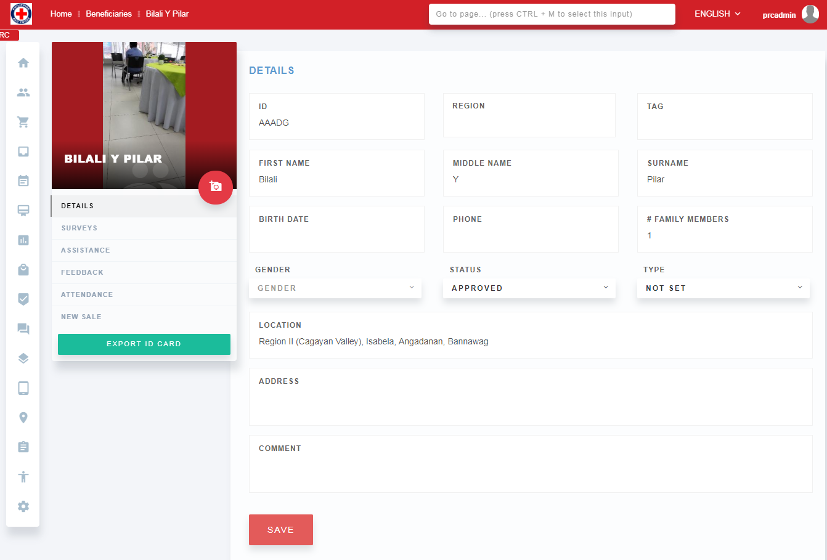
You can also view and print the Beneficiary Card by clicking on “Export ID Cards”.
Depending on the Intervention type, the Beneficiary may have one or two cards (Livelihoods and/or Shelter)
Example of Livelihoods Ben Card:
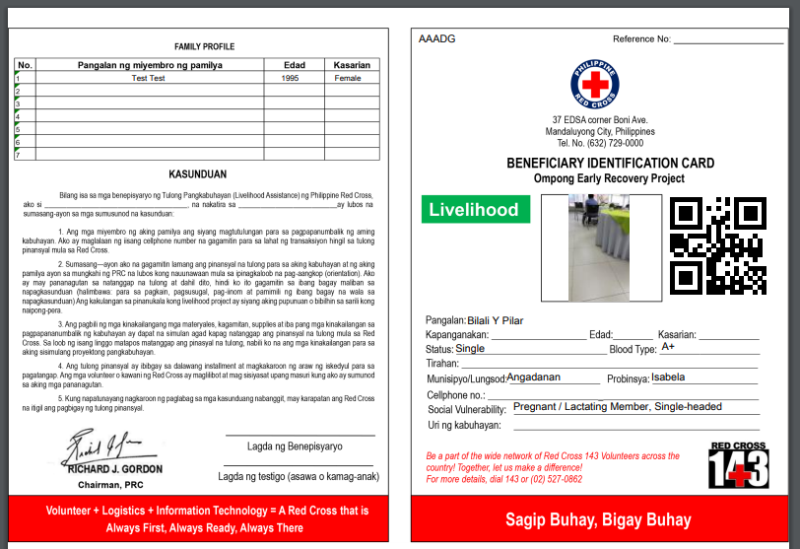
Note: only the front part of the BenCard has been decided to be generated from RedRose. The back part will be printed separately by the program team. The back part looks like this.
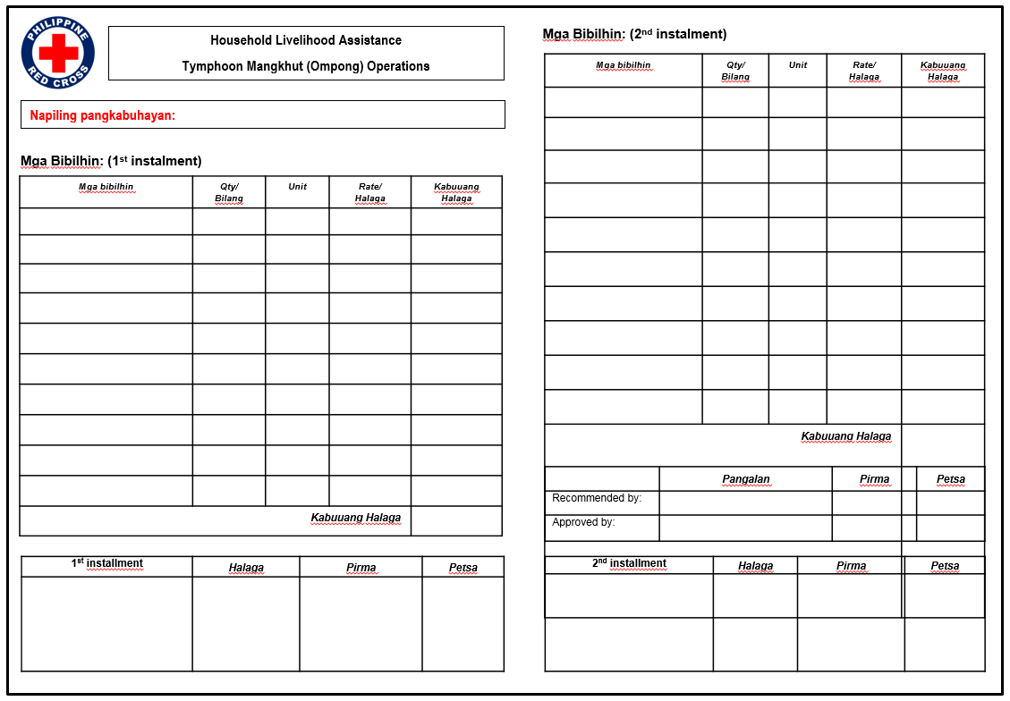

Duplication Check
Go to Beneficiaries > Beneficiary Duplicate Analyses
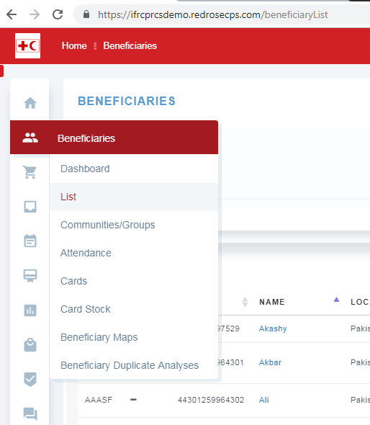

Click on the blue + sign to Create New Beneficiary Duplicate Analysis.

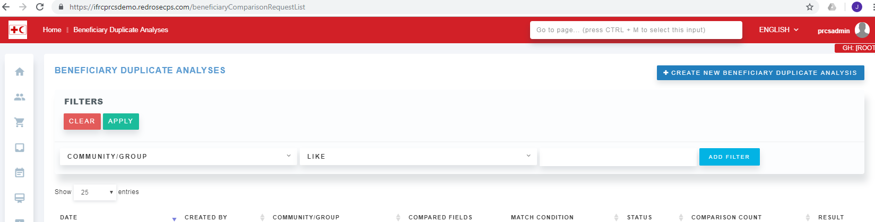

Select the Beneficiary Group you would like to check for duplicates.
Decide whether to select all fields or specific fields to check for duplicates. You can choose “At Least 1 Selected Field”.
Click on Basic button to see all available fields that could be checked.
Select the fields you want to check. Strict indicates as close as possible to the characters in the field. Loose means to allow some characters to match but not exact matches.
Click on Save.
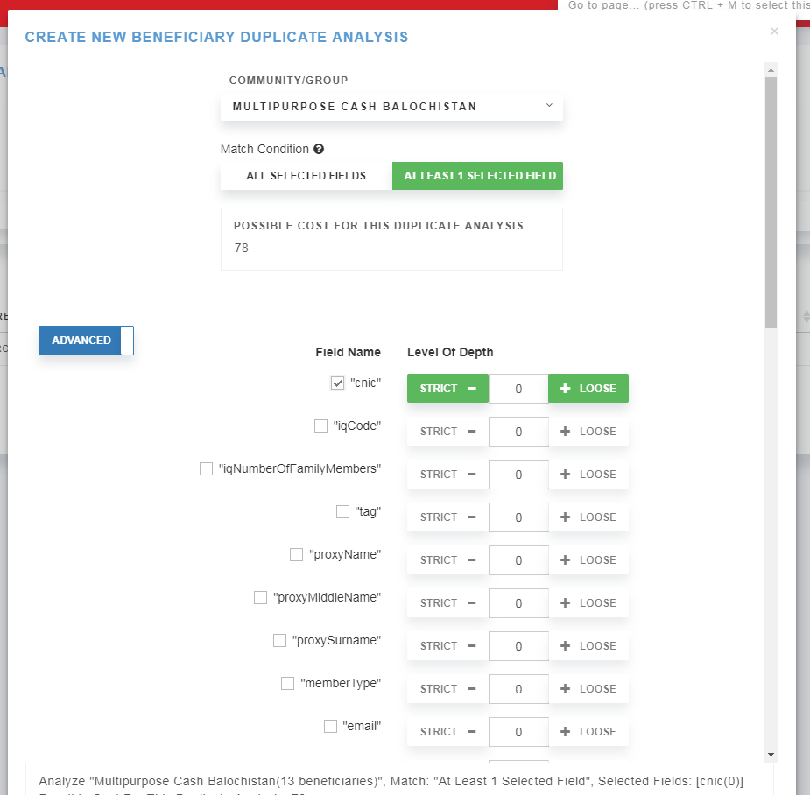

Click on the Result button to view the duplicates.
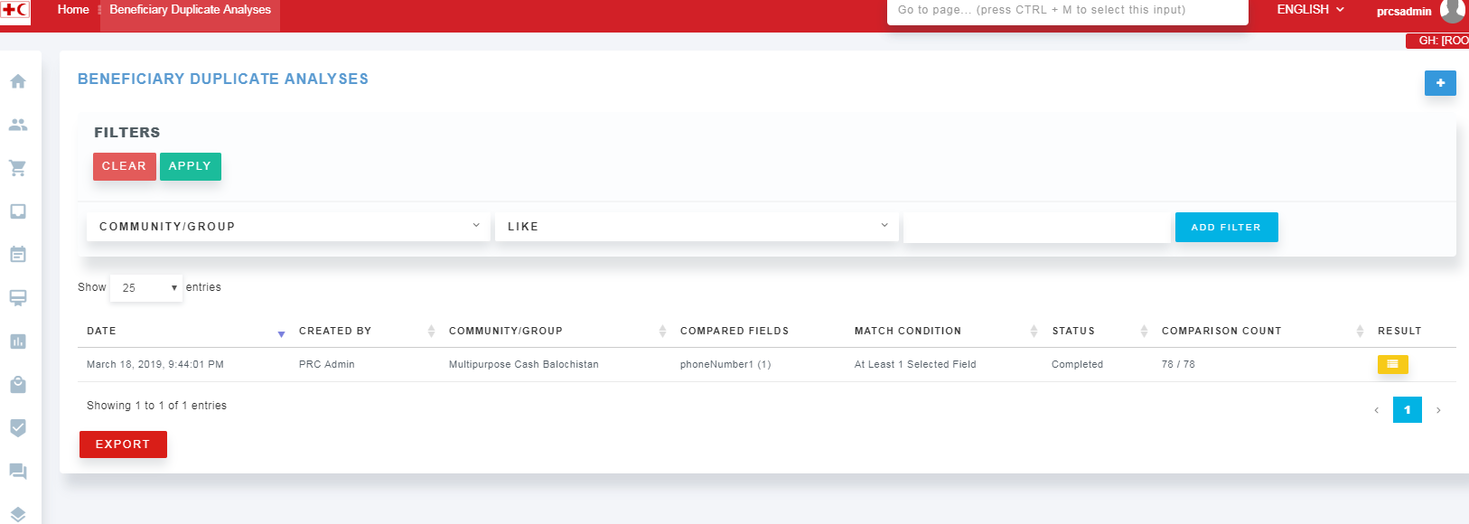

Click on the Names to view the duplicate profiles.
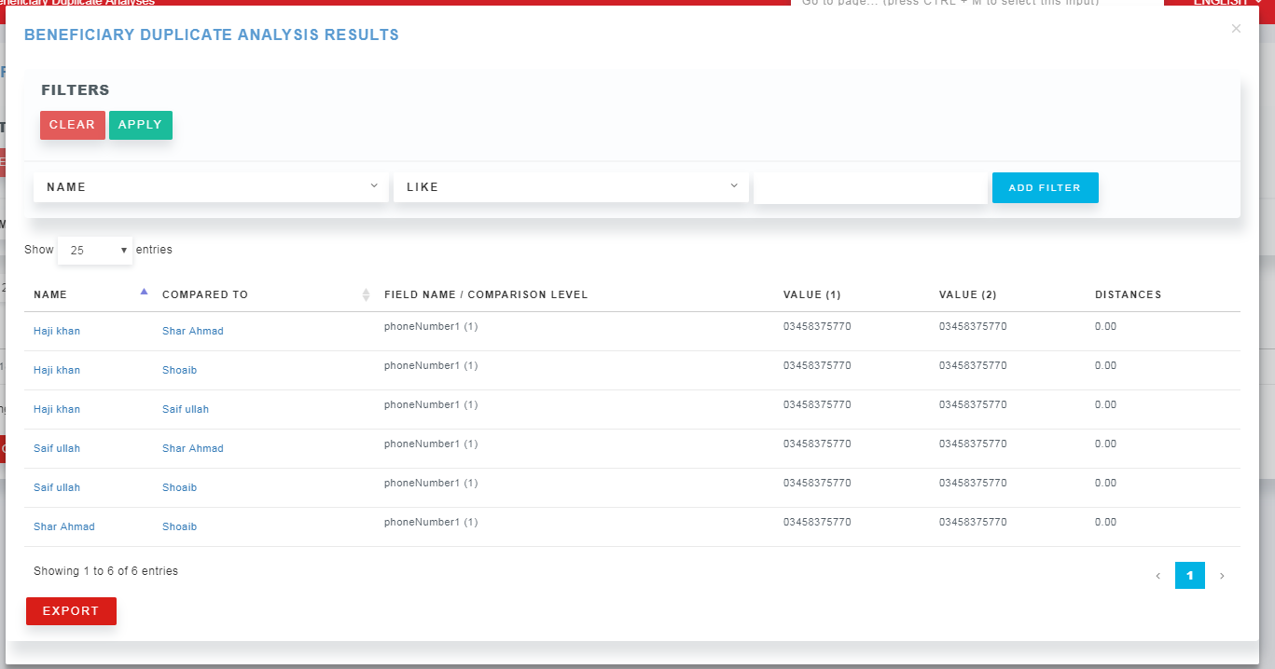

Distribution Planning & Scheduling

Distribution Planning & Approval Process
The following diagram illustrates how the “Fund”, “Activity”, and “Top-up” concepts relate to each other.
Fund is the big pot budget to which cash will be disbursed, this is typically agreed with the donor before the project or program is signed. This could be from the IFRC’s EPoA or PRC’s PoA; need to be decided beforehand. The fund budget can be increased or decreased at a later time.
Activity is the distribution plan to which the Fund will be utilized. There could be multiple Activities taking a portion of the overall fund, but the total budget across all activities should not exceed the budget set in the Fund itself. This is one of the financial controls in the system. For Mangkhut, it’s proposed to create activities based on Intervention type and Province. Eg. Shelter Recovery for Cagayan, Shelter Recovery for Ilocos, Livelihoods Recovery for Cagayan, etc.
Top-up is basically the actual distribution order, after all the beneficiaries have been finalized and amounts set for each beneficiary. There could be multiple top-ups for a given activity (e.g. 1st and 2nd instalments could be 2 different top-ups). Again, the system will monitor to make sure you do not go over the budget set for the activity.
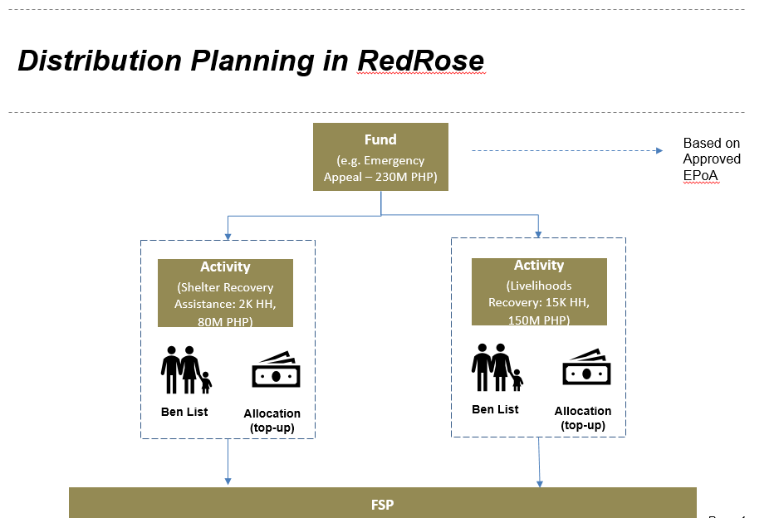

The following is a diagram of the approval process between the program team and finance. This is meant to ensure segregation of duties, so the requester is not the same as the approver. This is another way to ensure controls for the provision of cash assistance. At each step, there will be an audit log that could be referred to for investigation purposes and to ensure decision makers are held accountable.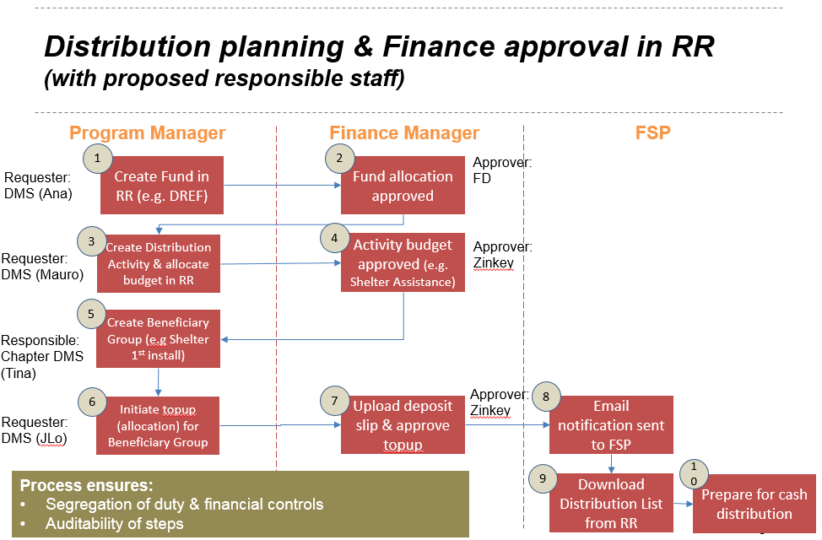

Distribution Plan Creation

Distribution planning uses Activities in RedRose, where distribution dates are defined and entitlements assigned.
Go to the navigation bar and select “Activities”.
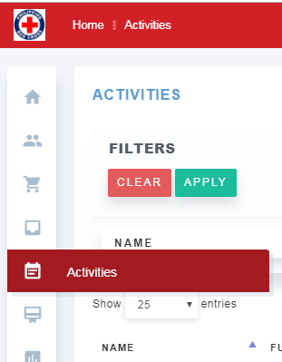
Click on the “+” sign on the upper right to add a new Activity. Complete the form and save. Make sure the Fund, Commodity (E-PHP), and Vendor (PHILPOST) has been setup. Refer to the Configuration section above, if necessary.
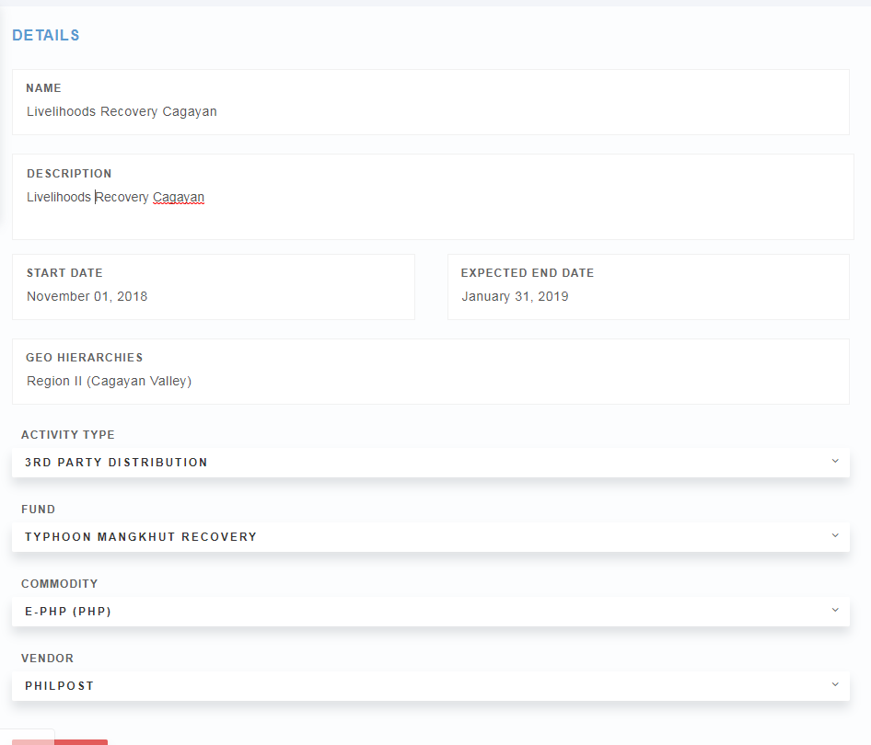

When using PHILPOST for the FSP integration, make sure to go back to the Vendor profile of PHILPOST and select PHILPOSTINTEGRATION under the 3rd Party integration dropdown. This will ensure that the integration workflow for PHILPOST is used.
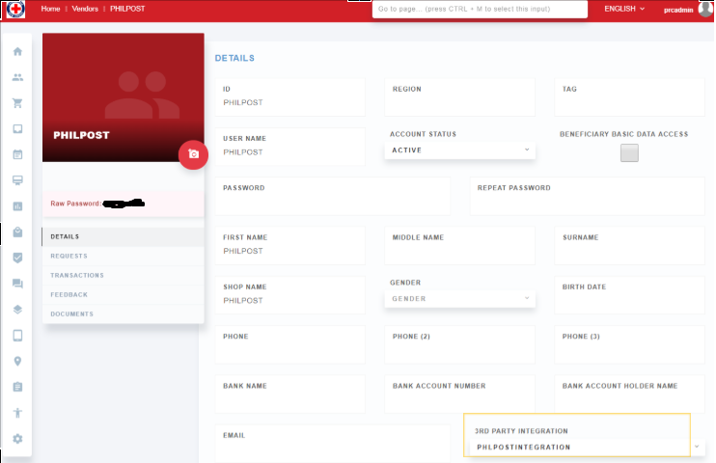

Go back to the Activity and allocate the budget.
Activities > Click on the Activity you created.
Click on “Budget Allocation” on the left column. Enter the budget amount and click Request. Click on Confirm.
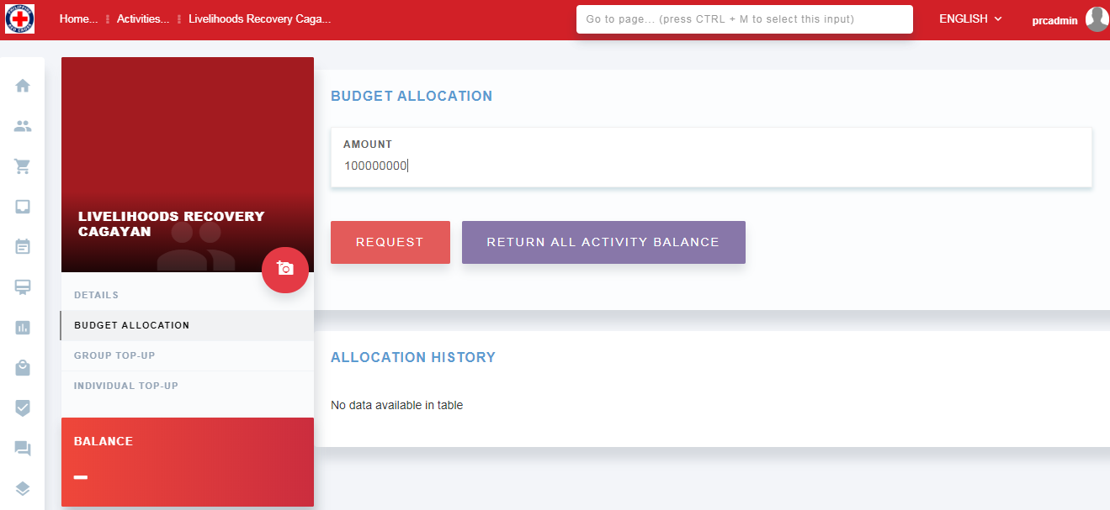

On another browser, go to the web portal and login as a Finance user to approve the budget. See the finance user in the introduction section above.
Go to Finance > Requests and approve the budget allocation of this activity. Note again that this approval process can only be done by users with the appropriate permissions, in this demo the user finance has such permission to approve the budget.

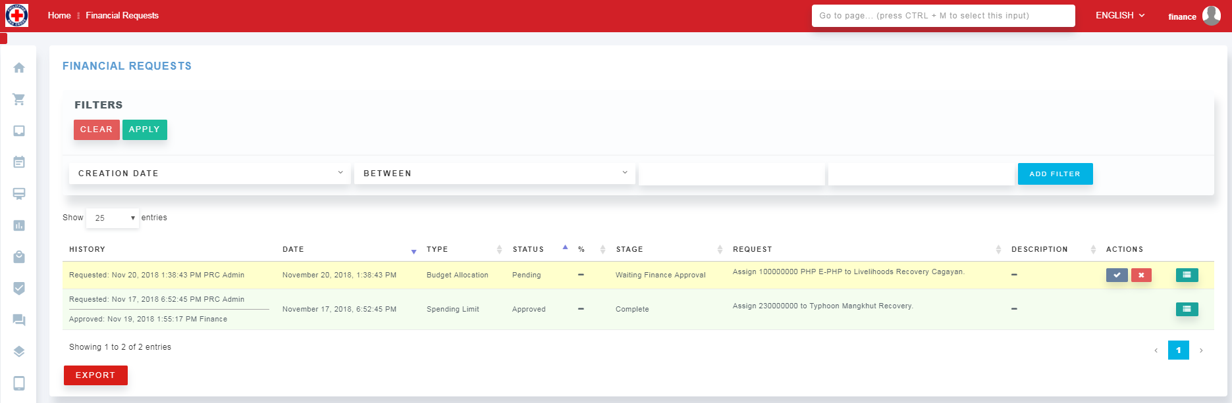

Click on the Approve button (Blue checkmark icon). The row will refresh indicating that the approval has been Completed.
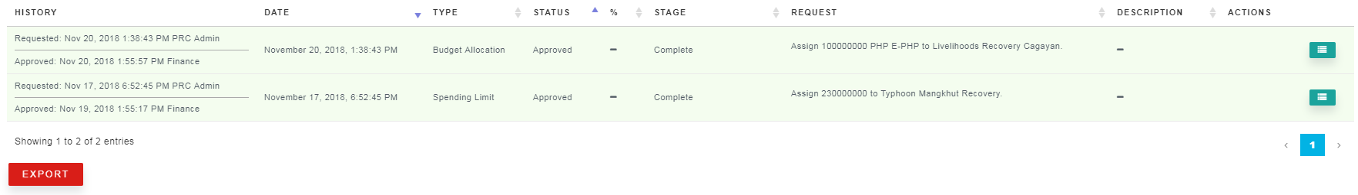

Go back to the Activity, and you should now see the new balance updated.
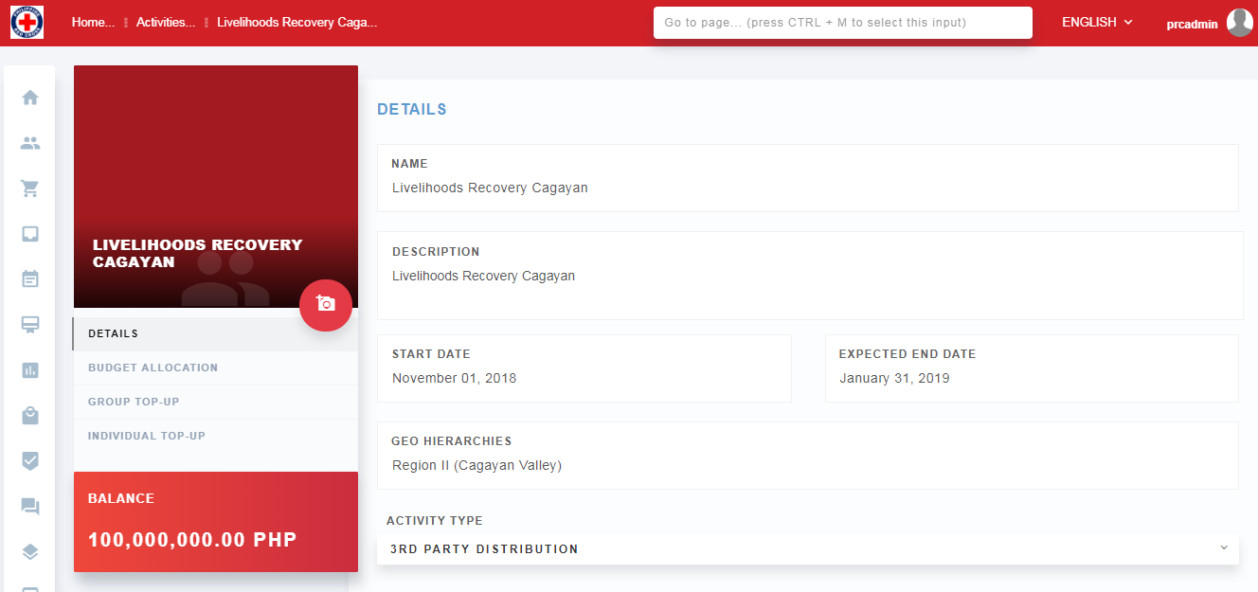

Assigning Entitlements
To assign entitlements to Households, go to the Activity.
From there, you can do either a Group Top-up or an Individual Top-up. Group top-up means everyone in the beneficiary group will receive the same entitlement (e.g. 6,000 PHP for all). Individual Top-up means the program manager may provide different amounts per beneficiary based on program requirements/criteria. For this operation, only Group Top-up will be done.
Group Top-up
Group Top-up is used if you already have Beneficiary Groups and you are providing the same entitlement to everyone in the group. If you have not created a beneficiary group, please see the section above.
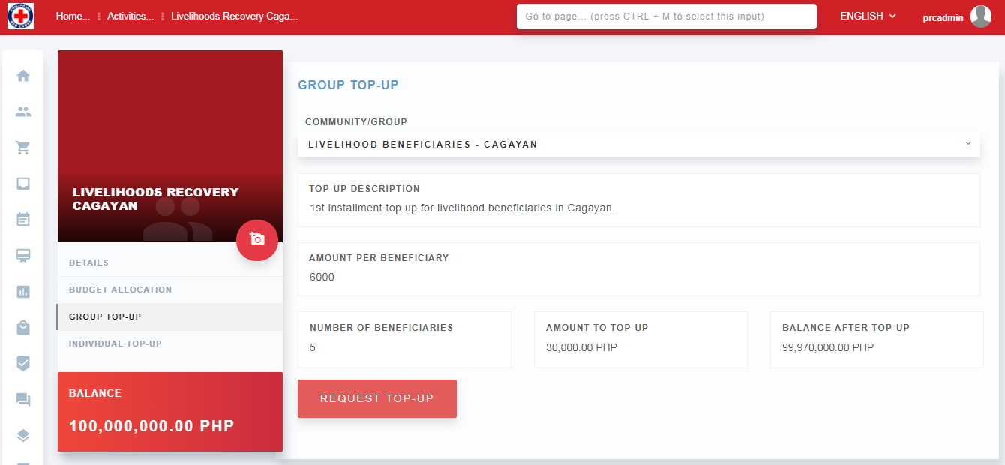

Once a beneficiary group is created, select that group from the list and enter the amount (in this case the distribution will be on a household level). The Amount to Top Up and Balance After Top Up will be auto calculated based on the number of beneficiaries in the group and the amount to give per beneficiary. Click on “Request Top Up” button. Click confirm.

Ask the finance person responsible for approvals to login and approve the request.
[open another browser and login with the “finance” user.]
Go to Finance > Request. You will see a request with Waiting for Finance Approval status.

If the finance person tries to click on the check icon, they will receive an error. Because the first step for finance is to upload the deposit slip or receipt.

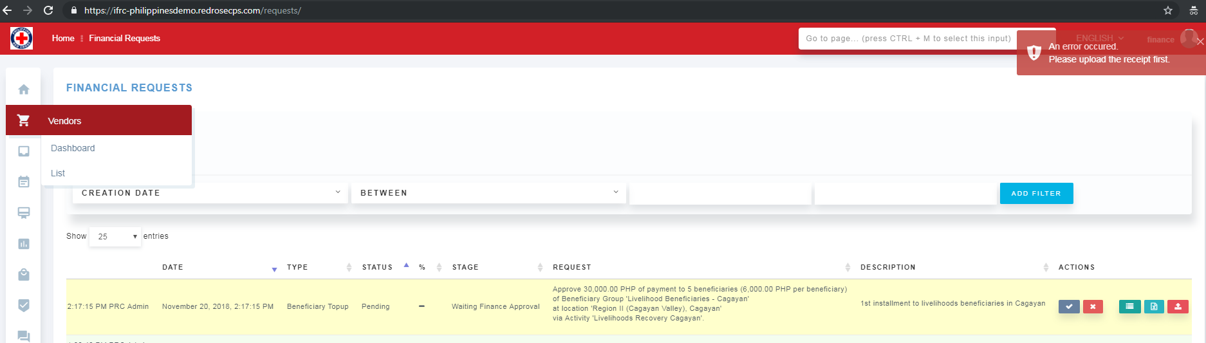

Finance person will need to have the deposit slip required by the FSP and upload it into the system by clicking the upload button on the far right of the icons row. A pop up box will appear so the user can select the file to upload. Click on Upload button.
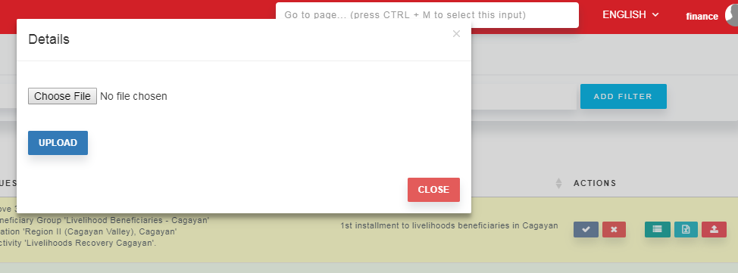

Sample of the deposit slip:
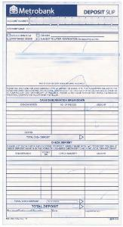

Once the file has been uploaded, click on Approve (blue checkbox icon) next to the request.
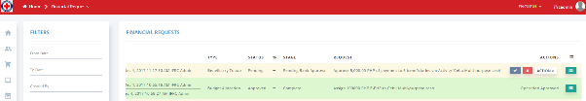

Distribution Tracking

Cash Distribution & Reconciliation
For PRC, there are two ways of tracking distribution:
- By FSP – done by downloading the beneficiary list from RedRose, updating who has received cash, and uploading the status back to RedRose
- By PRC – staff or volunteers will be provided a mobile phone with the RR ONEapp installed. This app will be used to scan barcodes given to beneficiaries when they are validated at the cash distribution site. Barcodes are scanned only when PRC sees that money has been given to the beneficiaries
There are two parts to this distribution tracking in order to have two independent ways of verifying who got paid what. This process also allows stakeholders to track the distribution process remotely with close to real time data. Note that there needs to be internet access at the site of distribution to get real-time data. If there’s discrepancy, an investigation should be called out immediately. At the end of the distribution day, all records should be completely reconciled.

The diagram below outlines a distribution and reconciliation process. This may vary slightly depending on the NS cash distribution processes and the FSP’s role and responsibilities within that process.
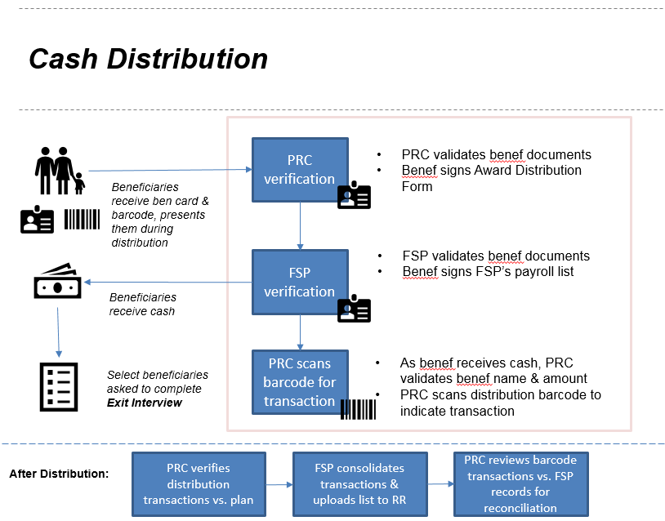

FSP Tracking
An email will then be automatically sent to the FSP notifying them of the official request from the PRC. They will be instructed to download the official list of beneficiaries and entitlements from the RedRose platform.
The FSP will have their own username and password to access the RedRose system.
For the demo environment, you can login as PHILPOST with password Please send a request.
After logging in, you will see that the menu options are limited. Click on the Requests menu. You will see a list of Activities. Scroll over to the right to see the red button for downloading the beneficiary lists.
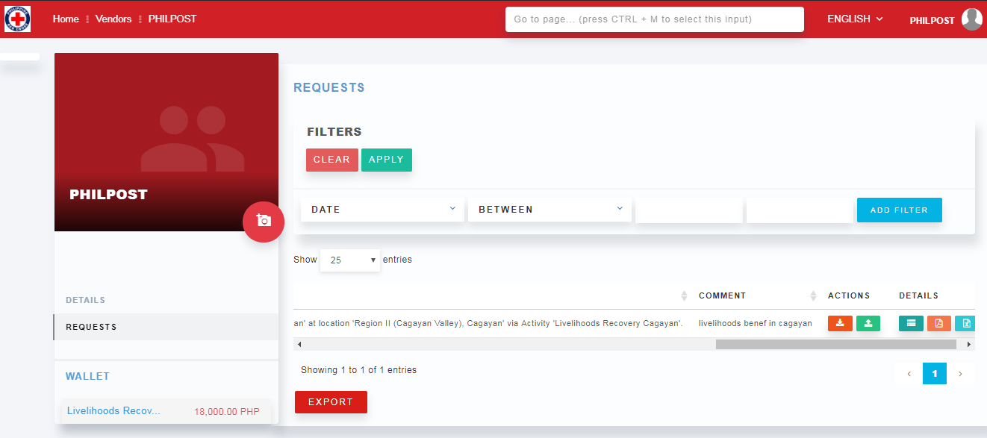

The file will be formatted by the system based on the specifications of the FSP. Sample below.
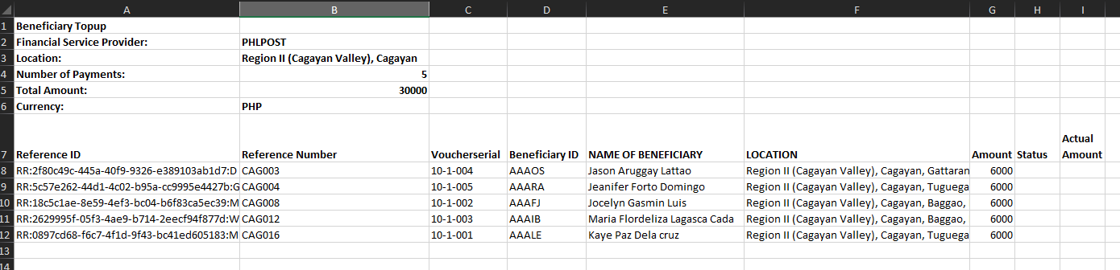
At the end of each distribution, FSP should update the downloaded excel sheet based on who was paid during the distribution. There are two columns that need updating: Status and Actual Amount.
If someone has been paid, their status should be changed to “PAID” (case sensitive). Otherwise, leave blank. Actual amount is generally the same as the original amount, but just in case, FSP should put the amount they actually disbursed. After the updates, FSP should upload the form back to RedRose, by logging back in, going to the Requests page, scrolling to the appropriate activity and clicking on the green upload button.
If there are errors, there will be a message popped up. If not, a success message will show up. Error could be in terms of the excel data or the wrong activity was used to upload the spreadsheet.
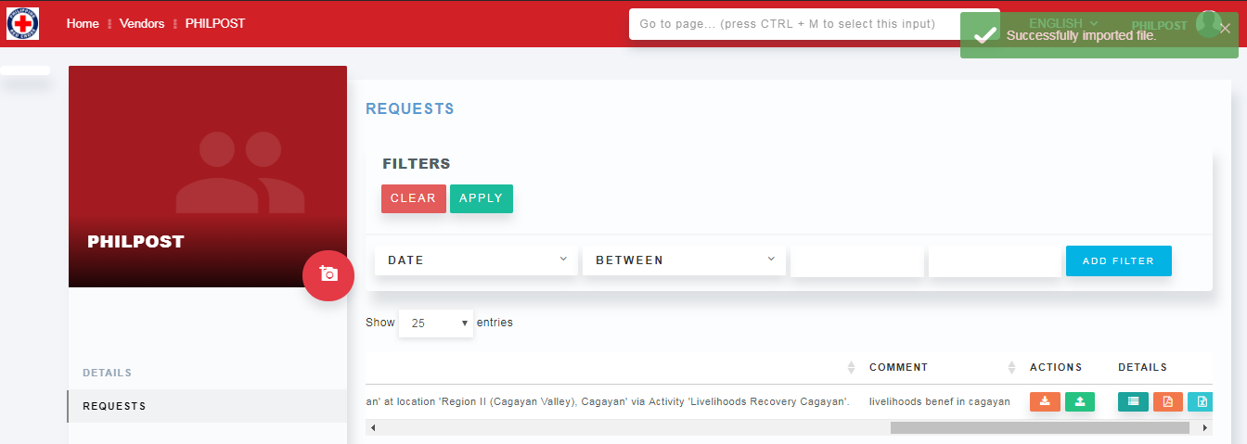

After successful upload, click on the details button. You will see the results of the automatic reconcilliation.

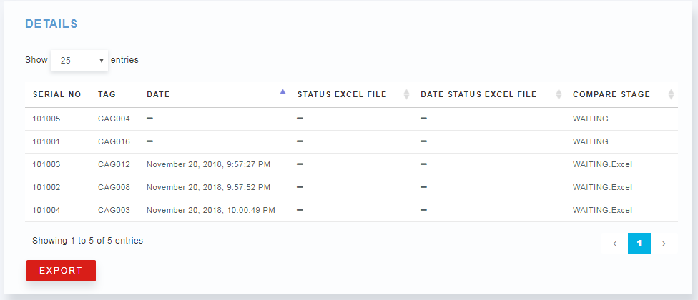

The column COMPARE STAGE will have one of four states:
- WAITING - for waiting for both scan and upload
- OK - both scan and download matches
- WAITING BARCODESCAN - if upload already but not scanned
- WAITING Excel - if scanned but no upload yet
PRC Tracking (This is an extra step at PRC which provided an additional form of reconciliation alongside the FSP recon process. i.e. PRC carrying out a direct monitoring/reconciliation of beneficiaries… this may not always be needed by other NS’s - depends on their own processes
PRC volunteers or staff will have the RR One app installed in their Android phone (minimum version 4). They will need to Synchronize their app at the beginning of each distribution to ensure the latest updates are captured. They can be given a badge that will enable them to be automatically login.
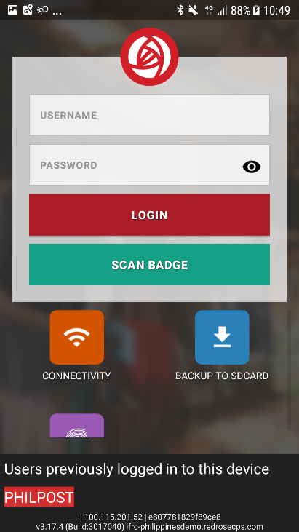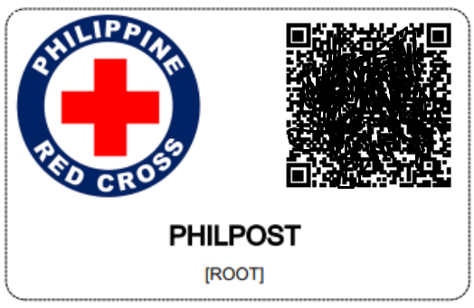

In the app they will click on “voucher sales/distribution” button > “New Sales /Distribution” > then scan the transaction barcode of the beneficiary (only after seeing that the money has been given to the beneficiary). After scanning the beneficiary’s transaction barcode, click Next and the information with the beneficiary name and expected amount are shown. User should verify this data to make sure they are accurate. If yes, click on Complete Sales/distribution button. App will refresh after 10 minutes and automatically synchronize (if connected to the intenet).
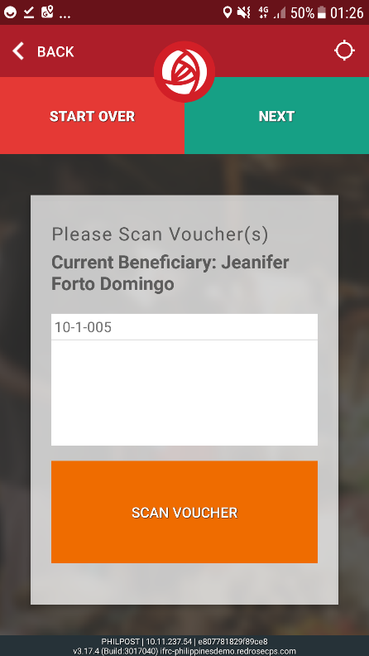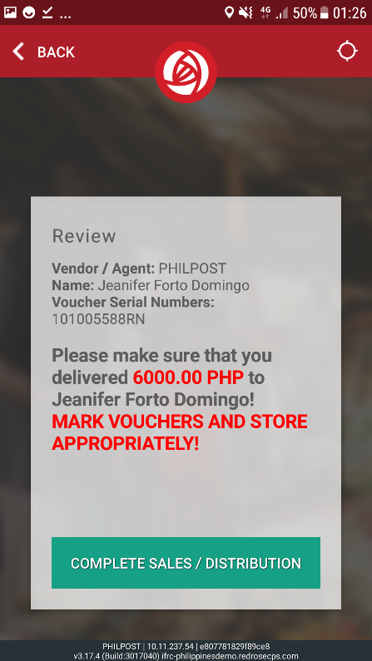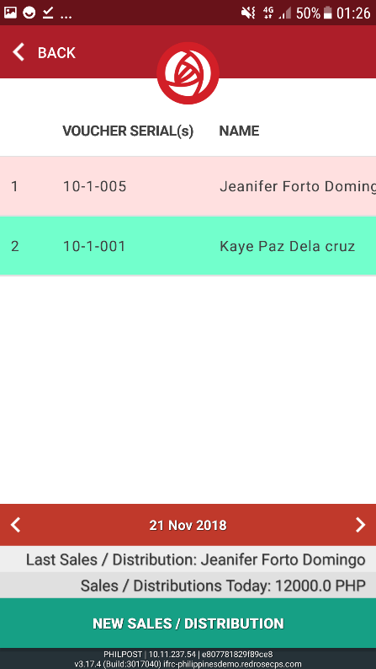
To view the transactions, a user can go to Vendors > PHILPOST > Transactions.
The list of transactions will be shown.
If for some reason, a barcode was scanned erroneously, there’s a possibility of cancelling this transaction by clicking on the X button (can only be done by the System Admin as an exception).
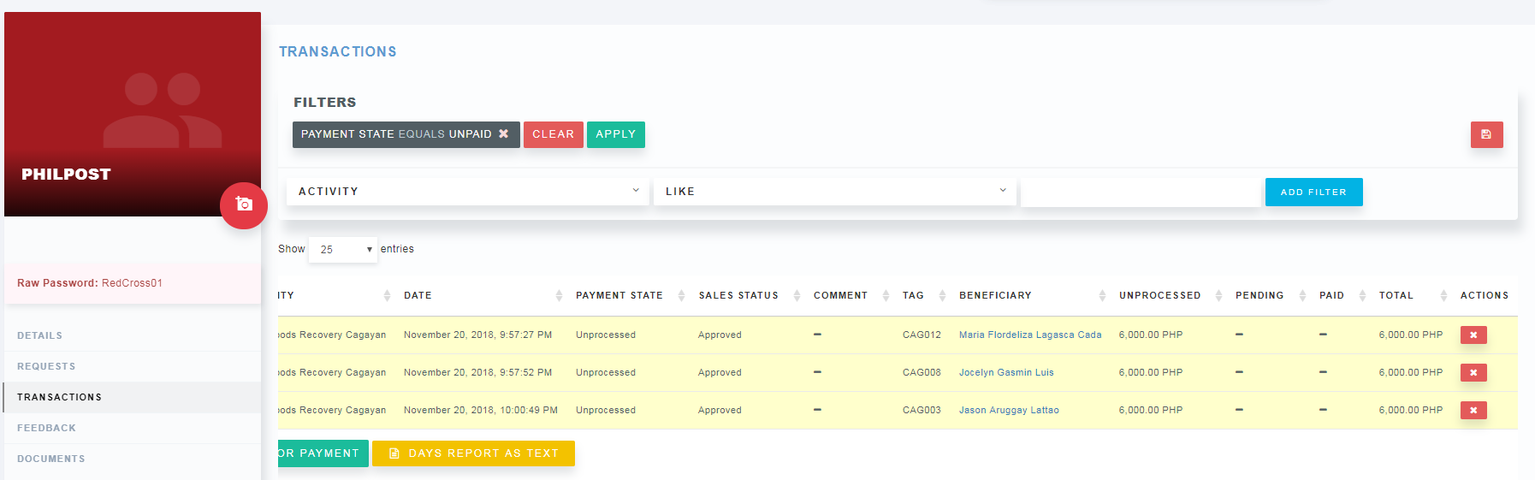

You may check the dashboards or the beneficiary profile for updated transactions (Commodities > Transactions).
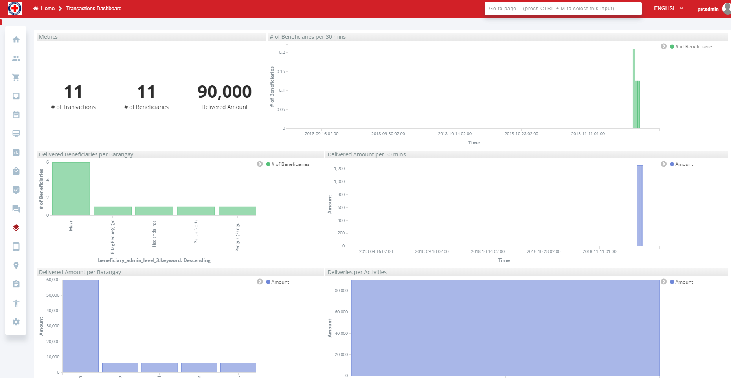

Feedback & Surveys

Feedback & Complaints
Feedback and complaints could be recorded directly on the Beneficiary’s profile.
Beneficiaries > List > click on one of the entries > Click on “Feedback”.
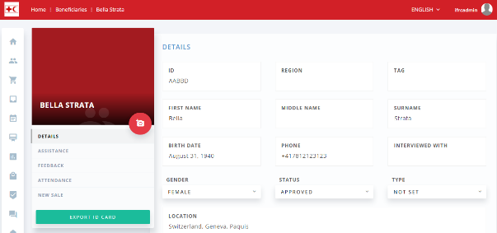

Click “Add Complaint” button.
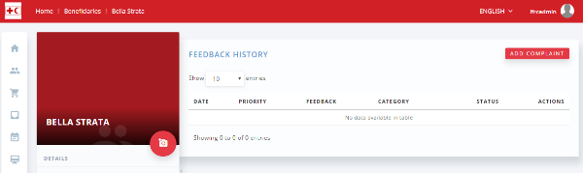
Enter details: feedback description, complaint category, priority. Click Send.
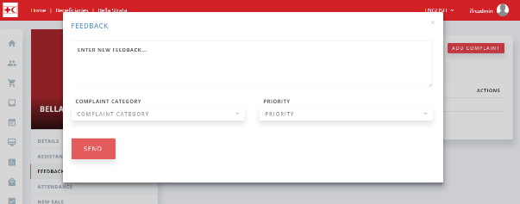
To update the Feedback, go to Complaints.
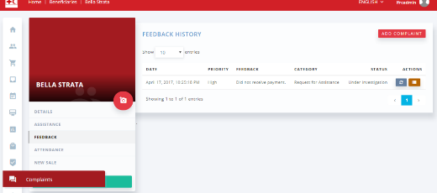

Click on the blue update button next to the feedback entry. Update the status and notes. Click on Confirm.
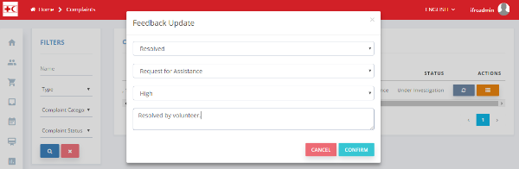

A call-center may be activated so an automated phone message system could record any feedback or complaints from beneficiaries and recorded them as Feedback in RedRose. Also, if the person’s phone number has been registered in RedRose and they call from that number, the person’s message will automatically linked to the beneficiary’s profile.
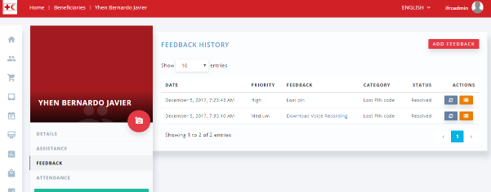

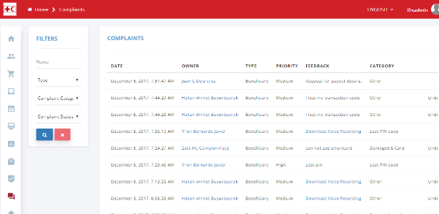

SMS communication to beneficiaries is also possible, however this has not been configured in the PRC instance.
Go to one of the Beneficiary Groups. Click on SMS from the left column. SMS capability has to be enabled to use this feature.
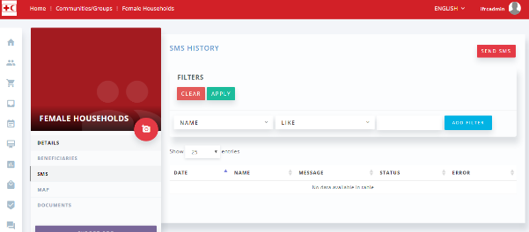

Click on Send SMS from the top right.
Enter a message, click on approve, and click Send button.
Note: This feature will actually send an SMS message if the phone number is able to receive it. Be careful when sending text messages to fake accounts.
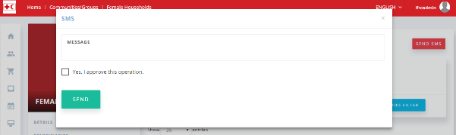

Reporting & Analytics

Report Generation
Typically, reports will be implemented by RedRose based on the requirements of the IFRC. The excel reports will be published under the Excel Reports section.
There are also downloadable reports under the Beneficiary, Vendors, Activities, and Commodities, by clicking on Export button.

Dashboards
Depending on the number of entries, default dashboards will be populated.
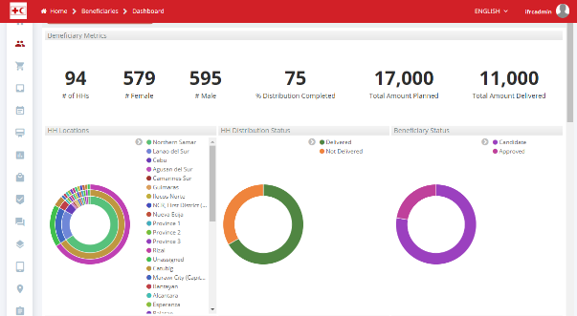

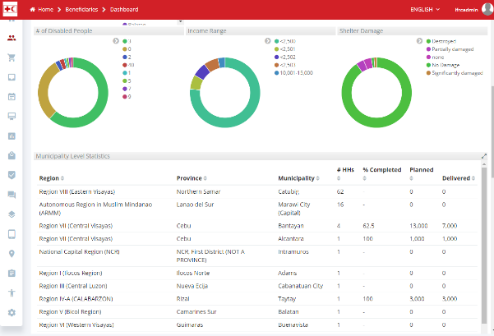

Screenshots below taken from another demo instance.
Overall Dashboard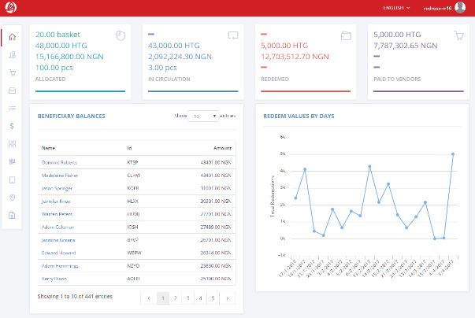
Beneficiary Dashboard
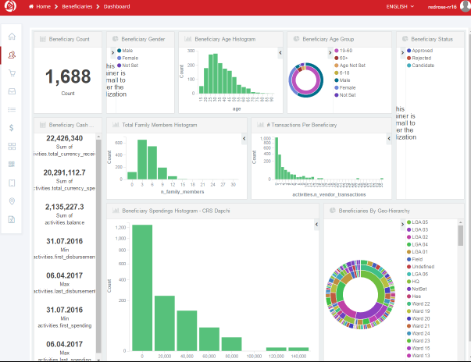
Vendor Dashboard
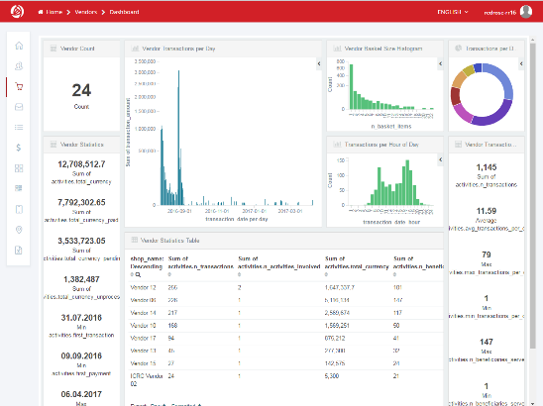
Market Dashboard
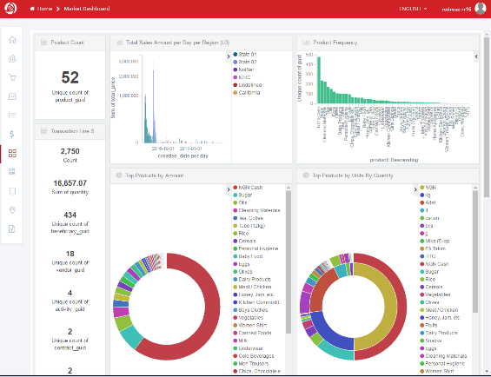
Commodities Dashboard
