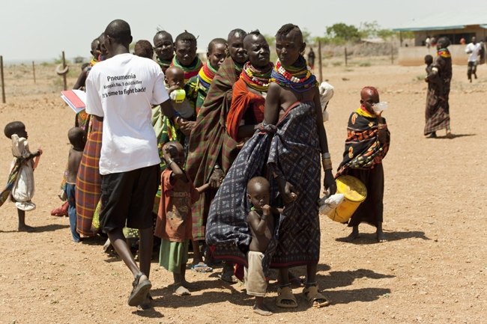Simlandia Drought Simulation:

A preparedness and response scenario for Red Cross and Red Crescent Societies

|  |  |
| --- | --- |
| **Introduction** | 4 |
|  |  |
| Part I Planning |  |
| 1. Simulation structure and agenda | 5 |
| 2. Developing an aim, objectives and deliverables | 6 |
| 3. Participants and facilitators | 7 |
|  |  |
| **Part II Design** |  |
| 1. Overview of the disaster | 8 |
| 2. Time jumps scenarios | 11 |
| a. Preparedness | 12 |
| b. One month after the declaration | 14 |
| c. Four months after the declaration | 17 |
| d. Eight months after the declaration | 20 |
| 3. Challenges | 22 |
|  |  |
| **Part III Facilitation** |  |
| 1. Monitors | 23 |
| 2. Setting up rooms | 23 |
| 3. Administration | 24 |
|  |  |
| **Part IV Debrief** |  |
| 1. Debriefing day one | 25 |
| 2. Debriefing the entire simulation | 26 |
|  |  |
| **Appendix A: Time Jump One News Articles** | 28 |
| **Appendix B: Time Jump Two News Articles** | 39 |
| **Appendix C: Time Jump Three News Articles** | 58 |
| **Appendix D: Time Jump Four News Articles** | 78 |
|  |  |

**Table of Contents**

© International Federation of Red Cross and Red Crescent Societies

*Any part of this handbook may be cited, copied, translated into other languages or adapted to meet local needs without prior permission from the International Federation of Red Cross and Red Crescent Societies, provided that the source is clearly stated.*

*Cover photo:* Simone Novotny

International Federation of Red Cross and Red Crescent Societies

P.O. Box 372 CH-1211 Geneva 19 Switzerland Telephone: +41 22 730 4222 Telefax: +41 22 733 0395 E-mail: secretariat@ifrc.org Web site: [www.ifrc.org](http://www.ifrc.org)

**Introduction**

**How to use this template**

This is a drought scenario template that is designed to be adapted for use by National Societies and other Movement Partners.

This drought simulation template comes with:

* A simulation guidebook
* An Excel matrix of suggested skills challenges

The guidebook complements this simulation template, and explains how to plan, design, facilitate and debrief a simulation. The Excel matrix gives a list of suggested challenges for a range of sectors.

This drought scenario takes place in the fabricated nation of Simlandia, East Africa. You can quickly convert the information in it to reflect your own context. The text in blue indicates facts and figures that may change as the simulation script is repurposed to suit the scale and context of different countries.

*Light brown text boxes offer examples along the way. Delete the example text and add your own.*

All Simlandian scenarios use the same names for important places. Use the key below to replace Simlandia’s information with your own. (The most efficient way is to use the find/replace command, Ctrl f).

|  |  |
| --- | --- |
| *Key to Simlandia’s places and people* | |
| *Capital city:* | *Abee* |
| *Secondary city:* | *Biko* |
| *Tertiary city:* | *Pao* |
| *Provinces:* | *Boort, Terry, Madang, Vakoda, Fyane, Tooloo* |
| *Main river:* | *Finn* |
| *Neighbouring country:* | *Nextlandia, Islandia* |
| *President/Prime Minister:* | *Lakvin Turk (female)* |

**Part I Planning**

**1. Simulation structure and agenda**

This two-day simulation has the following structure and agenda. There is no formal lunch break for day one, so it is a good idea to provide a packaged lunch for participants to pick up when they have time.

Simulation agenda and structure

|  |  |  |  |
| --- | --- | --- | --- |
|  | Day 1 | Challenges | News and updates |
|  | Introduction, confirmation of session deliverables, simulation rules | | |
| *09:00 – 11:00* | **Session 1:**  Preparedness | 2-3 challenges per sector / theme | 4-5 news articles |
| *11am – 14:00* | **Session 2:**  Alert  (One month after declaration) | 2-3 challenges per sector / theme | 5-7 news articles |
| *13:00 – 17:00* | **Session 3:**  Emergency  (Four months after declaration) | 2-3 challenges per sector / theme | 5-7 news articles |
|  | Day 2 | Challenges | News and updates |
| *09:00 – 11:40* | **Session 4:**  Recovery  (Eight months after declaration) | 2-3 challenges per sector / theme | 5-7 news articles |
| *11:40-12:00* | Presentation of a key deliverable such as the response strategy | | |
| *12:00-13:00* | Lunch | | |
| *1300 – 1700* | Debrief, learning and action planning | | |

**2. Aim, objectives and deliverables**

**a. Aim**

An aim is a high-level purpose for holding this simulation and is shared with participants. This aim of this simulation is to:

*Example*

*Test Simlandia Red Cross’ newly developed standard operating procedures.*

**b. Objectives**

Simulation objectives are specific ways in which individuals or groups can expect to improve their knowledge, enhance skill sets, develop new abilities or modify behaviour. The objectives of this simulation are:

*Example*

*1) Test Simlandia Red Cross’ readiness to receive and manage international assistance.*

*2) Test Simlandia Red Cross’ ability to manage the shelter cluster.*

*3) Facilitate a review of the key issues and gaps identified from the simulation.*

**c. Deliverables**

Facilitators and participants have been told they are expected to produce the following deliverables by the end of each time jump. At the end of the day facilitators should provide feedback on the daily deliverables.

The following is a list of key deliverables expected by the end of each time frame.

|  |  |
| --- | --- |
|  | *Example* |
| *Preparedness* | 1. *The contingency plan is enacted.* 2. *DMIS is set up and updated.* |
| *0-72 hours* | 1. *A DREF request is made* 2. *An Emergency Preliminary Appeal is developed* |
| *1 week after the disaster* | 1. *An Emergency Plan of Action is developed* 2. *Delegates are deployed* 3. *A 1 month strategy is developed* |
| *1 month after the disaster* | 1. *An exit strategy is developed* 2. *A 3-6 month strategy is developed* |

**3. Participants and facilitators**

**a. Participants**

The National Society is testing its head quarters office. Special challenges have been designed for people in the following areas:

|  |  |
| --- | --- |
| *Add or delete themes you require based on relevance* | |
| 1. *Cash* 2. *Communications/Beneficiary Communications* 3. *Disaster Management (coordination, DRR, DRM, DP resilience)* 4. *Finance* 5. *Health and care* 6. *Human Resources* 7. *Livelihoods* 8. *Logistics* | 1. *Relief (NFI and Food items)* 2. *Resource Mobilisation* 3. *Security* 4. *Shelter* 5. *Surge* 6. *Volunteers* 7. *WASH* |

**b. Facilitators**

Facilitators usually manage two or three sectors or thematic areas at a time. The following people will facilitate the simulation:

|  |  |
| --- | --- |
| *Lead facilitator:* | |
|  |  |

**Part II Design**

Part II is the simulation scenario. It begins with an overview of the disaster then gives specific details about each of the four time jumps.

**1. Overview of the disaster**

The following parts give an overview of the disaster.

|  |  |
| --- | --- |
| The rainy season in Simlandia traditionally lasts from April to June. Over the last two decades, records show that this weather pattern is becoming unreliable, and that Simlandia’s small-scale farmers dependent on rain for crops and livestock are under severe pressure. An estimated three million people are living in a state of food insecurity at any time. Malnutrition is increasing rather than decreasing.  The last good rainy season was two years ago. Last year, rains started late and stopped early, which affected crop yield and, more significantly for this year’s harvest, depleted water sources to around 40% of normal levels. The full effects were felt this year, when almost no rain meant horrific losses for rural communities in terms of cattle and crops. Households have no cash reserves and thus an extremely limited resilience to food insecurity.  As the government declares a famine in parts of southern Simlandia, the country grapples with issues of drought displacement and urban unemployment, civil unrest, maternal and child survival, livelihoods, farming methods and desertification. Food aid is urgently required to save lives, but so are programmatic responses to intensify community-based nutrition solutions and to ‘drought-proof’ vulnerable areas of Simlandia.  *Fast facts that summarise the disaster* | |
| Total population: 17 million  Regions affected: 5  Number food-insecure: 7.1 million  Acutely malnourished U5: 1.2 million  Number of persons displaced: 3.1 million | Livestock loss: 42% (deaths and sales)  Crop shortfall: Last year: 15% (225,000 mt); this year: 35% (525,000 mt)  Damage to infrastructure (USD): $4.2b  UN Appeal (USD): $1.2 billion |

**Drought overview graphic:** a graphic summarising the food insecurity and malnourishment from March to January.

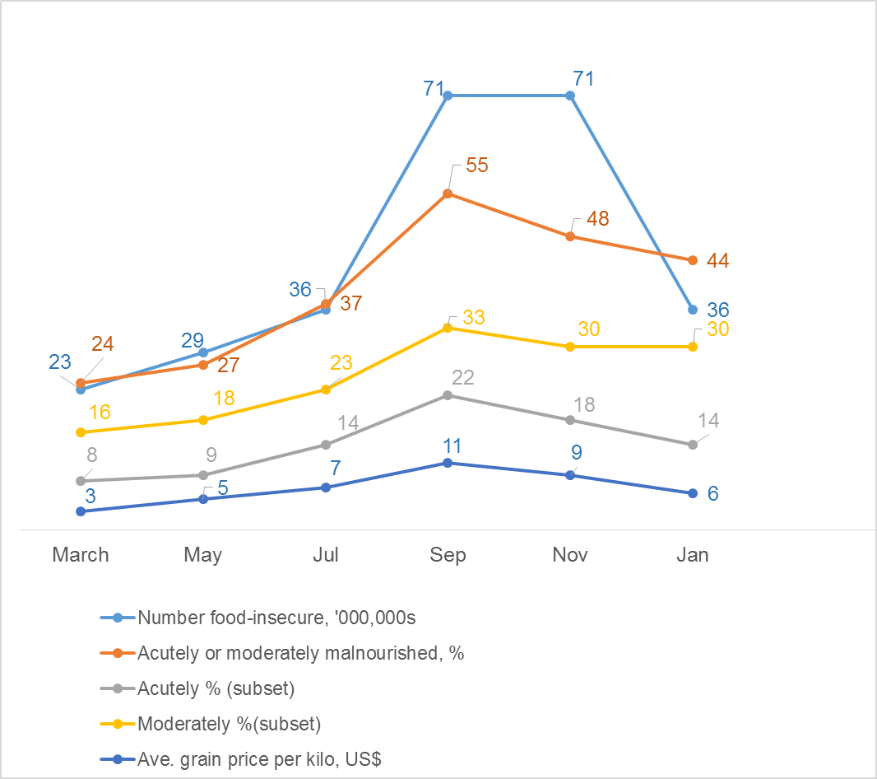

**Crisis map, 12 months**

**a. Declaration**

This simulation is practicing a category:

Yellow  Orange  Red

**b. Disaster impact map**

Starting state (Time jump one)

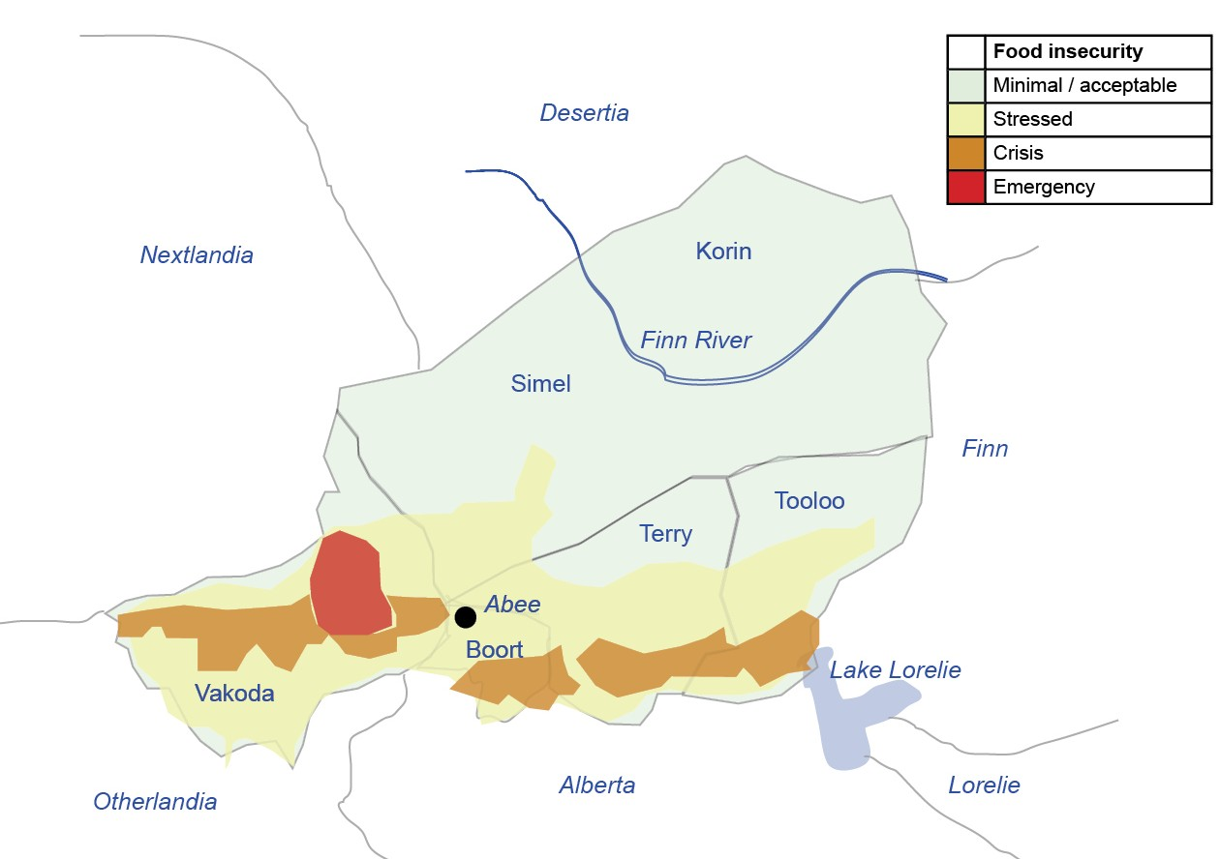

End state (Time jump four)

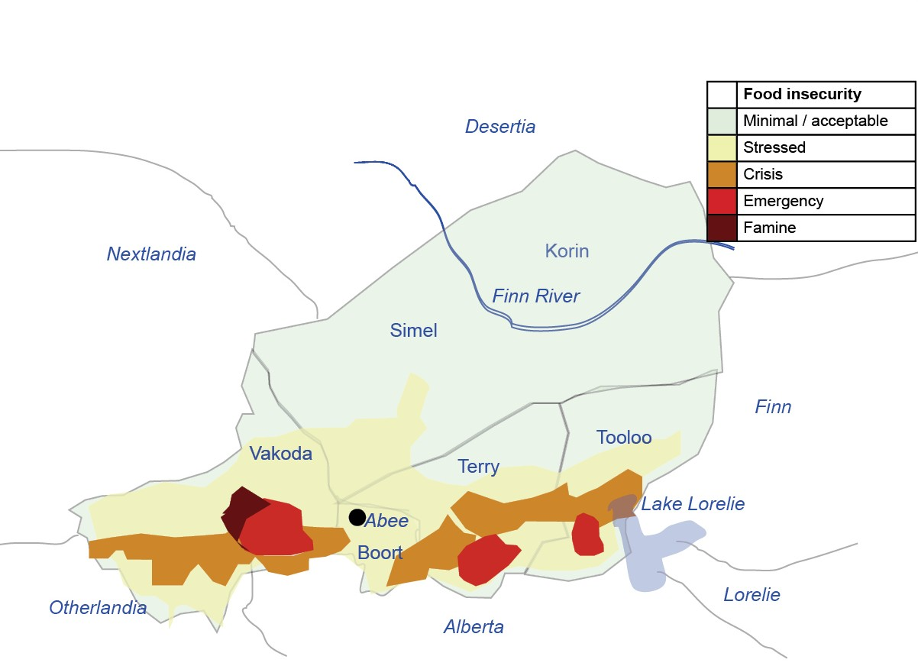

**2. Time jump scenarios**

The structure of the simulation is based on pastoralist communities in Africa. The length of each phase changes with each emergency. The Simlandia drought is a single season event compounding the effect of a similar drought only two years beforehand.

Based on this, the simulation is divided into four time jumps.

The challenges matrix that accompanies this simulation is in a separate Excel file.

***Time jumps***

1. Preparedness
2. One month after declaration
3. Four months after declaration
4. Eight months after declaration

**Time jump summary matrix:** Each time jump has a table that summarises key scenario details and impact of the disaster.

**News articles table:** A table that summarises the news articles follows. (Full-length news articles are featured in a separate folder.) The news articles should be emailed to a list of key participants in the simulation. Each of the news articles can be copy and pasted as draft emails into the lead facilitator’s email address ([simex.news@ifrc.org](mailto:simex.news@ifrc.org)) ahead of time.

1. **Time jump one: Preparedness**

|  |  |  |  |  |  |  |  |
| --- | --- | --- | --- | --- | --- | --- | --- |
| April – June  Summary Matrix   * Assessment taking place on large-scale drought from three years ago * Corruption on food aid evident; president acts * Early warning; signs of food insecurity due to rising food costs; Poor rains recognized as a trigger for extreme crisis * Changing populations: economic migrants returning due to unrest in Nextlandia | | | | | | | |
| Indicator | BOORT (inc. Abee) | TERRY | VAKODA | TOOLOO | SIMEL | KORIN | TOTAL |
| Total Population | 3,826,842 | 2,037,713 | 3,402,494 | 3,328,365 | 3,539,764 | 593,821 | 17 million |
| Number food-insecure | 380,000  (10%) | 470,000  (20%) | 680,000  (20%) | 450,000  (15%) | 300,000  (10%) | Marginally affected | 2.3 million |
| Acutely malnourished U5 | 33,000  (8%) | 20,000  (10%) | 32,500  (9%) | 29,000  (8%) | 28,000  (7%) | 9,500  (16%) | 152,000  (8%) |
| Moderately malnourished U5 (additional) | 57,000  (15%) | 39,000  (19%) | 63,000  (18%) | 49,000  (15%) | 56,000  (14%) | 13,500  (22%) | 277,500  (16%) |
| Deaths due to malnutrition, current year | 163 | 138 | 231 | 131 | 89 | 92 | 12,000 |
| % crops lost |  |  |  |  |  |  | 10% shortfall |
| % livestock lost |  |  |  |  |  |  |  |

**Time jump one: News articles**

|  |  |  |  |
| --- | --- | --- | --- |
| **Preparedness**  **News Articles** | | | |
| **Article number** | **Release**  **Time** | **Article title** | **Article date** |
| 1.1_DROUGHT | 9:00 | Unexpected shortfall in harvest ‘concerning’ | March 29 |
| 1.2_DROUGHT | 9:10 | Early warning #1 on monsoon | March 29 |
| 1.3_DROUGHT | 9:15 | Three years on: assessing the long-term damage of the drought cycle | April 15 |
| 1.4_DROUGHT | 9:30 | Early warnings escalate for poor rainy season | May 13 |
| 1.5_DROUGHT | 9:40 | Nextlandian violence pushes cross-border migration | May 15 |
| 1.6_DROUGHT | 9:45 | Simlandia to increase national budget with international assistance | May 21 |
| 1.7_DROUGHT | 10:05 | Food prices at all-time high | May 28 |
| 1.8_DROUGHT | 10:15 | Food aid scandal rocks Simlandia | May 30 |

**B. Time jump two: One month after the declaration**

|  |
| --- |
| **Time jump two summary matrix**  **July (one month after the declaration)**   * Pastoralists seek help to find feed for livestock * Early warning shows half of Simlandia’s arable land is water-deprived this year * Estimate crop reduction of 20% * Malnutrition in children under five already increasing; WFP estimates up to 500,000 children at risk * Cash for work, food for work programmes are commencing * WFP increases supplementary nutrition programmes to rural areas * Working-age men are leaving for job opportunities in neighbouring Nextlandia; female-headed households, including grandmothers, on the increase * Discussion on cluster system activation; nutrition, logistics, food security and agriculture clusters form |

|  |  |  |  |  |  |  |  |
| --- | --- | --- | --- | --- | --- | --- | --- |
| **Time jump two summary matrix**  **July (one month after the declaration)** | | | | | | | |
| Indicator | BOORT (inc. Abee) | TERRY | VAKODA | TOOLOO | SIMEL | KORIN | TOTAL |
| Total Population | 3,826,842 | 2,037,713 | 3,402,494 | 3,328,365 | 3,539,764 | 593,821 | 17 million |
| Number food-insecure | 400,000  (10%) | 650,000  (30%) | 1,150,000  (34%) | 950,000  (28%) | 450,000  (15%) | Marginally affected | 3.6 million |
| Acutely malnourished U5 | 39,000  (11%) | 36,000  (18%) | 54,000  (18%) | 36,000  (12%) | 42,000  (14%) | 7,500  (16%) | 211,500  (14%) |
| Moderately malnourished U5 (additional) | 78,000  21% | 40,000  23% | 90,000  26% | 70,000  24% | 70,000  20% | 12,000  23% | 360,000  (23%) |
| Deaths due to malnutrition, current year | 163 | 260 | 430 | 210 | 141 | 108 | 1272 |
| % crops lost |  |  |  |  |  |  | 30% shortfall |
| % livestock lost |  |  |  |  |  |  | 800,000 |

**Time jump two: News articles**

|  |  |  |  |
| --- | --- | --- | --- |
| **July 1 – 8 (one month after declaration)**  **News Articles** | | | |
| **Article number** | **Release**  **Time** | **Article title** | **Article date** |
| 2.1_DROUGHT | 11.00 | Emergency declared | July 1 |
| 2.2_DROUGHT | 11.00 | UNOCHA situation report | July 1 |
| 2.3_DROUGHT | 11.20 | The population challenges of a country caught in a drought cycle | July 1 |
| 2.4_DROUGHT | 11:45 | Crackdown on urban violence in Simlandia’s capital | July 3 |
| 2.5_DROUGHT | 12:00 | Scale up in Simlandia, urges UN | July 3 |
| 2.6_DROUGHT | 12:15 | Livestock toll means long-term hardship for Simlandian herders | July 4 |
| 2.7_DROUGHT | 12:30 | Hollow harvest | July 4 |
| 2.8_DROUGHT | 13:00 | Male exodus from Simlandia’s villages as hunger bites | July 4 |
| 2.9_DROUGHT | 13:25 | Food crisis camps run dry | July 6 |

**C. Time jump three: four months after the declaration**

|  |
| --- |
| **Time jump three summary matrix**  **4-9 October (four months after the declaration)**   * Calls for priority emergency assistance; WFP is not reaching all affected areas * FAO estimates 15,000 infants and young children have died due to malnutrition * Starvation among adults, particularly in households that cannot work (elderly or disabled); exodus of male labour * Clean water an urgent need in camps and villages * UN declares famine; seeks US$160 million * Further discussion on appropriate clusters: shelter, protection, health, camp management, early recovery |

|  |  |  |  |  |  |  |  |
| --- | --- | --- | --- | --- | --- | --- | --- |
| **Time jump three summary matrix**  **4-9 October (four months after the declaration)** | | | | | | | |
| Indicator | BOORT (inc. Abee) | TERRY | VAKODA | TOOLOO | SIMEL | KORIN | TOTAL |
| Total Population | 3,826,842 | 2,037,713 | 3,402,494 | 3,328,365 | 3,539,764 | 593,821 | 17 million |
| Number food-insecure | 1,400,000  (10%) | 1,500,000  (50%) | 2,700,000  (80%) | 1,550,000  (45%) | 950,000  (25%) | Marginally affected | 7.1 million |
| Acutely malnourished U5 | 72,000  (18%) | 60,000  (30%) | 100,000  (35%) | 108,000  (32%) | 67,000  (19%) | 7,500  (16%) | 434,500  (22%) |
| Moderately malnourished U5 (additional) | 80,000  (23%) | 75,000  (38%) | 152,000  (44%) | 122,000  (38%) | 77,000  (22%) | 12,000  (23%) | 518,000  (33%) |
| Deaths due to malnutrition, current year | 3163 | 11,260 | 13,430 | 4,210 | 2141 | 1108 | 32,149 |
| % crops lost |  |  |  |  |  |  | 35% shortfall  (225,000 mt) |
| % livestock lost |  |  |  |  |  |  | 40%  (20 million animals) |

**Time jump three: News articles**

|  |  |  |  |
| --- | --- | --- | --- |
| **9-16 October (four months after declaration)**  **News articles** | | | |
| **Article number** | **Release**  **Time** | **Article title** | **Article date** |
| 3.1_DROUGHT | 14:00 | The slow but steady fall into famine | Oct 9 |
| 3.2_DROUGHT | 14:00 | Flash Appeal and situation report #21 | Oct 9 |
| 3.3_DROUGHT | 14:15 | Women stay at home and starve | October 10 |
| 3.4_DROUGHT | 14:30 | Sweet potato as a weapon against famine | October 11 |
| 3.5_DROUGHT | 14:45 | Simlandia’s children never had a chance | October 11 |
| 3.6_DROUGHT | 15:00 | Simlandia’s food crisis desperate for international attention | October 12 |
| 3.7_DROUGHT | 15:30 | Simlandia men at risk of labour trafficking | October 12 |
| 3.8_DROUGHT | 16:00 | Second truck hijacked: ‘pirates still at large | October 14 |
| 3.9_DROUGHT | 16:30 | Therapeutic feeding comes to remote Biko | October 14 |

**D. Time jump four: eight months after the declaration**

|  |
| --- |
| **Time jump four summary matrix**  **2-8 February (eight months after the declaration)**   * Violent race-related clashes at livestock auction * Funding insufficient to continue with distribution and recovery strategies * Aid organisations under pressure to close camps, fast-track early recovery * UNOCHA notes insufficient microfinance, agricultural, agroforestry investment * Rebel groups threaten camp security; government crackdown imminent * Unpredictable fluctuations in meat, grain prices * Malnourished children are succumbing to other health causes; measles epidemic * WFP challenges continue * Threat of future food crisis due to locusts |

|  |  |  |  |  |  |  |  |
| --- | --- | --- | --- | --- | --- | --- | --- |
| **Time jump four summary matrix**  **2-8 February (eight months after the declaration)** | | | | | | | |
| Indicator | BOORT (inc. Abee) | TERRY | VAKODA | TOOLOO | SIMEL | KORIN | TOTAL |
| Total Population | 3,826,842 | 2,037,713 | 3,402,494 | 3,328,365 | 3,539,764 | 593,821 | 17 million |
| Number food-insecure | 400,000  (10%) | 650,000  (30%) | 1,150,000  (34%) | 950,000  (28%) | 450,000  (15%) | Marginally affected | 3.6 million |
| Acutely malnourished U5 | 39,000  (11%) | 36,000  (18%) | 54,000  (18%) | 36,000  (12%) | 42,000  (14%) | 7,500  (16%) | 214,500  (14%) |
| Moderately malnourished U5 (additional) | 79,000  (20%) | 62,000  (22%) | 126,000  (36%) | 96,000  (30%) | 86,000  (21%) | 23,500  (23%) | 471,500  (30%) |
| Deaths due to malnutrition, current year | 11,000 | 23,550 | 55,000 | 28,450 | 15,000 | 2500 | 135,500 |
| % crops lost |  |  |  |  |  |  | 35% shortfall  (225,000 mt) |
| % livestock lost |  |  |  |  |  |  | 42%  (22 million animals) |

**Time jump four: News articles**

|  |  |  |  |
| --- | --- | --- | --- |
| **Time jump four news articles**  **2-8 February (eight months after the declaration)** | | | |
| **Article number** | **Release**  **Time** | **Article title** | **Article date** |
| 4.1_DROUGHT | 09:00 | UNOCHA / WFP Food Crisis Strategic Update | 1 Feb |
| 4.2_DROUGHT | 09:15 | Simlandia air distribution may cease at end of month | 1 Feb |
| 4.3_DROUGHT | 09:30 | Simlandia’s people smuggling tragedy leads to government crackdown | 2 Feb |
| 4.4_DROUGHT | 09:45 | Abee in lockdown after race riots | 2 Feb |
| 4.5_DROUGHT | 10:00 | UN under pressure to close ‘unnecessary’ drought displacement camps | 3 Feb |
| 4.6_DROUGHT | 10:15 | Too little, too late for Simlandia’s starving | 4 Feb |
| 4.7_DROUGHT | 10:30 | Crop controversy: GM or not GM | 4 Feb |
| 4.8_DROUGHT | 11:00 | Early warning on locust infestation for new season crops | 5 Feb |
| 4.9_DROUGHT | 11:15 | Measles epidemic in forgotten south west | 5 Feb |

**3. Designing challenges**

While the participants are working on deliverables, facilitators will give them challenges to test specific skills. Challenges are like bumps in the road; they interrupt participants by asking them to solve an immediate problem or respond to a need. Arriving through a role-played phone call or email request, a challenge prompts action from individuals or teams. They are released at strategic times as the ‘disaster story’ unfolds in order to test a particular skill. Open the corresponding Excel file to find the challenges to adapt for this simulation.

**Part III Facilitation**

Part III provides tips to remember when facilitating a simulation.

**1. Monitors**

*Option a:* Participants monitor themselves by being taken out of the simulation for 20 minutes to watch the simulation and recalibrate team activities when they rejoin.

*Option b:* Facilitators wear a badge or a ribbon to indicate that they are monitors. Before the simulation starts brief the participants that sometimes facilitators will come and monitor the teams. The monitors are not allowed to interact with the participants, and should be considered invisible.

**2. Setting up the rooms**

Regardless of where the simulation is held – the office or a hotel – the rooms will require key facilities. A checklist is provided below.

*Facilitators’ room*

A ‘Restricted Access’ sign on the door

Access to phones (landlines or mobiles)

A list of staff phone numbers

Email access between facilitators and participants

Maps and news articles displayed on the wall

Equipment such as a printer, stationary and IT support

An A0 print out of the challenges matrix

Flip chart paper to write new details that emerge

Water, coffee and pre-packaged lunches

*Participants’ room*

Access to phones (landlines or mobiles)

Email access between facilitators and participants

Wall space to track progress, hang flip chart paper

Equipment such as a printer, stationary and IT support

Access to DMIS

Participants bring their own computers

Water, coffee and pre-packaged lunches

**3. Administration**

Below is a description of the administrative components to plan for.

*Email*

Draft emails of all challenges before the simulation starts

Here are some simple rules to guide the use of email.

1. Facilitators send emails using pre-generated addresses such as simex.faciliator1@ifrc.org.
2. Participants reply to the emails using their work email addresses.
3. Facilitators should draft all emails before the simulation starts.
4. Keep emails short – one or two sentences.
5. Always add SIMULATION ONLY in the title of the email then add the abbreviation for the thematic area followed by the time the email should be released and the title of the email. Always stipulate whom the email is *to* and *from*. See example below:

SIMULATION ONLY: HC_11:05_overcrowding concerns

To: Health and Care

From NDMA: Overcrowding in IDP camps has become a huge issue. Can you come up with a list of 3-5 recommendations for immediate implementation across all camps. What evidence do you base these recommendations on?

*Mobile phones*

Buy sim cards and phone credit for facilitators without local sim cards

*Printing documents*

|  |  |
| --- | --- |
|  | Phone numbers of office staff and new sim cards |
|  | News articles – one copy each group/department and one full set for the facilitation room. |
|  | Challenges matrix – one per facilitator (A4 size) and one extra large size copy (A0 size) for the facilitation room so each challenge can be crossed off as it is completed for the whole group to see. |
|  | Simulation scenario – a copy of for each facilitator and one for the facilitation room wall |

*IT support*

Internet is available

IT person is present for support

**Part IV Debrief**

**1. Debriefing day one**

There are many different ways to debrief a simulation. Below is a suggested format for debriefing day one.

|  |
| --- |
| **Learning objective:**  Identify key individual and team learning from the day to improve performance for the next day. |
| **Total time allocated:** 1 hour |
| **Debrief format:**  Ask participants to form groups of 3-4 persons who have worked closely together during the day. If there are persons who have worked by himself or herself, or with only one other person, then join one of the groups. On flip chart paper do the following:  **1. Celebrate (20 minutes):**  A. Each person writes one thing s/he is personally proud of accomplishing today.  B. The group brainstorms a list of three things the team did well over the day.  **2. Areas of improvement (20 minutes):**  A. Each person writes two things they plan to do differently tomorrow.  B. The group brainstorms a list of three things the team will improve on tomorrow.  **3. Sharing the learning (20 minutes):**  Gather into a large group. Ask each individual group to highlight one accomplishment to celebrate. The next group should not repeat previously mentioned ideas. Collect the flip chart papers. |

**2. Debriefing the entire simulation**

Below is a suggested format for debriefing the entire simulation. Adapt this format by linking it to the simulation aim and objectives.

|  |
| --- |
| **Learning objective:**  Identify key individual and team learning from the entire simulation to take forward for improved performance in future disasters. |
| **Total time allocated:** 3 hours |
| **1. Recalling events (30 minutes):**  Help participants to recall key events they engaged in during the simulation. This exercise is like speed dating. Find a partner. You are given two minutes to ***“Share one thing you did during the simulation that you thought was significant”.*** After two minutes, switch partners.You can spend the last five minutes in a large group recounting some of the events, but do it quickly to establish good momentum.  **2. Review of deliverables (15 minutes):**  Write session deliverables on a flip chart paper, and ask the group to identify how well they thought they did on each one by clapping quietly or loudly.  **3. Personal learning (45 minutes):**  Reflect on personal learning from the simulation by asking, ***“What is my biggest learning from the simulation exercise? What will I do differently now as a result of this learning?”***   * 1. Find a partner you worked closely with and exchange your biggest learning (3 minutes).   2. Change partner, repeat process in new pairs (3 minutes).   3. Form groups of five people who worked closely together. Identify the top three learnings people in the group have in common – write these on a separate flip chart (15 minutes).   4. Share findings to the larger group (15 minutes).   **4.** **Response analysis (1 hour):**  **Select topics (5 minutes)**  The purpose of this exercise is to discuss different aspects of the response. Prepare a list of topics for discussion in groups of five to six people. Below are some suggestions, but feel free to create your own. Write the topics on flip chart paper and hang them up on the wall around the room. Ask participants to stand next to the topic that most interests them.  *Suggested topics:*   * Coordination with external stakeholders * Internal communications * Information management (storing, sharing, using information) * Management of risks (including safety and security of staff, assets and beneficiaries) * Resources (people, funding, supplies, equipment) * Adherence to standards (international humanitarian and IFRC) * Accountability * Roles and responsibilities * Business continuity of existing projects and programmes * Quality of the response plan * Response quality including timeliness, efficiency, appropriateness and effectiveness   **Debrief topics (30-40 minutes)**  Spend approximately ten minutes on each assignment below.   * Create a list of things that were done well. * Create a list of things that could be improved upon. * Create a list of actions or next steps that could improve the theme under discussion.   **Tour of topics (10-20 minutes)**  Groups are given 3-minute rotations to read the flip chart papers of other groups and add information in another colour, if desired. Rotate until all groups have read each other’s work  **5.** **Sector/theme analysis (1 hour):**  **A**. Divide participants into the sectors / themes used for the challenges in the simulation. For example, you may have the following groups (45 minutes):   |  |  | | --- | --- | | * Cash * Comms / Beneficiary Comms * Disaster management * Finance * Health and care * Human Resources * Livelihoods * Logistics | * Relief (NFI and Food) * Resource mobilisation * Security * Shelter * Surge (RDRT/RIT) * Volunteers * Water and Sanitation |   **B**. Answer the following questions on flip chart paper:   * What went well? * What can be improved? * What do we need to do next, and what resources are required? Who will ‘champion’ each activity?   **C**. In a large group, share one key action your group commits to taking as a first step after this simulation (5 minutes to decide in small groups, 10 minutes to share in a large group).  **Close the simulation.** |

1.1_DROUGHT

**Appendix A – Time Jump One News Articles**

SIMULATION ONLY

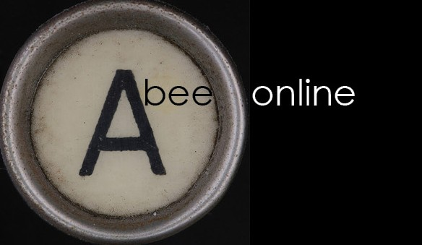

**Unexpected shortfall in harvest ‘concerning’**

*March 29, Abee:* More than 2.5 million people in Simlandia are suffering from food insecurity because of a shortfall in last year’s cereal harvest, the agriculture minister said on Saturday.

"A survey conducted in March indicated that 15.7 percent of the population, or 2,588,128 people, are in a situation of food insecurity, including 410,297 in severe insecurity," the minister told MPs.

The situation has been aggravated by the presence of some 200,000 refugees who had fled attacks by militant groups in neighbouring Otherlandia.

|  |
| --- |
|  |
| *The WFP and government are warning that grain will be in short supply this lean season.* |

Food insecurity in the poor country, which is plagued by recurring food crises, is linked to a cereal deficit of more than 230,000 tonnes at the end of the last crop year, he explained.

The government attributed the shortfall to drought, though rainfall was not significantly less than normal.

‘We cannot say that Simlandia is suffering chronic insecurity but this is still very concerning,’ said Marc Tring, a spokesman for the World Food Programme in Abee, which has helped some 480,000 people since May last year.

‘We are distributing food from the lean period onwards, when the granaries are empty and there is nothing to eat,’ he said.

The lean period lasts several months in Simlandia, usually from April through to July when grain crops are harvested.

The presence in southwest Simlandia of more than 200,000 refugees was having a further negative impact on the food situation, Tring said.

In an attempt to reduce the cereal deficit, the government has already launched a programme to irrigate 130,000 hectares of land to produce 500,000 tonnes of food, he said.

A poor and arid country with rapid population growth, Simlandia is often plagued by food crises.

In April, more than 150,000 children aged under five years, or 8% of that age group, were suffering from acute malnutrition.

1.2_DROUGHT

SIMULATION ONLY



**Early warning**

*March 29*

The monsoon forecast for the Sahel region has just been issued by the African Centre of Meteorological Applications for Development (ACMAD). This is the consensus forecast for the region, drawing together forecasts from many different countries.

The forecast focuses on the months of April to August, when the majority of the rain falls across the region.

This year, the forecast suggests that the majority of the region will experience average rainfall, or even above average in some locations.

The exception is the belt extending between the Finn River and the Pacific Ocean to the West. It is estimated that this region will receive between 70 and 90% of annual average rainfall and also that the onset of the rains is likely to be delayed.

This means that Simlandia, Nextlandia and the northern parts of Otherlandia, Alberta and Finn are all likely to face disruptions and reduced yield.

Farmers in these regions are encouraged to prioritise crops that will withstand low rainfall, repair storage facilities and sow water-stress resistant seeds.

1.3_DROUGHT

SIMULATION ONLY

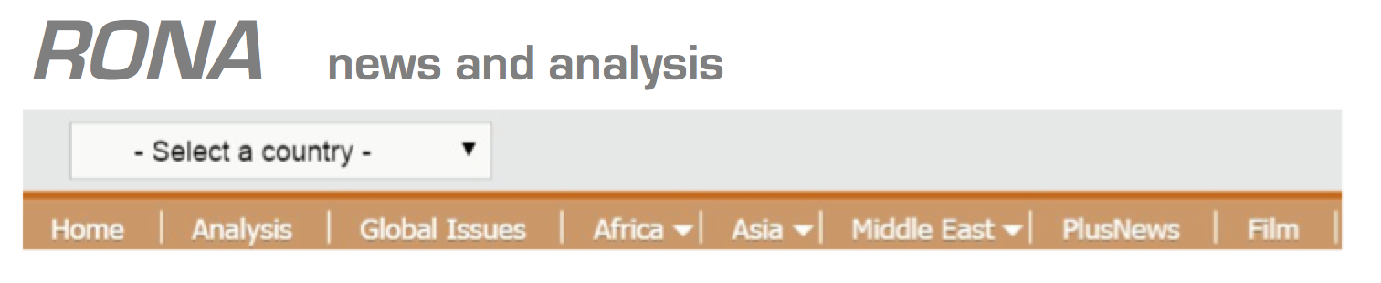

**Three years on: assessing the long-term damage of Simlandia’s drought cycle**

|  |
| --- |
|  |
| *Household solutions like this low-cost reservoir or reserve stock feed could buffer against the effects of erratic rainfall.* |

*April 15, Abee:*  A new report assessing the damage to Simlandia from the drought three years ago suggests th

at the crisis was avoidable and that its effects have weakened the nation’s resilience to future droughts.

The report, by the UN’s FAO, says that a new approach to decision-making on international assistance is badly needed for countries prone to drought. In the six months before the last drought, the Famine Early Warning Systems Network and Simlandia-focused Food Security and Nutrition Analysis Unit (FSNAU) produced 78 bulletins and undertook over 50 briefings to agencies and donors.

Simlandia lies in one of the region’s most productive farming areas for livestock, due to its hardy, semi-arid grassland. But even this land needs rainfall each year if the grass is to grow to its seasonal cycle. In recent years, rain has been increasingly erratic and farmers are forced to purchase food for their stock rather than grazing.

With this cycle well documented, early interventions such as commercial destocking, better farming and water storage methods, cereal banks and cash transfers could have protected livelihoods and household wealth during the lean months. Instead, the drought three years ago pushed 3.3 million people into food insecurity, from which they have struggled to recover.

‘Comparing national statistics now to those of just three years ago, we see higher rates of malnutrition in children, a slight increase in numbers living under the poverty line, and a deficit of around two million livestock,’ explained Sam Pang, spokesperson for the FAO. ‘Recovery is slow not because of weather conditions. Simlandia has had three good harvests since. It is slow because the international community

1.3_DROUGHT

SIMULATION ONLY

underestimated the setback to financial security and nutritional diversity at the time.’

“Traditionally, pastoralists move with seasons. [But] this way of living is threatened by climate change. Animals suffer more and more regularly from a lack of food during the dry season and this has dramatic consequences for the population.”

Government policies need to be developed to take this into account, said the regional humanitarian adviser, Jan Eijenaar, at the European Commission’s Humanitarian Aid Office. “The sector needs to be regulated and stockpiles need to be made during good years.”

Stockbreeder Abdou Magagi backed up these views. “We don’t stock grass because when the situation is normal, we don’t need to. [This year] we should have made stocks, but if the situation gets back to normal, no one will think about stocking any more.”

1.4_DROUGHT

SIMULATION ONLY



**Early warnings escalate for poor rainy seasons**

|  |
| --- |
|  |
| *A child eats high protein ‘plumpynut’ at a therapeutic feeding centre.* |

*May 13, Abee:* Weather forecasters have released a third early warning for the south of Simlandia based on reduced rainfall in April and May. Six weeks into the rainy season, forecasters say that at this stage no more than 70% of average rainfall levels is possible. The water shortages are likely to lead to severe drought conditions in Vakoda and Terry provinces and to reduced crop yields for the July harvest across the country.

The WFP is now making plans to provide supplementary food including nutrition supplements to up to one million people and describes the situation as ‘critical’.

WFP spokesperson Marc Tring said on Thursday that Simlandia should learn and act on lessons from the previous drought.

‘At that time, thousands of children needed treatment for acute malnutrition and President Harold Mulemmi exacerbated the emergency by denying the extent of the hunger,’ said Tring.

Mulemmi was toppled in a military coup in January this year, and it is hoped that the new government, along with close and transparent monitoring of the situation, will help the humanitarian response this time.

‘The new government is not in denial, so the situation may not turn out to be as serious as last time,’ said Tring. ‘The international community and the local authorities have been preparing for this.’

UNICEF reports that demand at therapeutic feeding centres in Vakoda is already on the rise, with an increase of 15% on March figures.

“We are very concerned about mothers in particular, because good nutrition in mothers is vital to the health of their infants and young children. However, mothers do not seek help for themselves. By the time they bring their children, it is often too late, and irreparable damage has been done to the child’s development.”

1.5_DROUGHT

SIMULATION ONLY

***the* standard**

**Otherlandian violence pushes cross-border migration**

*May 15, Abee:* Otherlandian militia have driven nearly 200,000 people into neighbouring Simlandia’s impoverished Vakoda Region this year, sparking food security and protection worries.

Initially, the displaced population were Simlandians heading home or settling within communities in Vakoda. More recently, amid reports that entire villages are being burned and their residents massacred or taken prisoner, Otherlandian nationals are also crossing the border as refugees. The Simlandian government has now sought UNHCR’s help to establish camps at least 50km from the border.

|  |
| --- |
|  |
| *Refugees set up basic shelter as they wait for a formal policy on their future.* |

“At first the majority were returnees, Simlandian citizens who had been working in the gold mines in Otherlandia. But we now believe that the majority are refugees who have nowhere to go. We have come to the point where refugee camps are necessary,” the, International Rescue Committee (IRC) for Simlandia, said yesterday.

The influx has gradually increased over the months as Otherlandia Freedom Army (OFA) stepped up its bloody campaign. An average of 7,000 people have crossed into Simlandia every month since June last year, but from February to date, between 10,000 and 30,000 have arrived every month. After one deadly assault on a border town, the population of displaced people in Vakoda’s Pao district (a makeshift refugee site) rose from 3,000 to 17,000 in less than a week, according to figures from the government appeal.

Competition for space, food and other community resources has sparked violence in several border areas, and there are also concerns that the OFA may use the refugee situation as a smokescreen to attempt incursion into Simlandia.

“The real problem in the long-run is food insecurity,” said a UN Refugee Agency (UNHCR) Simlandia representative. Around 20 percent of Vakoda’s 3.4 million residents are food insecure, and one in four children are malnourished. With the majority of people dependent on livestock or agriculture to survive, the influx of new arrivals is also impacting space for pasture and crops. This is a food-deficient region even during normal times. The arrival of this population is going to increase the difficulty,” Sting said on Saturday.

1.6_DROUGHT

SIMULATION ONLY

**NATION**

**Simlandia to increase national budget with international assistance**

*May 21, Abee:* Simlandia has increased its annual budget by more than 10 percent, in line with what the government described as challenges posed by drought and conflicts along its porous borders.

|  |
| --- |
|  |
| *With unrest in neighbouring countries the nation will spend one third of the budget increase on military and policy capacity.* |

This is the second time this year that the nation, with average income per head hovering around $1 a day, will be increasing its budget.

Around one third of Simlandia’s GDP is foreign aid.

According to a statement by the government on national TV: “All the supplementary allocations are covered by additional exterior resources and new internal resources as well as by restructuring funds along existing budgetary lines.”

President Lakvin Turk, who was elected six months ago following the ousting of previous President Harold Mulemmi, has promised to invest massively in education, health, agriculture, infrastructure and jobs. But her programme has been challenged by the impending food crisis in addition to the fallout of war in neighbouring Otherlandia.

Simlandia also shares a border with Desertia, which is currently under the control of rebels and Islamist groups with links to Al-Qaeda.

It is therefore not surprising that about a third of the new budget increase has been earmarked for security and defense. The government announced recently a 100% increase in the daily wages of Simlandia’s low-ranking soldiers and police.

1.7_DROUGHT

SIMULATION ONLY

**SIMLANDIA SUN**

**Food prices at all-time high**

|  |
| --- |
|  |
| *Children beg for leftover food at a popular restaurant in the nation’s capital.* |

*May 28, Abee:* The prices of grain and milk in drought-hit Simlandia have risen to record highs, exacerbating hardship for the estimated 3.6 million people in the region who are facing severe food shortages and famine in some parts of the country, the United Nations reported today.

According to the August food price monitor of the UN Food and Agriculture Organization (FAO), high prices of cereals such as sorghum and maize in Simlandia are the result of a combination of factors, including drought, reduced secondary season harvests earlier this year and high fuel prices that have driven up transport costs.

The price of milk, a key staple in the drought-affected pastoralist areas, has also surged with the deteriorating conditions of the livestock in recent months. It decreased or stabilized in several markets last month, but remained well above last year’s levels. In the southern region where some parts are experiencing famine conditions, milk prices in June were twice the levels of the similar period year earlier.

Prices of wheat, the country’s staple food, rose sharply last month, reaching new peaks. Wheat prices have been on the increase since February and are currently double what they were a year ago. The high prices are being driven not only by current shortage, but also the anticipated reduction of the “long rains” crop, to be harvested beginning later this month, following the late onset of the rains in many areas.

Higher domestic fuel prices and a food export ban imposed by neighbouring country Finn, also experiencing drought conditions and food shortages, are exerting additional upward pressure on food prices in Simlandia, the FAO report pointed out.

1.8_DROUGHT

SIMULATION ONLY



**Food aid scandal rocks Simlandia**

*May 30, Abee:* As much as half the food aid sent to Simlandia is diverted from needy people to a web of corrupt contractors, radical Islamist militants and local United Nations staff members, according to a new Security Council report.

|  |
| --- |
|  |
| *Food distribution; the UN Security Council estimates up to one half of the aid is lost to corrupt contractors.* |

The report outlines a host of problems so grave that it recommends that UN Secretary General Ban Ki-moon open an independent investigation into the World Food Program’s Simlandia operations. In addition to the diversion of food aid, regional Simlandian authorities are suspected to be tipping off road hijackers on the route aid trucks will take, and Simlandian government ministers have auctioned off diplomatic visas for trips to Europe to the highest bidders.

President Lakvin Turk is emphatically denying any corrupt practices from government on food aid since her appointment to power in January this year.

‘My predecessor was in power for 20 years and was thrown out by his own people for corrupt and criminal misuse of power. I welcome this report as evidence that Simlandia deserves better,” she said in a government press release earlier today.

Several of the report’s authors have received death threats, and the United Nations recently relocated them from Simlandia to New York for safety reasons.

Aid obstructions, theft and inefficiencies were a recurring topic under Mulemmi’s regime and contributed to delays in aid shipments by the American government during a major food crisis three years ago.

The report singles out the World Food Program, the largest aid agency in the crisis-racked country, as particularly flawed.

“Some humanitarian resources, notably food aid, have been diverted to military uses,” the report said. “A handful of Simlandian contractors for aid

1.8_DROUGHT

SIMULATION ONLY

agencies have formed a cartel and become important power brokers — some of whom channel their profits, or the aid itself, directly to armed opposition groups.”

Allegations of food aid diversions first surfaced last year, when a leak to media named individuals at the WFP who were staging the hijacking of their own trucks, then selling the aid in Simlandia and neighbouring war-torn Otherlandia.

The report also says that fraud and corruption exists at every stage of the aid distribution cycle, with about 30 percent of aid skimmed by local partners and local World Food Program personnel, 10 percent by the ground transporters and 5 to 10 percent by the armed group in control of the area. That means as much as half of the food never makes it to the people who desperately need it.

**Appendix B – Time Jump Two News Articles**

2.1_DROUGHT

SIMULATION ONLY

**PRESIDENT DECLARES DROUGHT, STATE OF EMERGENCY**

OCTOBER 2, GOVERNMENT OF SIMLANDIA – The government has declared a state of emergency due to drought conditions across three of its five states.

The state of emergency also sets up a government board tasked with rushing to deliver a long-term food and water security plan within six months.

The number of food insecure people in Simlandia has risen by an estimated one million as a result of reduced harvests and income since rains failed earlier this year.

The government is seeking international support for food assistance, therapeutic feeding, irrigation and alternative cropping programmes.

In a statement issued today, the president said: “This is not the first time we have faced conditions that place the nation in a state of food insecurity. We call on our international friends and partners to help us overcome not only the short term struggles of those affected but also the patterns of weather, desertification and climate change that bring us to this point too often.”

The National Disaster Management Authority is coordinating the response. A senior official said emergency food and water were top priorities in the short term, but that livelihood recovery would be very important in the coming weeks and months.

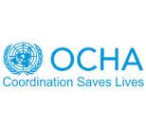2.2_DROUGHT

SIMULATION ONLY

SIMLANDIA FLASH APPEAL, 1 JULY

The United Nations Country Team in Simlandia is launching a Flash Appeal for US$45,919,886 to address the looming food crisis as a result of crop shortfalls in the March to June harvests.

|  |  |
| --- | --- |
| Simlandia food appeal statistics |  |
| Food-insecure population | 3,600,000 |
| Districts affected (see map below) | 4 |
| Children under five severely malnourished | 211,500 |
| Children under five moderately or slightly malnourished | 360,000 |
| Pregnant and lactating mothers at risk | 361,360 |
| Deaths associated with hunger or poor nutrition since March this year | 1272 |

The appeal focuses on support to authorities in their efforts to distribute subsidised cereals and fodder.

The Flash Appeal aims to address the needs of an estimated 200,000 severely malnourished children, 360,000 moderately malnourished children, and 3.6 million of Simlandia’s most vulnerable people who will be provided with food aid, including 361,360 pregnant and lactating women in the most critical areas.

The current food security crisis is further compounded by poor water, sanitation and health conditions that need to be addressed in tandem with food aid.

The strategy for the upcoming months will be to:

* Save lives;
* Reduce
* vulnerability in the immediate term;
* Enhance coping mechanisms in the medium term.

The activities in this appeal will be carried out in close collaboration with the Government of Simlandia, national and international non-governmental organisations, and will complement development programmes already undertaken by the United Nations system.

The UN System and the Government will ensure that they jointly plan and implement recovery activities for the medium and longer-term response efforts

2.2_DROUGHT

SIMULATION ONLY

during the relief phase. As further assessments are undertaken and more accurate information is obtained and analysed, including the results of the upcoming harvest, the Flash Appeal may be revised accordingly.

|  |  |
| --- | --- |
| Simlandia food appeal sectors / clusters | US$ |
| Food aid | 22,068,842 |
| Logistics | 4,400,000 |
| Nutrition | 13,412,644 |
| Agriculture | 4,510,000 |
| Coordination | 1,528,400 |
| TOTAL APPEAL | 45,919,886 |

**BACKGROUND**

The acute food insecurity has structural causes that have been compounded by drought. Some of the structural causes include population growth, non-sustainable farming and livestock-raising in an unpredictable environment. These are further compounded by trends like sub-regional speculation of cereal prices. In addition, conflicts in the sub-region are hindering the migration of labour that has always been the main coping mechanism during the lean season.

According to a joint assessment carried out by the Government, UN and NGO partners in June, 3.6 million people (2,988 villages) are adversely affected by the food crisis, of which 2.5 million are thought to be extremely vulnerable and requiring food assistance. Most of the rural population is facing serious difficulties in accessing staple foods, such as millet and sorghum, and essential health services.

As a result, many people are migrating out of the most vulnerable zones, while others have begun to consume wild food. The limited availability of pasture and fodder is endangering up to 10 million head of herder livestock (3.2 million cattle, 4.1 million goats, 2.1 million sheep and 600,000 camels) in Simlandia’s southern districts. With an initial deficit of 36% or 4.6 million tons of animal dry feed already the case due to the drought two years ago, fodder remains very expensive. The value of cattle is also dropping dramatically due in part to their extremely poor condition, with reports of herds being purchased for as little as $15 per head (usual price is around $150).

**OVERVIEW OF NEEDS**

According to recent localized surveys in the most affected areas (Vakoda, Terry, Tooloo), an estimated 14% of children are severely malnourished and a further 23% moderately or slightly malnourished, compared to the most recent national census (2012) where rates were 8% and 17% accordingly. These rates are comparable to those observed in conflict zones and the worst emergencies in the world.

2.2_DROUGHT

SIMULATION ONLY

At therapeutic feeding centres supported by WFP, UNICEF and MSF, admissions are rising dramatically. As of mid-May, they were at least twice as high as those registered last year for the same period. A further increase in malnutrition is expected up to the end of the lean period, which runs from the exhaustion of food reserves in April until the new harvest in October.

UNFPA estimates that 261,360 women in affected areas are due to deliver over the next three months. During acute humanitarian crises the interplay between malnutrition and communicable diseases results in very high levels of mortality particularly among children. This is further compounded by lack of adequate safe water and sanitation, the rainy season, and difficulties in maintaining basic hygiene. Specific disease threats include malaria, diarrhoea (including cholera), acute respiratory infections, measles and hepatitis. People in Simlandia normally pay for access to government-provided health care. In light of the current threats to their livelihoods, the erosion of their coping abilities, the subsequent reduction in purchasing power and their inability to pay for health care will contribute to a sustained increase in morbidity and mortality. Over the next six months as many as 3.6 million people will require free access to essential health care, medicines, and appropriate public health interventions (such as immunization, diarrhoeal disease and malaria control). International support is needed to permit these life-saving actions – particularly the provision of emergency services, effective nutritional rehabilitation and technical coordination (and monitoring) of activities in the health sector.

**HUMANITARIAN RESPONSE PLANS**

The following section outlines the overall objectives of each sector and indicates the activities that will be undertaken to support the overall strategy.

FOOD:

* Provide two months of targeted free food distribution (full general ration) or 28,842 Mts to 1.6 million food insecure and extremely vulnerable people (WFP).
* Provide one month of targeted free food distribution (reduced general ration) to some 900,000 food insecure and vulnerable people
* Keep a contingency stock of 14,000 Mts of food commodities for free distributions to 502,550 vulnerable people after the harvest in October in case of crop failure
* Provide 5,922 MTs in supplementary food, including CSB, sugar and oil through targeted free food distributions to 480,000 children under five and pregnant and lactating women (WFP).

Total requirements for the food sector amount to: US$ 22,068,842.

2.2_DROUGHT

SIMULATION ONLY

LOGISTICS:

* Reinforce the logistics capacity to ensure the timely delivery of food aid
* by hiring additional trucking capacity [40 trucks] for use along the supply corridors (Nextlandia and Alberta)
* by mobilizing additional pick-ups to support distribution within Simlandia; and by organizing airlifts.
* While Nextlandia and Alberta are the current key supply corridors for Simlandia a third, Finn, is under consideration.

Total requirements for the logistics sector amount to US$4,400,000

NUTRITION

* Provide therapeutic food and non-food items to treat 32,000 severely malnourished children (UNICEF);
* Enhance capacities to treat severe malnutrition at health centre levels by ensuring that staff receives focused training and that therapeutic food supplies are available. World Health Organization (WHO);

Total requirements for the nutrition sector amount to: US$13,412,644

AGRICULTURE:

* Protect livestock in the most vulnerable and affected areas (FAO);
* Thorough sanitation and prophylactic activities (destruction of dead cattle, de-worming) (FAO).
* Recapitalise livestock for the most vulnerable pastors including sensitisation / training activities on de-stocking procedures. Vétérinaires Sans Frontières - Belgium (VSF-B);
* Provide animal fodder (2,500 metric tonnes) for pastors returning to the south on the migration path (FAO); • Provide vegetable (cabbage, tomato and potato), niebe and maize seeds, as well as tools for irrigated farming and gardening (FAO);
* Improve the food security situation for the most vulnerable pastoral households through restocking small livestock (FAO);
* Enhance logistical and technical aspects of the emergency actions and coordination (FAO).

Total requirements for the agriculture sector amounts to: US$ 4,510,000

COORDINATION/ENABLING PROGRAMMES

* Enhance strategic and sectoral-level coordination (OCHA);
* Facilitate decision-makers’ access to timely and accurate information and data analysis on the humanitarian situation and needs (OCHA);
* Enhance public information and advocacy efforts to sustain appropriate international response (OCHA).

2.2_DROUGHT

SIMULATION ONLY

* Facilitate data sharing between key actors working in information management related to the humanitarian situation. (OCHA)
* Analysis of data to improve targeting and identify gaps. (OCHA)
* Reinforce the DNPGCA in coordinating humanitarian assistance. (UNDP)
* Conduct advocacy at national and international levels. (UNICEF)
* Strengthen UN System's planning and response efforts for longer-term recovery activities (UNDGO).
* Reinforcing the personnel and logistical capacity of DNPGCA in coordinating (UNDP).

2.3_DROUGHT

SIMULATION ONLY



**The population challenges of a country caught in a drought cycle**

|  |
| --- |
|  |
| *Population growth outstrips increases in food production capacity by one third each year.* |

*July 1, Abee:* Simlandia’s food insecurity is as much to do with rapid population growth as with low rainfall, according to a new report from Abee University’s School of Anthropology and Culture.

Dean of School William Lang says “There is no magic bullet to resolving our food insecurity. We need to tackle a number of the country’s development challenges, including the high fertility rate which will triple the number of mouths to feed by 2050.”

The report says that population growth – both historical and projected – is a key part of Simlandia’s food security story and deserves more attention. Simlandian women give birth on average to 7.4 children. Less than one in 100 is using contraception or other family planning methods and reproductive health knowledge is extremely limited.

Past population growth helped fuel the country’s rapid deforestation in the 1970s and 1980s, and since the early 1990s, Simlandia has reliably been among the world’s fastest growing countries. Between 1975, when the country was a “virtual desert,” and today, more than 10 million Simlandians have been born.

In the face of such growth, the country’s capacity for food production has not kept pace; while population growth is 3.5 percent a year, food production increases by only 2.5 percent, indicating a persistent and growing gap between the two. And, because of the multiplicative effects of high birth rates, Simlandia’s population by 2050 is conservatively estimated at 55 million.

2.3_DROUGHT

SIMULATION ONLY

The report also points out that a larger population means less land is available per person, which undermines the land rights of the most vulnerable, particularly women, because traditional regulations do not support their access to, and control over, land.

Although modern and religious laws formally provide land rights to women, their weak and sometimes contradictory application adds to the problem. Women are often prevented from participating in farming, and in some areas are excluded completely from society beyond their immediate family.

2.4_DROUGHT

SIMULATION ONLY



**Crackdown on urban violence in Simlandia’s capital**

|  |
| --- |
|  |
| *Cities are filling up fast as dual tensions of drought and conflict force people out of rural areas.* |

*July 2, Abee:* The city of Abee is raising security measures in response to rioting and scuffles between different ethnic groups living there.

Rising food prices, food scarcity and competition over jobs, are all triggers for tensions between long-standing residents of Abee and ‘drought refugees’ from neighbouring districts or countries.

Save the Children, which has launched an emergency appeal for Simlandia, says in some cases families have trekked more than 600 miles to reach the capital Abee to find work or beg for food.

The city has grown from 1.2 million to an estimated 1.5 million in just four months, according to international NGO IRC. A representative of IRC said: “It has not been a good year for the host population and the increased number of people has made it more difficult.”

The bulk of the displaced population arriving in Abee do not have IDs, making it difficult to determine who is a Simlandian citizen and who has travelled from neighbouring countries.

“There are two problems with the lack of paperwork,” the IRC representative said. “Firstly, we don’t know officially who is in need of humanitarian refuge and shelter and whether the UNHCR should be running a bigger programme in the urban context. Secondly, though we may not know, the local communities always do.”

“That represents a risk to civil harmony, because it fuels tensions between ethnic and cultural groups competing for the same limited resources and aid.”

2.4_DROUGHT

SIMULATION ONLY

Though mixed, Abee’s population is around 70% Muran ethnicity, with the remaining groups Swahte, Romel and Simel at around 10% each.

The Swahte are often marginalised within Simlandia and have close tribal ties to people of Desertia, who are considered Arab rather than African. Likewise, the Simel live in and along the border with Finn and Lorelei and many Simlandians see the group as more closely tied to these countries than to their own.

As the numbers of both ethnic groups increases in proportion to the Muran, host community tolerance and patience is wearing thin.

Announcing the heightened security measures at a press conference on Monday, Head of Military Colonel Miko Chang said: “We are seeing vicious attacks on individuals, as well as organised gang fights between different groups, as the demographic of the city changes.”

“We are also concerned about the very real likelihood of insurgents or terrorists among the unregistered arrivals.”

“While we understand concerns from the international community about increased military surveillance, particularly given the previous leader’s reputation for endemic corruption, we believe we have limited alternatives to protect the city from social chaos.”

2.5_DROUGHT

SIMULATION ONLY****

|  |
| --- |
|  |
| *At the end of a long journey, a man carries his weakened daughter towards a UN feeding centre* |

**Scale up in Simlandia, urges UN**

*July 3, Simlandia*: The world should not wait until famine is declared in Simlandia to respond to worsening hunger caused by drought and conflict, the most senior United Nations official in the country said on Monday.

Philippe Lazzarini, the U.N.’s humanitarian coordinator for Simlandia, said $60 million is needed to save the lives of 50,000 children over the next two months and to deliver food and water to 857,000 people, many of whom are internally displaced.

"This situation has troubling similarities with the situation which prevailed before the famine three years ago," Lazzarini said at a news conference on Monday.

The [Office for the Coordination of Humanitarian Affairs](http://www.unocha.org/top-stories/all-stories/sahel-5-things-you-need-know-about-one-world%E2%80%99s-poorest-and-most-vulnerable) has raised the threat of the domino effect of militia violence in neighbouring countries as an additional risk for Simlandia if resources and economy were allowed to weaken further.

Donors have so far provided just over 20% of the $46 million the UN appealed for in July. Lazzarini pleaded with donors to meet the target and allow further discussions on increasing the response to at least $60 million.

"The situation for countless communities in Simlandia... is still desperate," the OCHA factsheet says.

It outlines five key points about "one of the world's poorest and most vulnerable nations."

* The number of people who do not know where their next meal will come from has almost doubled in the past year
* Food and nutrition are at the heart of the crisis, but there are many other factors at play
* A new approach is needed to break this cycle of hunger and vulnerability
* Humanitarian groups are collaborating with governments and development agencies
* Aid groups are confident they can make a huge difference

Lazzarini told media that the country is at ‘make or break time’.

"It's the year we see if we can translate theory into practice and start bringing aid workers together to work with the national government and reverse these trends that have been deteriorating year after year," he said.

2.6_DROUGHT

SIMULATION ONLY



**BERGEN EDWARDS**

**Livestock toll means long-term hardship for Simlandian herders**

*July 4, Abee:* Simlandians are likely to take years to recover from selling their weakened livestock at a fraction of its normal value due to drought in the region.   
  
The drought threatens almost 70 percent of herds, according to rough estimates from the FAO.

|  |
| --- |
|  |
| *Cattle are a vital asset in economic and cultural patterns; rebuilding herds after this year’s drought may take ten years or more.* |

Following the drought, even households with some surviving stock will find their income and wealth substantially diminished for a number of years while their herd numbers slowly rebuild.

Small stock – chickens or goats - will take between eighteen months and three years to reconstitute following losses of 30-40%, whereas a cattle herd will need from 10 to 12 years to recover after a similar level of loss.

The increase in domestic meat prices following a period of drought may be substantial. For example, urban meat prices in Senegal doubled over the first half of 1975, following losses of stock estimated at 30-35% over the previous two years. This large rise in price occurred despite efforts by the government to set a controlled price for meat and a short-term ban on the export of livestock.

“It can take up to 10 years to rebuild a herd with no assistance,” head of the Simlandia Association for the Revival of Breeding (AREN), Dodo Boureima, said. “Next year, people will not be able to survive off their livestock.”

In a country where almost three quarters of the estimated 17 million inhabitants depend at least partly on livestock, animals represent economic security: providing milk and meat for the family; money for food, education and health care; and a dowry in marriage contracts.

2.6_DROUGHT

SIMULATION ONLY

Pastoralists experiencing the greatest losses may be forced to change livelihood, to guard others’ animals, or to find work in towns and cities, said Boureima.   
  
With good rains, good government and international support, herders could recover from their losses much more quickly, said a spokesperson from the FAO. “Our focus must be on fair prices and reasonable solutions for every stock owner, not driving them to desperation and liquidation.”

**Supporting the stockbreeders**

The director of pastoral development in Simlandia’s Ministry of Livestock and Animal Husbandry, Haido Abdul Malik, has been travelling across the country for the last two weeks to evaluate pasture conditions. He is alarmed by what he has seen: hardly any grazing land left; soaring prices of animal feed and weak or sick animals.

“We just met with a stockbreeder who had 50 animals that could no longer move. We saw several dead ones,” Malik said.

“We have seen cattle worth USD$300 sold to butchers for USD$6. That is not even enough to buy one bag of food for the animals.”

To protect the poorest stockbreeders, organizations such as FAO and Veterinarians Without Borders (VSF) have been buying some of the weakest cattle at higher than current market prices.

In the past two months VSF purchased and slaughtered nearly 20,000 animals and treated another 60,000 against parasites in southern Simlandia, paying the equivalent of a month’s worth of food for each animal purchased. The animal meat was redistributed to the most vulnerable community members.

2.7_DROUGHT

SIMULATION ONLY

**Hollow harvest: 'We manage to eat four times a week, but even when we have food it's not enough'**

|  |
| --- |
|  |
| *Assia can feed her family just four times a week at the moment.* |

*July 4, Terry:*

Assia, 20, is desperately worried about her two children, especially her youngest, 20 month old Najaatou. They live in Korgom Village, southern Terry, one of the areas hardest hit by poor harvests last year.

"We only harvested about 10 bundles of millet, and since that ran out, we've had to buy millet. I collect wood to sell so we can buy millet. But we don't have enough food to feed the family because I don't have enough money. I'm not happy to see my children without food. We manage to eat four times a week, but even when we do have food it's not enough.

"It's the same problem for many families in my village. People are living in a lot of difficulty. There are a lot of sick children in the village – both sick and malnourished. For me, it's really linked to the bad harvest, because if a child doesn't have enough food, I'm sure they won't develop properly. My children don't have enough to eat.

UNOCHA estimates 560,000 children in Simlandia are moderately or severely malnourished and is calling for $45 million in international aid to support affected villagers and protect their future livelihoods with early recovery of agricultural and herder practices.

“If we act now we can avoid a full scale famine, but time is running out,” said UN Humanitarian Coordinator for Simlandia Phillipe Lazzarini earlier this week.

2.8_DROUGHT

SIMULATION ONLY

# Male exodus from Simlandia’s villages as hunger bites

July 4, Vakoda: **Manno Gayya is something of a rarity in his village, in that he’s one of the few men still living there.** Most of the male folk have left the scorched land they farm to go mining in neighbouring Nextlandia, or even further afield to Europe, seeking work after last year’s poor harvest.

|  |
| --- |
| Photo: Richard Hanson/Tearfund |
| *Manno’s children work alongside their father so the family can buy food they would usually have on hand.* |

Manno would have gone with them but his wife Hadiza has long-term psychological problems, and as a deputy pastor at a local church he has responsibilities that bind him to his community.

‘We are really facing a problem. The last harvest was not good enough. Last year I collected ten bags of millet but this year it was less than five and it only lasted 45 days.

‘There is no way out right now. We don’t have food, we don’t have money to buy food, and there is not even any food to buy.’

To try and make ends meet, Manno hires himself out as a labourer to other farmers, helping them get their land ready for the planting season, while his children earn money by fetching water for people. Their education suffers as a result.

All my children are going to school but their results are not good because they are working, they are tired, and not eating as much as we would like. Also the teachers asked us to buy the children writing paper but we can’t afford that because of the poor harvest.’

2.8_DROUGHT

SIMULATION ONLY

We ask to see what they will be eating today. Manno brings out a bowl of millet which is a third less than what they need. He points to one of his boys who has a condition that has resulted in clumps of missing hair, explaining that he can’t afford to take him to the clinic for treatment.

Manno says most people in his village are affected like him and a gathering of 50 or so locals seems to bear this out. When we ask for a show of hands about how many meals people eat each day, no hands go up for three meals. Two-thirds put their hands up for two and the remainder say they eat just once a day.

2.9_DROUGHT

SIMULATION ONLY



**BERGEN EDWARDS**

**Food crisis camps run dry**

*July 6, Pao:* Aid agencies say that the current food crisis in Simlandia is forcing population movement at a rate that makes it difficult to keep up with food and water needs.

**Camps and populations (UNHCR figures)**

|  |  |  |
| --- | --- | --- |
| Drought camp | District | Numbers (estimate) |
| Pao 1 (existing, refugee) | Vakoda | 14,000 |
| Pao 2 (existing, refugee) | Vakoda | 6,000 |
| Pao 3 | Vakoda | 7,000 |
| Pao 4 | Vakoda | 2,800 |
| Pao 5 | Vakoda | 4,200 |
| Pao 6 | Vakoda | 2,900 |
| Biko 1 | Tooloo | 5,500 |
| Biko 2 | Tooloo | 3,900 |
| Lorelei | Tooloo | 2,800 |
| Fyane 1 | Terry | 9,000 |
| Fyane 2 | Terry | 5,500 |
| Southern Terry | Terry | 6,000 |
| Abee | Boort | 8,200 |
| Southern Boort | Boort | 4,000 |
| Living in camp peripheries |  | 220,000 |
| **TOTAL** |  | **299,000** |

“We have seen this before, and for this reason, it is doubly frustrating,” said Peter Singh, head of UNHCR operations in Simlandia. “We say that drought moves slowly, and we can predict months in advance that there will be humanitarian impact. But once it happens, its effects are felt rapidly, particularly in the unpredictable movement and needs of affected populations.”

Singh has been in charge of managing camps for the massive swell of people displaced by their hunger. He said that the picture is constantly changing.

“Six weeks ago we opened four camps in Pao district, after the population grew from 18,000 to around 40,000 in two weeks. Already, we have opened two more, and another three near Biko on the other side of the country. Now we are looking at our limited funding, knowing that we need to get to Fyane in Terry district.”

“People don’t register, they simply come and camp nearby. This makes it difficult to identify the most vulnerable, to count the dynamic population, or to ensure that there are sufficient services to meet their needs.”

2.9_DROUGHT

SIMULATION ONLY

**‘Virtually impossible’ to meet water, sanitation needs**

Singh said that given the expense of trucking in water from international sources, and the bad roads and remote locations of areas worst affected, it is proving ‘virtually impossible’ to meet minimum water and sanitation standards in camps.

‘A project to drill or repair boreholes within Simlandia, and keep water delivery as local as possible, looks expensive on paper. But what we do instead, trucking the water from other countries, is false economy. We are looking at up to six months of supply for these camps and we will have nothing to show at the end.’

Singh wants the government to take greater responsibility for the long-term water and irrigation needs of the country.

‘The longer we truck in water, the more difficult the humanitarian response will be. The longer these people stay away from home, the more difficult the recovery will be.’



**Appendix C – Time Jump Three News Articles**

3.1_DROUGHT

SIMULATION ONLY

SIMLANDIA FLASH APPEAL UPDATE AND SITUATION REPORT #21

|  |  |
| --- | --- |
| Simlandia food appeal statistics |  |
| Food-insecure population | 3,600,000 |
| Districts affected (see updated map below) | 5 |
| Children under five severely malnourished | 434,500 |
| Children under five moderately or slightly malnourished | 518,000 |
| Pregnant and lactating mothers at risk | 361,360 |
| Deaths associated with hunger or poor nutrition since March this year | 32,149 |

*9 October:* The United Nations Country Team in Simlandia is updating and increasing its Flash Appeal to address the humanitarian crisis unfolding as a result of chronic food shortage.

**The United Nations has declared emergency levels of food shortage in three districts, crisis levels in four and, in Vakoda district, the highest declaration of famine for the Pao region.**

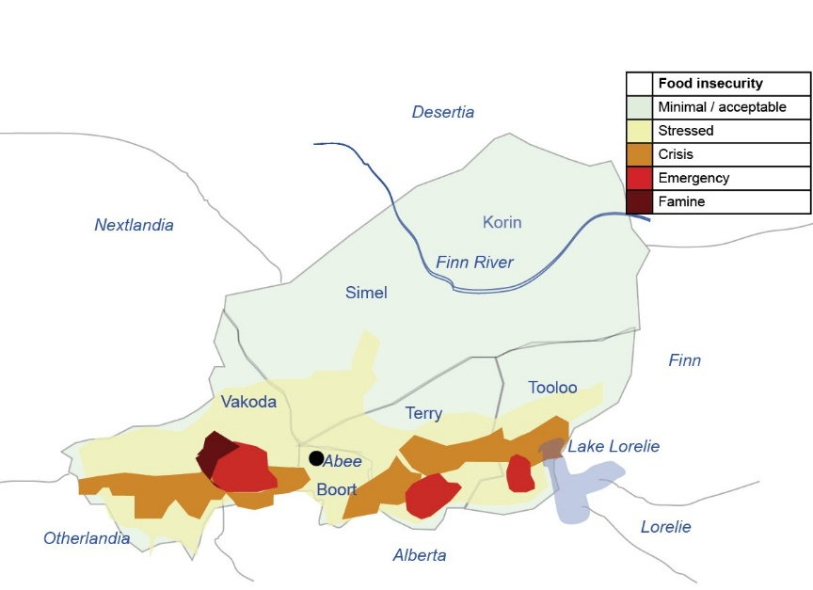Consequently, the Country Team has decided to revise the requirements of the Flash Appeal, expanding the scope and level of activities for an extended period to June next year.

The Flash Appeal now aims to mitigate the effects on and respond to the needs of an estimated 7.1 million food-insecure people in Simlandia. This includes close to 1 million children who are estimated to be either severely or moderately malnourished, as well as 361,360 pregnant and lactating mothers. Figures by province are included as an appendix to this report: see final page.

3.1_DROUGHT (cont.)

SIMULATION ONLY

The Flash Appeal is updated in response to the confirmation of harvest shortfalls and decimation of livestock and fodder reserves among farmers and pastoralists. Livestock prices have fallen as low as $1.50 and all efforts must be made to support farmers to retain, rather than sell, these primary assets for long-term recovery.

The Flash Appeal also expands significantly in terms of health, water/sanitation (WASH), shelter and early recovery, with coordinated clusters put in place one month ago for these sectors. It is evident that weakened nutrition, particularly among children, pregnant and lactating mothers and the elderly, represents risk of infection and death from communicable diseases on a large scale.

The strategy for the upcoming months remains to:

• Save lives;

• Reduce vulnerability in the immediate term;

• Enhance coping mechanisms in the medium term.

The food crisis in Simlandia is being coordinated by the National Food Crisis Prevention and Mitigation Mechanism (NPGCA). While development partners were the first to respond to the food crisis, their capacities have now been stretched beyond limits as only a few humanitarian partners who were present in Simlandia had the expertise and sufficient capacity to implement immediate intensive therapeutic feeding activities and ensure comprehensive and adequate coverage of the most vulnerable areas in order to save the lives of children affected by severe malnutrition. Over the past months several organisations have deployed emergency response resources to boost current efforts as the international response continues to increase gradually.

**BACKGROUND**

In July, the United Nations Country Team in Simlandia launched a Flash Appeal for US$45,919,886 to address the then “looming food crisis” during the lean season from May to September. This appeal focused on support to the authorities in their efforts to distribute subsidized cereals and fodder. The slow initial response to the appeal, however, resulted in the deterioration of the situation, leading to higher-than-usual malnutrition and mortality rates, and prolonging the projected duration and impact of the crisis beyond the current lean season into the harvest and post-harvest period. There has also been some “divergence of views among international actors on the magnitude and intensity of the crisis”.

This has also delayed the formulation of an adequate response strategy beyond food subsidies. The declaration of emergency levels in three different areas and a fullscale famine in Pao, Vakoda, brings the response to a new level of urgency and coordinated action.

3.1_DROUGHT (cont.)

SIMULATION ONLY

**OVERVIEW OF NEEDS**

|  |  |
| --- | --- |
| Simlandia food appeal sectors / clusters | US$ |
| Food assistance | 41,964,010 |
| Logistics | 8,042,000 |
| Health and nutrition | 18,540,000 |
| Shelter, camp coordination | 12,013,420 |
| Food security | 8,501,622 |
| Early recovery | 11,105,000 |
| WASH | 11,428,101 |
| Protection | 3,201,620 |
| Coordination | 1,810,000 |
| TOTAL APPEAL | 116,605,773 |
| Total pre-committed | 39,620,522 |
| Shortfall | 76,985,251 |

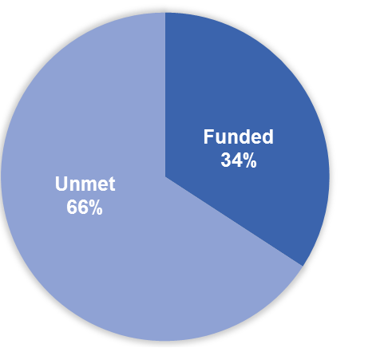Assessments from the Government, UN and NGO partners across five districts in September confirmed that very limited household resilience to reduced food supply had pushed populations into food crisis, fuelling forced migration, selling of farm assets and other decisions detrimental to security and development. The assessments indicate that nearly one third, or 7.1 million, Simlandians are now food insecure. Until August, the focus for food relief had been primarily rural. However, emerging patterns of urban migration, competition for jobs and rapidly escalating food prices are now leading to widespread food insecurity in the country’s capital Abee.

*Funding shortfall - total*

Supplies of fodder for animals are only available through relief agencies, as the nation was not able to replenish any dry feed this year.

Assessments also confirm that around 20 million head of livestock have either died or been sold at liquidation prices, representing nearly 40% of Simlandia’s total.

*Funding shortfall – by programme*

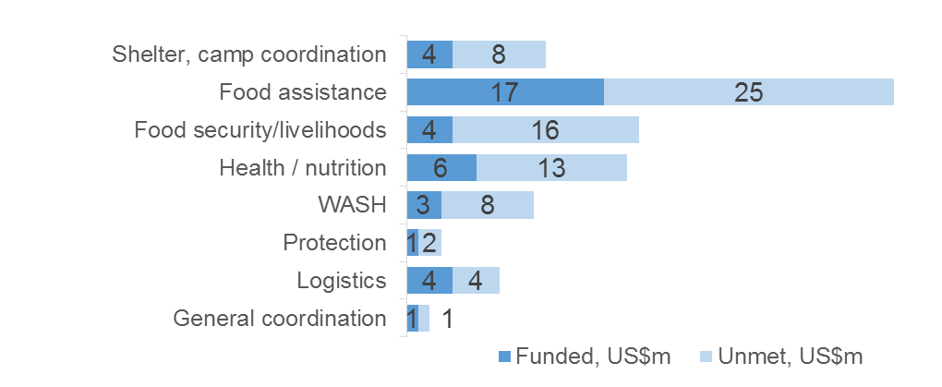

Rates of up to 85% malnutrition in children have been registered in the emergency and famine areas, pushing the estimated national rate to around 55% (22% acutely malnourished, 33% moderately malnourished).

Simlandia started with an unusually high undernutrition rate even before the drought (8% acutely malnourished, 16% moderately malnourished) and recovery efforts must find ways beyond nutrition programming to improve the nutrition status of children.

3.1_DROUGHT (cont.)

SIMULATION ONLY

This requires intentional partnership between nutrition, WASH and health sectors to reduce diarrhoea, one of the leading causes of undernutrition in infants and young children.

Camps have been established to house large numbers of families seeking medical and nutritional care for their children. Some camp residents are staying short term (less than one month) but others, with stock depleted or gone in their home villages, require medium term shelter support in conjunction with livelihoods strategies. Migration of men to neighbouring countries for work is resulting in a high rate of female-headed households in villages and camps.

While much of Simel district and all of Korin are not at levels of concern for food insecurity, it must also be noted that these are among Simlandia’s most disadvantaged and remote areas to begin with. While rates of malnutrition in Korin have not increased, they have always been significantly higher than the national average (16% acutely malnourished, 22% moderately malnourished). These children are living in everyday crisis. The international response must find ways to address ongoing issues of food scarcity and diversity, water and sanitation in geographical areas that are not identified as drought-affected.

Humanitarian Response and Plans

 Camp Coordination and Camp Management; Shelter

|  |
| --- |
| US$12m  (funded: $4m) |

Needs:

Up to 350,000 people are seeking short or medium term shelter located near therapeutic feeding centres or distribution points

Response*:*

* Six interim camps have been established under management of UNICEF, UNHCR, housing 120,000.

Constraints:

* Population movements are unpredictable
* Security issues in camps close to Otherlandia border

3.1_DROUGHT (cont.)

SIMULATION ONLY

 Food Security, Food assistance and livelihoods (early recovery)

|  |
| --- |
| US$62m  (funded: $21m) |

**Needs:**

* Degradation of household assets (livestock and seed) challenges short term recovery for up to 200,000 herders and pastoralists
* Cash-for-work and food-for-work alternatives to limit economic migration

***Response:***

* Procurement of 6,183 Metric Tonnes (MT) of food commodities (WFP);
* Distribution of 502 MTs of food commodities to some 27,000 affected persons (WFP);
* Procurement of 614 MTs of cereals to restock 61 cereal banks in affected areas (UNICEF);
* Distribution of 110 MTs of bean seeds to 400,000 farmers for the current cropping season and 853 MTs of fodder to some 10,000 pastoralist households (FAO).
* Reinforce cereal banks in the most affected areas (UNICEF);
* Use 953 Mts of food commodities through Food-for-Work actions for 59,184 beneficiaries (WFP)

***Gaps and constraints:***

* Animal dry feed is only available on the black market, some of it reselling of FAO distributions
* Engaging women in cash-for-work, food-for-work, is culturally challenging

 Health and nutrition 

|  |
| --- |
| US$19m  (funded: $6m) |

**Needs:**

* Midwife and ante-natal care facilities to mitigate risk for pregnant mothers
* Simlandia’s health system is user-paid, reducing levels of health-seeking behaviour through government facilities

**Response:**

* Procurement and distribution of therapeutic food and essential drugs for 15 therapeutic feeding centres, dispatched through 10 implementing partners (UNICEF);
* Training of 80 health workers and partners on the treatment of severe malnutrition nationwide (UNICEF);
* Procurement and distribution of 190 MTs of Unimix to feed 31,666 moderately malnourished children for one month (UNICEF);

3.1_DROUGHT (cont.)

SIMULATION ONLY

* Community-led total sanitation projects in villages in Simel, Terry, Tooloo through World Vision.

*Gaps and Constraints:*

* WASH programming in Simel and Korin outside the emergency areas is underserved by NGOs and government. (Korin, with a low and largely nomadic population, has a child mortality rate of 1 in 7).

 Protection

|  |
| --- |
| US$3m  (funded: $1m) |

**Needs:**

* Distribution riots have been reported and must be monitored carefully
* Gender protection and inclusive programming for women and girls is required in and around camp areas.

**Response:**

* All distribution teams will be assigned uniformed military officers to provide security.
* A Child Protection Assessment is being conducted by the Ministry of Women, Youth, Children and Family Affairs.
* UNFPA is coordinating an assessment on current diversion of programming away from social (gender, disability and vulnerability) to emergency programming, and will deliver recommendations for the NGO community for integrated approaches to the food crisis.

**Constraints:**

* Challenges in working with informal power structures on issues such as peacebuilding, social cohesion, gender-based violence.

Logistics

|  |
| --- |
| $US8m  (funded: $4m) |

**Response:**

* Supply routes from three neighbouring countries are now open to trucks running water, cereals and animal dry feed.
* Airlifts remain key to reaching worst affected areas, allowing weekly distributions in nine remote locations.

**Constraints:**

* Higher delivery costs, multiplied seven-fold in some cases, to airlift and immediately deliver relief supplies.
* Air drops are seen to contribute to the risk of violence and black market reselling, and have been banned by government.

3.1_DROUGHT (cont.)

SIMULATION ONLY

Appendix: Food security statistics by province

|  |  |  |  |  |  |  |  |
| --- | --- | --- | --- | --- | --- | --- | --- |
|  | **BOORT (inc. Abee)** | **TERRY** | **VAKODA** | **TOOLOO** | **SIMEL** | **KORIN** | **TOTAL** |
| Total Population | 3,826,842 | 2,037,713 | 3,402,494 | 3,328,365 | 3,539,764 | 593,821 | 17 million |
| Number food-insecure | 1,400,000  (10%) | 1,500,000  (50%) | 2,700,000  (80%) | 1,550,000  (45%) | 950,000  (25%) | Marginally affected | 7.1 million |
| Acutely malnourished U5 | 72,000  (18%) | 60,000  (30%) | 100,000  (35%) | 108,000  (32%) | 67,000  (19%) | 7,500  (16%) | 434,500  (22%) |
| Moderately malnourished U5 (additional) | 80,000  (23%) | 75,000  (38%) | 152,000  (44%) | 122,000  (38%) | 77,000  (22%) | 12,000  (23%) | 518,000  (33%) |
| Deaths due to malnutrition, current year | 3163 | 11,260 | 13,430 | 4,210 | 2141 | 1108 | 32,149 |
| % crops lost |  |  |  |  |  |  | 35% shortfall  (225,000 mt) |
| % livestock lost |  |  |  |  |  |  | 40%  (20 million animals) |

3.2_DROUGHT

SIMULATION ONLY



**The slow but steady fall into famine**

*Press Release October 9: embargoed till 10am EST.*

__________________________

On October 9, the United Nations declared that the conditions in Pao region, Vakoda district, met the definition of famine.

|  |
| --- |
| Boy's arm being measured for malnutrition |
| *Rates of acute malnutrition in children have recently been measured at 38%.* |

Famine has a technical definition based on food security and nutrition. In order for a famine to be declared, there must be evidence of the following three conditions:

1. At least 20 percent of the population has fewer than 2,100 calories of food a day;

2. Prevalence acute malnutrition must exceed 30 percent of children; and

3. The death rate must exceed two deaths per 10,000 people, or four child deaths per 10,000 people per day.

Tragically, all three of these conditions have been found in the Pao region of southern Simlandia. At least one third of the population are eating fewer than 2,100 calories. Acute malnutrition has been measured at 38%, or approximately 550,000 children aged under five. The death rate in some areas is as high as six deaths per 10,000 people with children especially vulnerable. UNICEF has estimated that as many as four children are dying every hour in Pao.

Nutritional and livelihoods surveys across all drought-affected areas revealed crisis and emergency levels of hunger in three states – Vakoda, Terry and Tooloo – and significant food stress in Simel and Boort.

Rainfall in northern Simlandia was above average and Korin district is not affected; however this district is the most impoverished and under-serviced of any in Simlandia. Its people are likely to feel the effects of the drought in high costs of food, food shortages and reduced employment opportunities.

3.3_DROUGHT

SIMULATION ONLY

**NATION**

**Women stay at home and starve**

*October 10, Abee:* The current food crisis across five of Simlandia’s six districts is exposing the particular vulnerabilities of girls and women. In traditional cultures, particularly those associated with farming or herding, women rarely take part in economic decisions or activities. Though they are legally entitled to own land, a powerful counter-influence exists in the tradition of *kubli* where women are kept in seclusion and not taught about farming practices.

|  |
| --- |
|  |
| *It is not usual for women to participate in farming. This reduces family productivity and the role of women in household decisions.* |

*Kubli* began in wealthy households where the husband had the means to provide for his wife or wives, absorbing any land she owned at the time of marriage and allowing her a life of relative comfort. However, the practice is now widespread and is preventing women in poor households from generating any income towards the household’s food and nutrition needs.

With high numbers of female-headed households due to male migration for work, the reduced participation and capacity of women living in *kubli* is particularly concerning.

Where women are given the opportunity, they have the capacity to produce fast-producing crops with high nutritive and economic values, such as beans, groundnuts and moringa (the leaves of which are eaten during the ‘lean season’), millet and sorghum. However, because of their exclusion from some or all farming activities, many women are unable to make their farms work without their male relatives.

Marli Heng, spokesperson for UNHCR, says that though protected by law, many women are hesitant to leave home on their own to attend training or even to collect distributions.

‘We find that the women in the camps are more likely to get involved with the agricultural training and start gardening, often forming their own cooperatives

3.3_DROUGHT

SIMULATION ONLY

to share the load. Women who are not displaced are actually more vulnerable because they are frightened of what people will say if they start participating.’

‘Allowing women to be productive and participating in their household livelihood will create additional resilience to the lean season. Instead, there are women who are literally staying at home and starving, because they don’t know what to do. It will not just be a problem this year. We need to be engaging local leaders, law enforcers and men, to change the practice long term.’

3.4_DROUGHT

SIMULATION ONLY



**Sweet potato as a weapon against famine**

*October 11, Simel:* The cropping of **orange-fleshed sweet potatoes** – containing high levels of Vitamin A precursor – as animal fodder and food for humans has been successfully tested in southern Simlandia.

The initiative was conducted in the framework of an FAO-United Nations Children’s Fund (UNICEF)–World Food Programme (WFP) **Joint Resilience Programme** in Simlandia, which seeks to help vulnerable communities to better withstand shocks and avoid resorting to negative coping strategies.

|  |
| --- |
|  |
| *Ali Bajun, a farmer, has raised his first crop of orange-fleshed sweet potato despite current drought conditions.* |

Vitamin A deficiency can erode the immune system and contribute to malnutrition, most seriously affecting pregnant women and young children in low-income countries. Simlandia, like many low-income countries, has a high prevalence of Vitamin A deficiency. With levels of hunger and malnutrition pushed well into the emergency zone across four of Simlandia’s six districts this year, the FAO believes investment in crop diversification using the sweet potato is urgently required.

Over the past 12 months, FAO agronomists have been working with farming communities in Simel and Terry districts, where livestock is a mainstay, to conduct trials on the use of sweet potatoes to overcome pasture scarcity.

The trials included four strains of potatoes, as well as Sudan, Kikuyu and Napier varieties of grass.

Disappointingly, drought conditions saw the pilot in Terry fail, but the results from Simel are encouraging, with the orange-fleshed variety a clear winner.

“Sweet potatoes are very sweet and nutritious to eat,” said Ali Bajun while eating a boiled sweet potato for lunch in his field. “The animals too love

3.4_DROUGHT

SIMULATION ONLY

potato leaves as fodder and we have already seen good results in their body condition and the amount of milk they provide.”

The sweet potato is a year-round crop that can be planted at any time and actually benefits from reduced watering as the crop matures.

The farmers producing these sweet potatoes will also be supplying nutrition projects, under the **FAO-WFP-UNICEF**joint resilience programme. WFP will use the produce in its school feeding programmes and UNICEF will promote the consumption of the Vitamin A rich potatoes to reduce deﬁciencies in children and pregnant and lactating women.

“It is our hope that by re-introducing orange-fleshed sweet potatoes in Simlandia, we will not only be combating widespread malnutrition, but also be providing fodder for livestock, which many households depend on”, said Jose Lopez, FAO’s agriculture sector coordinator in Simlandia.

3.5_DROUGHT

SIMULATION ONLY

***the* standard**

**Simlandia’s children never had a chance**

*An opinion piece by Dr Zhair Schafer, regional nutrition advisor, UNICEF*

*October 11:* It is significant that the biggest ‘famine’ emergency in Simlandia – the admission of thousands of very malnourished children to nutritional centres – did not come from the pastoral and agro-pastoral zones experiencing drought first hand. The children found in Médecins Sans Frontières (MSF) and other nutritional rehabilitation centres in Pao were from wealthier areas of Simlandia, including urban hubs as well as farming areas well away from the harsh desert landscape of the north-east.

This area is the country’s breadbasket, the source of most of its agricultural surpluses and commercial crop production and its commercial hub. It enjoy close trade links with Nextlandia and was largely untouched by the drought of three years ago. But the guilty secret here was existing chronic rates of malnutrition in children despite the resources to avoid it. It did not take much to push this into emergency levels.

|  |
| --- |
|  |
| *Existing poor nutrition in children is at the heart of vulnerability to famine.* |

A Food and Agriculture Organisation (FAO) nutritional profile for Simlandia from nearly three years ago found that: ‘… high levels of wasting (20%) and stunting (43%) make children vulnerable to sudden diet deficiencies or illness. Numerous factors including diarrheal disease, very young first-delivery mothers, and above all, feeding habits such as the early weaning of newborns 4-5 days after birth being fed on water, herbal teas and cow’s milk, partially explain the contradictions observed between nutritional status and food consumption.’

Because of the low priority of educating girls and women in Simlandia, the situation has changed very little since then. These explanatory factors are still the case today. They do not relate to the consumption of food, and food aid will not eliminate the causes of the area’s malnourishment.

The vast majority of cases of severe malnutrition have been infants aged between six and 24 months, who are very vulnerable to weaning-related illnesses, and it was reportedly uncommon to see more than one child from

3.5_DROUGHT

SIMULATION ONLY

any single household in these camps. There were almost no cases of severe acute malnourishment of adults.

Taken together, all of these features are more consistent with a chronic poverty-related condition, where non-food factors are more important in creating the nutritional crisis, than a generalised lack of food in the household, or starvation. Yet the case has been forcefully made by numerous actors, including MSF, the media and UN organisations, that a famine was occurring in these areas, and the pictures and the nutritional centre admissions were there to prove it.

It is true that the current levels of vulnerability meet the definition of famine, and also true that children in their weakened state are dying by the hundreds. On the other hand, as one Simlandian government official noted last week, ‘we have often seen famine, and it is not this.’ A single season of reduced calorific intake is undoubtedly a hardship. But the current practices of early childhood health and nutrition take it from hardship into catastrophe. These children never really had a chance.

3.6_DROUGHT

SIMULATION ONLY****

**Simlandia’s food crisis desperate for international attention**

*October 12, Abee:* Aid agencies warned yesterday that 7 million people are facing severe food shortages in the landlocked nation of Simlandia, after a drought led to the failure of last year's crops. As many as 400,000 children are at risk of dying from starvation, according to Save the Children.

Robert Bailey, Oxfam's West Africa campaigns manager, said that some food was available in marketplaces in Simlandia, but was too expensive for ordinary households to afford. As a result, many were reduced to eating leaves and berries.

|  |
| --- |
|  |
| *Local markets have less to sell and are selling at a higher rate, pushing many families into food insecurity.* |

Organisations including Oxfam and Save the Children say that the slow international response to the emergency means that only 40 per cent of those affected are receiving food aid. In Pao, the area declared a famine zone by the government and the United Nations earlier this month, as many as four out of five children require treatment for malnutrition in clinics.

Such is the shortage of international aid that the United Nations World Food Programme has had to scale back its US$50m programme to reach 5 million people in Simlandia and instead concentrate its efforts on the most vulnerable, children under two.

Save the Children says the increased malnutrition rate could swiftly be followed by an increase in the number of children dying from disease because the water that is available is contaminated and stagnant, a breeding ground for childhood killers such as malaria and diarrhoea.

"After six months without proper nutrition, these children have little resistance to disease," said Severine Courtiol, Save the Children Simlandia. "There is little children can do to avoid coming into contact with this contaminated water. Trucking in water is much more expensive than filtering local sources,

3.6_DROUGHT

SIMULATION ONLY

but we are struggling to find donors for water infrastructure projects like sinking or repairing boreholes.”

"The donors shouldn't now just pack up and go home," Mr Bailey said. "The food aid does nothing to address the ongoing vulnerability. The region continues to be exposed to this kind of emergency in the future. We are asking donors to stay and help with a transitional programme. These kinds of emergencies are insidious because they are slow burning, which means they don't have the same impact in the media as the floods in Pakistan or earthquake in Haiti, for example."

Save the Children added that last week 2,400 severely malnourished children under the age of five visited its clinics. This was up from 609 in the first week of September, just one month previously.

3.7_DROUGHT

SIMULATION ONLY



**Simlandia men at risk of labour trafficking**

*October 12, Biko:* “It was the drought that made people move away from here,” Ousmane Touré said in Biko, 450km northeast of Simlandia’s capital and a 10 hour bus ride across the scorched scrubland of the country’s desert region. “When the harvests failed in the 1970s we saw a real surge in emigration. There was simply not enough to eat, so people took off for France, Germany and the United States. They knew it was only the way of feeding their families back home in Biko. The same thing is happening this year.”

|  |
| --- |
|  |
| *Existing poor nutrition in children is at the heart of vulnerability to famine.* |

Touré heads the Association of Returning Migrants of Biko (ARMB), a welfare organization that tries to provide short-term shelter and counselling to people coming back to this part of the country. The returnees, particularly those from the ethnic Simel community, have played a major role in developing eastern Simlandia through remittances and other cash transfers, giving it a stronger identity and economic base. Many of them are now deportees who have fallen foul of immigration restrictions in France or other countries.

“The emigrants have been well-organized and have always ensured money gets channelled back, building health centres, schools, even roads,” said Touré, “but the economic crisis in Europe and tighter immigration controls are having a serious knock-on effect, and impoverished villages can no longer count on the same level of support.”

“At the same time, migrants who are leaving for European countries are placing themselves in serious danger of exploitation, trafficking or criminal charges. The best thing for everyone would be for these migrants, mainly men, to stay put and help with the main planting season which is already upon us. Instead, the slow starvation of families is too much to bear, and they are leaving in desperation.”

So ARMB is changing its focus from repatriation to reduced migration. The timing is less than ideal but according to Touré, the urgency to find solutions outweighs the challenges.

“We are seeking partnerships, particularly in livelihoods, so that men who are thinking about leaving have other options to explore.”

ARMB is also expanding its farmers’ associations, which once focused solely on returnees, to incorporate all men in the community. These associations pool resources and operate their own bank with small loans at low interest that can be used for business or personal shortfalls.

As a local organisation, Touré says it is difficult to get attention or funds for the cause compared to the current spotlight on Pao. “We do feel forgotten up here, as if nothing has changed since that first wave of migration. If this organisation was not in place, there would be nobody to help these men at all.”

3.8_DROUGHT

SIMULATION ONLY

**SIMLANDIA SUN**

**Second truck hijacked; ‘pirates’ still at large**

*October 14, Pao:* The Simlandian government has labelled a criminal gang ‘pirates on land’ after they hijacked a truck and killed a driver delivering UN food aid to south-eastern Simlandia yesterday.

The truck was carrying 80 tonnes of food aid including beans, rice, oil and canned goods when it was stopped at gunpoint on the main highway around 140 km outside Fyane*,* said Stephanie Savariaud, a spokeswoman for the UN's World Food Programme. It is the second truck to be hijacked on the road since camps opened in Fyane, Terry province, two weeks ago.

|  |
| --- |
|  |
| *The WFP has been plagued by accusations of corruption and cartel involvement.* |

“We are saddened and concerned by the death of our staff member and must now work closely with the government to resolve security issues for distribution in the south,” said Ms Savariaud.

In a statement on the attack, SimlandianAttorney General Marko Som stated: "We consider these unforgivable acts to be akin to piracy. The perpetrators of this violence are denying food to the starving, undermining further deliveries to the region and worsening the prevailing humanitarian situation.

“We will find and stop these pirates on land.”

According to other members of the team, the Boortian driver fought with the hijackers and was shot in the struggle. The driver and distribution teams were not harmed in the previous hijacking. In both cases the truck was then driven in the direction of the Otherlandiaborder.

3.9_DROUGHT

SIMULATION ONLY



**Therapeutic feeding comes to remote Biko**

*October 14, Biko:* The UNICEF Therapeutic Feeding Centre has just opened its doors in the commune of Illela, some 30km south of Biko, Tooloo province. Operating from six tents in the shade of the local community hall, it has so far registered 1108 children for treatment. Sadly, doctors have also recorded the deaths of 17 children from nutrition-related causes, their weak bodies unable to withstand yet another minor infection, fever or diarhhoea.

On the dusty steps of the community hall, sits Jacouba and his mother, Halima. She is feeding the 10-month-old spoonfuls of a nutritious porridge she has mixed herself from the enriched Unimix flour handed out here last Friday.

Jacouba's belly is still visibly distended from the chronic lack of food in his short life, but his eyes are bright and his breathing is easy.

|  |
| --- |
| Halima and her 10-month-old son Jacouba  *Jacouba's appetite is back, his mother says.* |

Halima is happy to report that he has started breast-feeding again and his appetite is back.

"Our situation was a catastrophe, I was so worried about Jacouba," she says. "But he's got so much better; it's a total change from how he was before."

Zara says she could hardly believe it when the town crier announced that families with malnourished children should go to Illela, where they would receive food; not just for the children, but for their relatives as well. She came one week ago and says she will stay at least another week, to be sure of Jacouba’s recovery, before walking around 15 km home with her baby and her WFP family rations.

A few kilometres down the road, in the village of Guidan Karo, Chamcia’s grandmother Zara is caring for her at home. “I am needed here,” she says, “so I cannot stay closer to Illela. It is better to remain in your home if you can.”

But Chamcia, aged two, is clearly not recovering as rapidly as Jacouba. Zara, says she is still vomiting, a sign that she has yet to metabolise her nutritional supplements. "She has improved a little today," says Zara, who has been looking after Chamcia since her mother died from gastric illness last year.She's been sick ever since she was born, she couldn't get any milk from her mother, it was terrible. The only thing we've had to eat has been grass.

**Appendix D – Time Jump Four News Articles**

|  |
| --- |
| **Country name:** Simlandia  Earthquake  Situation Report No. 32 (as of 27 October) |
|  |

This report is produced on a weekly basis by OCHA Regional Office in collaboration with WFP and other humanitarian partners.

Situation overview

 The situation in Simlandia has continued to improve since the crisis of June to October last year, when 7.1 million people experienced extreme food insecurity and famine occurred in some regions of the south.  Continued improvements are attributed to average-to-above-average rainfall in the July to December period, which has led to some recovery of livestock prices, improved milk availability, lower prices of both local and imported staple food commodities, and sustained humanitarian intervention.

**Humanitarian Assistance Remains Vital**

|  |  |
| --- | --- |
| **Impact Estimates** |  |
| Food-insecure population | 3.6 million |
| Districts affected | 5 |
| Children under five severely malnourished | 214,500 |
| Children under five moderately or slightly malnourished | 471,500 |
| Pregnant and lactating mothers at risk | 1 million |
| Deaths associated with hunger or poor nutrition since March last year | 135,500 |

However, despite consistent improvement in the overall situation, 1.6 million Simlandians remain in "crisis" or "emergency" conditions, according to the FSNAU data of January. A further 2 million are considered to be “stressed,” meaning they are struggling to meet their minimum daily needs. Households belonging to this group remain highly vulnerable to major shocks that could easily push them back into food security crisis.

4.1_DROUGHT (cont.)

SIMULATION ONLY

As a result, lifesaving humanitarian assistance and livelihood support remain vitally important through to the end of this year to help food insecure populations meet their immediate food needs, protect livelihoods, and build resilience.

**Malnutrition Rates Remain High**

Global Acute Malnutrition (GAM) rates nationwide have fallen since the height of the crisis, from 22% in October to the current level of 14%. Despite this gain, it should be noted this is dangerously close to WHO emergency threshold for U5 GAM of 15%, and that one year ago, the rate was 8%. Any gains made in food security and nutrition could be lost without continued humanitarian assistance as the situation must be considered fragile, with communities recovering from many seasons of failed rains and subsequent drought. Meanwhile, insecurity and conflict continue to contribute to poor household food security and high malnutrition rates.

**WFP programming update**

WFP’s focus during the past year has been and through 2014 will continue to be on longer-term recovery programmes. These are aimed at providing responses that help to enhance the resilience of an individual or community by increasing household income, providing basic services and establishing predictable "safety nets" to address basic needs.

WFP will continue to focus on nutrition programmes that support the most vulnerable members of the population, namely women and children. Through supplementary feeding programmes and, where possible, through health centres, WFP provides specialised nutritional food products to treat and prevent malnutrition. At times of greater need, during lean or dry seasons, a family ration is included as there is a likelihood of other family members also being malnourished.

**Social Safety Nets**

To assist communities and strengthen their resilience to shocks, such as drought or floods, there are community asset-building programmes that include the construction of reservoirs, wells and roads.

WFP continues to expand its school meals programme, which provides school-going children with a cooked meal each day during the school term. This has the added benefit of increasing school attendance and promoting the well-being of future generations. While continuing to provide targeted emergency or relief assistance when needed, WFP’s programme to the end of the year aims to help some 1.3 million people cope more effectively with hardships that might affect themselves and their communities.

4.1_DROUGHT (cont.)

SIMULATION ONLY

Funding

|  |
| --- |
| Simlandia Consolidated Appeal  US$120 million requested |
| Funding by programme  ­­­­ |

All humanitarian partners, including donors and recipient agencies, are encouraged to inform OCHA's Financial Tracking Service (FTS - http://fts.unocha.org) of cash and in-kind contributions by e-mailing: [fts@un.org](mailto:fts@un.org)

4.1_DROUGHT (cont.)

SIMULATION ONLY

Humanitarian Response

 Camp Coordination and Camp Management; Shelter

|  |
| --- |
| US$12m  (funded: $9m) |

Needs:

* Existing camps around therapeutic feeding areas in Vakoda continue to experience growth and shelter demand, due to dual pressures of food insecurity and violence in the border areas.

**Camps and populations (UNHCR figures)**

|  |  |  |
| --- | --- | --- |
| Drought camp | District | Numbers (estimate) |
| Pao 1 | Vakoda | 22,000 |
| Pao 2 | Vakoda | 11,000 |
| Pao 3 | Vakoda | 9,000 |
| Pao 4 | Vakoda | 11,800 |
| Pao 5 | Vakoda | 8,200 |
| Pao 6 | Vakoda | 2,900 |
| Biko 1 | Tooloo | 1200 |
| Biko 2 | Tooloo | 2,900 |
| *Lorelei* | *Tooloo* | *2,800* |
| *Fyane 1* | *Terry* | *9,000* |
| *Fyane 2* | *Terry* | *5,500* |
| Southern Terry | Terry | 6,000 |
| *Abee* | *Boort* | *3,200* |
| *Southern Boort* | *Boort* | *1,900* |
| *Camps in italics are expected to close within three months* |  |  |
| **TOTAL** |  | **97,400** |

* Shelter kits or tents for new arrivals are urgently required.
* Camps in Lorelei, Fyane and Boort seek support for closure and early recovery activities that will help residents to return home.

Response*:*

* UNHABITAT has provided 8500 shelter kits, including 2500 in Pao and surrounds, 2500 in Boort and 2500 in Biko.
* UNHCR has taken over management of all camps in Pao including security, registration and distribution.
* Local and international partners continue to work in these camps for health, nutrition and WASH services.
* The Camp Management Cluster is working on an action plan for camp closure.

Constraints:

* Security remains a concern as Otherlandian rebel groups become more active within Simlandia.

4.1_DROUGHT (cont.)

SIMULATION ONLY

 Food Security, Food assistance, education and livelihoods (early recovery)

|  |
| --- |
| US$70m  (funded: $37m) |

**Needs:**

* Cash-for-work and food-for-work alternatives to limit economic migration
* Farmers returning to their land or pastures require seeds (groundnuts, sweet potato, sorghum, maize, red bean) and technical support to cooperatives.
* Small loans, microfinance and microinsurance programming is an unmet component of the early recovery strategy.

***Response:***

* WFP has so far distributed 920 MT of food commodities to 60,000 affected people
* WFP is distributing supplementary food for school aged children in 480 schools with plans to expand to 900 pending further funding.
* FAO has distributed 220 MTs of drought-hardy seed since the commencement of the lean season.
* The government in collaboration with FAO and the Government of Canada will commence a US$10 irrigation and drip feed project in Vakoda and Fyane.
* UNICEF’s ‘cow bank’ has introduced 2,000 head of cattle as breeding stock to farmers in Biko
* WFP food for work and cash for work has assisted 90,000 beneficiaries

***Gaps and constraints:***

* WFP distributions are regularly halted or disrupted by government
* School feeding programmes are not reaching girls to the same extent as boys due to imbalance of gender inclusion in education.

 Health and nutrition 

|  |
| --- |
| US$19m  (funded: $11m) |

**Needs:**

* Community health posts and growth monitoring clinics to reduce dependency on NGO facilities as camps phase out
* Education and awareness on age-appropriate maternal and child nutrition
* Pao remains at emergency/famine levels for U5 nutrition
* Mosquito nets in camps
* Measles outbreak noted in Vakoda

4.1_DROUGHT (cont.)

SIMULATION ONLY

**Response:**

* UNICEF and partners continue with “train the trainer” for community health workers and village health teams, and have so far reached an estimated 1800 community-based health volunteers.
* 29 therapeutic feeding centres remain operational (UNICEF/MSF/UNHCR/Care), attending around 13,000 U5s per month.
* World Vision has provided refrigerated vaccines for 6,000 children in Pao camps.
* The government with WHO has introduced a major campaign to promote exclusive breastfeeding to six months and avoiding dirty drinking water for under 2s.
* Hil and Bill Foundation has confirmed a two year, US$5 million grant integrating reproductive health education, functional literacy and female health worker training using the Timed Targeted Counselling household approach.

**Gaps and Constraints:**

* Low female participation in community-based health networks

 Water, Sanitation and Hygiene

|  |
| --- |
| US$11m  (funded: $4m) |

**Needs:**

* Hygiene promotion and zero open defecation targets within and outside camps.
* Human waste and garbage disposal contracts in camps are not currently sufficient for the camp growth due to conflict displacement.
* A recent WASH cluster assessment reported that less than 1 in 60 households with livestock were using separate water facilities for people and animals.

*Response:*

* Plan International has funded borehole construction in three locations, providing 30,000 litres of potable water per day to aid trucks.
* Ministry of Health hygiene promotion teams supported by NGO are working with village health committees.
* The World Bank is considering a proposal to dam sections of Lake Lorelie to improve irrigation in the area during times of drought.

4.1_DROUGHT (cont.)

SIMULATION ONLY

 Protection

|  |
| --- |
| US$3m  (funded: $1m) |

**Needs:**

* Trafficking of refugees and economic migrants is now of serious concern.
* The Otherlandian Freedom Army is reportedly holding six villages in southwest Vakoda; women and girl children from these villages have been taken captive and forcibly moved across the border to Otherlandia.

**Response:**

* Government has increased military presence in Vakoda province.
* All distribution teams will be assigned uniformed military officers to provide security.
* IOM and the Simlandian police, supported by the Government of France, are working on a strategy to reduce unsafe labour migration in the male population.

**Constraints:**

* Deteriorating security as a result of rebel group activities (OFA and others).

Logistics

|  |
| --- |
| $US8m  (funded: $4m) |

**Response:**

* 3 additional water trucks have been purchased, not 10 as originally reported due to funding constraints.
* Road maintenance to the south east is under way to ensure road distributions to the area can continue in the winter season.

**Constraints:**

* The government ban on air drops remains due to security concerns.
* Without increased funding, airlifts may also need to be discontinued. This will particularly affect Tooloo province.

4.1_DROUGHT (cont.)

SIMULATION ONLY

**Appendix 1: Food security statistics by province, February**

|  |  |  |  |  |  |  |  |
| --- | --- | --- | --- | --- | --- | --- | --- |
|  | **BOORT (inc. Abee)** | **TERRY** | **VAKODA** | **TOOLOO** | **SIMEL** | **KORIN** | **TOTAL** |
| Total Population | 3,826,842 | 2,037,713 | 3,402,494 | 3,328,365 | 3,539,764 | 593,821 | 17 million |
| Number food-insecure | 400,000  (10%) | 650,000  (30%) | 1,150,000  (34%) | 950,000  (28%) | 450,000  (15%) | Marginally affected | 3.6 million |
| Acutely malnourished U5 | 39,000  (11%) | 36,000  (18%) | 54,000  (18%) | 36,000  (12%) | 42,000  (14%) | 7,500  (16%) | 214,500  (14%) |
| Moderately malnourished U5 (additional) | 79,000  (20%) | 62,000  (22%) | 126,000  (36%) | 96,000  (30%) | 86,000  (21%) | 23,500  (23%) | 471,500  (30%) |
| Deaths due to malnutrition, current year | 11,000 | 23,550 | 55,000 | 28,450 | 15,000 | 2500 | 135,500 |
| % crops lost |  |  |  |  |  |  | 35% shortfall  (225,000 mt) |
| % livestock lost |  |  |  |  |  |  | 42%  (22 million animals) |



4.2_DROUGHT

SIMULATION ONLY



**BERGEN EDWARDS**

**Simlandia air distribution may cease at end of month**

|  |
| --- |
|  |
| *Though UN air cargo transport is still desperately needed, it is likely to be withdrawn to cut costs.* |

*February 1, Abee:* The United Nations warned on Monday that it will be forced to ground its fleet of six aircraft in Simlandia – which are being used to lift goods to remote drought-affected communities and camps – unless it receives more funding.

The UN says it has received less than half the US$8 million needed to keep flying until June as planned, and that the service will cease at the end of February unless it can make up the shortfall.

Last week, the UN Humanitarian Air Cargo and Passenger Services (UNHAS), which maintains air cargo operations to transport relief materials, submitted an urgent appeal to donor nations for additional funding or the loan of military aircraft and personnel so that the services could continue.

The airlifts are critical as the next rainy season commences, because many communities have impassable roads during this time. There are fears that this season may be worse than usual because of the number of trucks using unsuited routes to deliver drought aid in the last six months.

The UN cargo planes are workhorses in humanitarian emergencies around the world, assigned for months at a time. According to UN spokesperson Alan Lang, it is not the cost of the planes themselves, but the overheads in running them, that is challenging their usage in Simlandia.

“Each UN appeal contains a contingency for transport logistics, the fuel, the people and the maintenance required on vehicles that transport aid,” explained Lang. “Underfunding in this emergency impacts our ability to meet these costs.”

“Since September our cargo planes have transported around 700 metric tonnes of food aid around Simlandia. At least 45,000 people have depended on this service and we calculate the number will rise to 100,000 if roads to the north east become impassable.”

Lang also said that the cheaper option for distribution, air drops, was ruled out by the Simlandian government during initial aid negotiations.

“We stand by that decision,” said a government spokesperson today. “Given the high level of corruption and the increasing rebel activity in drought affected communities, we cannot allow distribution without accountability.”

4.3_DROUGHT

SIMULATION ONLY



**Simlandia’s people smuggling tragedy leads to government crackdown**

*February 2, Abee:* Simlandia has ordered the immediate installation of additional military checkpoints along Highway 1 after 92 victims of people smuggling died of thirst trying to cross overland into Desertia. In a statement read on public television, the government also announced that all those involved in smuggling or trafficking migrants would be identified and "severely punished".

The decomposed bodies of 62 men, 23 women and seven children were found on Wednesday following their grisly death an estimated two months before. Two trucks carrying the migrants had broken down on the way to Desertia and parked off road to avoid detection. Unable or too frightened to leave, the group had slowly perished.

|  |
| --- |
|  |
| *Next to the broken-down truck that sealed their fate, the bodies of 92 migrants are interred in a mass grave by local volunteers and officials.* |

It is thought that at least one driver remained with the group and is among the dead, but it is not known whether other drivers went for help or simply abandoned the victims to their fate.

"This tragedy is the result of criminal activities led by all types of trafficking networks," a government statement said as it announced the increased checkpoints and a reward of around US$100 for any information leading to a trafficking-related arrest.

“It is not acceptable that 92 people, crammed onto two or three pickup trucks travelling together, passed along 400 kilometres of Simlandia’s main highway without anyone – civilian, police or military – stopping or reporting the suspicious convoy.”

4.3_DROUGHT (cont.)

SIMULATION ONLY

President Lakvin Turk will pay a visit to the southern district of Fyane where most of the deceased came from, to present the "condolences of the nation wounded by this tragedy" to their families, according to the statement.

The journey through northern Simlandia and Desertia is known as a discreet and rapid overland route for migrants, people smugglers and labour traffickers, due to Desertia’s sparse population and high rates of corruption and crime. A spokesperson for the IOM said the risks were known but that desperation forced people to try regardless.

“The last 12 months have been particularly difficult for farmers and herders. While this is a difficult industry to monitor, the empty villages indicate that many Simlandians are falling prey to trafficking. We welcome the crackdown as a new beginning for ending this horrendous trade in human lives.”

4.4_DROUGHT

SIMULATION ONLY



**BERGEN EDWARDS**

**Abee in lockdown after race riots**

*2 February, Abee:* The city of Abee is in lockdown after low prices at a livestock auction led to riots and the deaths of ten people.

Amid shouts of “Corruption!” and “Thieves”, an angry mob stormed the barricades of the auction ground and dragged three auctioneers outside where they were beaten to death. The mob then took to the streets for around six hours, smashing property and chanting slogans against the marginalised Swahte people. A further seven people were killed in the violence including two policemen, with over 60 hospitalised.

Police have now restored order but are seeking military reinforcement to contain further expected outbreaks.

|  |
| --- |
|  |
| *A mob of around 800 men ran riot in the streets yesterday, resulting in the deaths of 10 people.* |

The violence follows several smaller incidents involving attacks on Swahte families or property. The Swahte are ethnically more aligned with northern Simlandia and neighbouring Desertia, and have been accused of bribing auctioneers to ensure they can buy up stock including grain and cattle at lower prices than other groups. However, the murdered auctioneers were not Swahte.

A spokesperson for the Abee livestock auction yards said the speed and size of the mob was terrifying. “We could not do anything to stop them. They knew who they had come for, they ran towards them and dragged them away. We tried to follow to protect our colleagues but were beaten by sticks and we had no weapons.”

Cattle were selling for as low as US$3 through the auction yards six months ago. The average price per head is now $40. One year ago, cattle were worth around $150 per head.

4.5_DROUGHT

****SIMULATION ONLY

**UNHCR under pressure to close ‘unnecessary’ drought displacement camps**

*2 February, Abee:* The government of Simlandia has asked UNHCR to coordinate the closure of up to seven camps and settlements formed in the past year by drought displacement.

Citing security concerns and the threat to early recovery of commercial and household food security, the government has nominated two camps in Boort, two in Fyane and one in Lorelei for closure by the end of March.

|  |
| --- |
|  |
| *The government believes the closure of camps will reduce the likelihood of long-term ‘tent cities’.* |

A spokesperson for UNHCR said this morning that phasing out camp facilities in these areas was part of the long-term strategy for the drought response, but that at least another six months was required.

“The NGOs working in these camps would be the first to back repatriation if the signs were there that the community, environment and infrastructure is ready. We know from past experience that simply closing camps without appropriate recovery support can lead to aggravation of conflict, environmental hazards, failure of crops and microbusiness and gender-based risks for unaccompanied women.”

Government spokesperson Sam Pang told reporters outside Parliament House today the decision had been taken because these camps were “unnecessary.”

He said “We are grateful for the support of UNHCR and other agencies to genuine refugee situations in the southwest. However, we cannot allow the fracturing of our communities and our agricultural productivity by maintaining camps that are unnecessary.”

4.6_DROUGHT

SIMULATION ONLY



**Too little, too late, for Simlandia’s starving**

*4 February, Abee:* Thousands of needless deaths occurred from famine in Simlandia because the international community failed to heed early warnings, according to a rapid evaluation from Oxfam and Save the Children.

|  |
| --- |
|  |
| *Last year’s ruined harvest would have been less catastrophic if farmers had been supported to stay where they were and replant, according to Oxfam and Save the Children research.* |

An estimated 135,000 people died as a result of hunger or malnutrition in Simlandia in the last 12 months. Approximately 60,000 of them were children aged under five. The report concludes that it took more than six months for aid agencies to act on warnings of imminent famine, and that governments, donors, the United Nations and NGOs need to learn from the mistakes.

The report finds that a culture of risk aversion stalled a large-scale aid effort. Part of the problem was donor confidence, based on Simlandia’s recent political and civil instability as well as unresolved issues of corruption in food aid. But the biggest problem was competition from other disasters perceived as larger or more significant in global terms.

"Many donors wanted proof of a humanitarian catastrophe before acting to prevent one," the report says. "Sophisticated early warning systems first forecast a likely emergency as early as March last year, but the full-scale response was not launched until July, and a famine not declared until October."

By that time it says, "malnutrition rates in parts of Simlandia had gone far beyond the emergency threshold.”

## 'Grotesque situation'

At the height of the Simlandian famine the UN estimated that 7.1 million people were in need of humanitarian assistance, yet only 4.3 million were eventually reached. Hundreds of thousands of people migrated from their

4.6_DROUGHT (cont.)

SIMULATION ONLY

own land to camps in search of food, losing any chance of short term cropping to increase locally available food.

“This contributed to thousands of deaths that might have been averted with more money, more trucks and better coordination,” says the report. “Forcing farmers to forego the next harvest because of the failure of the last is a grotesque situation.”

Asked to comment on the report, Head of Simlandian national disaster response said: “The openness is refreshing and the issues raised describe our frustration well. But how will the international community respond if governments call for help, only to find they have overestimated the scale of a problem? Will they not be accused of scare-mongering to increase government revenues? It's a difficult balance to get right.”

4.7_DROUGHT

SIMULATION ONLY

***the* standard**

**Crop controversy: GM or not GM?**

*4 February, Abee:* The Hill and Bill Foundation has invested heavily in the recovery phase for Simlandia’s drought affected communities, but is stirring controversy by recommending genetically modified seeds be included in the package.

The Foundation funds a variety of food enhancement science, including the modification of cassava to increase its nutritional value and its shelf life, and a new variety of ‘super sorghum’ that has more vitamins and protein and is easier to digest.

In the future, drought-tolerant varieties of maize could lead to big increases in food supply and incomes of poor farmers in parts of Africa, said a spokesperson for the Foundation.

|  |
| --- |
|  |
| *Superfoods or a super conspiracy? Gates Foundation’s promotion of GM seeds is proving controversial for traditional markets.* |

“This is our reasoning for introducing GM now, not later. This, along with smarter irrigation, reforestation and food storage, could mean true resilience to weather patterns.”

However the foundation has been described by one local activist as a “profit-hungry corporation vying to control the seed market in African countries, which will harm indigenous seeds and biodiversity.”

The situation was further complicated when former U.N. Secretary General Kofi Annan, now chairman of AGRA’s board, made a statement that African journalists interpreted as rejecting the use of genetically modified seeds.

Though the Simlandian recovery project is not conditional on accepting genetically modified seed, it remains a possibility for farmers to choose this option.

4.7_DROUGHT (cont.)

SIMULATION ONLY

This worries Joshua Machinga, a Simlandian farmer who works with the nonprofit Common Ground Program. Farmers share local seeds with other farmers and cannot afford to buy seeds, let alone more expensive transgenic varieties that often require fertilizer and pesticide, he said.

“People do not know the hidden agenda behind it,” he said, “that once they get the high-yielding seed, they have to keep buying it. Once you get in the system, then getting out becomes difficult.”

Ultimately, it will be a decision for African governments and farmers, Shah said. “Our goal is to develop things that help small farmers lead better lives. If it doesn’t help small farmers, we are not interested.”

The Simlandian government currently does not have a policy on GM agriculture.

4.8_DROUGHT

SIMULATION ONLY



**Early warning on locust infestation for new season crops**

|  |
| --- |
|  |
| *An unchecked locust infestation could decimate drought recovery.* |

*5 February, Abee:* Locusts are swarming on new season crops across the south east of Simlandia, threatening the nation’s main harvest for a second year. Last year’s drought led to a 35% shortfall in grain production and widespread food emergencies.

While the Food and Agriculture Organisation (FAO) is working closely with the Department of Agriculture to contain the problem, the areas hardest hit are near the border with Otherlandia.

It is believed that infestations in this war-torn nation are going unchecked. As vegetation is consumed, swarms are left untreated to move east and over the border. The insecurity of the area and tense relations with interim government in Otherlandia challenges cross-border eradication.

Normally there is only one generation of locust breeding, but a different pattern of rainfall – late, then early – have altered the pattern. A significant increase in locust populations would further devastate the millions of people still facing hunger in Simlandia due to last year’s drought, reduced yields and high food costs.

The worst case scenario would be that this summer there will be two generations of breeding, resulting in large numbers of locusts, including swarms that would be present in northern Otherlandia and southern Simlandia. By April, the new generation will be on the move. That timing will coincide with the peak growing period for grain crops.

4.8_DROUGHT (cont.)

SIMULATION ONLY

**A locust cloud the size of a city**

Issa Sissoko, a locust control project coordinator in Fyane, Terry province, said he had been told of a cloud of locusts about 800 metres wide and 10 km long in the northern region of Otherlandia.

“It is not safe for us to go into the area, as the government of that country is not in control there. So we must work on our side of the border only. The implications of this are clear.”

“If you have one swarm that’s the size of the city of Abee, for instance, the amount of food that that one swarm can eat in two days is the same as the population of Simlandia eats in a week,” added Issa.

4.8_DROUGHT

SIMULATION ONLY

**NATION**

**Measles epidemic in forgotten south-west**

*5 February, Pao:* Children already weakened by chronic food insecurity in Simlandia’s south-west corner are succumbing at epidemic rates to a measles outbreak.

MSF reports that the flash outbreak has swept through upwards of 20 villages in the last week, with 540 cases diagnosed and at least 100 deaths in children (under 15).

Adults are also falling ill, but as yet no deaths have been reported.

While NGOs are working with the military to reduce movement between villages and stop the highly contagious disease spreading further, MSF is calling for intensive medical support to save lives of those affected.

|  |
| --- |
|  |
| *A child receives measles vaccination; one in four children is not sufficiently vaccinated to ensure immunity.* |

MSF spokesperson Celia Rang said: “We face three challenges in the area: firstly, that people are not used to attending a doctor or medical clinic because it has traditionally been too expensive; secondly, the low rate of vaccination against measles and other childhood killers; and of course, thirdly, the poor existing nutrition status of children in Vakoda.”

Families now living in camps due to drought displacement in and around Pao are actually at a health advantage, added Rang.

“Health and nutrition experts have worked together in camp situations to ensure minimum standards in services such as vaccination, growth monitoring, early diagnosis and treatment. Back in the villages, very little has changed. And despite success in convincing the government to provide free healthcare and basic medicines to pregnant women and children under 12, nobody has been told about it in the villages.”

According to the 2012 census, around one in four children in Simlandia is not sufficiently vaccinated against measles.