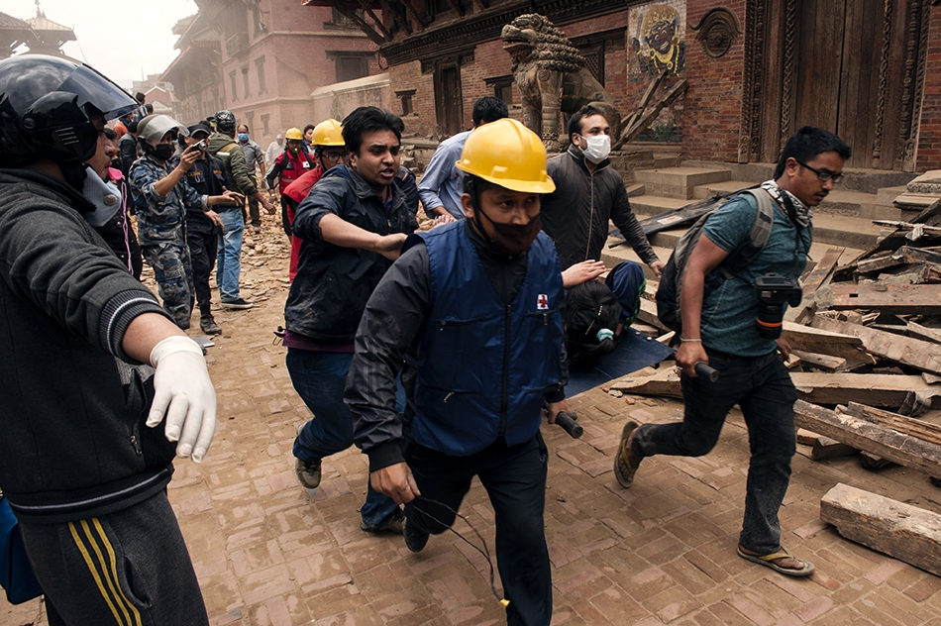

**Preparedness and Response Simulation Guide:**

A Facilitators’ Guide for Red Cross and Red Crescent Societies adapting ‘Simlandia’ simulation templates

© International Federation of Red Cross and Red Crescent Societies

*Any part of this handbook may be cited, copied, translated into other languages or adapted to meet local needs without prior permission from the International Federation of Red Cross and Red Crescent Societies, provided that the source is clearly stated.*

*Cover photo:* Carl Whetham

International Federation of Red Cross and Red Crescent Societies

P.O. Box 372 CH-1211 Geneva 19 Switzerland Telephone: +41 22 730 4222 Telefax: +41 22 733 0395 E-mail: secretariat@ifrc.org Web site: www.ifrc.org

**Table of Contents**

|  |  |
| --- | --- |
| **Introduction** | 4 |
|  |  |
| Part I Planning |  |
| 1. Where are you heading? | 5 |
| 2. Structure and agenda | 6 |
| 3. Aim, objectives and deliverables | 6 |
| 4. Choosing participants and facilitators | 8 |
|  |  |
| **Part II Design** |  |
| 1. Overview of the disaster | 10 |
| a. Identify scale of impact | 10 |
| b. Choose the hazard | 11 |
| c. Summarise the facts | 11 |
| d. Create a disaster impact map | 12 |
| e. Choose your timeframes | 12 |
|  |  |
| 2. Designing specific scenario details | 13 |
| a. Create a summary narrative for each time jump | 13 |
| b. Provide an impact matrix | 13 |
| c. News articles | 15 |
|  |  |
| 3. Challenges | 16 |
| a. Thematic areas | 18 |
| b. Challenge title | 18 |
| c. Expected action | 18 |
| d. Mode of communication | 18 |
| e. Script | 18 |
|  |  |
| **Part III Facilitation** |  |
| 1. The art of facilitation | 19 |
| 2. Facilitation team composition | 19 |
| 3. Simulation monitors | 20 |
| 4. Setting up rooms | 20 |
| 5. Administration | 22 |
| 6. Role playing | 24 |
|  |  |
| **Part IV Debrief** |  |
| 1. Evaluating the simulation | 25 |
| 2. Debriefing day one | 25 |
| 3. Debriefing the entire simulation | 26 |

**Introduction**

**What is a simulation?**

Simulations mean different things to different people. A simulation can run for a few hours or a few days. It can be a table-top exercise in an office or a drill exercise in a ‘real’ setting. Simulations change in shape and size depending on the aim, participants, and location.

**The IFRC definition of a simulation is: “*… a partial representation of reality that selects crucial characteristics of an actual situation and makes a replication of it within a protected setting free of risks”*[1]*.***

**Why use simulations as a learning tool?**

Simulations offer the benefits of being able to practice or refine contingency plans, standard operating procedures, disaster preparedness or response mechanisms. They replicate high-pressure environments where information is limited or conflicting, demands are high and time is short.

Crucially, simulations are an effective tool for building trust between individuals and teams. They practice communication, coordination, leadership and management skills. Simulation training is an exploratory, hands-on learning approach that helps people better understand their own roles and responsibilities as well as the roles of others.

**How will this guide help me?**

This *Facilitators’ Guide* takes the user through steps for planning, design, facilitation and debrief of a *table-top* simulation exercise[2].

Though the Guide can be used to design a scenario from scratch, it is likely that most facilitators will be adapting a fabricated ‘Simlandia’ scenario. The Simlandia scenarios have been written specifically for use by National Societies and other movement partners, and can easily be adjusted to reflect the user’s national context, training priorities and disaster risk landscape.

The five Simlandia scenarios are:

Flooding – Tsunami – Earthquake – Public Health (Ebola) - Drought

**Part I: Planning**

This section provides details about how to plan your simulation from the structure and agenda to the aim, objectives and deliverables as well as how to select participants and facilitators.

**1. Where are you heading?**

Let’s start with an overview of how the Simlandia simulation templates work.

Over two intensive days, participants face a rapid-fire set of interconnected challenges relevant to their roles and responsibilities. Four fast-paced time jumps – preparedness plus three time jumps of response – are followed by a thorough debrief on what worked well and what needs to improve before a real disaster event occurs.

Figure 1 below shows a simulation in action. A team of facilitators write emails, make phone calls and send news articles to trigger decisions and actions from sector-based teams in the National Society. During the debrief, participants consider the relevance and quality of their deliverables.

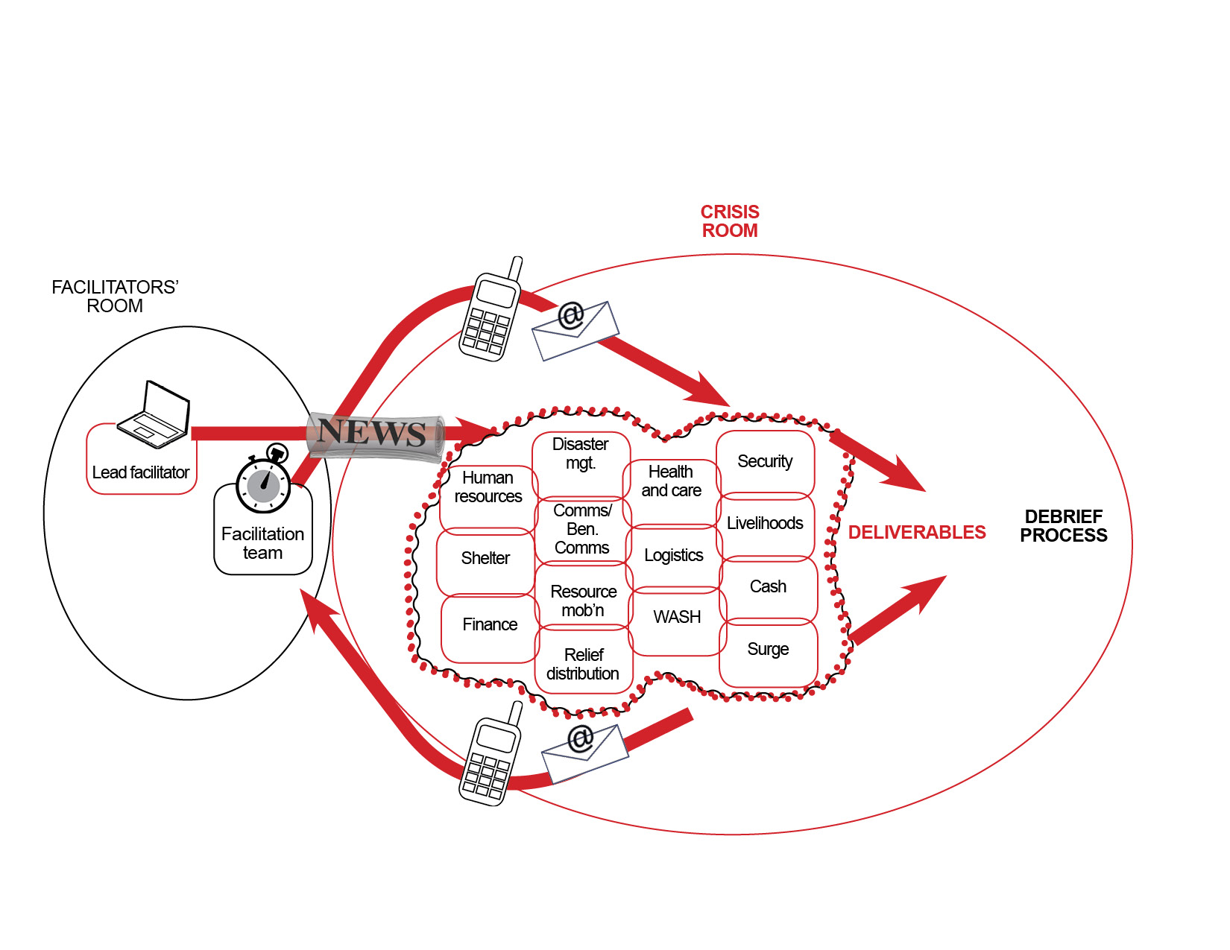

Figure 1: Workflow for a desktop simulation

**2. Structure and agenda**

All Simlandia scenarios have been written to the following structure and agenda. There is no formal lunch break, so it is a good idea to provide a packaged lunch for participants to pick up when they have time.

|  |  |  |  |
| --- | --- | --- | --- |
|  | Day 1 | Challenges | News and updates |
|  | Introduction, confirmation of time jump deliverables, simulation rules | | |
| *9am – 11am* | **Time jump 1:**  Preparedness time jump | 2-3 challenges per sector / theme | 4-5 news articles |
| *11am – 1pm* | **Time jump 2:**  Time jump 1 | 2-3 challenges per sector / theme | 5-7 news articles |
| *2pm – 5pm* | **Time jump 3:**  Time jump 2 | 2-3 challenges per sector / theme | 5-7 news articles |
|  | Day 2 | Challenges | News and updates |
| *9am – 11:40pm* | **Time jump 4:**  Time jump 3 | 2-3 challenges per sector / theme | 5-7 news articles |
| *11:40am-12:00pm* | Presentation of a key deliverable such as the response strategy | | |
| *1pm – 5pm* | Debrief, learning and action planning | | |

Figure 2: A suggested agenda and structure for two-day simulation

**3. Aim, objectives and deliverables**

**a. Aim**

It is vital to know why you are doing this exercise. Declaring your aim helps with the decisions you will take going forward. For instance, your aim might be to test standard operating procedures, contingency plans or preparedness and response mechanisms. Depending on this, you will set different objectives and use different challenges.

The aim will be shared with co-facilitators and participants from the beginning, so everyone shares the same understanding of the exercise.

*Example Aim*

*The aim of this simulation is to test Simlandia Red Cross’ newly developed standard operating procedures.*

**b. Objectives**

Simulation objectives are specific ways in which individuals or groups can expect to improve knowledge, enhance skills, develop new abilities or modify behaviour.

Most simulations have between three to five objectives. Objectives are shared with facilitators and participants at the start of a simulation, and should be clear and concise.

*Example objectives*

*1) Test Simlandia Red Cross’ readiness to receive and manage international assistance.*

*2) Test Simlandia Red Cross’ ability to manage the shelter cluster.*

*3) Facilitate a review of the key issues, and gaps identified from the simulation.*

**c. Deliverables**

Table-top simulations can cover any time jump in the disaster management cycle, and they usually differ between rapid and slow onset disasters. Each time jump has different deliverables that test specific skills and procedures.

Deliverables involve teamwork and planning, and are usually completed as a document: for instance, a situation report, a Plan of Action, an operations strategy or a security brief.

These simulations do not aim to ‘catch people out’ and are designed to give participants every chance to succeed. Deliverables are shared in advance of each time jump, so that participants have a sense of what they must achieve in that time jump.

Remember to ensure the deliverables link back to the simulation aim and objectives. At the end of the day each day facilitators should provide feedback on the process and quality of the deliverables.

As a way of closing the simulation, have the participants present one of the deliverables – an exit strategy or an operations plan, for example – to a ‘guest’. Plan for a 15-minute presentation and invite all simulation participants to celebrate the big achievement.

|  |  |
| --- | --- |
|  | *Example Deliverables* |
| *Prepared-ness* | 1. *The contingency plan is enacted.* 2. *DMIS is set up and updated.* |
| *0-72 hours* | 1. *A DREF request is made* 2. *An Emergency Preliminary Appeal is developed* |
| *1 week after the disaster* | 1. *An Emergency Plan of Action is developed* 2. *Delegates are deployed* 3. *A 1 month strategy is developed* |
| *1 month after the disaster* | 1. *An exit strategy is developed* 2. *A 3-6 month strategy is developed* |

**4. Choosing participants and facilitators**

Simulations replicate responses, and therefore involve multiple actors and stakeholders. There are two broad groups to plan for: facilitators and participants. Carefully select and properly brief each group, using the aim you have set as a guide.

**a. Participants**

Select your participants and let them know well in advance, so you can be confident of the types of roles and responsibilities that will be tested or practiced. You cannot move forward to design the challenges without knowing this. Your selection of participants also impacts the role play parts required to test them.

The Simlandia scenarios assume that the Head Quarters (HQ) office is being tested, which can be adapted as necessary. More offices can be added such as branches and sub-branches. Note that for every group you add, you will need to design challenges to keep them motivated and busy.

**b. Facilitators**

Facilitators are responsible for facilitating planned challenges. The number of facilitators you need will depend on the selection of participants. Facilitators may role play an organisation, office or individual seeking ‘help’, ‘advice’ or ‘expertise’ from the participants as a means of verifying that the participants are taking a required action or practising a specific skill.

Facilitators usually manage two or three sectors or thematic areas at a time. For instance, if you are testing 12 sectors/themes, this means you will need at least four to five facilitators to manage the release and monitoring of these challenges.

|  |  |
| --- | --- |
| *The five simulation templates have been designed to test the 15 themes below.*  *Add or delete themes you require based on relevance* | |
| 1. *Cash* 2. *Communications/Beneficiary Communications* 3. *Disaster Management (coordination, DRR, DRM, DP resilience)* 4. *Finance* 5. *Health and Care* 6. *Human Resources* 7. *Livelihoods* 8. *Logistics* | 1. *Relief (NFI and Food items)* 2. *Resource Mobilisation* 3. *Security* 4. *Shelter* 5. *Surge* 6. *Volunteers* 7. *WASH* |

**Part II: Design**

This section provides details about simulation design. First you will design the overview of the disaster and summarise its impact. You will then move to more specific details such as adapting news articles to support the story of your scenario. Finally, you will develop a unique set of challenges, identify characters for role-play and write the scripts to bring the challenges to life.

**1. Overview of the disaster**

Begin the design time jump by developing a timeline of events and then adding the finer details, as follows:

**a. Identify scale of impact**

Consider which scale of impact best fulfils the simulation aim and objectives. Some offices may wish to train for smaller scale, more frequently occurring disasters, whilst others may prioritise a ‘once in a life time’, large-scale event.

|  |  |  |  |
| --- | --- | --- | --- |
|  | **Yellow** | **Orange** | **Red** |
| **Objective Criteria** | | | |
| 1. # affected | Less than 200,000 | 200,000 to 2,000,000 | More than 2,000,000 |
| 2. Extent of geographical area affected | Limited to a specifically defined or smaller  geographical area | * Moderate to large geographical area * Moderate to large urban centre * Possible cross border impact | * Large geographical area * Large urban centre * Multiple countries * More than one Zone involved |
| 3. Population density | Low population density (<5,000) | High population density (e.g. 5,000-15,000 / km2) | Very high population density (e.g. > 15,000 / km2) |
| 4. Level of media attention | * Local media * Limited international media interest | International media attention | Major global headline attention |
| 5. Government response | * No disaster declaration * Possible disaster declaration | * Declared a national disaster * International assistance requested | * Declared a national disaster * International assistance requested |
| 6. Engagement of other humanitarian actors | * Local * Regional | * Local & Regional * International * Cluster may be activated | * Local * Regional * International * Cluster activated |

Figure 2: IFRC secretariat’s Global Disaster Response Standard Operating Procedures (2013).

**b. Choose the hazard**

Revisit the simulation aim and objectives in order to decide which hazard will best achieve the training goals. If you’re rehearsing a contingency plan, the choice is simple; if your aim is to test organisational preparedness or response mechanisms, choose a hazard that is relevant in your context.

If you are choosing from one of the Simlandia simulations (flooding, tsunami, epidemic, earthquake, drought), the design is already complete. All you need to do now is adjust the details to fit your context. Remember to keep the hazard a secret from the participants. You want them to be surprised.

**c. Summarise the facts**

A disaster summary is a good way to create the skeleton of your simulation. Use the fast facts below to create a macro picture of the final impact of your disaster. You may not need to use them all, and you may want to add new ones.

|  |  |
| --- | --- |
| *Fast facts that summarise the disaster* | |
| Total population: 73 million  Number of persons killed: 905  Number of persons affected: 3.8  Number of persons displaced: 2.2  Houses damaged: 500,000 | Houses destroyed: 600,000  Livestock killed: 250,00  Crops affected: 1.1m hectares  Damage to infrastructure (USD): 4b  UN Appeal (USD): 356 |

Based on the fast facts above, write a short summary of the disaster.

*Example disaster summary*

*Flooding affected 3.8 million people and damaged or destroyed 1.1 million homes when dams broke and rivers breached their banks in Simlandia’s capital city, Abee. At the worst point, approximately 20% of Simlandia’s total area was underwater.*

**d. Create a disaster impact map**

Next, find an electronic map of your country and indicate where the impact will be. The Simlandia scenarios spread impact over three to four states or provinces. For a less complex, localised emergency, you may wish to select a smaller area of impact.

*Example of an impact map*



**e. Choose your time jumps**

The type of hazard and the extent of impact will dictate the time jumps for your scenario. Generally:

* The first time jump of the simulation will take place at a time of preparation and early warning,
* The second at a time of immediate impact, assessment and declaration of emergency,
* The third at a time when relief is under way with contextual challenges developing,
* And the fourth at a time when relief is transitioning to rehabilitation and recovery programming

Though each time jump follows from the last, it has its own narrative, statistics and challenges, creating a realistic sense of disaster unfolding.

*Example time jump (flooding)*

*Preparedness: 3 months - impact*

*Time jump 1: 0-72 hours*

*Time jump 2: One week after the disaster*

*Time jump 3: One month after the disaster*

**2. Designing specific scenario details**

For each time jump, you’ll need:

1. A summary narrative
2. An impact matrix of facts and figures at a state or provincial level and
3. News articles that advance the disaster story.
4. **Create a narrative summary of events for each time jump**

The narrative summary describes an overview of what happens in each timeframe. Though you may only have two hours in your agenda, your simulation narrative can stretch events as far as needed, for instance 24 hours or two months, in order to make the deliverables possible. Summarising the story for each time jump helps you to remember what happens at a glance. The narrative summary goes in bullet points at the top of the impact matrix as shown in figure 4.

1. **Provide an impact matrix**

The impact matrix provides a useful reference point for making facts, figures and news releases consistent. Throughout the time jumps, the statistics in your impact matrix will increase, much like a real emergency, as more information becomes known. By your final time jump, the statistics in your impact matrix will match with those in your initial disaster summary.

|  |  |  |  |  |  |  |
| --- | --- | --- | --- | --- | --- | --- |
| *Example of a narrative summary*  Time jump one: *0 – 72 hours after the disaster* | | | | | | |
| * *Madang, Terry and Vakoda provinces in the north flood* * *Many say they received no warnings that raging waters were heading their way* * *President declares a state of emergency* * *Aid moving slow due to flooded roads and damaged infrastructure* * *Cessation of aid to autonomous Terry region; decision reversed two weeks later* * *Thousands are forced to live in wretched conditions beside roads, sleeping in the open* | | | | | | |
| *INDICATOR* | *Terry* | *Padang* | *Vakoda* | *Boort* | *Tooloo* | *TOTAL* |
| *Total population* | *6m* | *17m* | *16m* | *15m* | *16m* | *70m* |
| *Number of people killed* | *70* | *430* | *240* | *Not affected* | *Not affected* | *740* |
| *Number of people displaced* | *5000* | *230,000* | *165,000* |  |  | *400,000* |
| *Number of people affected* | *20000* | *600,000* | *410,000* |  |  | *1.3 million* |
| *Houses damaged* | *600,000* | *200,000* | *200,000* |  |  | *1 million* |
| *Houses destroyed* | *200,000* | *50,000* | *50,000* |  |  | *300,000* |
| *Crops affected* | *400,000 hectares* | *400,000 hectares* | *300,000 hectares* |  |  |  |
| *Livestock killed* | *50,000* | *100,000* | *100,000* |  |  | *250,000* |
| *Damage to infrastructure (USD)* |  |  |  |  |  | *$2.27 billion* |
| *UN Appeal (USD)* |  |  |  |  |  | *$356 million* |

Figure 3: An example of a summary narrative and impact matrix for 0-72 hours after flooding started.

**c. News articles**

News articles, which are distributed to everyone in the simulation, develop context and momentum during each time jump. Most are quick-read materials with facts and figures that help the team design a response. For example, you might like to include media reports and government press releases.

In each time jump at least one detailed situation report is also needed, so that participants have the most detailed information to hand on impact, response and specific needs of affected communities. It is ideal if the reports can come from the affected areas such as a rapid assessment reports for 24 hours, 72 hours and so on. You will need to create the finer details of the reports.

The Simlandian scenarios contain a bank of over 120 news articles relevant to many contexts, and can be easily adapted to fit yours. You can use them exactly as provided, or adjust them to your requirements. Delete and add articles as appropriate for all four timeframes, then change the facts and figures highlighted in blue to match the ones in your impact matrix. Use a minimum of three articles when designing your simulation. If the team is quite advanced, consider using all the news articles in the simulation template.

Figure 5: An example of a news article table for Time jump 3 (one month after the disaster struck) in the flooding scenario.

|  |  |  |  |
| --- | --- | --- | --- |
| 0-72 Hours After the Disaster  News Articles (2-4Oct) | | | |
| **Article number** | **Release**  **Time** | **Article title** | **Article date** |
| 2.1_FLOODS | 11:00 | Hundreds dead, 300,000 displaced by flooding | Oct 2 |
| 2.2_FLOODS | 11:20 | President declares state of emergency | Oct 2 |
| 2.3_FLOODS | 11:40 | OCHA Situation Report | Oct 3 |
| 2.4_FLOODS | 12:00 | Relief workers face logistical nightmare | Oct 3 |
| 2.5_FLOODS | 12:15 | Immediate cessation of aid to Terry Region | Oct 4 |
| 2.6_FLOODS | 12:30 | Hundreds killed, 1.1. million people homeless | Oct 4 |
| 2.7_FLOODS | 12:45 | Widespread flooding imminent in south | Oct 4 |

The ***article number*** indicates the time jump the article is from and the order they belong in. This makes it easier for either email or hard copy distribution.

The ***time*** ***of release*** assists facilitators to know what time each article is released. Part III, on facilitation will describe more about how and when to release news articles.

The ***article title*** gives a short summary of the article.

The ***article date*** refers to the date events took place. Having the right date, in your planning document and on the articles themselves, is important. It allows participants to replace out-dated information with new, and it also sets the pace for each time jump.

**3. Designing challenges**

While the participants are working on deliverables, facilitators will give them challenges to test specific skills. Challenges are like bumps in the road; they interrupt participants by asking them to solve an immediate problem or respond to a need. Arriving through a role-played phone call or email request, a challenge prompts action from individuals or teams. They are released at strategic times as the ‘disaster story’ unfolds in order to test a particular skill.

Challenges are different from deliverables. The deliverables are set and shared in advance with participants to give a sense of where they are heading. Challenges, on the other hand, are introduced by facilitators at planned times, unknown to the participants. They test participants’ knowledge under pressure of their own role within an organisational response.

It is not possible to ‘fail’ a challenge, but at times facilitators may need to add further prompts or hints in order to see it fulfilled. Facilitators help with the design of the challenges in thematic areas assigned to them before the simulation starts.

Every challenge needs to come from a ‘real’ person who would normally be associated with emergency preparedness and response. Selecting the most likely person to ask a question or make a request is part of the challenge design. It is not always straightforward because at times the person most likely to make the request is another participant in the simulation. If this is the case, you will need to find another plausible party, for instance a Partner National Society (PNS), a government worker or another non-governmental organisation (NGO).

Figure 4 below gives you some ideas of who might be a good character for role-playing the challenges you have chosen. Again, seek the advice of your co-facilitators to finalise the roles and scripts for each challenge.

**Participants**

(National Society)

HQ office

Figure 4: The dark red circle represents the participants being tested. The smaller, light red circles indicate the roles that could be played by facilitators.

It is recommended that two to three challenges be designed per sector in each time jump. The Simlandia scenarios provide a strong starting point for this, with several hundred challenges to choose from across all sectors and themes. As with the news articles, you can use the challenges exactly as written, or adjust for best possible relevance.

Below is a snapshot of the challenges for logistics. Refer to excel matrix for a full version.

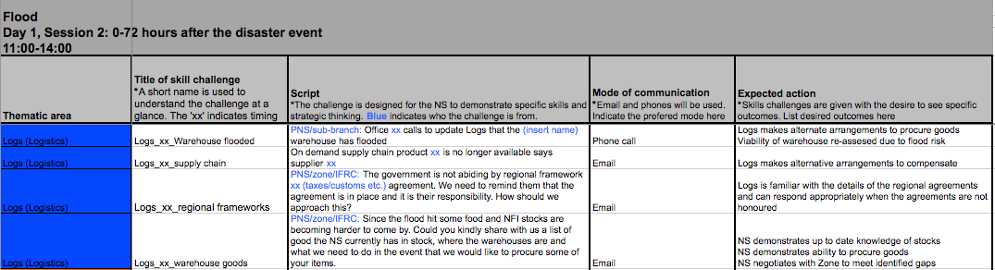

Figure 5: Challenges for logistics from the Simlandia flood simulation

**How to use the matrix of challenges**

**a. Thematic areas**: Delete or add thematic areas that will be covered in your simulation. Do this in all of the time jumps.

**b. Challenge title**: A short title is used so the challenge can be identified at a glance. The title always has the code in it. For example, ‘logs’ is code for ‘logistics’. The title also has a time in it, which signifies the time the challenge is given.

**c. Script**: a script of one to two sentences is written up for the facilitator to use in a phone call or to send in an email. Emailed challenges are drafted ahead of time and loaded into email so the facilitator merely has to press send when the simulation is active. It is the responsibility of the facilitator to respond to the emails and role-play during the phone calls until s/he feels the participant has achieved the expected output.

**d. Mode of communication**: some challenges will be conducted using a mobile phone; others will use email. This column specifies the way in which the challenge is communicated.

**e. Expected action**: the expected outcome of the challenge is written in this column.

**Part III: Facilitation**

In this section, you will learn more about how to lead a simulation including briefing and preparing your co-facilitation team. After a reflection on the ‘art’ of facilitation, you will find practical guidelines for setting up the room, identifying co-facilitator roles and responsibilities, enabling the simulation monitor role, and using the right tools and technology to communicate challenges. Part III concludes with considerations for logistics, administration and IT support.

**1. The ‘art’ of facilitation**

Running a simulation is about managing the tempo and flow. It means feeling the pulse of the simulation by ensuring the facilitation team releases timely challenges and participants are feeling the ‘right’ amount of pressure in order to achieve the training aim and objectives.

Facilitating a simulation requires people who are flexible and adaptive. Challenges may need to be added or deleted; news articles may need to be modified; and sometimes the entire simulation may need to be paused to make sure participants understand what is required of them. At the heart of the simulation is the need to ensure the disaster storyline is maintained and that participants are given the space and freedom to make mistakes and learn in a safe environment.

2. Facilitation team composition

The facilitation team is responsible for the design, implementation and debrief of the simulation. Ideally, the team is a mix of people who have simulation training experience, and humanitarian response expertise.

Within the facilitation team there is one *lead facilitator* who is responsible for the entire simulation. Her or his role is to make sure everything flows smoothly, to troubleshoot and adapt the planned activities when necessary. The lead facilitator releases news articles to the participants at the planned times via a central email account as well as through printed copies.

The *facilitation team* is usually comprised of 2-10 people, depending on how large your simulation is. Ideally one person is responsible for two themes or sectors. The facilitation team has a diverse range of responsibilities, including:

**Simulation preparation:**

* Development of aim and objectives
* Design of simulation structure and timetable
* Design of news articles and challenges

**Simulation delivery**

* Monitoring challenges and expected actions
* Role-playing stakeholders
* Debrief of the simulation to draw out lessons learned

3. Simulation monitors

Monitoring a simulation can take many forms. One powerful way to monitor is to remove participants from the simulation for a period to observe what their team is doing. Anywhere between 20 minutes is recommended, at which time participants cannot speak or engage. They should observe the simulation from a place where they see and hear everything that is going on, ideally out of the view of others. When the participants re-join the simulation they can use their observations to improve their own engagement and that of their colleagues.

A second way to monitor a simulation is to have the facilitators wear a badge or a ribbon to indicate that they are monitors. Before the simulation starts brief the participants that sometimes facilitators will come and monitor the teams. The monitors are not allowed to interact with the participants, and should be considered invisible. Watching the participants work together is an excellent way to measure the tempo and flow of the simulation.

4. Setting up rooms

You can hold a simulation in a hotel or in an office. If it is in a hotel, ensure there are at least two rooms – one for the participants to work from, the other for the facilitators. Both rooms replicate what an Emergency Operations Centre looks like. You may need additional space for meetings to take place.

If you hold a simulation in your office, participants should sit where they normally sit in a disaster. If additional offices are joining such as a branch or a sub-branch, have them sit together in one room. Running a simulation in multiple offices is possible but you lose time when people are required to meet, and therefore is not recommended.

Where ever your simulation takes places, ensure the rooms are fully equipped with the list of items below.

*Facilitators’ room*

The facilitators’ room should offer privacy for facilitators to discuss with one another. It should have big, open wall space for hanging up news articles so the facilitators can keep track of where the story line has reached. There should also be space to hang the challenges matrix. The facilitators’ room should also have the following facilities:

Access to phones (landlines or mobiles)

A list of staff phone numbers

Email access between facilitators and participants

Maps and news articles displayed on the wall

Equipment such as a printer, stationary and IT support

An A0 print out of the challenges matrix or overhead projector

Flip chart paper to write new details that had to be created on the spot

Water, coffee and pre-packaged lunches

*Participants’ room*

There are three ways to organise participants, depending on the size of the group and purpose of the simulation.

*Option A – Participants work together in a single room*

Participants work together in a single room (even if it is unnatural to do so) in order to improve communication and coordination. When participants are in the same space they are more likely to talk to each other, which is where most of the learning comes from. This is a good arrangement for smaller groups of around 30 people.

*Option B – Participants work from their own desks*

Participants work from their own desks using meeting rooms and an emergency operations centre as they normally would during a disaster. This set up is helpful for large numbers of participants of around 80 people from one office.

*Option C – Participants work from their own desks and a meeting room*

If the simulation has participants from branch and sub-branch offices, it may be best to bring them to HQ and have them work in a meeting room. The alternative is to have the branch of sub-branch work from their regular office location, but this creates additional logistical challenges if people need to meet face-to-face. The simulation is short so it is a good idea to eliminate travel time where possible.

The participants’ room should have the same facilities as those in the facilitators’ room, including:

Access to phones (landlines or mobiles)

Email access between facilitators and participants

Wall space to track progress, hang flip chart paper

Equipment such as a printer, stationary and IT support

Access to DMIS

Water, coffee and pre-packaged lunches

**5. Administration**

Try to remain as organised as possible. Below is a description of the administrative components to plan for.

*Email*

Ensure you ask facilitators and participants to bring their laptops so they can communicate by email. Pre-generated, generic emails for the use of this simulation package have been generated for facilitators and are shared in the appendices.

Here are some simple rules to guide the use of email.

1. Facilitators send emails using pre-generated addresses such as [simex.faciliator1@ifrc.org](mailto:simex.faciliator1@ifrc.org).
2. Participants reply to the emails using their work email addresses.
3. Always add SIMULATION ONLY in the title of the email.
4. Facilitators should draft all emails before the simulation starts.
5. Keep emails short – one or two sentences.
6. The title of the email indicates the time that it should be sent.
7. Copy the text from the challenges matrix and paste it into the body of the email. Always stipulate whom the email is *to* and *from*. See example below:

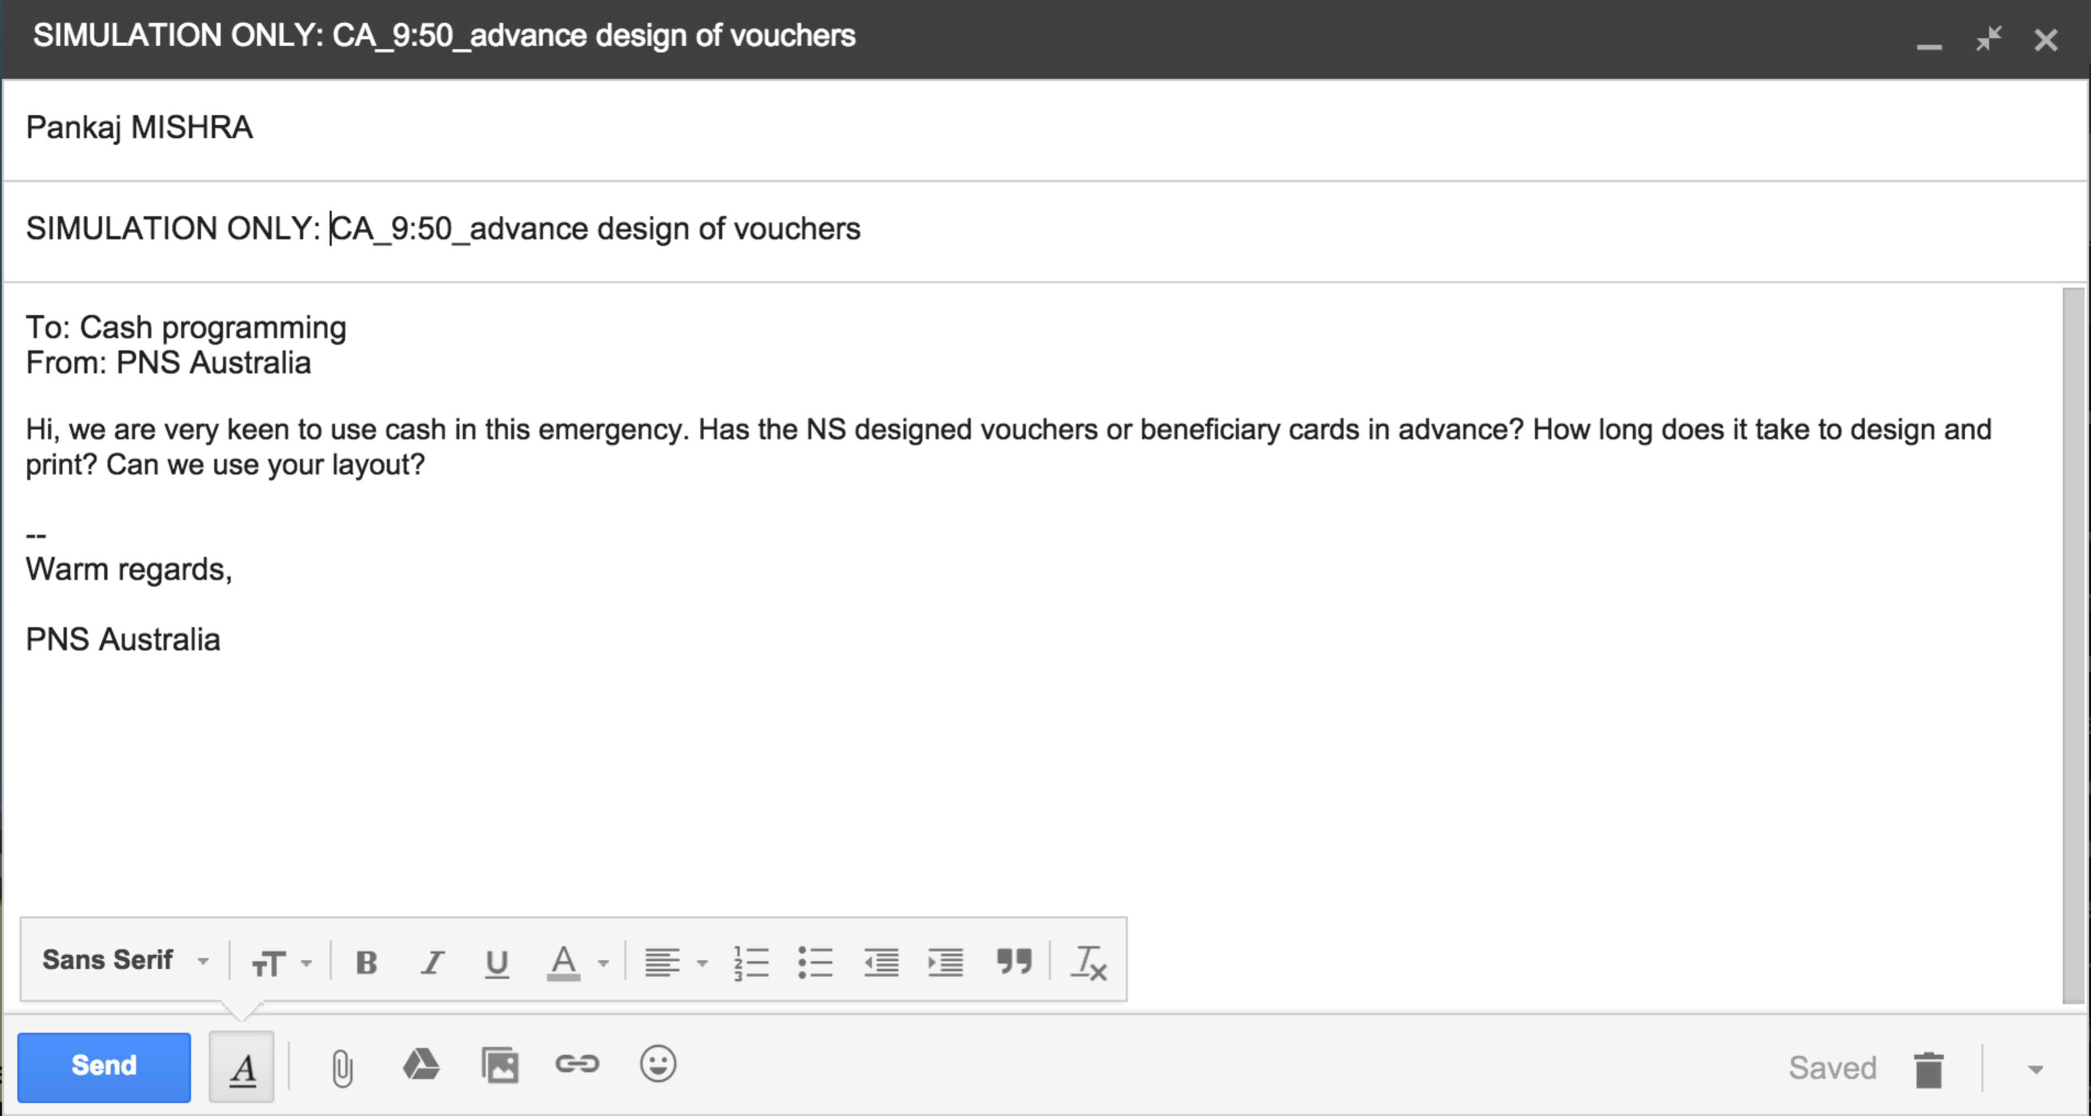

Figure 6: An example of how to set up an email from a facilitator to a participant.

*Mobile phones*

If you are using mobile phones, it is a good idea to buy sim cards and allocate one sim card and adequate phone credit to facilitators without a local sim card. If a list of phone numbers for office staff exists, print it and make it available for use in the facilitation room. Ensure a list of the new sim card phone numbers is also available.

*Printing documents*

Ensure that all documents used in the simulation are marked ‘Simulation Only’ in the header or footer, and printed in colour where possible. Colour adds to the realism of the simulation. Print all documents two days before the simulation starts in case you have problems with the printers.

Key documents to print:

|  |  |
| --- | --- |
|  | Phone numbers of office staff and new sim cards |
|  | News stories – one copy each group/table/department in addition to a full set for the facilitation room. |
|  | Challenges matrix – one per facilitator (A4 size) and one extra large size copy (A0 size) for the facilitation room so each challenge can be crossed off as it is completed for the whole group to see. |
|  | Simulation scenario – a copy of for each facilitator and one for the facilitation room wall |

*IT support*

Ensure that Internet is available and that the connection is strong. It is a good idea to have an IT person present to offer support when required.

**6. Role-playing**

Facilitators are responsible for playing the actors participants need to engage with. For example, if facilitator one is working with logistics and communications then s/he is contacted if a participant wants to speak to someone who is not in the simulation.

For example, suppose the World Food Programme (WFP) contacts the Simlandia Red Cross (SRC) logistics team to find out if they can have some space in the SRC warehouse. The expected action of that particular challenge is for SRC logistics to demonstrate knowledge about warehouse space. The person role playing WFP is waiting to hear evidence that the SRC team is up to date regarding the status of warehouse space.

In resolving a challenge, participants may take an unpredictable path. This includes unforeseen questions back to the facilitator and at times requests to talk to unanticipated characters. If the facilitator is uncertain about how to respond to any of the participants’ questions, s/he should speak to the lead facilitator first.

**Part IV: Debriefing**

Part IV offers some ideas and recommendations for evaluating your simulation training. It touches upon the need for good facilitation and the ways to compile and share lessons learned.

**1. Evaluating the simulation**

The purpose of debriefing a simulation is to determine how well the aim and objectives of the simulation were met. Ensure participants get ample time to share the lessons they learn because they will have a deep sense of what went well and where the shortcomings were. Simulation facilitators should also be given an opportunity to share their observations, either by joining the participant debrief or by doing one of their own.

Good facilitation is at the heart of gathering learning. Where possible, avoid using lecture style feedback techniques. It is important to create an open and participatory environment where people can share and discuss. When gathering lessons learned celebrate what was done well as much as concentrating on ways to improve. Remember, this is a team building opportunity.

**2. Debriefing day one**

There are many different ways to debrief a simulation. Below is a suggested format for debriefing day one.

|  |
| --- |
| **Learning objective:**  Identify key individual and team learning from the day to improve performance during the next day. |
| **Total time allocated:** 1 hour |
| **Debrief format:**  Ask participants to form groups of 3-4 persons who have worked closely together during the day. If there are persons who have worked by himself or herself, or with only one other person, then join one of the groups. On flip chart paper do the following:  **1. Celebrate (20 minutes):**  A. Each person writes one thing s/he is personally proud of accomplishing today.  B. The group brainstorms a list of three things the team did well over the day.  **2. Areas of improvement (20 minutes):**  A. Each person writes two things they plan to do differently tomorrow.  B. The group brainstorms a list of three things the team will improve on tomorrow.  **3. Sharing the learning (20 minutes):**  Gather into a large group. Ask each individual group to highlight one accomplishment to celebrate. The next group should not repeat previously mentioned ideas. Collect the flip chart papers. |

**3. Debriefing the entire simulation**

It is important to frame the learning around the overall aim and remember to link simulation experiences back to the training objectives.

Below is a suggested format for debriefing the entire simulation. This debrief starts by recalling key events that occurred throughout the simulation, then identifies personal learning and finishes by focusing on team learning. Adapt this format by linking it to the simulation aim and objectives.

|  |
| --- |
| **Learning objective:**  Identify key individual and team learning from the entire simulation to take forward for improved performance in future disasters. |
| **Total time allocated:** 3 hours |
| **1. Recalling events (30 minutes):**  Help participants to recall key events they engaged in during the simulation. This exercise is like speed dating. Find a partner. You are given two minutes to ***“Share one thing you did during the simulation that you thought was significant”.*** After two minutes, switch partners.You can spend the last five minutes in a large group recounting some of the events, but do it quickly to establish good momentum.  **2. Review of deliverables (15 minutes):**  Write time jump deliverables on a flip chart paper, and ask the group to identify how well they thought they did on each one by clapping quietly or loudly.  **3. Personal learning (45 minutes):**  Reflect on personal learning from the simulation by asking, ***“What is my biggest learning from the simulation exercise? What will I do differently now as a result of this learning?”***   * 1. Find a partner you worked closely with and exchange your biggest learning (3 minutes).   2. Change partner, repeat process in new pairs (3 minutes).   3. Form groups of 5 people who worked closely together. Identify the top three learnings people in the group have in common – write these on a separate flip chart (15 minutes).   4. Share findings to the larger group (15 minutes).   **4.** **Response analysis (1 hour):**  Select topics (5 minutes)  The purpose of this exercise is to discuss different aspects of the response. Prepare a list of topics for discussion in groups of 5-6 people. Below are some suggestions, but feel free to create your own. Write the topics on flip chart paper and hang them up on the wall around the room. Ask participants to stand next to the topic that most interests them.  *Suggested topics:*   * Coordination with external stakeholders * Internal communications * Information management (storing, sharing, using information) * Management of risks (including safety and security of staff, assets and beneficiaries) * Resources (people, funding, supplies, equipment) * Adherence to standards (international humanitarian and IFRC) * Accountability * Roles and responsibilities * Business continuity of existing projects and programmes * Quality of the response plan * Response quality including timeliness, efficiency, appropriateness and effectiveness   **B. Debrief topic (30-40 minutes)**  Spend approximately ten minutes on each assignment below.   * Create a list of things that were done well. * Create a list of things that could be improved upon. * Create a list of actions or next steps that could improve the theme under discussion.   **C. Tour of discussions (10-20 minutes)**   * Groups are given 3-minute rotations to read the flip chart papers of other groups and add information in another colour, if desired. Rotate until all groups have read each other’s work. * Finish in a large group asking if there are any comments or questions about what participants have seen. Discuss for 10-20 minutes.Collect flip chart papers.   **5.** **Sector/theme analysis (1 hour):**  **A**. Divide participants into the sectors / themes used for the challenges in the simulation. For example, you may have the following groups (45 minutes):   |  |  | | --- | --- | | * Cash * Comms / Beneficiary Comms * Disaster management * Finance * Health and care * Human Resources * Livelihoods * Logistics | * Relief (NFI and Food) * Resource mobilisation * Security * Shelter * Surge (RDRT/RIT) * Volunteers * Water and Sanitation |   **B**. Answer the following questions on flip chart paper:   * What went well? * What can be improved? * What do we need to do next, and what resources are required? Who will ‘champion’ each activity?   **C**. In a large group, share one key action your group commits to taking as a first step after this simulation (5 minutes to decide in small groups, 10 minutes to share in a large group).  **Close the simulation** |

1. IFRC, 2008. IFRC Practical Guide to Develop Simulations and Drills by the Regional Reference Centre in Disaster Preparedness.
2.