CTP M&E training facilitator notes template

Why this module matters
As cash transfer programming remains under scrutiny within the humanitarian sector as a whole and by donors, the monitoring of such programmes needs to be clear and credible and results need to be documented and shared systematically. The module stresses the importance of developing an effective monitoring and evaluation systems. These measure progress, process and impact and identify issues for remedial action. Clear and measurable objectives and outcomes need to be developed at the design stage of a cash transfer programme.

Module aim
To understand the importance of monitoring and evaluating cash and voucher programmes in order to be able to interpret, learn and respond to findings

Module objectives
At the end of the module you will be able to:
- design objectives and indicators
- analyse and respond to monitoring findings
- ppreciate the key issues about monitoring the efficiency and effectiveness of cash transfers

Key learning points
- M&E should include indicators specific to cash and vouchers
- M&E should be part of response design
- Monitoring should be timely enough to allow a response to findings

Handouts
- Handout 5.1: Monitoring market impact
- Handout 5.2: Measuring multiplier effects
- Handout 5.3: Key questions for monitoring and evaluating cash projects

Module 5 Session 1: Process and Impact Monitoring

Session plan:
Session | Activity | Content | Time
SESSION PLAN 5.1: 11:00 – 13:00 (120 mins)
Process and impact monitoring | Activity 5.1.1 Objectives | Introduction to the module | 40 mins
 |  | Objectives
 | Activity 5.1.2 Process and impact Indicators | Indicators | 80 mins
 |  | Exercise
 |  | Smart indicators

Activity 5.1.1 Objectives (40 minutes)

Introduction to the module

Clear and measurable objectives with indicators are the essential and basic tools for conducting monitoring and evaluation activities. Good analysis of impact and effectiveness through monitoring and evaluation can take place effectively only if the project has clear objectives and indicators for measuring its intended outcomes.

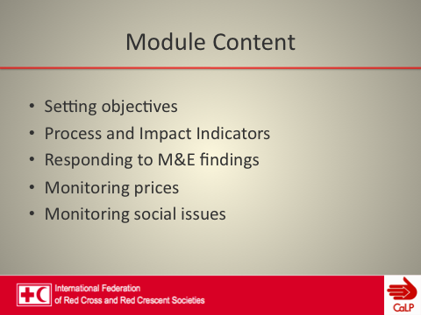 | 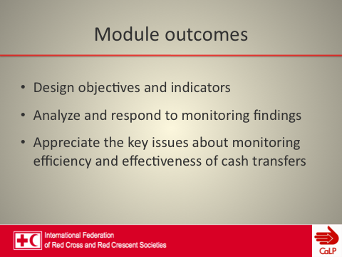

Explain that this session is devoted to the basics of getting started on monitoring and evaluation activities.  Show slide: What does monitoring and evaluation start with? (Gather group’s responses on a flipchart and highlight those that may be useful for the following exercises).  Answers should include: defined objectives, outcomes or indicators  Participants may mention baseline data which is fine also but an area that will be covered slightly later in the session. | 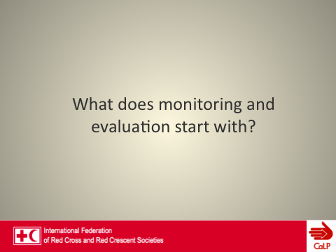
Split attendees into four small groups.
Explain that the purpose of the following exercise is to make a link with the response options discussed in the ‘response analysis’ session and the monitoring and evaluation of projects, through linking the development of objectives with monitoring systems.
Write on a flipchart three possible response options:
1. Unconditional cash transfers (for the most vulnerable)
2. Cash-for-work (timed and structured so as not to harm the agricultural labour market)
3, Distribution of quality seeds for farmers through vouchers.
Ask the groups to consider whether or not the objectives are clear and express an intended programme outcome. Provide an example on the flipchart to start the exercise.
Remind participants how the objective needs to respond to the four questions: What? Where? When? Whom?
Ask each group to rewrite its objectives, ensuring that it illustrates a clear intention or outcome.  Allow 15 minutes and then ask groups to display their objectives on the wall. Circulate among the groups to orient them where necessary.  Ask for comments from other groups. Do not close down this part of the exercise until everyone is happy with the way the objectives are worded. |  | 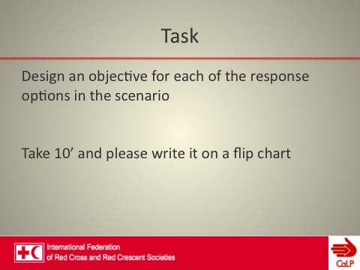
Cash is not an end in itself: the aims and objectives in an emergency remain the same whether cash is used or not. Due to their flexibility, cash and vouchers can be used to achieve a wide range of objectives related to different sectors.  A project can set tightly defined objectives by introducing measures of control (restrictions) on how people use grants. This, in turn, reduces the flexibility for beneficiaries to choose what meets their needs best. Alternatively a project can define objectives more broadly and this allows for flexibility. Sometimes setting broader objectives can be difficult for agencies with specific mandates. | 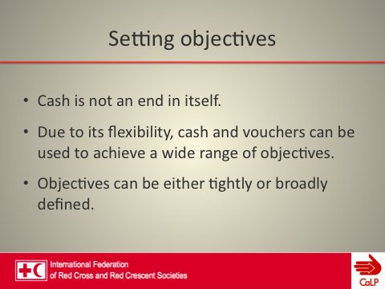

Activity 5.1.2: Process and impact indicators (80 mins)
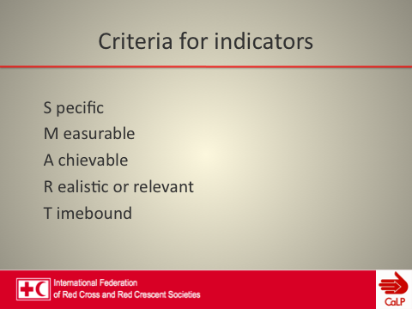 | 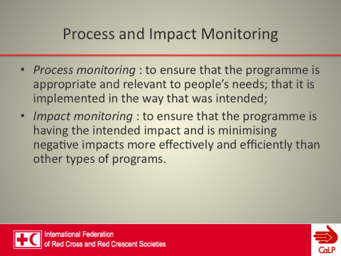
Show slides on process and impact indicators.
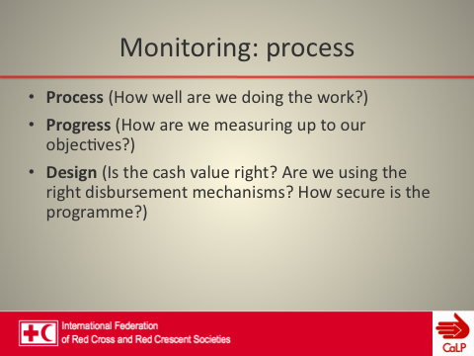 | 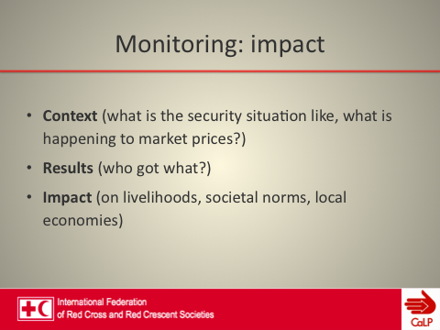

Group exercise
Ensure that participants have understood the difference between process and impact indicators before beginning the exercise. Ask participants to move into their scenario groups.

Ask them to write two process and two impact indicators for one of the project objectives that they have developed. Assign one objective to each group so that they cover the different modalities (unconditional grants, seeds vouchers, cash for work)  Then, each group will present in plenary and the facilitators will complement with the examples provided in the slides below.  If groups have designed only those questions that would elicit quantitative data, ask the plenary to come up with a suggestion for a question that would elicit qualitative data. | 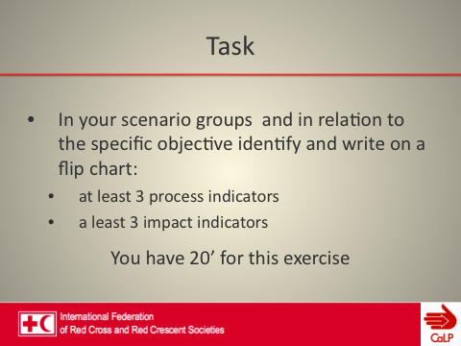

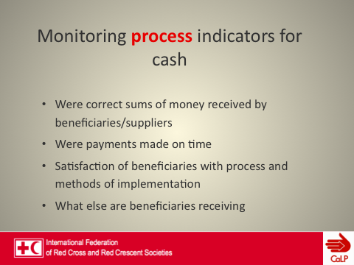 | 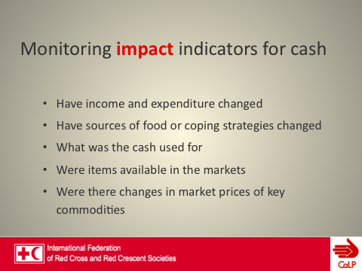

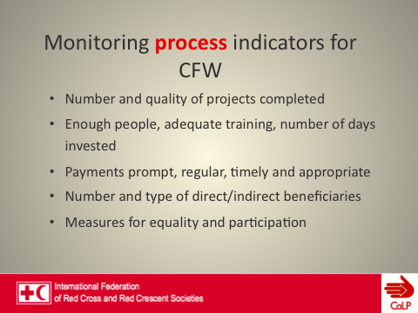 | 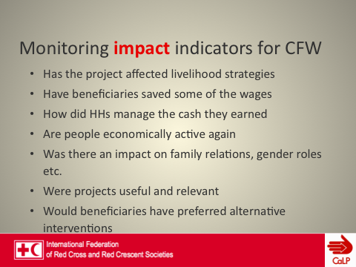

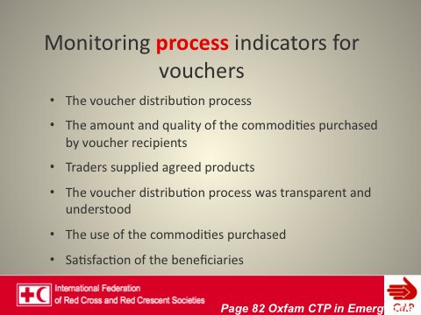 | 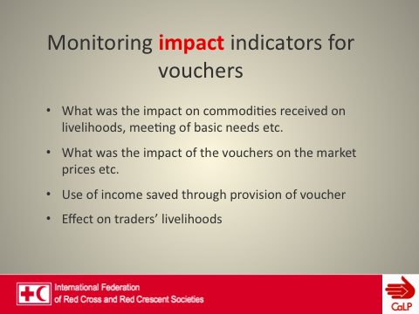
Hold a general discussion ending with the importance of having a monitoring system, which involves programme beneficiaries, in order to make amendments and gather evidence on the effectiveness of cash transfer projects.
Show slides: Monitoring essential points and Monitoring the minimum
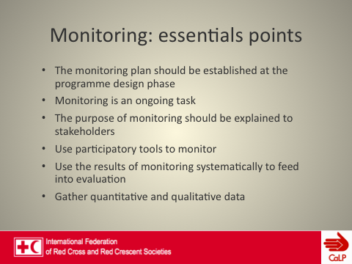 | 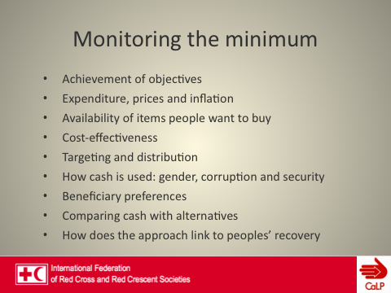
Show slide: How: Elicit examples from participants

Module 5 Session 2: Monitoring prices and social issues

Session Plan:
Session | Activity | Content | Time
Session plan 5.2: 14:00 – 15:30 (120 mins)
Monitoring prices and social issues | Activity 5.2.1 Responding to monitoring findings | Responding to monitoring | 30 mins
 | Activity 5.2.2 Monitoring prices | Prices monitoring | 30 mins
 | Activity 5.2.3 Monitoring efficiency and effectiveness (optional) | Monitoring social issues | 30 mins
 |  | Multiplier effects
 |  | Wrap up

Activity 5.1.3: Responding to monitoring (30 mins)
The activity consists of a series of hypothetical scenarios that aim to stimulate practical thinking. There are no ‘correct’ answers to any of the five scenarios that follow. Participants should be encouraged to consider the problems and discuss specific ways that they might be solved during the project implementation period (brainstorming or in small groups).
It should take only a few minutes to discuss each slide meaningfully, without being lost in small or hypothetical details; there is insufficient information to clarify small details.
The key points across all examples are that:
- monitoring agencies need to be timely in their data collection and analysis
- agencies also need to be sufficiently flexible in order to have the capacity to respond to their findings in time to improve implementation (and, ultimately, make an impact).
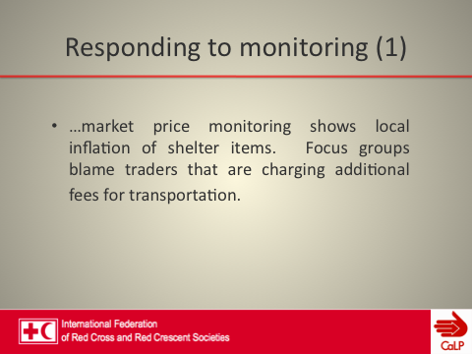 | 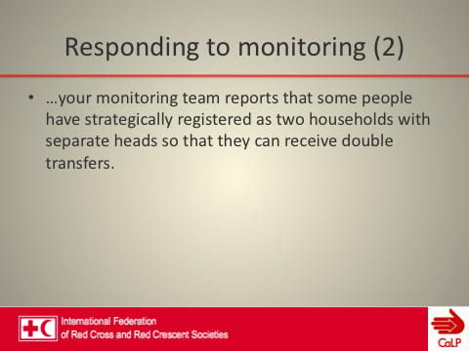

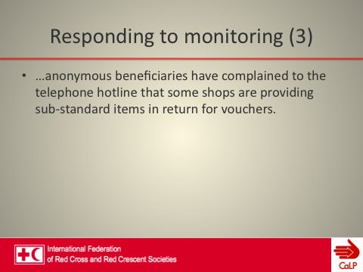 | 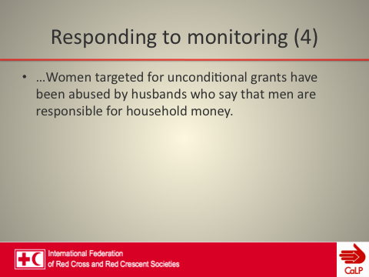

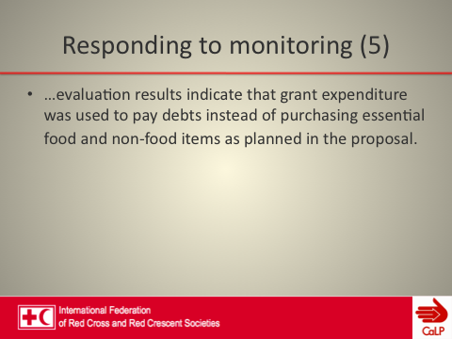

Activity 5.2.2: Prices monitoring (30 mins)

Ask participants why is important to monitor prices. The answer is that it is important to be sure that recipients are able to access their entitlements and that the project cash injection is not causing inflation.  The first step should be to determine whether other agencies are monitoring prices already.  Facilitators need to remind participants that price monitoring can be quite challenging. Some of the issues listed in the slides below create inconsistencies in price data that undermine data reliability and analysis. | 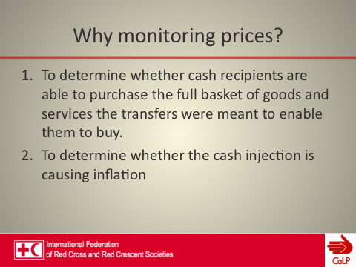

Another pitfall in price monitoring is the difficulty in building trust with traders who might be reluctant to share price information, especially with NGO staff members who are not making purchases. Price monitoring, in practice, often becomes pure data collection (and accumulation!), with insufficient reliability, analysis, or application.  Facilitators should emphasize the point that price monitoring can be more effective or more complementary if undertaken in coordination with other agencies or stakeholders. | 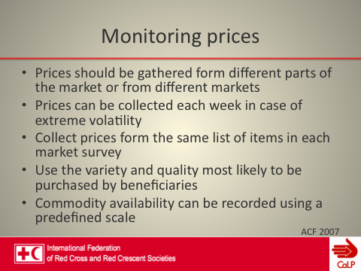

Explain the use of the commodity tracking tool. It is used mainly for monitoring of programme implications and warning of inflation. It can be used at the design stage to calculate the amount for grants and, during ongoing monitoring, to check whether the amount of the grant/voucher is still sufficient. It includes minimum information to fit your programme (this deliberately covers several sectors). | 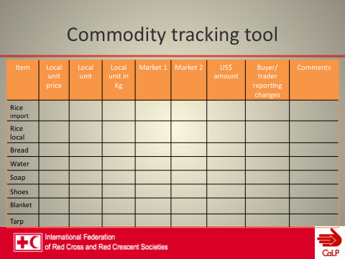

This slide illustrates an example of food basket monitoring in Pakistan, which focuses on a very few essential commodities rather than on every conceivable expenditure item.  It could nonetheless be possible to streamline this list further, for instance rice and cooking oil could be removed (because household economy analysis always assumes that during crises households will purchase the least expensive options.  The spike in sugar prices came as a result of government controls, not from CTP. | 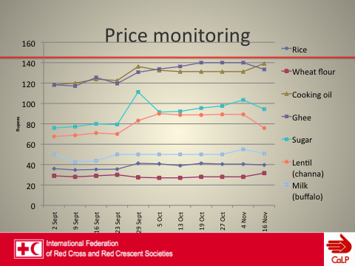

This is an example of food basket monitoring. It is another view of exactly the same data as that given on the previous slide, here aggregated into a single food basket. This could make inter-agency monitoring, for example, easier when comparing across different locations.  Which version would participants prefer? There is no correct answer, but justifications could bring interesting points into the discussion. Also note, however, that this aggregated version is not possible without first collecting individual commodity prices (and ensuring consistency in all of the other criteria discussed already). | 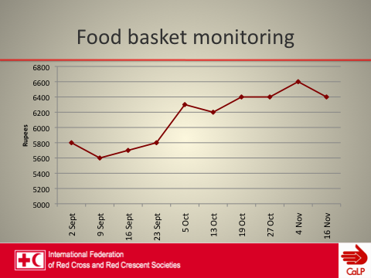

Activity 5.2.3: Monitoring efficiency and effectiveness (optional) (30 mins)
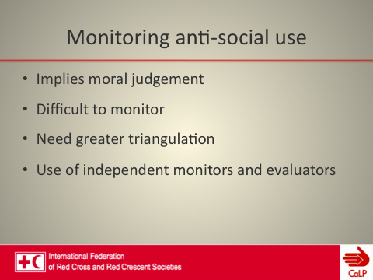 | Monitoring anti-social use implies moral judgment on what is and is not anti-social. It is difficult to monitor since it is intrinsically unlikely that beneficiaries will tell to monitors about anti-social use.  Monitoring anti-social use needs greater triangulation, a wider range of actors in communities and the use of independent monitors and evaluators (locals, with understanding of local contexts)

Show slides on multiplier effects and consider a brief (10 min) exercise to explain how to measure the multiplier effects through the supply-chain based approach.
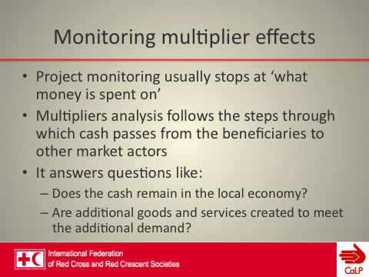 | Briefly introduce the methods to measure multiplier effects:  Social accounting matrix (SAM) that classifies and quantifies the financial flows throughout different economic actors in the local economy (difficult to construct and require accurate data).  Supply-chain-based approach is a simplified method, which analyses the impact of the transfer on the main market actors.

Wrap up
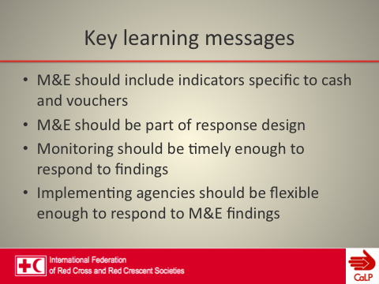

Give handouts
- Handout 5.1: Monitoring market impact
- Handout 5.2: Measuring multiplier effects
- Handout 5.3: Key questions for monitoring and evaluating cash projects

MODULE 5: HANDOUTS

Handout 5.1: Monitoring market impact∗
This table offers guidance on monitoring the impact of cash transfer programming on markets.

Issue | Questions
Supply | - Were traders always able to meet demand?  - Have traders ever refused customers because of shortages?  - If YES, why were they in short supply (transport problems, shortages at regional level, government restrictions, higher demand than usual, etc.)?  - Were these shortages ‘normal’ at that time of year?  - For which items did these shortages occur?
Demand | - How did the number of customers change? (Quantify if possible, but trend is sufficient.)  - How did their level of activity change? (Quantify if possible, but trend is enough.)  - What were the items for which demand increased or decreased more than usual (if any)?  - Can traders explain the reasons for these changes?
Prices | - How would traders qualify the current price situation?  - Did they increase the selling price of certain items more than usual?  - If YES, why and for which items did the inflation occur?
Competition | - How did the number of traders in the market evolve (Quantify and compare figures with baseline data)?  - What impact did this change have on the market (prices, tensions, activity)?  - Will the traders that moved in (if any) remain in the market or will they quit at the end of the project?
Impact of the project | - What is trader perception of the impact of the project on their business?  - What do traders recommend for future projects?
Note: The recall period for such questions can vary depending on the context. For example: in the past two weeks, in the past month, since the start of the project, etc.

Handout 5.2: Measuring multiplier effects∗
This table offers guidance on assessing the multiplier effects of cash transfers. Most project M&E does not look beyond initial beneficiary expenditure, but following cash flows further through local economies gives additional insight into who else benefits from transfers, whether cash remains in the local economy, and whether transfers encourage greater production of goods and services. The depth of information required will depend on context, analytical needs of individual projects, agency and staff capacity, and data availability.
Type of information | When | How | Sample questions
Step 1: Livelihood groups, income, food, and expenditure
Patterns in food sources, income sources, and expenditure of livelihoods groups | Baselines | Household surveys | Level of household income/expenditure in a ‘normal’ period or during the previous month, disaggregated by livelihoods groups and market actors?
 | Baselines | Focus groups | Livelihoods mapping based on Household Economy Analysis methodology?
Step 2: Market mapping
Identification of the key markets that are affected by cash transfers | Baselines (ex-ante) | Household interviews, focus groups, key informants | What are the market systems for commodities and services that project participants most need?
 |  |  | In which market(s) is the target group planning to spend its transfers?
 | Monitoring (ex-post) | Sample interviews | On which items has cash been spent? How much has been spent on each group of commodities or services?
Development of key market models | Baselines or monitoring | Focus group discussions and interviews with key informants, local market actors, project beneficiaries | Where (location) and how (activities and roles) are different groups involved in market systems?
 |  |  | Which market chains are most important in meeting beneficiary needs?
 |  |  | What forms of infrastructure and types of supporting services are especially important?
 |  |  | What are the rules, regulations, social norms, or practices that affect the performance of key market systems?
Step 3: Use of cash transfers
First round of expenditure: beneficiary spending patterns | Post-distribution monitoring | Sample interviews with project beneficiaries; focus group discussions | On which commodities and services have the transfers been spent?
 |  |  | How much has been spent on each type of item or service?
 |  |  | From where and from which market actors have the different goods and services been purchased (farmers, local traders, local shops, wholesalers, etc.)?
 |  |  | What is the origin of purchased products (local or imported)?
Second round of expenditure and beyond | Post-distribution monitoring | Sample interviews or focus groups with market actors | What product(s) or service(s) did the ‘local market actor’ provide to project participants?
 |  |  | From where did ‘local market actors’ provision the additional supplies of necessary commodities to meet increased demand?
 |  |  | By how much has their business activity increased?
 |  |  | How have they spent their additional income? (This applies to third and subsequent rounds of cash transfers and expenditure.)
Step 4: Impact on primary and secondary beneficiaries
Local market actors | Monitoring or final evaluation | Sample interviews or focus groups with market actors | What is the level of expenditure/income of main market actors compared with that of project baseline and ‘normal’ times?
Changes in the market system environment and services | Monitoring or final evaluation | Focus groups, interviews with key informants, local market actors, project beneficiaries | What changes have there been in the number of actors (traders) in key commodity value chains?
 |  |  | What changes have there been in the volume of business and types of goods in markets?
 |  |  | What changes have there been in prices of key market commodities and services?
 |  |  | What changes have there been in availability and accessibility of key market services?

Handout 5.3: Key questions for monitoring and evaluating cash projects
Questions | Methods/Indicators
Appropriateness
- Was there sufficient food and other essential goods available locally to be purchased?  - Were markets functioning to deliver affordable food and other essential items?  - Were markets accessible?  - Did recipients prefer cash over food? | - Interviews with project staff.  - Key informant interviews with local food traders in the communities and local authorities  - Available documentation – assessment and monitoring reports
Coverage
- How were beneficiaries targeted?  - Was targeting perceived as fair?  - Did the use of cash make targeting more difficult?  - Was cash shared with households that weren’t targeted? | - Focus group discussions with members of the community and village committees  - In-depth interviews with households that received cash and households that did not  - Analysis of whether beneficiaries met targeting criteria and whether people who met the criteria were excluded.  - Where possible, comparisons made with targeting in other interventions.
Connectedness
- How did the cash transfers interact with other forms of assistance? | - Key informant interviews with project staff  - Mapping of other interventions and interviews with other organizations in the area  - Interviews with communities about the range of interventions
Impact
- What was the effect of the income on people’s livelihoods?  - What multiplier effects may have occurred due to the cash?  - What effect did the project have on local markets for key goods and services?  - Where and how accessible were the markets were cash was spent?  - How did households decide how to use cash and were there tensions between men and women or different generations?  - How has the cash project affected traditional community self-help systems?  - How has the cash project influenced local debt and credit markets? | - Focus group discussions with people and committees involved in implementation  - Significance of the transfer as a component of household income  - Ranking of income sources including the cash grant.  - Distance to market  - Time taken to purchase goods  - Focus on potentially vulnerable groups such as the elderly  - Separate discussions with men and women.  - Interviews with households that received cash from the project  - Key informant interviews with local traders and shopkeepers in the communities and local authorities  - Use of cash to repay debts  - Influence of cash project on willingness to repay debts  - Interviews with credit providers
Effectiveness
- Did people receive the right amount of cash?  - Were distributions timely and efficient?  - What did people spend the cash on?  - Was cash delivered and spent safely?  - What costs were borne by the beneficiary in receiving and using the cash?  - Did beneficiaries see payment levels as fair and adequate?  - Was there any corruption or abuse by agency staff, local elites or authorities involved in targeting or distribution?  - Is there any evidence of anti-social use? | - Key informant interviews with local traders and shopkeepers in the communities, and with key local authorities  - Waiting times at distribution sites  - Accessibility of transfer mechanism  - Travel distance and costs of traveling to the distribution point  - Focus group discussions with members of the community and village relief/development committees  - Analysis of any security incidents  - In-depth interviews of households that received cash  - Documentation  - Independent monitoring and triangulation with key informants such as teachers and health staff
Efficiency and cost effectiveness
- How efficient and appropriate were the delivery systems used for disbursements?  - Did the agency have sufficient skills to manage the project effectively?  - What were the management costs/requirements in implementing the project?  - What was the total cost of the project per beneficiary?  - What were the external costs borne by the beneficiary?  - What was the total cost of comparable in-kind projects per beneficiary? | - Key informant interviews with programme and finance staff  - Focus group discussions with programme team  - Assessment of qualifications and experience of key staff members  - Focus group discussions with members of the community and village relief/development committees  - In-depth interviews with households that received cash from the project  - Documentation from the programme of cash transfers and food aid
Cash for work
Did cash for work projects build useful and sustainable community assets? | Assessment of the quality of assets built and sustainability issues, such as arrangements for maintenance
Did cash for work projects affect local labour markets? | Local casual labour rates before and after cash for work projects  Interviews and focus group discussions with labourers and employers
Did participation in cash for work interfere with other work opportunities or caring or social obligations? | Interviews and focus group discussions with men and women beneficiaries.
Were wages set at self-targeting levels?  Were labour poor households excluded from cash for work?  What provisions were made for those unable to work?  Were women able to participate? | Wage levels compared to casual labour rates  Project guidelines  Levels of female participation
What was the level of employment (disaggregated according to gender)? | - Number of people who worked, disaggregated by gender and, if possible, by marital status, household type (female/male-headed) and former occupation  - Number of work days provided in total by the project  - Number of average work days per household  - Number of work days provided in total for village and average across project area
Did labour-poor households and other at-risk groups benefit economically (and sufficiently) from the project? | - Find out whether policies were in place to ensure support was provided to labour-poor and vulnerable households  - Find out whether children worked or were excluded. If children were excluded, find out whether their needs were addressed
Voucher projects
Did shopkeepers supply products of an appropriate quality and price without any dishonest practice?  Was the process transparent? Did everyone understand the value of vouchers, and the products they could buy?  Do shops display price lists as required?  Do shops charge beneficiaries extra fees or offer to purchase vouchers?  Do food prices differ between partner and non-partner shops?  Are all commodities available at all times in partner shops?  Do shops treat voucher customers differently? (For example, do they give them low quality food)?  Are shops respecting food and safety standards in the contract?  Are vouchers sold or exchanged for unauthorized items? | Interviews with project beneficiaries, shopkeepers and other key informants  Spot checks of participating shops.  Monitoring agents pretending to be beneficiaries can check the quality of goods, prices and how they are treated.
Sector specific objectives
Did cash meet specific objectives such as shelter, livelihoods recovery or food security? | Number of houses built  Percentage of cash grant spent on shelter  Income generated from investments  Livestock levels  Percentage of household food needs met through cash grant.  Types of food purchased and impact on dietary diversity  Impact on negative coping strategies.

This session is adapted partially from the CaLP basic training
∗ Based on ACF (2007) Implementing Cash-Based Interventions: A guideline for aid workers. Action Contre la Faim: Paris.
∗ Adapted from Creti, Pantaleo (2010) The Impact of Cash Transfers on Local Markets. Cash Learning Partnership: Oxford.

