Evaluating multiplier effects on markets[1]

This guidance relates to all interventions that directly or indirectly involve markets, including in-kind, market support interventions, cash and voucher responses, income-generating activities or those related to service provision. Any project, including those that are not directly market-related, can produce indirect effects on the local economy. Indirect or multiplier effects can be intended (stated in the project objectives) or unintended (out of the scope of the project objectives), and can also strengthen or weaken the overall programme objectives. They are considered positive when they generate investment in productive inputs (creating short-term income) or in productive assets (fostering longer-term development).

The objectives of the programme are fundamental to this process as they outline the expected impact or outcome of the intervention. For example, nutritional objectives of a program may lead to an evaluation of the availability of specific food groups in the market, such as: the number of traders selling specific items, the frequency of sale, quality aspects, the turnover / sales figures of such items, the consumers of specific items etc.

### How to integrate market information in the evaluation

Evaluations can be carried out during or after the project implementation period and generally involve a systematic and objective assessment of the programme, the response strategy and at times, the capacity of the agency. The relevance, fulfilment, efficiency, effectiveness, impact and sustainability of the project objectives are reviewed, with recommendations for future programming commonly made. Market information can play an important role in determining all these aspects. Therefore, it should be integrated in the overall project evaluation.

This guidance will focus on how market information can contribute to understanding how multiplier effects spill over from the target population to the other market actors and to what extent they remain in local economy. The analysis of multiplier effects extends the scope of the evaluation beyond the impact on direct beneficiaries.

### A step-by-step process to evaluate the multiplier effects on the local economy[2]

Four Driving Questions (DQs) will guide you through the evaluation process. The DQs are linked to tools that can be used to directly gather and analyse the relevant market information or as checklists to guarantee that this information is integrated in the overall project evaluation.

|  |  |  |  |  |  |  |  |  |  |  |  |  |  |  |  |
| --- | --- | --- | --- | --- | --- | --- | --- | --- | --- | --- | --- | --- | --- | --- | --- |
| |  |  |  | | --- | --- | --- | | Driving Questions | Tools | | | DQ 4.1. Which market systems have been most affected by the project? | **Tool 4.1: Checklist for interviews with beneficiaries** |  | | DQ 4.2. Which actors have been affected by the project? | **Tool 1.4: Market mapping** |  | | DQ 4.3. What has been the impact of the project on the primary beneficiaries and their access to the market? | **Tool 4.2: Checklist for FGDs with beneficiaries and non-beneficiaries** |  | | DQ 4.4. What has been the general impact of the project on the traders? | **Tool 4.3: Checklist for FGDs and interviews with traders** |  | |

|  |
| --- |
| DQ 4.1. Which market systems have been most affected by the project? |

The answer to this question revolves around issues such as expenditure, income and investment that the project has generated. It is recommended that you involve your staff in a discussion that leads you to identify:

* The market systems in which the beneficiaries have spent (invested) most of the cash / income. Are these the same market systems that you expected them to invest in? If not, why? Does this vary according to gender / age / ethnicity / livelihood?
* The market systems whose commodities and/or services have local origin.
* The market systems for which the project-induced expenditures represent a relatively impor­tant share.
* The market systems that have more complex chains (involve larger numbers of local actors).

This information should be available from the post-distribution monitoring. Otherwise, **Tool 4.1** provides a checklist for the direct collection of this information by means of interviews with project beneficiaries.

Based on this information, you will be able to spot the market systems that have been most involved in the project and therefore potentially, the most affected by the project. However, there may be some less obvious market systems used by the target population that were not considered as impor­tant during the programme design phase. Your evaluation should focus on both types of markets, as the impact on these less obvious markets may be of significance, especially if they were less competi­tive, or relate to any gender / ethnicity / livelihood / age / protection preferences.

The box below gives an actual example of how market systems were selected for the evaluation of a cash-voucher programme in the Gaza Strip[3].

**Evaluation of the multiplier effects of a cash-voucher project in Gaza Strip oPt**

**Selection of market systems**

The post-distribution monitoring found that 31% of the value of the vouchers was spent on dairy products, 21% on vegetable oil, 14% on eggs, 13% on rice and 10% on pulses.

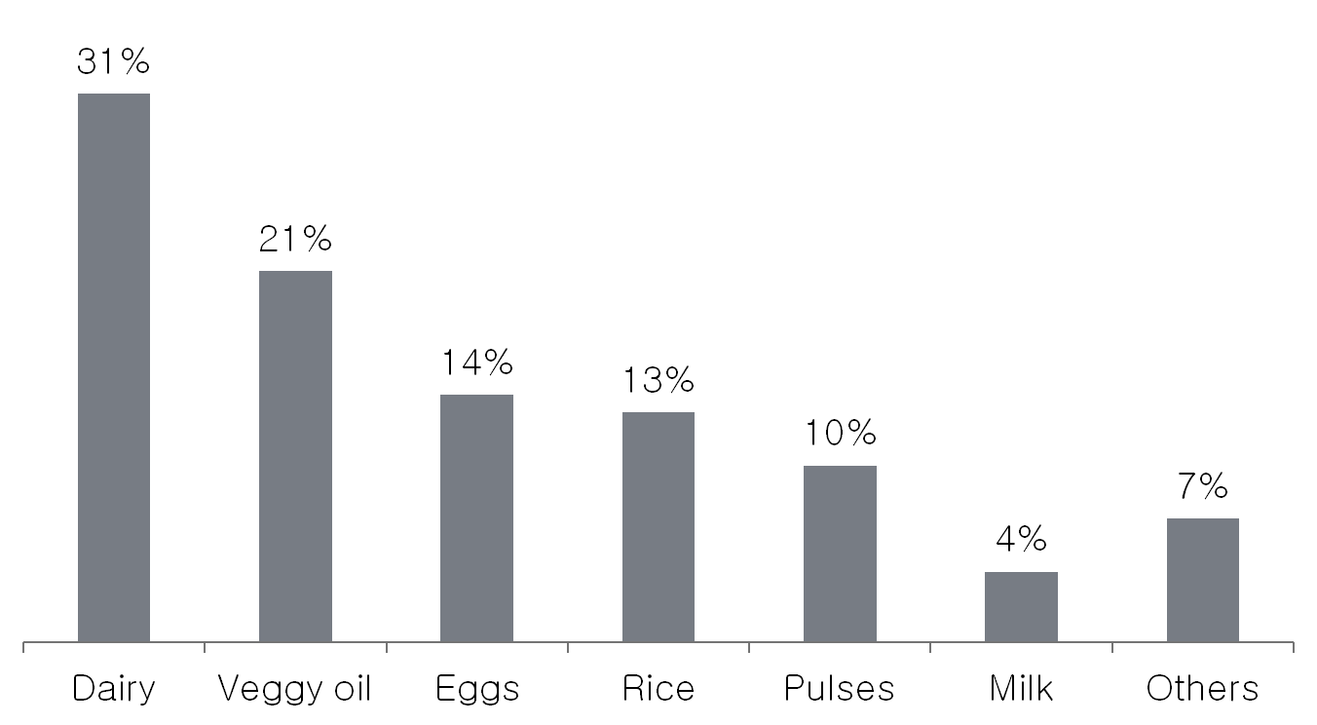

Dairy products and eggs were chosen as ‘focus’ market systems, not only because they represented a high percentage of the value of exchanged vouchers, but also because the products where mainly locally produced and were traded by a large number of local actors.

The market systems for vegetable oil, rice and pulses, instead, had limited impact on the local economy, because they involved a few traders, most of them importers, and the amounts traded within the project scope were negligible compared to the total volumes.

|  |
| --- |
| DQ2. Which actors have affected by the project? |

This question is aimed at identifying the economic actors that have been directly or indirectly affected by the project in a given intervention area. Market system maps are excellent tools for this purpose. They allow a good understanding of the local market chain for the selected commodities or services.

If you are working with the same market system as the one analysed in the contingency plan or in the assessment, you can refer to existing baseline and emergency maps. Otherwise, you should develop new ones. **Assessment Tool 1.4**provides guidance on how to do it.

Analysing how expenditures and investments flow in the market chain helps identify which market actors have been positively or negatively affected by the project, hence enabling you to decide which actors the evaluation should focus on. In doing so, a reflection on the gender and ethnicity of the market actor should be made. The involvement of a gender adviser in the analysis would be ideal.

The box below shows a market map with the effects of the Gaza Strip cash-voucher project on the local dairy sector, and explains how the analysis of the cash flow generated by the project helped identify the market actors to be focused on.



The cash flow generated by the voucher project moves in the opposite direction of the market chain:

* Project beneficiaries spent cash-vouchers to purchase commodities in retail shops (first level of expenditures).
* Shop owners increased the purchase of dairy products from small and medium local factories. They also invested the extra-income generated by the project in improving productive assets and employing new people (second level of expenditures).
* Dairy factories purchased milk from local herders (third level of expenditures).

Based on this information, it was decided that the actors who had benefited from the cash flow generated by the project should be the focus of the evaluation. However, the analysis should also have included some focus group discussions with traders who apparently had not benefited from the project, in order to verify if they had been negatively impacted.

|  |
| --- |
| DQ 4.3. What has been the impact of the project on the primary beneficiaries and their access to the market? |

This question is aimed at identifying how the project has changed beneficiary market access market and what further changes can be expected in the near future. It is also related to how beneficiaries have used the additional and tangible income generated by the project. When reviewing the questions below, a reflection on gender / ethnicity, livelihoods and environment is needed to add more substance, learning and understanding to the evaluation.

To answer this question, you need to know:

* How beneficiaries have managed the income generated by the project
* Which marketplaces and traders were visited by beneficiaries during the project
* How prices have changed during the project
* How the market has changed compared to before the project
* How sustainable the impact of the project is
* How the project has impacted the beneficiary community

**Tool 4.2** has been developed to facilitate the process of gathering the information above by means of Focal Group Discussions (FGD) with beneficiaries. It is recommended that a few FGD be conducted with non-beneficiaries as well, so as to understand how the project has impacted on them.

|  |
| --- |
| DQ 4.4. What has been the general impact of the project on the traders? |

This question helps you understand how the cash flow generated by the project has affected the local traders, either positively or negatively. When reflecting on the questions below, consider gender, ethnicity and type of trader (including the services provided by the trader). In order to be able to answer this question, you need to know:

* Which traders have benefited from the project and which have been negatively affected/ harmed?
* How much of the income generated by the project traders has been invested in productive inputs and assets? Are these local assets or outside the programme area?
* To what extent has the income generated by the project been transmitted to other actors in the chain?
* To what extent the income generated by the project has moved towards other sectors and outside the local economy?
* How has the project changed the trader access to communication, information, technology, physical infrastructure, licenses, etc.?

In order to gather this information it is recommended that you interview different types of traders. Talking directly to traders is helpful to understand their perception of how the project has impacted their business and the whole market system. **Tool 4.3** provides a checklist for FGD and individual interviews with traders.

1. Source: Market Assessment Guidance (2013) - International Red Cross and Red Crescent Movement
2. The same type of analysis can be conducted for in-kind distributions. In this case, the focus should be on the effects of the agency’s purchases and distributions on local producers and other market actors.
3. Creti, P. 2010