Access IFRC Kobo Server- FSL Tools
On the server you can
- Create, Edit and delete a form
- Deploy or publish a form
- Download submitted data
a. Connecting to IFRC Kobo Server - FSL Tools
- Go to https://kobonew.ifrc.org
- Connect username and password
  - Username. Enter: fsl_collect
  - Password. Enter: Datahub!
- View deployed FSL Tools in Kobo 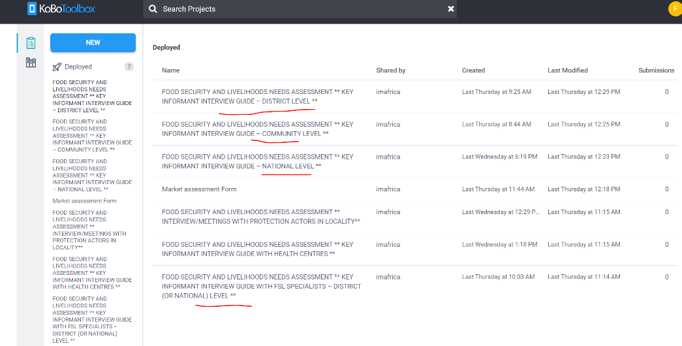
- Click on any of the tool to modify, edit or download xls Form for further adjustments or modification and deploying to any internal kobo server
- Once edit or modification is done,
  - Save the tool for online kobo edits and deploy/ the changes
  - For xls form edits: Download the tool, edit, upload the tool to deploy changes.
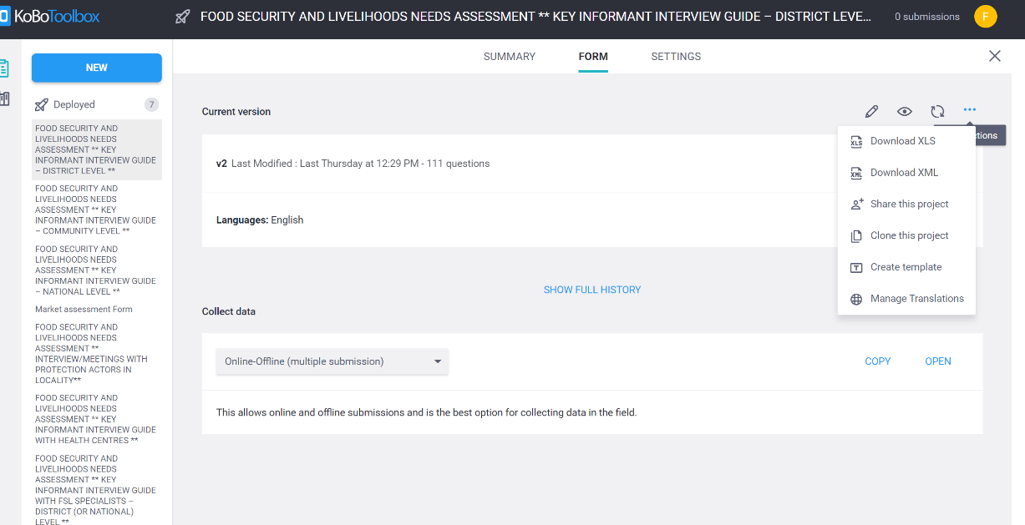

Online Kobo tool edit
NB: This server is acting as a central server location for hosting FSL tools Assessment, for any personal account testing please copy the tool via downloading the XLS form or use “share this project”.
Open the tool in the browser
Share the tool to any kobo user server for modification and deployment

XLS form download and modifications/edits
FSL tools

