Roadmap for assessment planning and preparation
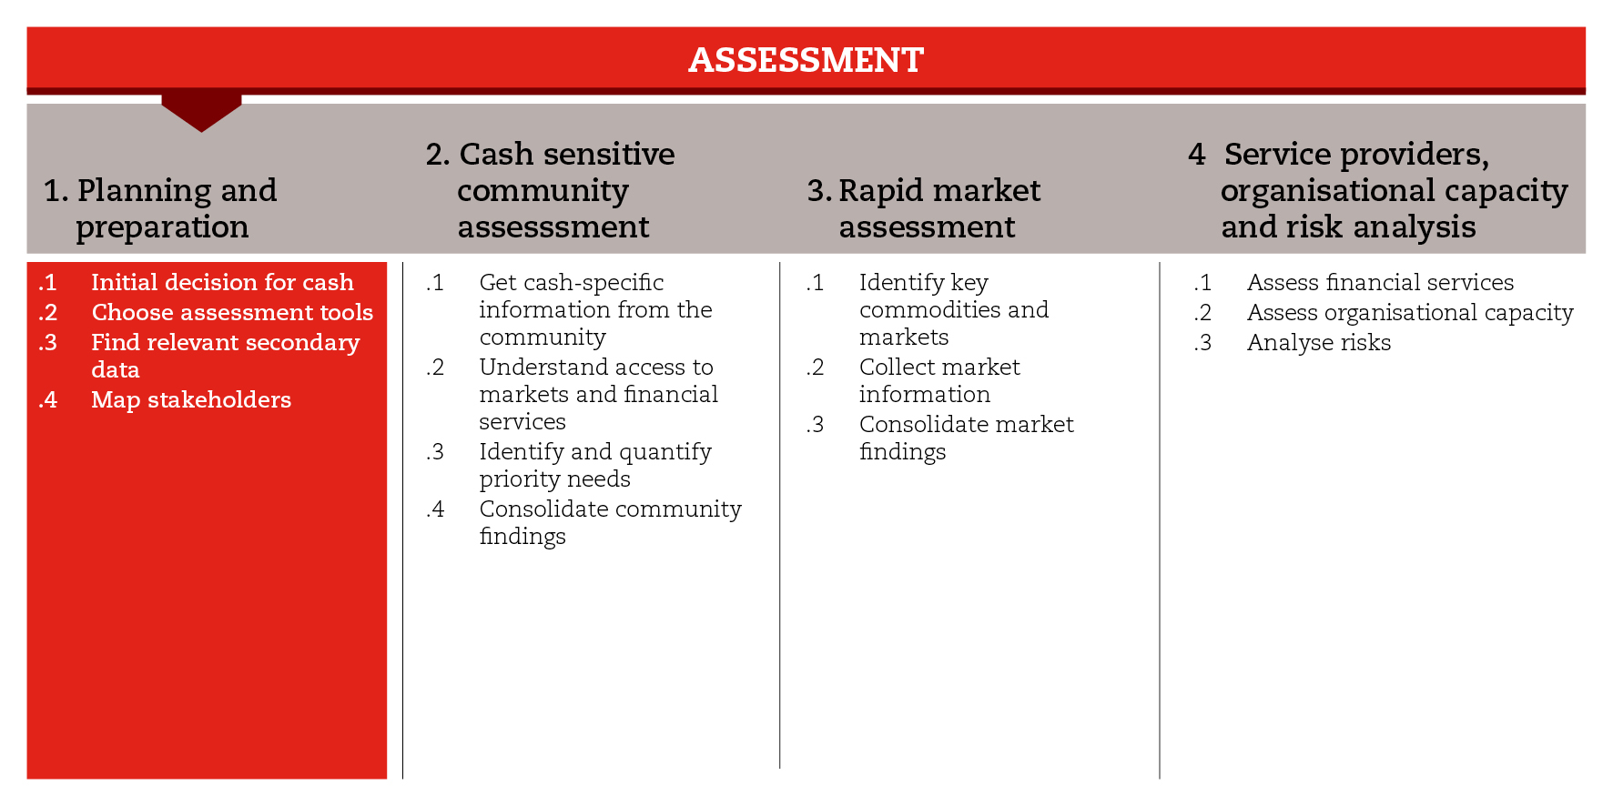

INTRODUCTION
Initial decisions on the response modality can be made immediately after the shock, by staff members who have technical expertise and experience, based on information gathered directly during initial field visits or taken from contingency plans and coordination meetings. It is important to consider that, whatever immediate decision is taken, only a subsequent, more detailed assessment followed by response analysis can confirm whether in-kind or cash-based assistance will be the best option to meet the needs of the affected population in the next phases.
When choosing the assessment approach and tools, consider that most of them are not cash-sensitive. If you haven’t integrated cash-specific information into them during preparedness, it is likely that you will need to do this while planning and preparing for assessment. This road map will help you plan and prepare the assessment taking cash-specific issues into account.
For the purposes of the CiE Toolkit, assessment planning and preparation is divided into four sub-steps. The first sub-step can support initial decisions about the feasibility of cash. The second sub-step will guide you through commonly used assessment approaches and tools, most of which are not cash-specific, so cash-specific issues will have to be incorporated along the assessment process. The most common assessment guidelines and their most relevant tools can be found in the reference documents. The third sub-step will introduce you to secondary data sources that can be relevant for the use of cash in emergency responses. The last sub-step will help you identify key stakeholders and gather cash-specific information from them.
In an emergency situation, you will not always be able to use all the suggested tools but you should, at least, comply with the minimum standards set for the process.

MINIMUM STANDARDS
- Decisions on the feasibility of cash in the immediate aftermath of a shock must be taken by staff with technical experience and expertise
- The possibility of providing multipurpose cash assistance should be considered from the beginning.
- Any decision on the immediate feasibility of cash must be confirmed by subsequent assessment and response analysis.
- The assessment approach/tool should be chosen based on the agency’s preferences, the sector and depth of the analysis and the phase of the emergency. If the chosen approach/tools are not cash-sensitive, cash specific issues should be integrated.
- Cash-specific secondary data must be collected and analysed before planning the primary data collection.
- Cash-specific issues should be integrated into key stakeholders’ analysis and mapping.
- Stakeholders’ analysis should include the mapping of national safety nets and the identification of possibilities to reinforce or adapt existing systems to humanitarian purposes.

SUB-STEPS AND TOOLS

Initial decision for cash
The first decisions on how to respond to a sudden-onset emergency are made immediately after the shock. Usually, emergency appeals are issued within hours after a major emergency or disaster has occurred, and should provide some indication on how initial needs are to be covered. This requires a short-term decision on whether cash-based modalities will be used to cover immediate needs. This decision should be made by staff with technical expertise and experience (generally a senior emergency cash or market specialist). Among the sub-step tools, you will find a checklist that can support this initial decision-making.
The sound use of the checklist will depend on an on-hand understanding of the context, the capacity of the organization and its partners, and the immediate effects of the shock on the population and infrastructure. This information can be gathered directly during initial field visits, or taken from National contingency plans and coordination meetings.
When going for cash, consider the possibility of using multipurpose cash grants (MPG) rather than limiting CTP to specific sectors (e.g. cash for food, seeds, shelter, rent). The unrestricted nature of MPG allows for meeting beneficiaries’ needs more holistically, as it increases choice and flexibility.
It is important to consider that, whatever the immediate decision is, only a subsequent assessment followed by response analysis can confirm whether CTP will be the best option to meet the needs of the affected population in the next phases of the response.

Choose assessment tools
When planning and preparing for an assessment, one of the first things to do is to decide which approach and tools to use. In the sub-step tools, you will find a summary table of the assessment tools most commonly used, with a brief description of each tool, information on the ideal time to use it, in which sector, and whether it is cash-sensitive or not. As you will see, most of the assessment tools available are not cash-sensitive; therefore, it is likely that you will need to integrate cash-specific information into them or conduct cash-specific supplementary analysis. Be prepared to add cash-sensitive questions to existing multi-sectoral tools and devise specific cash questions for sectors such as shelter or water, sanitation and hygiene. In all cases, keep the commodity markets in mind and use the Red Cross Red Crescent market assessment tools for clearly identified commodities and financial service providers.

Find relevant secondary data
Before planning primary data collection, you should check for available cash-specific secondary data. Secondary data can be collected from a number of locations, including from preparedness documents. Among the sub-step tools, you will find a list of potential secondary data sources. Remember that there is usually an in-country market price monitoring system, which will provide key information.

Map stakeholders
Key stakeholders are those that can influence significantly or are important to the success of a potential cash intervention. Information about them is fundamental for determining cash feasibility. The sub-step tools include a matrix that can help you put together information on key stakeholders. Among the sub-step tools, you will find two checklists that can help you gather cash-specific information during interviews with local authorities and humanitarian agencies.
When interviewing local authorities it is important to understand the government’s opinion on CTP, to determine whether the government has any established safety nets and to identify opportunities to reinforce or adapt existing systems to humanitarian contexts.
You can extend these to use within International Red Cross Red Cross Movement actors too, through a working group meeting on CTP, if needed. The checklists suggest questions to choose from and adapt to your context in order to ensure that cash issues are taken into account in your assessment. Finally, the 4Ws tool can help you gather and consolidate information on who is doing what, where and when in response to the emergency.

REFERENCE DOCUMENTS
Household Economic Security (HES) Technical Guidelines for Assessment Analysis and Programme Design (BRC) http://www.livelihoodscentre.org/livelihoods/portal.portal?_nfpb=true&_pageLabel=pages_documentDetail_page&language=en&nodeId=%2FLivelihoods%2F16011&section=Publications&l=en#wlp_pages_documentDetail_page
MIRA (Multi-cluster/sector Initial Rapid Assessment) (UN-OCHA) https://docs.unocha.org/sites/dms/Documents/mira_final_version2012.pdf
IFRC How to do a VCA A practical step-by-step guide for Red Cross Red Crescent staff and volunteers (2007) http://www.ifrc.org/Global/Publications/disasters/vca/how-to-do-vca-en.pdf
CaLP urban toolkit http://www.cashlearning.org/downloads/resources/calp/CaLP_Urban_Toolkit_web.pdf
CaLP Social Protection Thematic Page www.cashlearning.org/thematic-area/social-protection
ICRC (2014) ECOSEC Executive Brief on Social Safety Nets

