Financial Service Provider (FSP) Procurement

Standard Operating Procedure (SOP)

IFRC Africa Region 2021

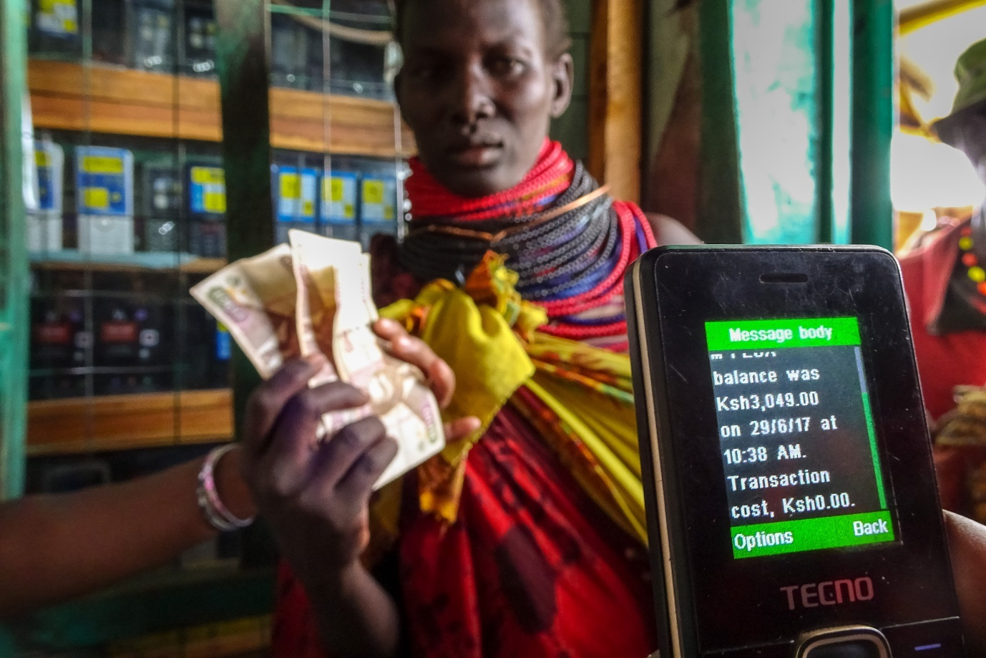
Picture 1: (c) IFRC 2021

Authors:
Maja Tønning, Regional CVA Coordinator, IFRC Africa, Maja.Tonning@ifrc.org
Vanesa Colsa, FSP Procurement Surge Support
Sergio Fernandes, Regional Procurement Manager, IFRC Africa, Sergio.Fernandes@ifrc.org
Carren Auma Oyayo, Senior Procurement Officer, IFRC Africa Carren.OYAYO@ifrc.org

Table of Contents
Abbreviations* 2
1. Introduction 3
2. The document’s purpose and audience 3
2.1. Who is this document for? 3
3. FSP Procurement Process 4
3.1. Scope of Work (SoW) and Tender Documents 4
3.2. Tendering 5
3.3. Types of contract 6
3.4. IFRC procurement manual 6
3.5. Free online learning 7
4. FSP Framework Agreement 7
5. Use/activation of the FSP framework agreement 9
6. Request for exceptional approval 9
Annex 1: Checklist of IFRC Compliance Requirements 12
Annex 2: Process flows, roles and responsibilities for FSP selection and contracting 16
Annex 3: Glossary of terms 20

Abbreviations*
ARO Africa Regional Office
COC Committee on Contracts
CVA Cash and Voucher Assistance
FSP Financial Service Provider
IFRC International Federation of the Red Cross and Red Crescent Societies
KYC Know-Your-Customer
LR Logistics Requisition
MPC Multipurpose Cash
NS National Society
PNS Partner National Society
RLU Regional Logistics Unit
SOP Standard Operating Procedure
SoW Scope of Work

*See also, Annex 3: Glossary of Terms

Introduction
The delivery of cash and voucher assistance (CVA) often requires a third party such as a bank, a mobile phone company or a voucher vendor to be integrated into the process to deliver to the “last mile”. The evaluation and selection of these suppliers is critical as their performance has a direct impact on the quality of the assistance being provided. Procurement processes and procedures help ensure that the appropriate supplier is selected and allows management of risks and to offer a set of checks and balances. They are key to select services that enable recipients to receive the right assistance in the right way, have sufficient cash out points and liquidity, can reach people in a timely manner, are compliant with local financial regulations, and have sufficient coverage.
The following document details processes around Financial Service Provider (FSP) procurement. FSP procurement should be led by the relevant National Society (NS) programme and logistics staff and closely followed by IFRC counterparts at the Cluster offices and supported by the Regional Office (RO).
Prior to beginning the selection process for a Financial Service Provider, the NS should complete a CVA feasibility analysis and FSP mapping. More details on these steps are available in the document “CVA Process Flows”, which is available here.

The document’s purpose and audience
The purpose of this document is to provide guidelines to help NS and IFRC staff and volunteers to follow procurement best practice, managing contracting of suppliers, quality checks and all the other essential steps for the successful tendering of Financial Service Providers for CVA programs.
The document is supported by the Cash in Emergencies toolkit (en) / (fr), IFRC’s CVA Programme Guidance and other Cash Hub (en) / Cash Hub (fr) resources.
For a more detailed Standard Operating Procedure (SOP), see also IFRC Secretariat, Global Cash Standard Operating Procedures.

Who is this document for?
The document provides a generic explanation of internal IFRC processes for CVA to be used at the levels of the Africa Regional Office (ARO) (Nairobi), by Cluster Offices and by National Societies (NS), including staff functions in:
- All IFRC Africa Regional Office, including Cluster level, functional areas involved in the initial operational response decision making (Operations, Logistics, Finance, Legal, Security and Programmes), who need an understanding of the process flows for administering CVA
- All IFRC emergency response and service support staff, including Operations, Programmes, Logistics and Finance
- National Society programme, logistics and finance staff engaged in CVA preparedness and response
- Partner National Society (PNS) staff supporting NS in FSP procurement

FSP Procurement Process
After the decision has been taken that cash or vouchers is the appropriate modality based on the feasibility analysis and the risk analysis, a third party needs to be selected to support the programme until the “last mile”. When a NS would like to implement CVA as part of an Emergency Appeal (EA) or DREF, the NS will need to follow a FSP procurement process that is compliant with the IFRC procedures.
The procurement process always starts with a Logistics Requisition (LR) as it serves as the authorization document for procurement authority. The LR also details critical aspects such as the nature of the programme request (e.g. mobile money, cash in envelopes or other CVA modality) as well indicative timeline/deadline and currency amongst others. It should ideally be accompanied as annex by the Scope of Work (SOW) detailing the nature of the programme/request. The requester should prepare the LR with budget limits – one line for number of beneficiaries / amount per beneficiary / total amount to be disbursed, one line for budgeted FSP Service (and any other relevant fees).
A quick overview of the FSP procurement process is indicated in Figure 1. The detailed process including roles and responsibilities is available in Annex 2 of this document. Some steps in each process might be done concurrently (such as preparing the RFQ while establishing the SoW).
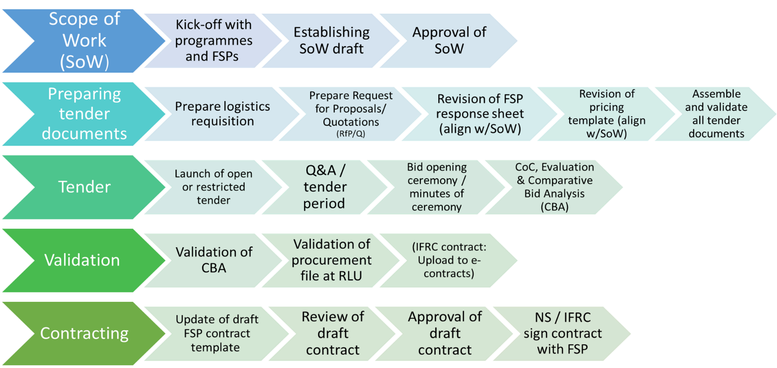
Figure 1: Process flow for FSP procurement

Scope of Work (SoW) and Tender Documents
The SoW is a critical document, which requires engagement of various functions. The SoW is used to give detail and context of the typical cash assistance programme and what the FSP needs to understand about the way we work, and the type of projects expected to be delivered. The Regional CVA Coordinator and Regional Procurement Manager can support with draft SoW’s and examples from other contexts.
The tender documents can be prepared simultaneously with the SoW. The tender package includes:
- RFP/RFQ
- SoW
- FSP Response Sheet
- Pricing template
- Declaration of Undertaking
- General Terms and Conditions for Service Contracts
- Supplier Registration Form (standard format)
The RFP response template lists the specifications or requirements of the service. The headers should remain and there should be AT LEAST ONE question per header. This is a template to adapt to your context. These are the questions we are asking to the FSPs, and we will evaluate their responses to understand if they meet our needs or not. Developing a delivery mechanisms checklist covering required and preferred requirements is helpful in completing the RFP supplier response sheet.
Data protection
- Always ensure that data protection requirements are reflected in both the SoW and the contract itself.
- All relevant IFRC and NS staff should familiarise themselves with and use the IFRC Practical Guidance for Data Protection in CVA, available in both English and French.

Tendering
To launch the tender if it is a restricted bid, the RFP and any attachments is sent directly to the FSPs preselected and the proposal submission timeline can range between 2 to 4 weeks depending on the urgency and capacity of response of the FSPs. If it is an open tender process, it should be advertised in the predetermined newspapers or other media with tender conditions and the interested FSP will ask for the tender documents. A “Tender Delivery Registry” should be kept with the list of the suppliers, name of person receiving the documents, date, time and signature of receiver.
It is required to ensure there is a period and a mechanism for bidding service providers to ask questions. Questions can be compiled and then answered as a group or answered each time a question is raised. It is necessary to send the response to ALL potential service providers regardless as to whether they asked the question or not – this ensures transparency in the process.
The deadline must be respected - once the pre-specified time has been reached on the deadline date, no additional proposals can be received. If there is an extension there must be evidence of timely notification to ALL FSP suppliers of tender extension deadline.
When using an email submission, the time on that email would be referred to. If physical bids in envelopes are accepted, then it is the responsibility of the individual accepting the bids to write the EXACT time and date on the envelope when submitted together with the relevant “Tender BID Submission Registry” with the list of suppliers, name of person delivering bid, date, time, and signature of person submitting to Sealed Bid Box.

After the deadline for receipt of proposals, a Bid Opening Ceremony must be scheduled as soon as possible. This reduces the risk of manipulating bids received or admitting late bids. Bids must be opened in the presence of the Local Committee on Contracts (COC) and all details of the procedure documented – date, place, list of officially nominated attendees with names, titles and organization (nominated by authorised NS/IFRC senior official such as Secretary General or Country Head/Head of Delegation, Tender Reference/RFQ Ref No. and Logistics Requisition Ref No. and general description of proposed program with number of beneficiaries, total budget and relevant currency, Other details as per procurement process checklist.

Types of contracts
There are two common types of contractual agreements with suppliers, including with Financial Service Providers (FSPs):
- Service Contract (SC): it is usually narrow in scope, created for a particular operation and generally cannot be extended outside the service type and geographical locations outlined in the tender. CVA program requirements are clearly defined, including geographic locations, number of people to be assisted, transfer amount, frequency, and duration.
- Framework Agreements (FA): are broader and longer in duration often two years + a two-year extension. Framework Agreements often can be used in most or all of the country or region and are used for goods or services that are frequently required for programme implementation. CVA program requirements are not always defined (unknown geographical locations, number of people to be assisted, transfer amount, frequency, duration).

IFRC procurement manual
It is critical to read and familiarise yourself with the IFRC procurement manual 2018 (It is important to read chapters: 2.2.3 Criteria for Supplier Pre-qualification; 2.3 on Framework Agreements and 3.6 Procurement of Cash Related Services).
Quick tips DREF and EAs:
No Existing Contract – Full Procurement Process
In this situation, if you wish to contract an FSP for implementing CVA for an Emergency Appeal/ DREF you will need to undertake a full procurement process following IFRC procurement procedures.
No Existing Contract – Sole Sourcing/No Competition
In this sitution, if you wish to contract an FSP for implementing CVA for an Emergency Appeal/ DREF and there is only one FSP relevant to the context, you will need to follow IFRC procurement procedures and apply the sole sourcing/no competition exception.
Existing Contract – Procurement Compliance Check
In this situation, if you wish to use an exiting contract for an FSP for implementing CVA for an Emergency Appeal/DREF, you will need to get confirmation from IFRC Regional Logistics Unit on compliance.
Existing Contract – Authorised Exceptions to Bid
In this sitution, if you wish to use an exiting contract an FSP for implementing cash assistance for an Emergency Appeal/DREF and the process has not be compliant or the contracted services needs amendment for the current operation, you will need to apply for an Authorised Exception to bid via the IFRC Regional Logistics Unit.

Free online learning
IFRC has created an online course to guide practitioners through the steps of FSP procurement for cash projects. The course is aimed at programme staff, logistics, procurement, and finance. It is required for staff engaged in FSP procurement to take the course, which is available on the IFRC learning platform here. The course spans over 13 modules and takes approximately 2 hours to finalise.

FSP Framework Agreement
The establishment of a FSP Framework Agreement is a requirement to respond rapidly with cash assistance. The FSP procurement process is led by National Societies and closely followed by IFRC CVA/DM/Ops technical and logistics staff at the cluster and regional offices.
It is mandatory that FSP Framework Agreements are compliant with IFRC procurement procedures if the contract is used for DREF’s and EA’s (see also Annex 1). Cluster offices are encouraged to engage with PNS’s in countries to ensure that they are aware of this requirement if and when they support National Societies in FSP procurement.
For third-party cash distributions, technical approval of the FSP procurement always need to be sought from the regional Logistics and Procurement office regardless of the procurement value. This is due to inherent risks involved with third-party FSPs.
Key points:
- On open tender requires a public advertisement (templates in the Procurement Manual) and allows all potential suppliers interested in bidding to participate. Open tenders can be international or local tenders.
- Potential Suppliers for FAs are selected based on strict criteria, such as professionalism and knowledge of international trade, reliability, service capability, coverage, liquidity, price range, quality assurance, compliance with regulations, and their previous record.
- Contract period is 2 years with a possible 2-year extension with a maximum of 4 years in total
- FA have no legal obligation to order any minimum or maximum quantity
- FAs shall be non-exclusive, hence IFRC may establish FAs with different Suppliers for the same services.
- The FA will not detail the transfer value explicitly. It will detail the service required and a typical value size (an average or maybe a range) which helps the FSP give the tariff of charges for the anticipated service as well as understanding the liquidity requirements they will need.
Framework Agreements can be created up to 2 years with a possible 2-year extension, so the maximum length is 4 years. Framework Agreements must not be open-ended contracts. The FSP market changes often, and it is necessary to periodically (every 2 or 4 years) conduct an open tender to re-establish the FA and/or decide if it is still required. National Societies are advised to conduct FSP market research/mapping frequently to inform the choice of whether to continue with the existing FA and/or whether to pursue contracting other FSPs.
If extending a FA, the service requirements or specifications should be updated to reflect the learning from the current contract and to improve the service going forward.
If conducting a new tender, this again should be an open tender for a new FA that meets IFRC compliance. It is possible to award the new FA to the current (incumbent) FSP if after the evaluation and Comparative Bid Analysis (CBA) it is demonstrated that the incumbent is the most suitable FSP.
Addition information on FSP FA procurement and key documents and templates can be found in the IFRC FSP Framework Agreement tip-sheet:

Important to remember:

- A National Society can hold more than one FSP Framework Agreement depending on for example, coverage in the operational areas.
- Minimum 8 up to 12 weeks should be allowed for the full procurement process:
  - Allow 2-3 weeks to establish the SoW and launch the tender
  - Allow 2-3 weeks for bid responses
  - Allow time for evaluation of bids
  - Allow 2 weeks for contracting
- Build in data protection and data management from the onset, including in the FSP mapping, SoW, and contract. A standard data protection section is included in the SoW format and an annex exists for the FSP contract on data processing. IFRC has furthermore developed a draft questionnaire that NS’ can use in their engagement with FSPs to understand their data protection and data management capacities. If support is needed, NS can contact the Regional CVA Coordinator to link to support from PNS.
- Balance mandatory vs. preferred requirements to ensure a successful tender. If some FSPs are unable to deliver on preferred requirements, the RCRCM can support FSPs in strengthening systems and procedures to adhere to programme requirements.

Use/activation of the FSP framework agreement
As the framework agreement is a contract meant to be used for repeat situations, it does not contain the exact details of upcoming distributions/services to be provided.
The predefined service with agreed terms, conditions and fees can be used by placing a Purchase Order (PO) via Logistics by submitting a Logistics Requisition and a programme specific Scope of Work. The PO typically contains an Annex with the SoW that details the cash assistance delivery and services, i.e., number of people, transfer value, instalments, locations, duration of project, and delivery schedule within the scope of the framework agreement.
The addendum must be reviewed and approved by CVA focal points at the cluster and regional levels.

Request for exceptional approval
Exceptional approval for contracting an FSP that are not IFRC compliant may be given under different circumstances. These circumstances typically include scenarios where a tendering process is not feasible or not practical to undertake or under other may be given under different circumstances outlined under #paragraph 2.7: Exceptions to tendering process of the IFRC Procurement Manual. Under permitted exceptions, contractual commitments may be made based on a single bid with a qualified supplier whose offer substantially meets FSP program the requirements at an accepted and competitive market price. This process might be relevant in cases where NS are planning to respond to an emergency but does not already have an IFRC-compliant FSP framework agreement in place. The most common reasons for applying for exceptional approval are:
- NS has a service contract with an FSP they wish to engage again
- NS has a non-IFRC compliant framework agreement
- NS works in a setting with no competition (i.e., only one FSP service provider in specific area)
Procurement thresholds for different levels and amounts of purchase is available here:
Logistics colleagues can support the process for exceptional approval. A template to apply for exceptional approval is available online as well as here:
First, it should be decided if the existing contract can be used. The following conclusion tree can support this decision:
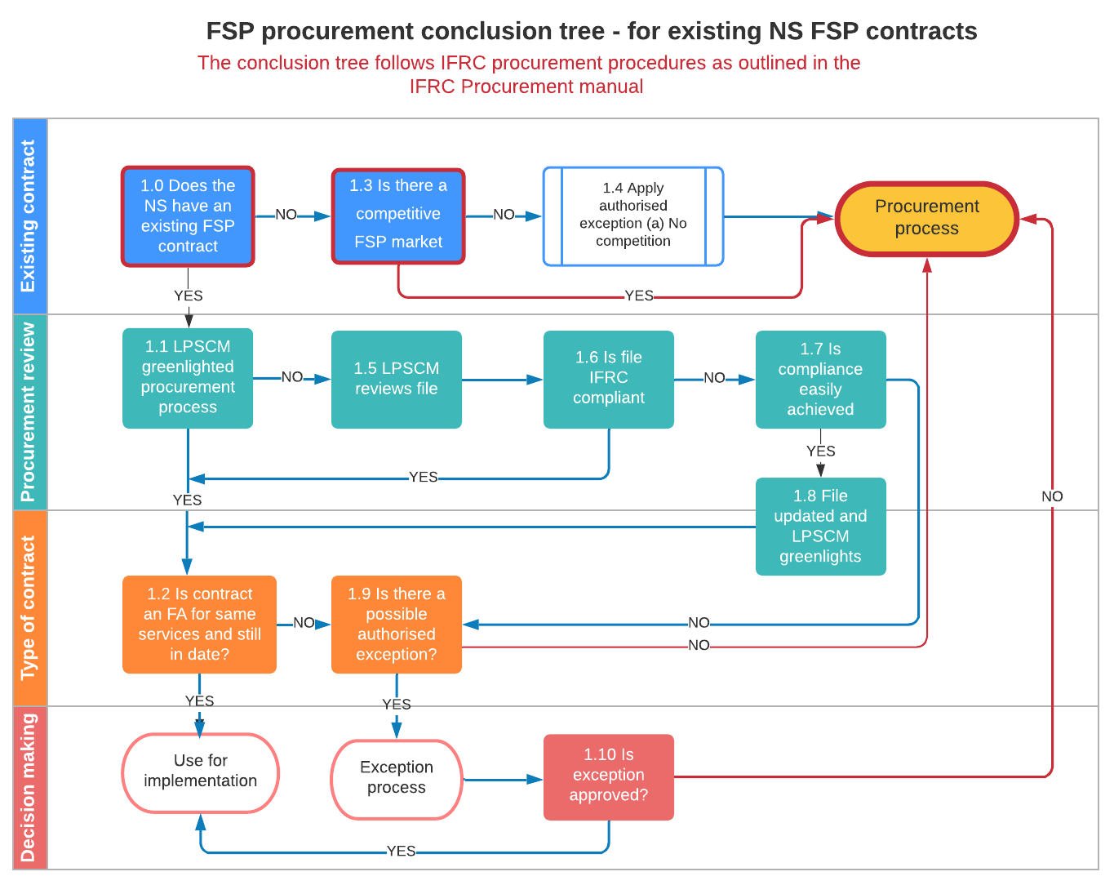
The approval request must be developed by the NS and reviewed by CVA focal points at the cluster and regional levels as well as with relevant procurement and logistics colleagues at country/operation, Cluster and Regional Level. A draft (soft copy) of the Request for Exceptional Approval should be submitted to the Regional Office CVA and Logistics for review before signature.
The final version of the Request for Exceptional Approval together with supporting documents should be sent to the Head of Africa RLU / Nairobi copy to Regional Procurement Manager and as follows:
- Logistics Requisition (Purchase Request) with budget limit and currency in which one line item for amount to be distributed to beneficiaries and one line for service fees to service provider, duly approved
- The SoW to be used in the FSP procurement
- The Annex SoW that is relevant to the current project if order placed with an existing FA
- In cases of single sourcing outside FA: Written confirmation (Offer) from FSP that it is willing and able to provide the services required under the SoW, of fees and charges being levied and of acceptance of Terms and Conditions of Service (NS/IFRC)
- Due Diligence Form duly completed
- Supplier Registration Form: documents including duly filled Supplier Registration Form (SRF) signed, dated, and stamped and all required supporting documents:
  - a.) Copies of last three years audited financial statements from the supplier
  - b.) Original Statement of the Supplier’s Bank confirming banking details (certifying the bank account and relevant details – Bank Name, Address, Brach Code, Banking Codes etc.)
  - c.) Copy of Company Registration Certificate
  - d.) Tax Clearance Certificate and any other relevant documents required by country law from the supplier.
- Copy of Existing/current contract with the FSP
- NS / IFRC General Terms and Conditions for Service Contracts

Annex 1: Checklist of IFRC Compliance Requirements
To comply with IFRC regulations the following documents are required to be submitted to IFRC:
# | Document | Information required | Format
1 | Logistics Requisition (LR) or equivalent with budget limits  INTERNAL IFRC DOCUMENT - NO NEED TO SEND TO SUPPLIER | a) Amount for distribution to beneficiaries  b) Amount budgeted for services fees  It is required to Annex the SoW (2.2) | Original scanned, completed in full and signed and dated by Requester, Logistics, Finance and Country Representative. EN, FR, SP or include translation.
2 | Newspaper Advert or other media publication  REQUIRED ONLY WHEN IT IS AN OPEN TENDER | Name of media and date clearly visible  Description of the program, dates, where and how to obtain the documents | Copy (or scan) of newspaper Advert or other media publication
3 | RFP/RFQ - Request for Proposal/ Request for Quotation | Tender Documents to be submitted to FSP’s including all annexes  Need to be received in sealed bids (sealed envelope/ sealed email address) | Final version that was shared with the FSPs as part of the tender. EN, FR, SP or include translation.
3,1 | Scope of Work (SoW) | Document which outlines the programme objectives and provides the FSPs information of what we are expecting of them
3,2 | RFP FSP Response Sheet | Response Sheet detailing the service requirements (mandatory and preferred) that we will be requesting from and evaluating FSPs against  Document must be reviewed by CVA programs and aligned with the SOW
3,3 | Pricing List template / Cost Breakdown | Document must be reviewed by CVA programs and aligned with the SOW and CVA Technical requirements
3,4 | General Terms and Conditions for Service Contracts (CVA) | CVA Version
3,5 | Declaration of Undertaking
3,6 | Supplier Registration Form (SRF) + supporting documents | a) Copies of last three years audited financial statements  b) Original Statement of the Supplier’s Bank confirming banking details (certifying the bank account and relevant details – Bank Name, Address, Branch Code, Banking Codes etc.),  c) Copy of Company Registration Certificate, Tax Clearance Certificate and any other relevant documents required by country law. | Original scanned, signed, dated, and stamped. EN, FR, SP or include translation.  All required supporting documents as per Procurement Manual 2.2.2 (subject to Legal and Finance verification/approval). EN, FR, SP or include translation.
4 | List of Suppliers targeted | Evidence of Tender Document Delivery to FSP
4,1 | Proof of emails sent to suppliers (if Tender Documents delivered by email) | Name of Supplier who documents were sent to and Date and Hour sent. | Copies of emails clearly stating name of Supplier sent to date and hour sent
4,2 | Tender Delivery Registry (If Tender Documents picked up by FSP in Envelopes (physical documents) or electronically (USB Stick)) | Company Name/Officer Name (person Picking up Documents)/ Date/Time/ Signature | Scanned copy of Tender Delivery Registry with signatures.
5 | Notification of Tender Deadline Extension to Suppliers | Evidence of Timely Notification to ALL FSP suppliers of Tender Extension Deadline | Copies of emails sent to suppliers notifying of Tender deadline extension clearly stating name of Supplier sent to date and hour sent
6 | BID / OFFER DELIVERY TO IFRC/NATIONAL SOCIETY | Evidence of Supplier Bid/Offer delivery to IFRC/NS
6,1 | If Bids/Offers delivered by email to sealed Bid E-Mail Address | Copy of emails with respective bid documents submitted with date/hour clearly visible and clearly identified by name of FSP
6,2 | If Bids/Offers delivered to / picked up by FSP or electronically (USB Stick) | Tender Receipt Registry with: Company Name/Officer Name (person Delivering Bid/Offer)/ Date/Time/ Signature
7 | BIDS / OFFERS/PROPOSALS FROM SUPPLERS | Scanned Copies of Bids submitted by Suppliers (each bid scanned separately)
8 | Minutes of Tender Opening Ceremony | Minutes of Meeting held by Local Committee on Contracts to Acknowledge and Open Bids received  - Place, Date, and time of Meeting  - List of names appointed for the Opening of Bids Committee and respective titles  - General description of program and purpose (number of beneficiaries, areas, and total amount to be distributed - if known)  - List of Companies that were sent RFPs by e-mail or received RFPs in physical format.  - List of Companies that submitted bids by e-mail or in sealed envelopes before the closing deadline (time/date) as requested in Tender documents  - List of Companies that submitted bids by email or sealed envelopes after the tender closing deadline (time/date)  - List of companies that were sent Tender documents by e-mail/physical format and did not reply  - END OF DOCUMENT: Names, Titles of attendees and date | Original scanned, completed in full, dated and signed by CoC members. EN, FR, SP or include translation.
8 | Minutes of Bid Evaluation and selection of Suppliers, CoC | Minutes of Committee on Contracts (Supplier Selection Committee) with the following:  Minutes Detailing Supplier Bid Evaluation and Supplier Recommendation  Place, Date, and time of Meeting  - List of names appointed for the Evaluation of Bids Committee and respective titles  - c) d) e) f) g) from the Tender opening minutes of the meeting  - Supplier selection criteria clearly defined  - Administrative Evaluation and criteria (min points required to pass to next stage and max points attainable)  Technical Evaluation and criteria (min points required to pass to next stage and max points attainable)  Financial Evaluation and criteria (minimum points required to pass to next stage and max points attainable)  - Final selection Supplier criteria  - Best Overall Offer  OR  - Best Financial Offer for Suppliers Meeting Administrative and Technical (Program) Requirements  - Committee on Contracts Supplier Recommendation:  - Supplier  - Amount to be distributed by beneficiary and total amount to be distributed to all beneficiaries and services fees (when known)  - END OF DOCUMENT: Name, Title and Signature of all committee members, Place and Date | Original scanned, completed in full, dated and signed by CoC members. EN, FR, SP or include translation.
10 | CBA (Comparative Bid Analysis) | Soft Copy and signed PDF. Signed PDF: Submitted by / Finance Official/ Head of Operation /Country Representative or Head of Cluster
11 | Draft of de contract | Soft Copy of Draft Contract

Annex 2: Process flows, roles, and responsibilities for FSP selection and contracting
Phase | Steps | Product / output | Responsible function | Accountable | Must be consulted | Keep informed
- Scope of Work (SoW) | 1.1 Establishing CVA Objective | None | - NS CVA focal  - Cluster programme staff* *(cluster CVA focal where available) | - Cluster Programme staff  - Regional CVA Coordinator | - Regional CVA Coordinator | Procurement  Country Cluster  Regional
 | 1.2 Kick off meeting with FSP | None / meeting minutes if applicable | - NS CVA focal  - Cluster programme staff | - Cluster Programme staff
 | 1.3 Scope of Work | SoW Draft | - NS CVA focal  - Cluster programme staff | - Cluster Programme staff  - Regional CVA Coordinator | - Regional CVA Coordinator  - Regional Logistics Unit (RLU)  - Finance NS  - Legal NS
 | 1.4 Green-light of SoW | Approved SoW | - NS CVA focal  - Cluster Logs staff  - Cluster programme staff | - Regional CVA Coordinator | - Regional CVA Coordinator  - Regional Procurement Manager
- Tender documents | 2.1 Preparing RfQ | RfQ | - NS Logs  - Cluster Logs staff  - NS CVA focal (review / technical inputs)  - Cluster programme staff | - Regional Procurement Manager  - Regional CVA Coordinator (review and technical inputs of tender documents) | - Regional CVA Coordinator  - Regional Procurement Manager
 | 2.2 Revising FSP Response sheet | FSP Response Sheet | - NS CVA focal  - Cluster Logs staff  - Cluster programme staff | - Regional CVA Coordinator  - (Technical overview of programme requirements reflected on Supplier Response Sheet) | - Regional CVA Coordinator  - Regional Procurement Manager  - Finance cluster
 | 2.3 Revising Pricing template | Pricing template | - NS CVA focal  - NS Logs staff  - NS Finance  - Cluster Logs staff | - NS CVA focal  - Cluster Logs staff  - Cluster programme staff | - Regional CVA Coordinator  - Regional Procurement Manager
 | 2.4 Sharing Declaration of Undertaking with field | None | - Cluster Logs
 | 2.5 Sharing Supplier Registration with field | None | - Cluster Logs
 | 2.6 Validation of tender package | Validated Package | - Regional Procurement Manager  - Regional CVA Coordinator (review and technical programme inputs)
- Tender | 3.1 Launching Tender |  | - NS CVA focal  - NS Logs staff  - Cluster Logs staff | - NS /Operations/Country/ Cluster Logs staff |  | Regional CVA Coordinator  Regional Procurement Manager  Finance Regional  Legal Regional
 | 3.2 Answering questions from FSPs |  | - NS CVA focal  - NS Logs staff  - NS Finance staff  - Cluster Logs staff | Officials Designated in tender, namely:  - NS /Operations/Country/ Cluster Logs staff in consultation with NS /Operations/Country/ Cluster Logs staff Cluster programme staff | - Finance NS  - Legal NS  - Cluster Logs / Procurement staff  - Cluster programme staff  - Finance cluster
 | 3.3 Bid Opening Ceremony |  | - NS CVA focal  - NS Logs staff  - Cluster Logs staff  - Cluster programme staff  - Finance NS  - (Other appointed members of Opening Committee) | - NS/Operation/Country/Cluster  Officially Appointed Local Committee on Contracts  - NS /Operations/Country/ Cluster Logistics/Procurement (process management)
 | 3.4 Evaluation of suppliers |  | - NS CVA focal  - NS Logs staff  - Cluster Logs staff  - Cluster programme staff  - Finance NS  - (Other appointed members of Local Committee on Contracts) | - NS/Operation/Country/Cluster  Officially Appointed Local Committee on Contracts  NS /Operations/Country/ Cluster Logistics/Procurement (process management) | - Regional CVA Coordinator (technical inputs)  - Regional Procurement Manager
 | 3.5 Making of Comparative Bid Analysis (CBA) | CBA | - NS/Operation/Country/Cluster/ Logistics/Procurement in close cooperation/consultation with  NS/Operation/Country/Cluster CVA Technical Focal Point and Finance if required (review) | - NS/Operation/Country/Cluster/ Logistics/Procurement in close cooperation/consultation with CVA Technical Focal Point and Finance if required (review- preferable) | - NS/Operation/Country/Cluster CVA Technical Focal Point and Finance if required (review – preferable)
- Validation | 4.1Validation of CBA | Validated CBA | - NS CVA focal  - NS Logs staff  - Cluster Logs staff  - Cluster programme staff  - Finance NS  - (Other appointed members of Local Committee on Contracts) | - NS/Operation/Country/Cluster/ Logistics/Procurement  - NS/Operation/Country/Cluster CVA Technical Focal Point  - Finance if required (review- preferable) | - Regional CVA Coordinator | Cluster  NS
 | 4.2 Validation of procurement file |  | - Regional Procurement Manager |  | - Regional CVA Coordinator (review of supplier selection / programme requirements / cost structure) | Cluster  NS
5A. NS Signing Contract with FSP (**preferred option**) | 5A.1 Updating contract template | Updated Contract Draft | - NS/Operation/Country/Cluster/ Logistics/Procurement  - NS/Operation/Country/Cluster CVA Technical Focal Point | - Contracting entity Legal Department:  Legal NS / IFRC Legal | - FSP  - Legal NS/IFRC  - NS CVA focal  - Finance NS/IFRC  - Regional CVA Coordinator  - Regional Procurement Manager | NS/Operation/Country/Cluster
 | 5A.2 Approving Contract draft (internal) | Approved Contract | - Cluster programme staff  - Regional CVA Coordinator (review of programme requirements as per TOR)  - Legal NS  - Legal IFRC (if IFRC Contract) |  | - Regional CVA Coordinator  - Regional Procurement Manager  - Finance NS  - Procurement NS
 | 5A.3 Contract signed | Signed Contract | - NS/Operation/Country/Cluster/ Logistics/Procurement  - NS/Operation/Country/Cluster CVA Technical Focal Point | - Legal NS |  | Regional CVA Coordinator  Regional procurement manager
5B. IFRC Signing Contract with FSP | 5B.1 Updating contract template | Updated Contract Draft | - NS CVA focal  - NS Logs staff  - Cluster Logs staff  - Cluster programme staff | - Legal Regional | - FSP  - Legal Regional  - Regional CVA Coordinator  - Finance Regional  - Regional Procurement Manager
 | 5B.2 Approving Contract draft (internal) | Approved Contract | - Legal Regional |  | - Regional CVA Coordinator  - Finance Regional  - Regional Procurement Manager
 | 5B.3 Contract signed | Signed Contract | - NS CVA focal  - NS Logs staff  - Cluster Logs staff  - Cluster programme staff | - Legal IFRC |  | Regional CVA Coordinator

Annex 3: Glossary of terms
Assistance Modality
‘Assistance modality’ refers to the form of assistance – e.g. cash transfer, vouchers, in-kind, service delivery, or a combination. This can include both direct transfers to household level, and assistance provided at a more general or community level e.g. health services, WASH infrastructure.
Cash and Voucher Assistance (CVA) (key term)
CVA refers to all programs where cash transfers or vouchers for goods or services are directly provided to recipients. In the context of humanitarian assistance, the term is used to refer to the provision of cash transfers or vouchers given to individuals, household, or community recipients, not to governments or other state actors. This excludes remittances and microfinance in humanitarian interventions (although microfinance and money transfer institutions may be used for the actual delivery of cash). The terms ‘cash’ or ‘cash assistance’ should be used when referring specifically to cash transfers only (i.e. ‘cash’ or ‘cash assistance’ should not be used to mean ‘cash and voucher assistance’). This term has several synonyms (CBA, CBI, CTP) but Cash and Voucher Assistance is the recommended term.
Committee on Contracts (CoC)
Pursuant to the IFRC Procurement Manual, rules, regulations, and policies, the relevant CoC (HQ (Geneva), Regional or Local level) is an advisory body and do not make decisions. The relevant CoC renders written advice with respect to adherence to the procurement procedural requirements of IFRC’s procurement manual, rules, and policies. The scope of relevant CoC review may not be limited to the following:
- Assess that appropriate authority has been obtained for the commitment of funds
- Assess whether the procurement process was conducted in a competitive, transparent, and fair manner, and
- Assess that the procurement activities are in accordance with IFRC Procurement Manual
- Assess and provide recommendations on whether the proposed supplier agreement exposes the IFRC to any financial or legal risks
Logistics focal points can advise further on the COC and engagement levels according to financial thresholds.
Commodity Voucher
Commodity vouchers are exchanged for a fixed quantity and quality of specified goods or services at participating vendors. They may also be exchanged for commodities selected by recipients from a pre-determined list. Commodity vouchers share some similarities with in-kind aid in that they restrict and specify the assistance received.
Conditionality
Conditionality refers to prerequisite activities or obligations that a recipient must fulfil to receive assistance. Conditions can in principle be used with any kind of transfer (cash, vouchers, in-kind, service delivery) depending on the intervention design and objectives. Some interventions might require recipients to achieve agreed outputs as a condition of receiving subsequent tranches. Note that conditionality is distinct from restriction (how assistance is used) and targeting (criteria for selecting recipients). Examples of conditions include attending school, building a shelter, attending nutrition screenings, undertaking work, training, etc. Cash for work/assets/training are all forms of conditional transfer.
Delivery Mechanism (key term)
Means of delivering a cash or voucher transfer (e.g. smart card, mobile money transfer, cash in hand, cheque, ATM card, etc.).
Disbursement
Disbursement refers to the transfer of funds to recipients e.g. the transfer of a digital payment to a recipient’s bank account, card, mobile money account, etc.
Distribution
This encompasses the distribution of physical items (e.g. currency, paper voucher, ATM card, smart card, SIM card, etc.). The term may also be used to refer to the broader distribution process, including both the preparatory activities and the distribution itself.
E-Transfer
A digital transfer of money or vouchers from the implementing agency to a program participant. E-transfers provide access to cash, goods and/or services through mobile devices, electronic vouchers, or cards (e.g., prepaid, ATM, credit, or debit cards). E-transfer is an umbrella term for e-cash and e-vouchers.
E-Voucher
A card or code that is electronically redeemed at a participating distribution point. E-vouchers can represent cash or commodity value and are redeemed using a range of electronic devices.
Financial Service Provider (FSP)
An entity that provides financial services, which may include e-transfer services. Depending upon your context, financial service providers may include e-voucher companies, financial institutions (such as banks and microfinance institutions) or mobile network operators (MNOs). FSPs includes many entities (such as investment funds, insurance companies, accountancy firms) beyond those that offer humanitarian cash transfers or voucher services, hence within CTP literature FSP generally refers to those providing transfer services.
Framework Agreement
An outline of a contract, also known as an umbrella contract, or master services contract. Call off or draw down agreements are similar but include financial information. This usage provided by private sector. Humanitarian agencies may use the term differently.
Know Your Customer (KYC)
This usually refers to the information that the local regulator requires financial service providers (FSPs) to collect about any potential new customer to discourage financial products being used for money laundering or other crimes. Some countries allow FSPs greater flexibility than others as to the source of this information, and some countries allow lower levels of information for accounts that they deem to be ‘low risk’.
Logistics Requisition (LR)
Logistics Requisition is a document which defines the requirement for procurement and serves as the authorization document for procurement authority.
Mobile Money
Mobile money uses mobile phones to access financial services such as payments, transfers, insurance, savings, and credit. It is a paperless version of a national currency that can be used to provide humanitarian e-cash payments.
Modality (key term)
Modality refers to the form of assistance – e.g. cash transfer, vouchers, in-kind, service delivery, or a combination (modalities). This can include both direct transfers to household level, and assistance provided at a more general or community level e.g. health services, WASH infrastructure.
Multipurpose Cash Transfers (MPC) (key term)
Multipurpose Cash Transfers (MPC) are transfers (either periodic or one-off) corresponding to the amount of money required to cover, fully or partially, a household’s basic and/or recovery needs. The term refers to cash transfers designed to address multiple needs, with the transfer value calculated accordingly. MPC transfer values are often indexed to expenditure gaps based on a Minimum Expenditure Basket (MEB), or other monetized calculation of the amount required to cover basic needs. All MPC are unrestricted in terms of use as they can be spent as the recipient chooses. This concept may also be referred to as Multipurpose Cash Grants (MPG), or Multipurpose Cash Assistance (MPCA).
Open Tender
A tendering process that is open to all qualified bidders and where the sealed bids are received from any potential Supplier for scrutiny and are chosen based on price and quality.
Procurement Authority (PA)
IFRC unit, department or office tasked to carry out procurement activities.
Procurement Technical Approval
Procurement Technical Approval is a quality assurance process that ascertains that applicable procurement procedures have been duly followed, and quality assurance is in place.
Restriction (key term)
Restriction refers to limits on the use of assistance by recipients. Restrictions apply to the range of goods and services that the assistance can be used to purchase, and the places where it can be used. The degree of restriction may vary – from the requirement to buy specific items, to buying from a general category of goods or services. Vouchers are restricted by default since they are inherently limited in where and how they can be used. In-kind assistance is also restricted. Cash transfers are unrestricted in terms of use by recipients. Note that restrictions are distinct from conditions, which apply only to activities that must be fulfilled to receive assistance.
Simplified Due Diligence (SDD)
Also known as minimal Know-Your Customer (KYC); can be a feature of a card product. National regulations will influence when SDD can be used.
Tendering
Also known as tender process. Process of inviting suppliers or services providers to submit proposals, offers and the like, with the intention of generating a purchase order or a contract.
Unconditional Transfer
Unconditional transfers are provided without the recipient having to do anything to receive the assistance, other than meet the intervention’s targeting criteria (targeting being separate from conditionality).
Unrestricted Transfer
Unrestricted transfers can be used as the recipient chooses i.e. no effective limitations are imposed by the implementing agency on how the transfer is spent. Cash transfers are by definition unrestricted in terms of use.
Value Voucher (key term)
A value voucher has a denominated cash value and can be exchanged with participating vendors for goods or services of an equivalent monetary cost. Value vouchers tend to provide relatively greater flexibility and choice than commodity vouchers but are still inherently restricted as they can only be exchanged with designated vendors.

KRCS beneficiary, Joyce Eldoret, receives a 3,000 KES cash grant during cash transfer programme as part of the drought response, through mobile money with MPesa. Lokori, Turkana County, Kenya
It is therefore recommended that NS always engage an IFRC compliant procedure for procuring FSPs, which can then be utilised in all NS programmes, including those supported by other partners.
Some NS’ may have service contract in place with FSPs valid for a single project, whereas a framework agreement is a contract meant to be used for repeat situations.
Adopted from the Africa LPSCM – Procurement Guideline
Kick-off meeting: Programmes led by NS and Cluster CVA focal points should initiate a kick of meeting with Logistics, Finance, and ICT (and potentially Legal) prior to beginning the procurement process and discuss: the procurement process and compliance requirements, programme details (i.e. what is required to deliver cash in the operational areas of the NS), FSP mapping and identification (done in the feasibility assessment), and financial service requirements including data protection.
https://www.calpnetwork.org/resources/glossary-of-terms/ and IFRC Procurement Manual https://cash-hub.org/resource/ifrc-procurement-manual/.

