CVAP final review workshop
FACILITATORS’ GUIDE

Preparation activities
- Share and invite feedback within NS on ToR
- CVA FP to collect RCRC Counting Cash data related to the Movement CVA operational readiness indicators (or NS to gather independently), prior the workshop
- Confirm participants. Approx. 10-15 participants are ideal. It is critical all relevant individuals are in the room. This includes members of the CVA Technical Working Group, Heads of Departments, staff that were most involved in the CVAP activities, representatives of senior leadership, and representatives of branches.
- Identify venue
- Organise workshop materials

DAY 1

Morning
9.30– 10.00 Welcome, Introduction to workshop
In Brief - This session introduces the background to the workshop. It begins with providing a basic overview of the key objectives of the final review workshop. Any suggestions or changes to the scheduling for the next days can also be mentioned here.
Outcomes: Clarity on objectives of final review workshop.
Process:
- Introductions: facilitators introduce themselves and respective roles.
- Everyone introduces themselves, if relevant
- Go through the agenda. Emphasise timekeeping (10 mins)
- Agree expectations and ways of working (10 mins). Ask everyone what they want to get out of the workshop.
Handouts: Workshop agenda

10.00 – 16.00 Reflection on overall CVAP programme
with morning/afternoon coffee breaks and lunch
In Brief – The whole of Day 1 is for participants to reflect on the overall cash preparedness programme, notably:
- the key activities that occurred
- goals at different stages of the process
- emotions and thoughts (morale, hopes and fears) at different levels of the process
- satisfaction with external support provided (e.g. from delegates, if relevant)
- moments of truth/critical moments
- sticking points/challenges
- reflection on time taken for each stage of the process.
Process:
- Explain to participants that this is a reflective process. Check the extent to which participants feel able and willing to share their feelings/reflections.
- Divide participants into groups. Suggested to divide this into senior management/heads of departments in one group, officers level in one group, branch representatives as a third group.
- Each group is given a ‘journey map matrix’ setting out the key stages of the programme:
- Initial decision to implement CVAP, self-capacity assessment and PoA
- Implementation
- Monitoring and Learning
- Each group identifies their key actions that they carried out at each stage (up to 3 for the first and third stage, and up to six for Implementation stage so that there isn’t more than 12 in total)
  - The main activities from the PoA should be identified here, relating to each outcome/area: leadership committment (Area 1), processes, systems and tools (Area 2), financial and human resources and capacities (Area 3) community engagement and accountability, coordination and partnerships (Area 4) and test, learn and improve (Area 5) Pilot/distribution activities designed to test all the above. However, let each group come up with their own activities organically, and then prompt by asking them to focus on different tracks.
- Each group identifies their thoughts and feelings at each stage.
  - Thoughts/feelings should be expressed as an Adjective + ‘because’ + Explanation
  - E.g. ‘I thought CVAP was a worthwhile project because I understood what the impact would be of the PoA’, or ‘I felt frustrated that the SOP development was very delayed’
- To help provide guidance on expressing feelings, ‘Feelings wheel’ handout can be distributed to participants: http://feelingswheel.com/

Prompt questions for facilitators:

- Initial decision to implement CVAP programme, CVA self-capacity assessment and development of the PoA à What did you think about and how did you feel about your level of involvement, the level of engagement of leadership, the amount of information you had available?

- Implementation à What did you think about and how did you feel about the implementation, e.g. things that worked particularly well, challenges in implementing the plan, the degree to which leadership was sufficiently involved and supportive?

- Monitoring and Learning à What did you think about and how did you feel about the programme, e.g. the effectiveness of the Technical Working Group in monitoring progress

  - Each group identifies their overall ‘experience ratings’ at each stage. Experience ratings are presented as a continuous line (high means good, low means bad) as per the example in the matrix below. To help guide what is meant by ‘experience’, the criteria used to rate experience can be: clarity of understanding role, right people involved in activity, timeliness of activity, quality of activity. These are shown in the table below.

At the end of the session, each group should complete a ‘user journey’ table, similar to the below, (Some examples are suggested for a few activities, but NS can use their own).

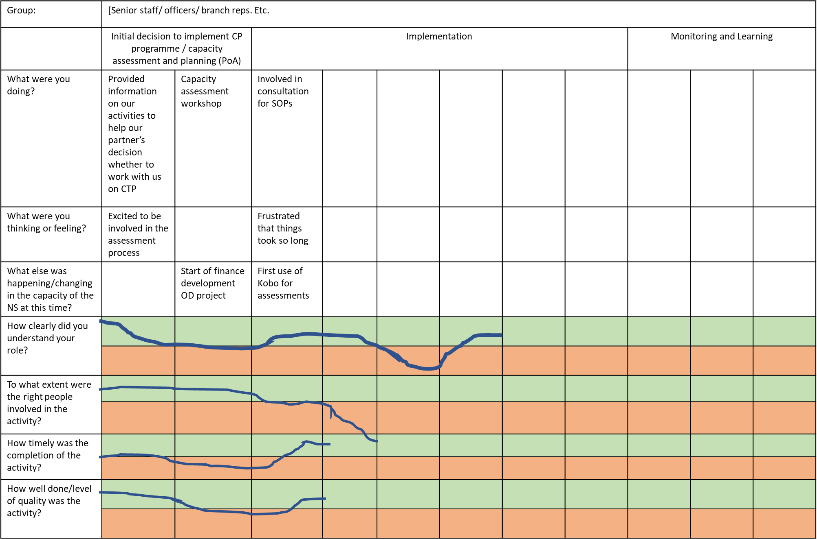
- The final activity is to review the completed tables in plenary and pose the following questions:
  - What have been the critical moments or turning points? And what has the NS and partners learned from these?
  - What have been the key enabling and blocking factors of achieving cash preparedness activities? And what have NS and partners done to address or build on these?

- Responses to these questions should be captured so that they can be fed into the report.

16.00 – 17.00 Facilitators debrief
In-Brief - An hour for the facilitation team to debrief after Day 1 and look around the room, to ensure all relevant discussions have been recorded, so that they can be integrated into the final report.

DAY 2

Morning

9.00 – 12.00 Mini scenario (CVA roles and responsibilities)
with morning/afternoon coffee breaks

In Brief – Using a CVA mini scenario, participants to test how well they understand their roles and responsibilities in CVA as set out in the relevant CVA tools (especially SOPs), and to identify any gaps in knowledge/procedures, through thinking through their actions during a typical CVA intervention. It is important to be clear that the objective is NOT to review the SOPs but rather to assess participants’ familiarity with them. However, if there are aspects of the SOPs that are identified that need to change, these can be an added output of the process, although the main objective is to look at awareness/familiarity of the SOPs, rather than revise them.
In addition to SOPs, in this session it is also important to ensure that facilitators probe on other aspects, e.g. CVA embedded into NS policy, systems (e.g. any disaster funds) and guidance, financial systems and approvals, agreed scenario plans (scale and speed for when cash should be used), coordination internally and decision making, external coordination with the government/other agencies/CWG/clusters, if in place/relevant.
Process:
- Divide participants into three groups, as before, ideally along seniority lines (e.g. leadership/heads of departments, officers, branches).
- Give the group a few minutes to come up with key questions they need to answer in order to design a typical response (such as the type of disaster, the location of the disaster, other actors working in the area, etc.) Facilitators will have pre-prepared the answers based on imagination/context and will then brief participants on the mini scenario (15 mins)
- Each group work on two steps each of the following steps of a CVA response programme. The steps are:
- Needs assessment
- Market assessment
- Financial service providers, organisational capacity and risk assessment
- Response analysis
- Implementation
- Monitoring, Evaluation and Learning
NB: Accountability is mainstreamed throughout the stages.
- Each group discusses what they will be doing and what tools they would be using during that particular stage. They complete the columns ‘what should you be doing’ and ‘what tools/methods should you be using’ of the table below (1 hour)
Stage | What should you be doing? (Including which department) | What tools or methods should you be using? | Important information missed by groups  (In plenary – this is useful to record as what is not raised is a finding in itself) | What ‘good’ looks like (example prompts for facilitators to show/discuss at end – these can be adapted)
Post-emergency needs assessment |  |  |  | - Appropriate mapping of key stakeholders  - Appropriate use of CVA questions integrated into NS assessment tools (access to markets, access to FSPs, previous experience with cash assistance etc).  - Data disaggregated by age, gender and diversity.
Market assessment |  |  |  | - RAM and MAG or equivalent used  - Logistics department is adequately involved
Financial service providers, organisational capacity and risk assessment |  |  |  | - Appropriate mapping of FSPs  - Finance and Logistics are adequately involved  - Approved Scope of Work, framework agreements, contracts etc
Response analysis |  |  |  | - Choice of response modality and mechanism is based on: suitability to the intervention objectives, capacity of the organisation/partners to implement the different modalities/mechanisms, beneficiary preferences and capacity, risks/mitigation (including protection-related risks), cost and alignment with government/other actors' policies and practices.  - Value of the transfer is based on a Minimum Expenditure Basket (MEB). The targeting criteria used is linked to the objectives of the intervention, relevant for the local population and context, and feasible with the resources available.
Implementation |  |  |  | - To identify beneficiaries, an official identification is matched with an internal verification tool (e.g. distribution lists, cards, SIM).  - Distribution and encashment plans are consistent with the service providers’ location and capacity.  - CEA for CVA plan developed and implemented  - Feedback/complaints from beneficiaries (e.g. through PDMs, focus groups etc.) is collected and used to improve the intervention.
Monitoring, Evaluation and Learning |  |  |  | - PDMs were carried out sufficiently early to inform further distributions.  - Monitoring data is reflected on and used to make decisions

- After an hour, the groups rotate, so that they work on two other steps, adding anything that was missed and highlighting what they agree/disagree with (15 minutes).
- Groups then rotate again and work on the final two steps (15 minutes).
- In plenary, facilitators help participants to review the tables, including identifying if anything is incorrect or missing (30 mins)
- Participants then rate themselves using RAG ratings in terms of how ready to do a CVA intervention they think they are:
  - Individually
  - As a department
  - As a NS overall
If there is sufficient time:
- During the above exercise, probably different opinions will have been given on the SOPs and ideas suggested about how to improve them. Given this, it will be useful to capture views on the SOPs. Participants rate their satisfaction with the SOPs (45 mins)
- They can either give an overall RAG rating, or rate according to different criteria, e.g:
      - Clarity
      - Comprehensiveness (is anything missing?)

LUNCH

The afternoon is dedicated to identifying the changes that have occurred in terms of CVA capacity as a result of the CVAP programme and identifying and mapping the final CVAP levels.

13.00 – 15.00 Updating the CVA self-capacity assessment and CVA organisational preparedness capacity (endline)
In Brief- This exercise uses the CVA self-capacity assessment that was done at baseline and the mid-term review, with participants updating the NS final capacity across each area and component, through the use of evidence. This includes identifying where changes in capacity have occurred and the enablers for this; identification of the most important capacities that have changed during the project; identification of capacities that were intended to change, but did not (or only partially), and the blockers. Also, identification of any unplanned changes in capacity (either positive or negative) and the enablers for this.

Outcomes: Final version of NS CVA self-capacity assessment with evidence and final CVA organisational preparedness capacity scores at endline.
Process:
Participants are divided into four groups, which three focused on one of the five CVAP areas and and one group taking two areas (Suggested this group takes areas 3 and 4). Each group should consist of people who know the content of each area. Participants are provided with the mid-term CVA capacity assessment results on laptops, showing the mid-term scores per area and component.
- Each group to see if they can identify any components where NS has made progress to suggest they need to increase a score. Conversely, also identify if any components where they may have decreased. Note for each answer, justification is required. This should be written in the activities and evidence columns under ‘Area scores’ (45 mins)
- At the end, summarise and discuss (15 mins)
  - Which are the most important capacities that have changed during CVAP?
  - Are there any capacities that were intended to change, but did not/only partially? What were the blockers?
  - Are there any unplanned changes in capacity (either positive or negative)? What were the enablers?
- Each group has 10 mins each to present the progress they have identified in the area they have been assessing, including the final score achieved, and what the enablers/blockers were for the progress. (1 hour)

The below is a list of example potential enablers/blockers that may be relevant to consider during discussion. The facilitator can consider providing a handout with the below information to enhance participants discussions – NS can adapt for their context:
  - Provision/lack of technical guidance
  - Presence/absence of dedicated Cash Focal Point
  - High/low functioning of Technical Cash Working Group
  - High/low digital technology capacity
  - High/low capacity for reconciliation
  - Clarity/lack of clarity of roles and responsibilities for CP beyond the Cash Focal Point
  - Presence/absence of central beneficiary database
  - Presence/absence of logistical and human resources for data gathering during an emergency
  - Presence/absence of digital data collection and registration mechanisms
  - Presence/absence of systems to pre-position cash
  - Presence/absence of cross-organisational buy-in across all sectors and with support services
  - Involvement/lack of involvement of support services which are not involved in assessments and CTO design
  - Quick/slow decision-making processes on the use of cash in emergencies
  - Abundance/limited numbers of staff familiar with CTP at branch and sub-branch levels.
  - Accessibility/inaccessibility of SOPs at branch level.

COFFEE BREAK

15.30 – 15.45 Reflection on Movement CVA operational readiness levels (endline)
In Brief – This session is a reflection on the final Movement CVA operational readiness levels the NS has achieved, compared where it was at the start of CVAP. It uses the five CVA operational readiness indicators for ablility, likelihood, timeliness, accountability and scale as measurements. The CVA Focal Point will use the data gathered either during the last annual RCRC Counting Cash exercise to compare against the mid-term and baseline data. Alternatively, the NS can gather the data independently. See Guidance on how to measure the Movement CVA Counting Cash or Operational Readiness Indicators

Outcomes: Updated Movement CVA operational readiness levels, showing what the NS has achieved by the final review.
Process:
- CVA Focal Point presents a summary of the latest NS CVA operational readiness levels from the RCRC Counting Cash exercise or independently (5 mins)
- Brief discussion in plenary to reflect on progress (10 mins)
  - Are the levels per indicator and overall, as expected?
  - What were the main enablers and blockers?

NS baseline and final CVA operational readiness levels
 | Level 1 | Level 2 | Level 3 | Level 3+
Indicator 1: % CVA through a framework agreement delivery mechanism
Baseline
Endline/final after CVAP
Indicator 2: % of CVA expenditure OR % branches delivering CVA
Baseline
Endline/final after CVAP
Indicator 3: Number of days from disaster to CVA delivery
Baseline
Endline/final after CVAP
Indicator 4: Number of CVA with key CEA/AAP activities
Baseline
Endline/final after CVAP
Indicator 5: Number of people supported with CVA
Baseline
Endline/final after CVAP
Overall CVA operational readiness level
Baseline
Endline/final after CVAP

Handouts: Data from latest RCRC Counting Cash exercise or by NS independently

15.45– 16.45 Impact of CVAP on future responses

In Brief – The final session provides space for the NS to reflect on how CVAP will impact future NS responses, including the use of CVA.

Process:
- Each group to reflect and identify how the CVAP programme has or will impact the NS responses – for emergencies, recovery, long term, etc. (i.e. increase of CVA as compared to in-kind, cash at scale, more timely assistance, more quality, etc.) (30 mins)
- Feedback in plenary, 5 mins per group, of key discussion points (30 mins)

16.45 – 17.30 Facilitators debrief
In-Brief – Time for the facilitation team to debrief after Day 2 and look around the room, to ensure all relevant discussions have been recorded, so that they can be integrated into the final report.

Additional sessions
These are optional and depend on the individual country and can be completed at any time.
- Interview with President/Secretary General
- Interviews with community committees involved in implementing pilots.

