Example 2.2.1 - Decision Log
Note: this is a real example of a list of steps in the process for implementing the rental assistance programme. It was developed relatively early in the Ukraine 2022 crisis rental programme.

IFRC Shelter Programme in Slovakia
Rental Assistance Steps
(EspoCRM / Espo is the Customer Relationship Management (CRM) System used on the Programme. Twilio is an application that can send out SMS or other communication from a CRM).
Targeting
- Targets do not allow for the programme to be opened up widely therefore we will go for the following targeting criteria:
  - Geographical targeting: six SRC branches across the country will provide shelter assistance in their respective districts through their local Humanitarian Service Point.
  - External referral (and verification): from local networks (civil society groups); Civil Protection; Municipalities and District Offices, Government institutions providing lists of TP holders with specific needs that require additional financial support.
  - Internal referral of most vulnerable households from the IFRC MP cash lists – families with high socio-economic vulnerabilities and/or special needs who may need housing support as continuation of MP cash support.
  - Collective centres to be closed / reconverted urgently to original functions (convention centres, gymnasium, education facilities).
  - Small hotels / pensions where the hosted families get temporary free accommodation via financial assistance from the Government but not found sustainable for the medium-term permanence.
- Need to communicate clearly that registration does not mean that they are eligible for the support, during registration their eligibility will be assessed as well as gaining understanding of other needs where RC may be able to support.

- Registration of HHs requesting rental assistance will be accepted at the HSP (by walk-in or by booking an appointment).
- Form will be filled in EspoCRM by Slovak Red Cross (SRC) staff and volunteers. Registration form: Cash for shelter registrations (510.global)
- The Registration Form calculates the scoring based on the eligibility scoring table: See tools in 2.1.4 Targeting and Selection Criteria.
- Assisted families will be responsible to find and secure the accommodation option of their choice as one of the following:
  - To stay in the current rental accommodation
  - To move in to a new rental accommodation
- Eligible HHs (scoring 50-100%) and non-eligible HHs (scoring 0 -49%) will be automatically validated by the system. The IFRC shelter manager in HQ (Bratislava) will see the validated cases and share with the branch staff the shortlist of eligible families only.
- Eligible and non-eligible HHs will be informed by SMS automatically sent from Espo/Twilio (TBD by 510) on weekly basis and invited to the branch for information on the assistance package and requirements.
Registration

- Branch staff will communicate with selected households about the rental package they are eligible for (1/2/3 room apartment and one off grants for utilities and HH items, adaptation work etc. – this is recorded and analysed in the registration form on Espo).
- It is the responsibility of the HH to find the rental unit that suits their needs and preferences. Branch staff will provide information and guidance as needed on seeking properties, including a briefing on housing adequacy guidelines that we will verify on site as a next step.
- If families struggle to find rent, the SRC branch will support finding an accommodation by using the local network of landlords, rental agencies and municipal offices.
- During the orientation session, HHs will be guided through the process as per slides below. The HH will receive information on the house visit, the documents needed for enrolment, the amount they are eligible for and the expected date of the first payment. They will be also informed about the monthly monitoring system which is the condition for the next payments.

HH orientation and support process to find rental property

Contents of the orientation session for rental assistance package and steps: See 2.1.5 Community Engagement and Accountability Tools in Rental Assistance Toolkit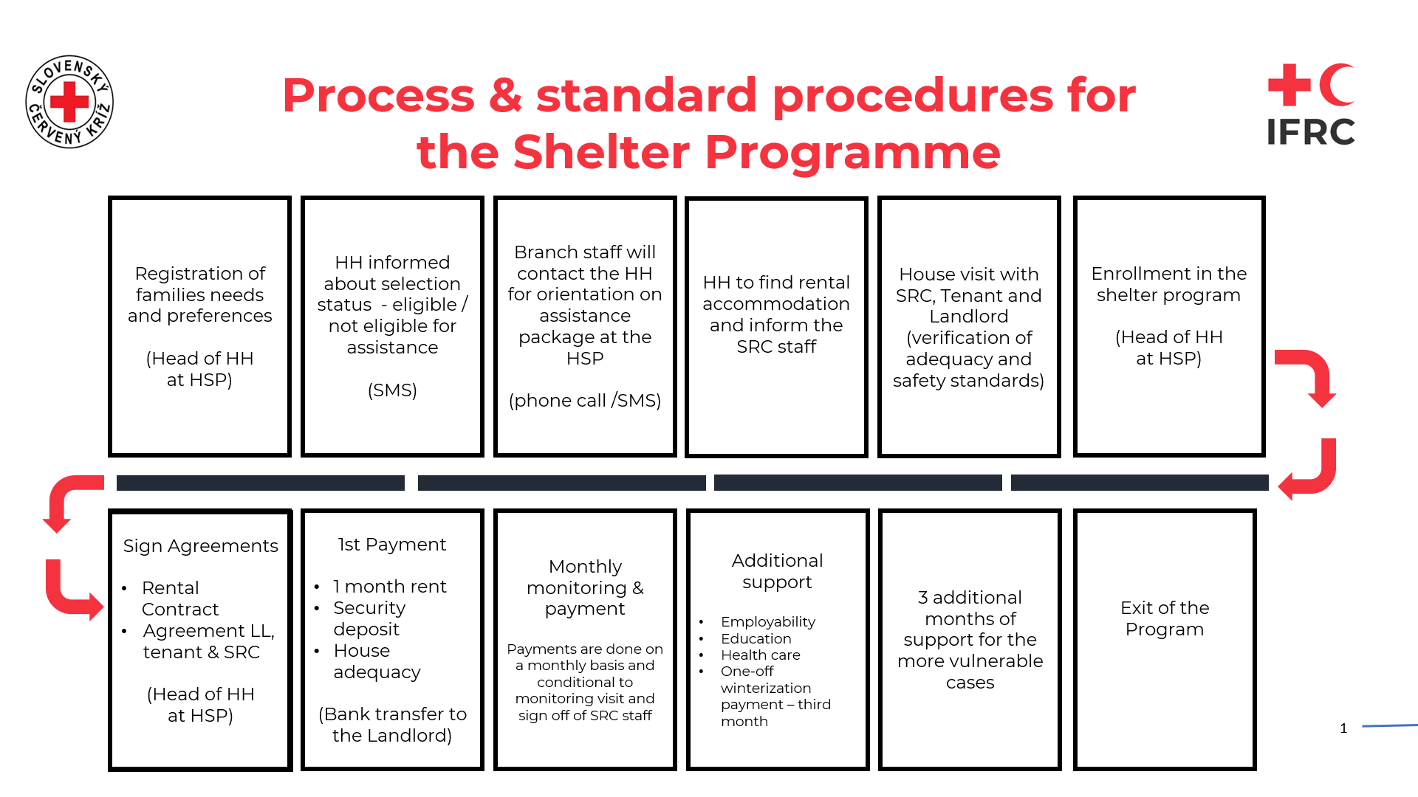
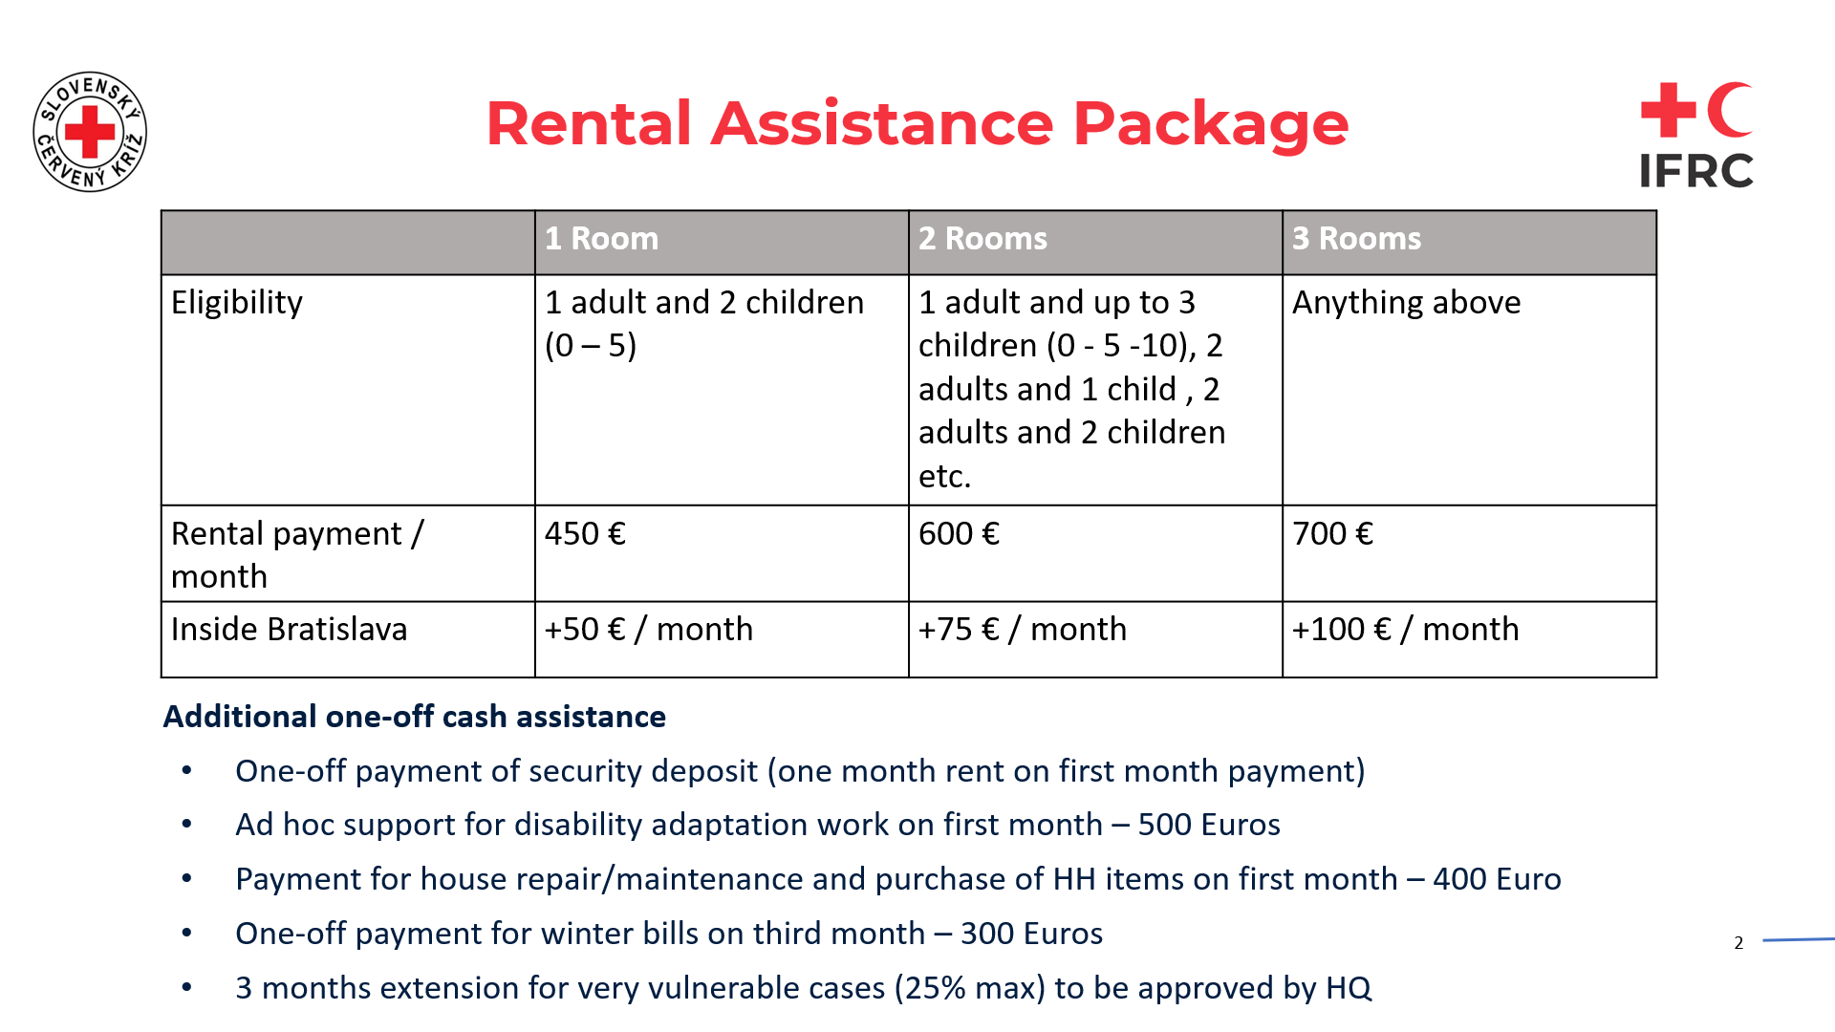
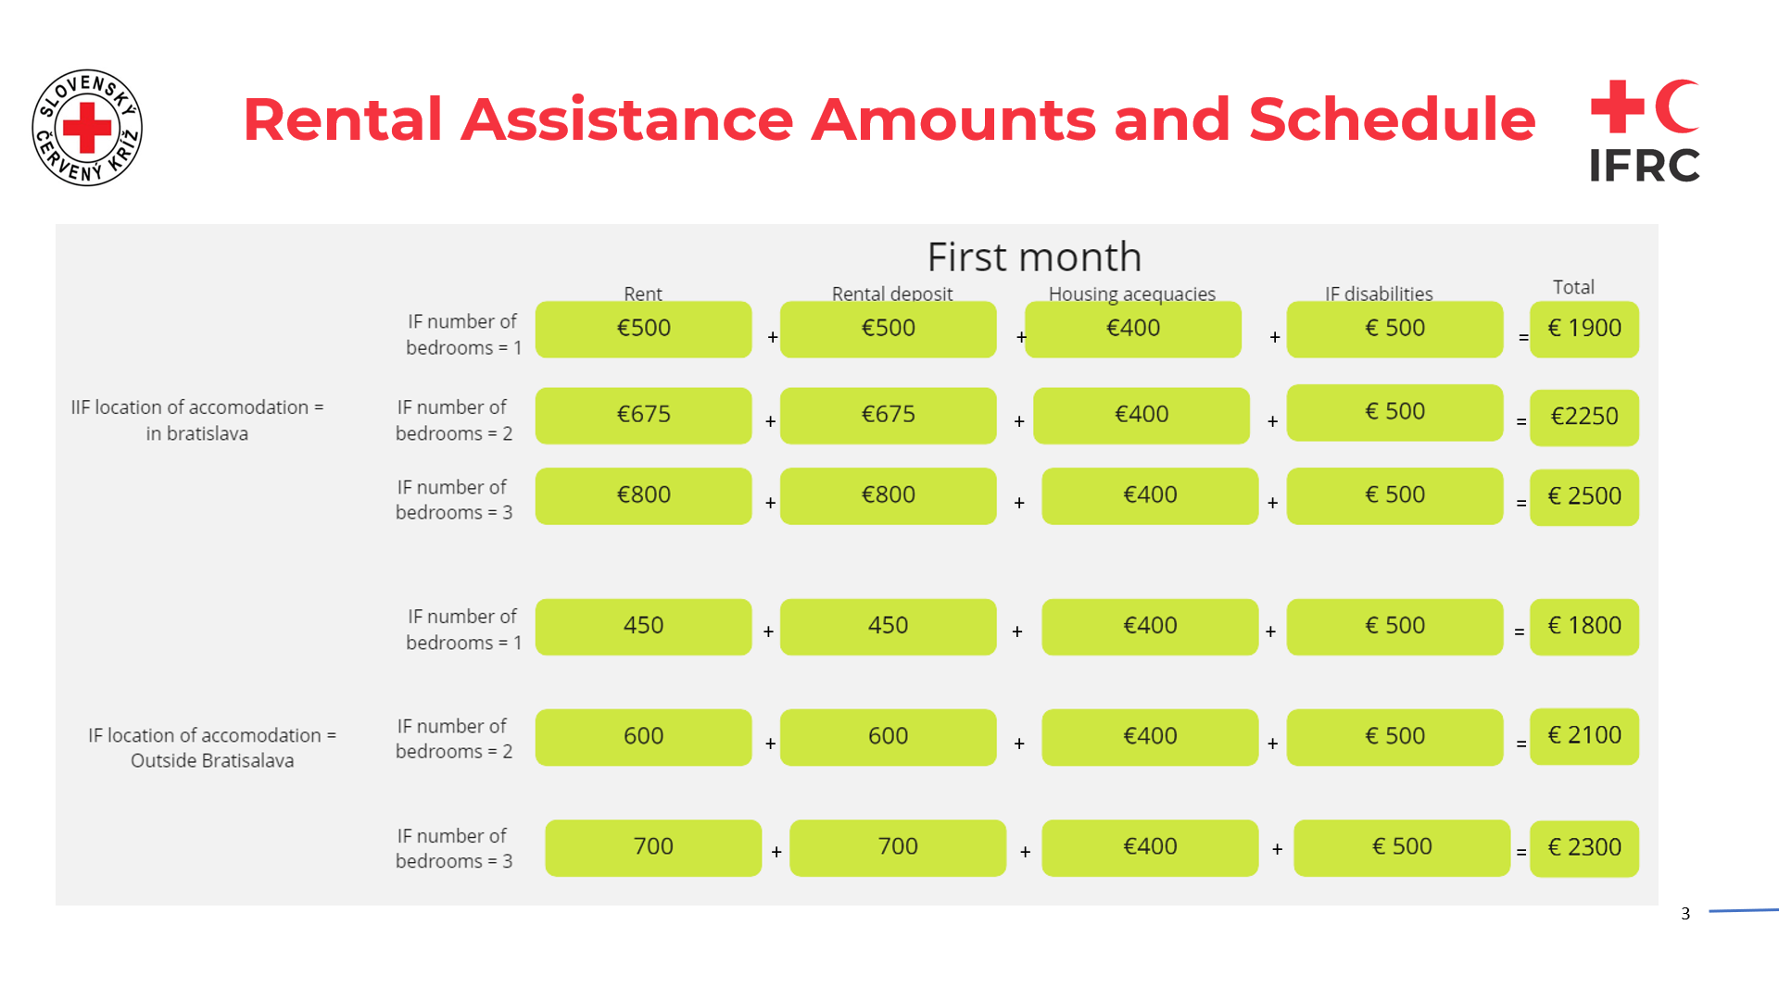
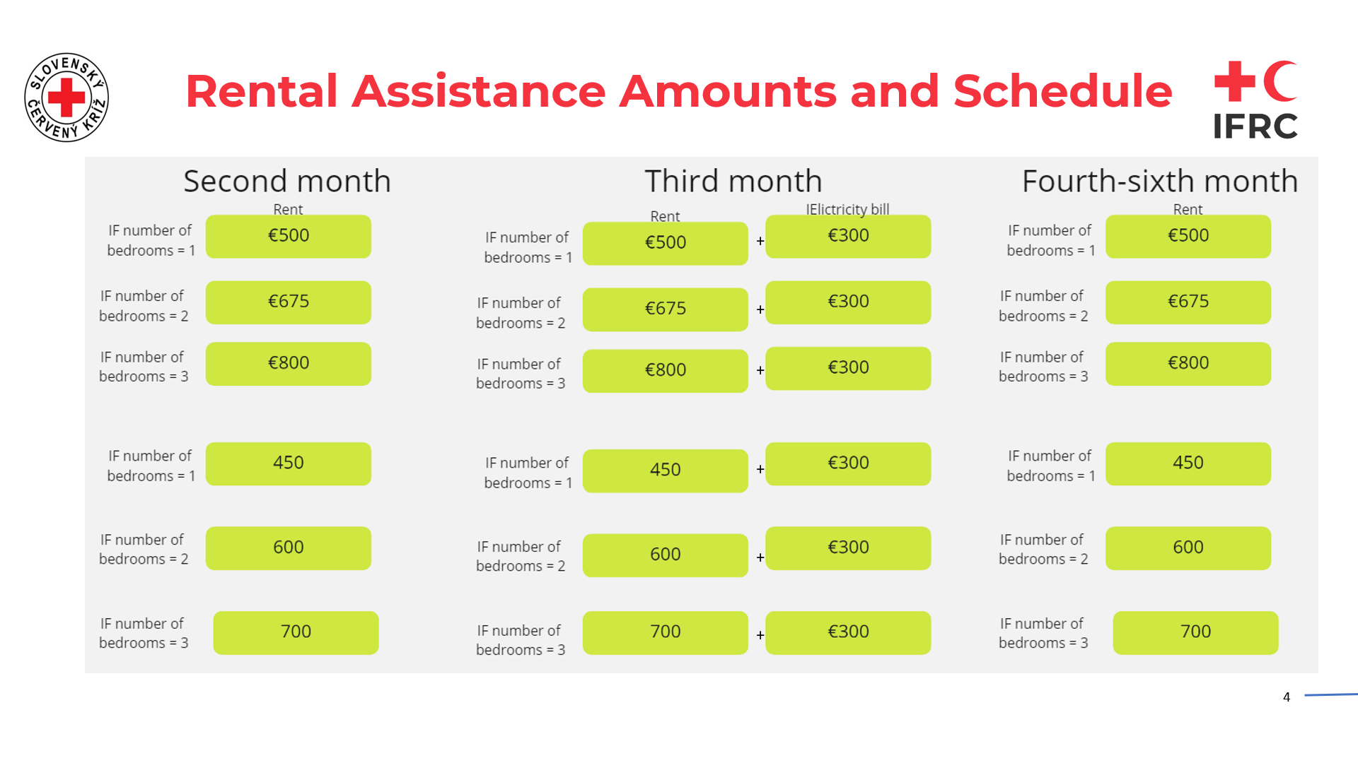
- Once the HH has found a rental unit, the house will be assessed by the SRC staff in presence of the Landlord and the Tenant (heads of HH).
- The house visit checklist is compiled by SRC brach staff and volunteers on a Kobo form: https://eenew.ifrc.org/x/CpGAqy1j
- Once submitted, all info will feed into EspoCRM for the shelter manager to review the minimum standards of the housing unit: Shelter Verifications (510.global)

House adequacy visit

- HH Application will be finalised at the HSP on EspoCRM, data collected by SRC branch staff: Cash for shelter applications (510.global)
- The Tenant and the Landlord will sign the rental contract. A standard rental contract has been prepared by SRC for guidance/use of both parties.
- The Tenant, Landlord will sign a tripartite agreement with SRC.
- All docs, including copy of ID of LL and Tenant will be uploaded to Espo. These are mandatory for approval of payment.
Application & Agreements

- The payment amount is calculated automatically in Espo through the information collected in the application form (number of rooms in the unit, location in or outside Bratislava, disability status of the HH). The batch is created in Espo and pushed to RR in 6 monthly payments.
- Landlord’s name, landlord IBAN and transfer amount are the financial data pushed to Red Rose through EspoCRM.
- The first payment amount will include the rental deposit (1 month fee), rental fee, one-off amount for purchase of HH items (400 euro) and if needed, the disability adaptation one-off amount (500 euros).
- Payments are made through IBAN transfer on monthly basis and on a fixed date:
  - Batching by the 1st of the month > payment on the 5th of the month.
  - Batching by the 15th of the month > payment on the 20th of the month.
- HHs will receive an automatic SMS when the transfer has been processed by RR.
Payments

- Monthly monitoring will be performed door to door and / or by phone by the branch staff and volunteers (condition for the next payment).
- The monitoring form will be filled in in Kobo and data collected will be pushed to EspoCRM. Once the information is validated by the shelter manager, this will work for the L1 approval in RR.
Form: https://eenew.ifrc.org/x/99UMmLeW
- Existing data to be loaded to Kobo ahead of each monitoring visit and then deleted once new data submitted.
Monitoring

