Example 2.2.3 - Shelter programme organogram

*Note: This is a real example of an organogram for a shelter programme (hosting assistance and rental assistance) established in Humanitarian Service points in Slovakia*

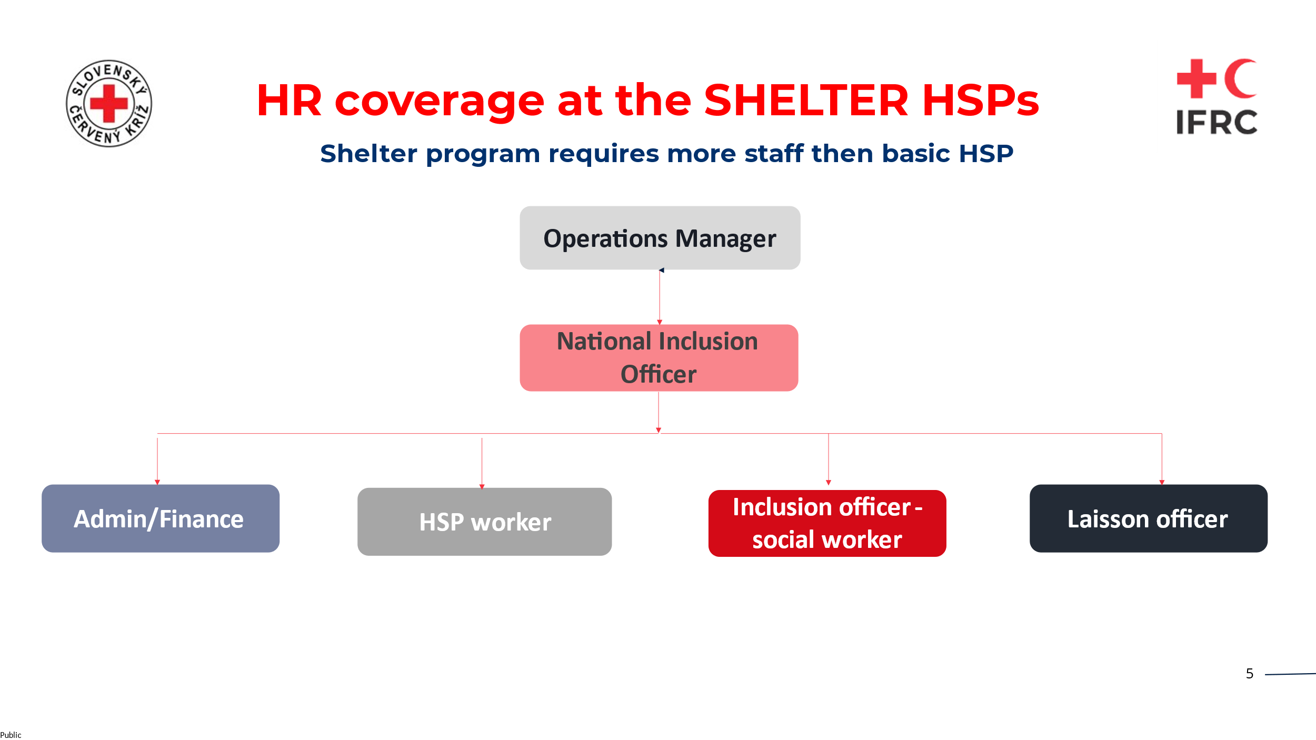

This is for the Humanitarian Service Points (HSP) – such that per HSP you would have 1 of the following:

1. Admin/Finance staff member
2. Humanitarian Service Point Worker
3. Inclusion Officer – Social worker
4. Liasson Officer