Introduction
Once a response option analysis has been undertaken and it is determined that rental assistance programming should be considered further, a more detailed analysis using this Go/no-go decision tree can be used.
The output of this tree is essentially whether further assessment and programme design should be considered.
The following is extracted from IFRC (2020) Step-by-step guide for rental assistance to people affected by crisis , step 1, sub-step 3, and is included below for completeness.

Key Considerations
The following considerations may be relevant to a Go/no go decision for further exploration of this programming option:
- NS readiness and government acceptance of rental assistance programming
- Rental assistance for the targeted population is accepted by the hosting community
- Housing market has sufficient available housing units
- Target population have been consulted, have identified shelter as a priority need, and consider living in rental accommodation to be a preferred option
- Rental accommodation will respond to the shelter and protection needs (PGI considerations, SGBV, do no harm, etc.)
- Security of tenure can be guaranteed
- Timely rental payments to property owners, and/or service providers are feasible
- A realistic exit strategy is possible.
- NS has capacity to implement rental assistance with internal and/or external support
It may be that you have not undertaken assessments so do not have enough information to respond to these considerations, and you may have to return to this step later in your context analysis. However, in many cases you may well have an understanding of what is possible and what are the “show stoppers” even with less detailed knowledge of the context.

Decision Making Tree for Rental Assistance Go/No Go
Do not do Rental Assistance
Do not do Rental Assistance

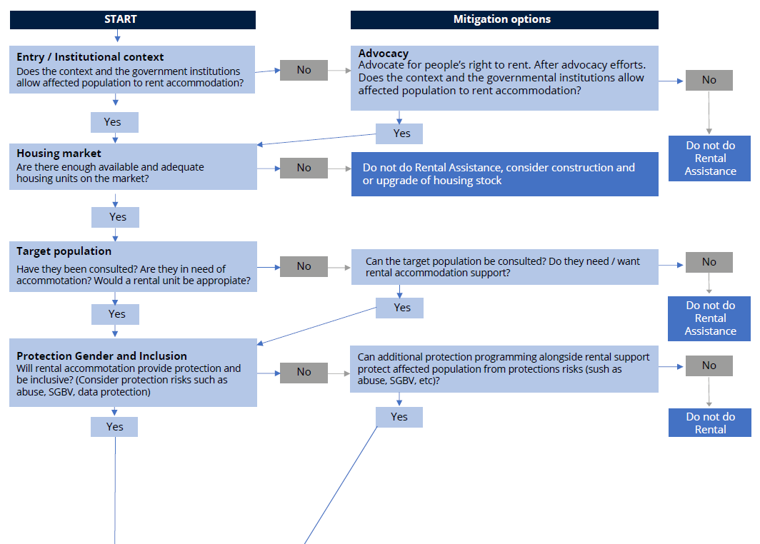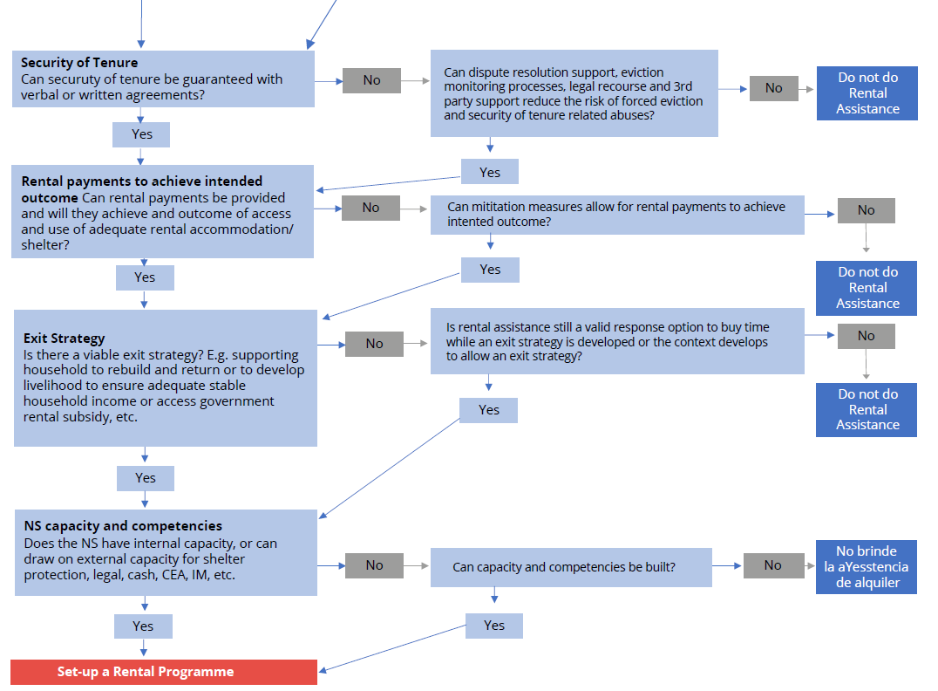

SoP 1.6 Rental Housing Market Assessment gives a large number of considerations to understand the rental market. One consideration of whether a rental programme in the mainstream rental market will be appropriate may relate to residential rental market vacancy rate (the number of unoccupied residential rental dwellings / total number of residential rental dwellings). A judgement will need to be called as to the size of the programme that the rental market can absorb. For example, when the residential rental vacancy rate are around 2% or less, then a large programme in a concentrated geographical area is going to be less feasible unless bringing new rental stock onto the market is part of the programme, whereas when the residential vacancy rate is 4% and above it might be more feasible.

